Document 3: Tests
Kit: qae_european 1.0.0 · Status of this document: Part 1 (test plan) frozen by its commit before the campaign (422ebfb); Part 2 (results) written after the campaign. Sign-off of the whole kit by Romain Dutrenois at the end, after an independent review.
Part 1 is pre-registered: it is written and committed before the campaign runs, and the commit date is the proof. Any change made after that commit is recorded in the deviations table (section 1.9), with its reason.

Part 1: Test plan

1.1 What we want to test, and why
The kit prices a European call with maximum-likelihood amplitude estimation (MLAE) on a quantum circuit simulator. The claim to test is the theoretical promise of amplitude estimation: it needs fewer samples than Monte Carlo to reach the same accuracy, quadratically fewer in the limit.
Measure of performance: relative efficiency in number of calls. Performance is measured by the error reached for a given number of calls (sample complexity, or query complexity for amplitude estimation, where a call is a query to the circuit A). Two methods are compared through their relative efficiency at a given RMSE ε:
E(ε) = N_comparator(ε) / N_QAE(ε)
where N(ε) is the number of calls a method needs to reach RMSE ε. E > 1 means amplitude estimation needs fewer calls than the comparator; E < 1 means it needs more. Calls are counted as follows:
- For amplitude estimation, a call is one application of the circuit A. One Grover step contains A and its inverse, so a measurement after k Grover steps counts as 2k + 1 calls.
- For Monte Carlo, a call is one simulated path, i.e. one payoff evaluation.
- For quasi-Monte Carlo, a call is one point of the Sobol sequence.
Out of scope:
- Speed (wall-clock time). The campaign runs on a classical simulator, which is far slower than Monte Carlo. No current quantum machine can run the deeper circuits usefully. Speed is discussed only as a projection from published resource estimates, labelled as such.
- Hardware noise. The simulator is noise-free. No run on a real machine in this campaign.
Accuracy is decomposed. The circuit prices the option on a grid of 2ⁿ points, not on the continuous distribution. Its error against Black-Scholes therefore has two parts, measured separately:
- discretisation bias = grid price − Black-Scholes price (deterministic, depends on n);
- statistical error = estimate − grid price (random, depends on the number of calls).

1.2 Hypotheses
# | Hypothesis | Type
H0 | The circuit computes the grid price exactly, and the identity used to accelerate the campaign holds. | Prerequisite
H1 | At equal calls, the RMSE of amplitude estimation is below that of plain Monte Carlo sampling the same grid, i.e. a relative efficiency E > 1. | Relative efficiency against plain Monte Carlo
H2 | The query complexity of amplitude estimation is O(1/ε), against O(1/ε²) for plain Monte Carlo: its statistical error falls like 1/N, against 1/√N. | Query complexity (convergence rate)
H3 | With 7 price qubits and the largest budget, the total error against Black-Scholes is within tolerance. | Accuracy against the reference
H4 | Against quasi-Monte Carlo, the best classical sampling method for this one-dimensional problem, no relative efficiency above 1 is expected. | Descriptive: measured, no pass/fail
H4 is stated in advance as an expected absence of gain (E ≤ 1). Quasi-Monte Carlo converges close to 1/N on smooth one-dimensional problems, the same rate as amplitude estimation.

1.3 Methods compared
Method | Target | Role
Black-Scholes closed form | Continuous price | Reference ("truth")
Exact circuit probability | Grid price | Checks the circuit (H0)
Amplitude estimation (MLAE) | Grid price | Method under test
Plain Monte Carlo on the grid | Grid price | Like-for-like comparator for H1, H2
Plain Monte Carlo, continuous | Continuous price | What a desk would see with plain sampling
Quasi-Monte Carlo (scrambled Sobol), continuous | Continuous price | Best classical sampling method (H4)
Methods and code are described in Document 2 (Benchmarks).

1.4 Scenario grid
Spot fixed at 100. All combinations of:
Dimension | Values | Count
Moneyness K / S₀ | 0.75 to 1.25, step 0.05 | 11
Maturity | 1W, 2W, 1M, 3M, 6M, 1Y, 3Y, 5Y | 8
Volatility | 20% to 80%, step 10% | 7
Rate | −1%, 0%, +1% | 3
That is 1,848 scenarios. Each is crossed with:
- price qubits n = 3, 4, 5, 6, 7 (grids of 8 to 128 points);
- 5 budgets: MLAE ladders of depth 4 to 8, i.e. Grover powers (0, 1, 2, 4, …, 2^(depth−2)), 100 measurements per power. That gives 1,800, 3,500, 6,800, 13,300 and 26,200 calls. Monte Carlo methods get the same number of calls; quasi-Monte Carlo uses the largest power of two not above it;
- 50 independent draws of every random method.
In total: 1,848 × 5 × 5 = 46,200 configurations, about 9.2 million priced estimates.

1.5 Measured quantities
For each scenario, number of qubits n and budget N, the campaign stores:
- the Black-Scholes price, the grid price and the exact circuit price;
- for each random method, the root-mean-square error (RMSE) over the 50 draws, against its own target (grid price or Black-Scholes, as in 1.3), and the RMSE of amplitude estimation against Black-Scholes;
- for amplitude estimation and Monte Carlo on the grid, the median absolute error against the grid price, which is not driven by a few large errors;
- for amplitude estimation, the share of mode errors: draws where the estimated θ is further than π / (2 m_max) from the true θ, with m_max = 2 k_max + 1 the multiplier of the highest Grover power. That is half the period of the most informative measurement, so such a draw has locked onto a wrong peak of the likelihood;
- the number of calls actually used.
Seeds are derived from a fixed master seed (20261103) and the indices of scenario, qubits, budget and method, so any row can be recomputed on its own.

1.6 Scope rules: decided before the run
- Out-of-grid scenarios. When every grid point is out of the money, the circuit price is exactly 0 and there is nothing to estimate. These are counted and reported, and excluded from H1 to H4.
- Negligible prices. Scenarios with a Black-Scholes price below 0.01 (one cent on a spot of 100) are reported separately and excluded from H1 to H4. Relative errors are meaningless there.
- Everything else is in scope. No scenario is excluded after the results are seen.

1.7 Acceptance criteria
# | Criterion | Pass if
H0-a | Circuit price against grid price, every scenario and every n | Absolute difference ≤ 1e-9 in 100% of cases
H0-b | Full statevector simulation of A Qᵏ against sin²((2k + 1)θ), on 20 randomly drawn scenarios (powers up to 64 for n ≤ 5, up to 8 for n = 6, 7) | Absolute difference ≤ 1e-9 in 100% of checks
H1 | At the largest budget (26,200 calls), RMSE of amplitude estimation < RMSE of Monte Carlo on the same grid | In ≥ 95% of in-scope (scenario, n) pairs
H2-a | Fitted slope of log RMSE against log N over the 5 budgets, amplitude estimation, n = 5 | Slope ≤ −0.8 in ≥ 90% of in-scope scenarios
H2-b | Same fit for Monte Carlo on the grid (checks the benchmark) | Slope between −0.65 and −0.35 in ≥ 90% of in-scope scenarios
H3 | n = 7, largest budget: RMSE of amplitude estimation against Black-Scholes ≤ max(1% of the Black-Scholes price, 0.01) | In ≥ 95% of in-scope scenarios
H4 | Ratio of RMSE against Black-Scholes, amplitude estimation (n = 7) over quasi-Monte Carlo, at each budget | Descriptive: distribution reported, no pass/fail
Verdict per hypothesis: Validated if the criterion passes; Not validated otherwise. If a criterion fails only in an identifiable region of the grid (for example very short maturities), the verdict is Validated with limits, naming that region. Failure of H0 stops the campaign: nothing else is interpreted.

1.8 Reported analyses (in addition to the criteria)
- Relative efficiency E at the largest budget, per in-scope scenario, against Monte Carlo on the grid (n = 5 and n = 7) and against quasi-Monte Carlo (n = 7): median, first and third quartiles. E is estimated from the fitted error curves: E = N_comparator(ε) / N_QAE(ε), with ε the RMSE of amplitude estimation at its largest budget, and N_comparator(ε) read from the comparator's fitted log RMSE against log N (extrapolated beyond 26,200 calls where needed, flagged as such).
- Errors by dimension: moneyness, maturity, volatility, rate and number of qubits, to find where amplitude estimation works best and worst.
- The crossing budget N*: the smallest budget where amplitude estimation beats Monte Carlo on the grid, for each scenario.
- Discretisation bias against Black-Scholes, as a function of n and of the scenario.
- The hard cases: deep out-of-the-money options (small amplitude), very short maturities, high volatility.
- Counts of out-of-grid and negligible-price scenarios.
- Mode errors of amplitude estimation: their share by scenario, number of qubits and budget, and where they concentrate. H1 is also reported on the median absolute error, as a sensitivity check. The criterion itself stays on the RMSE.

1.9 Deviations from the plan
Date | Deviation | Reason | Approved by
2026-11-10 | Proposed, not applied: H0-a restated as a relative tolerance, |circuit − grid| ≤ 1e-8 × grid price. Post hoc: made after seeing that H0-a fails as written (Part 2, section 2.4). | The absolute tolerance of 1e-9 did not allow for the floating-point error of Qiskit's state-preparation synthesis at 6 and 7 qubits (relative error up to 3.4e-9) | Pending: independent review and sign-off
2026-11-10 | First campaign run discarded, unread. It ran on a stale installed copy of the package (20 draws, without the measures added above). Detected when the analysis script stopped on the missing columns, before computing any statistic. The run was moved aside without being analysed; the package was reinstalled in editable mode; the analysis script (docs/analyse.py) was committed before the rerun; each run now writes results/run_info.json (git commit, draws, versions) next to its results. | Execution error, recorded for transparency | Developer (Veqctor)
2026-11-10 | Draws raised from 20 to 50; median absolute error and share of mode errors added to the stored measures (1.5) and reported analyses (1.8). Criteria unchanged. | While writing the user guide, one scenario was recomputed (scenario 1000: at the money, 5Y, vol 60%, rate 0%; n = 5, largest budget). One of its 20 draws had locked onto a wrong peak of the likelihood (θ off by about π/129), giving a price error of 33 on a price of 49; the RMSE over 20 draws was 7.4, against 0.5 over 200 draws. This is a known property of maximum-likelihood amplitude estimation: errors are mostly small, with rare large ones. With 20 draws the RMSE would depend on whether such a draw is in the sample. The method itself is left unchanged (the published one); the measurement is made more stable and the rare errors are counted rather than hidden. No other scenario was inspected. | Developer (Veqctor)
2026-11-03 | Terminology: "superiority" replaced by relative efficiency and query complexity (sections 1.1, 1.2), and the distribution of E added to the reported analyses (1.8). Criteria and thresholds unchanged. Made before any run. | Standard statistical terms, measurable per scenario | Romain Dutrenois
2026-11-03 | Before this campaign, in the exploratory version of the kit, the amplitude-estimation tolerance was tightened from 2% to 1% after a first run, and the budget increased. This plan replaces those exploratory tests; its criteria are set without reference to them. | Recorded for transparency | —

1.10 Execution
- Environment: Python 3.13, Qiskit 2.6.1, NumPy 2.5.4, SciPy 1.18.1, all versions pinned in requirements-lock.txt. CPU: 2-core Intel Xeon at 2.8 GHz, Linux. Details in Document 1.
- Commands: qae-european verify (H0-b), then qae-european campaign --processes 2 (resumable). Output: results/verification.json, results/campaign.csv and results/run_info.json (the git commit, parameters and library versions of the run). The analysis against the criteria is docs/analyse.py, committed before the run.
- Acceleration (declared). In the campaign, amplitude-estimation measurements are drawn from the exact probabilities sin²((2k + 1)θ), with θ taken from the exact statevector of the circuit A for each scenario. On a noise-free simulator, this is mathematically identical to simulating the circuits A Qᵏ. The identity is verified by H0-b.
- Sizing. Timing was measured on 3 scenarios, timing only, without inspecting results: about 1.5 s per scenario with 20 draws, so about 25 minutes in total. With 50 draws: about 1 hour on 2 cores.

1.11 Sign-off
Role | Name | Decision | Date
Author | Veqctor (kit generation) | Submitted | 2026-11-03
Independent review | AI reviewer (separate session, no access to the build)
Sign-off | Romain Dutrenois

Part 2: Results
Every number below comes from results/summary.json, produced by docs/analyse.py from results/campaign.csv and results/verification.json. All four files are in the repository.

2.1 Execution record
Item | Value
Code | commit 13af41d, no uncommitted changes (results/run_info.json)
Plan | frozen at commit 422ebfb, before the run
Environment | Python 3.13.17, Qiskit 2.6.1, NumPy 2.5.4, SciPy 1.18.1, Linux, 2 cores
Run | 2026-11-10: verification (100 checks), then 1,848 scenarios × 5 qubit counts × 5 budgets × 50 draws
Rows | 46,200 (complete)
Wall time | about 6 minutes for the verification and 17 minutes for the campaign
Incidents during execution:
- A first campaign run was discarded unread. It ran on a stale copy of the package (section 1.9).
- The analysis script had a bug in the relative-efficiency calculation: the fitted intercept was used on the wrong scale. The script crashed, the cause was fixed, and the analysis was rerun. The fix touches only the relative efficiency (section 1.8). No acceptance criterion depends on it.

2.2 Scope
Category | Count | Treatment
Scenarios with a Black-Scholes price below 0.01 | 55 (30 at 1W, 19 at 2W, 6 at 1M) | Excluded from H1 to H4, as planned
(scenario, n) pairs worthless on the grid | 147 (42 at n = 3, falling to 24 at n = 7) | Excluded, as planned; all of them are also negligible-price scenarios
In-scope (scenario, n) pairs | 8,965 | 1,793 scenarios at each n

2.3 Verdicts
# | Criterion (section 1.7) | Result | Verdict
H0-a | Circuit price against grid price ≤ 1e-9 in 100% of cases | 89.4% (41,310 of 46,200 rows); largest difference 8.4e-9 | Not validated as written; see 2.4
H0-b | Full simulation of A Qᵏ against sin²((2k + 1)θ) ≤ 1e-9 in 100% | 100% (100 of 100); largest difference 6.1e-10 | Validated
H1 | At 26,200 calls, RMSE of amplitude estimation < Monte Carlo on the grid, ≥ 95% | 97.8% (8,772 of 8,965) | Validated (conditional on 2.4)
H2-a | Slope ≤ −0.8 for amplitude estimation, n = 5, in ≥ 90% | 89.0% (1,595 of 1,793); median slope −0.98 | Not validated (conditional on 2.4)
H2-b | Slope between −0.65 and −0.35 for Monte Carlo on the grid, n = 5, in ≥ 90% | 99.8% (1,790 of 1,793); median slope −0.50 | Validated (conditional on 2.4)
H3 | n = 7, largest budget: RMSE against Black-Scholes ≤ max(1% of the price, 0.01), in ≥ 95% | 88.9% overall; 99.0% for maturities up to 1 year | Validated with limits: maturities up to 1 year (conditional on 2.4)
H4 | QAE against QMC, descriptive | Median RMSE ratio 18 to 20, at every budget | As expected: no gain over QMC

2.4 H0-a: what failed, and what it means
The facts.
- 978 of the 9,240 (scenario, n) circuits differ from the grid price by more than 1e-9. Every one has 6 or 7 price qubits (826 at n = 7, 152 at n = 6).
- The largest absolute difference is 8.4e-9. The largest relative difference, over all circuits, is 3.4e-9.
The cause. The deviation comes from Qiskit's synthesis of the state preparation, not from the logic of the circuit.
- Checked on the 5-year, 60%-volatility at-the-money option: the probabilities loaded by StatePreparation differ from the target p_i by at most 1.3e-13 at n = 5, 3.1e-11 at n = 6 and 6.4e-10 at n = 7. Their sum deviates from 1 by 2.5e-12 at n = 7.
- The error grows with the size of the synthesised circuit, as expected from floating-point accumulation over thousands of gates (Document 1, section 8).
- The payoff rotations and the Grover operator are not involved: H0-b, which simulates the full Grover iterations, passes at 6.1e-10.
Why the criterion failed. The criterion was set as an absolute 1e-9 on prices that reach a few hundred, and on circuits with up to 12,000 gates. A relative tolerance would have expressed the intent, "the circuit computes the grid price up to numerical precision", correctly. This is a specification error in the plan, made before the run.
Effect on the other results: none in practice. A relative error of 3.4e-9 is about five orders of magnitude below the smallest statistical error in the campaign: the smallest relative RMSE of amplitude estimation is 3.6e-4.
What the plan says. "Failure of H0 stops the campaign: nothing else is interpreted." Applied literally, H1 to H4 have no verdict.
Proposed deviation (post hoc, not applied). Restate H0-a as a relative tolerance: |circuit − grid| ≤ 1e-8 × grid price. Under it, H0-a passes in 100% of cases.
- The proposal is made after seeing the results, so it is not part of the pre-registered plan.
- It is left to the independent review and to the sign-off to accept or reject.
- The verdicts on H1 to H4 above are given conditionally on its acceptance, and marked as such.

2.5 H1: amplitude estimation against Monte Carlo on the same grid
At the largest budget, amplitude estimation has the lower RMSE in 97.8% of in-scope (scenario, n) pairs. On the median absolute error, the share is 99.98% (the sensitivity check of section 1.8).
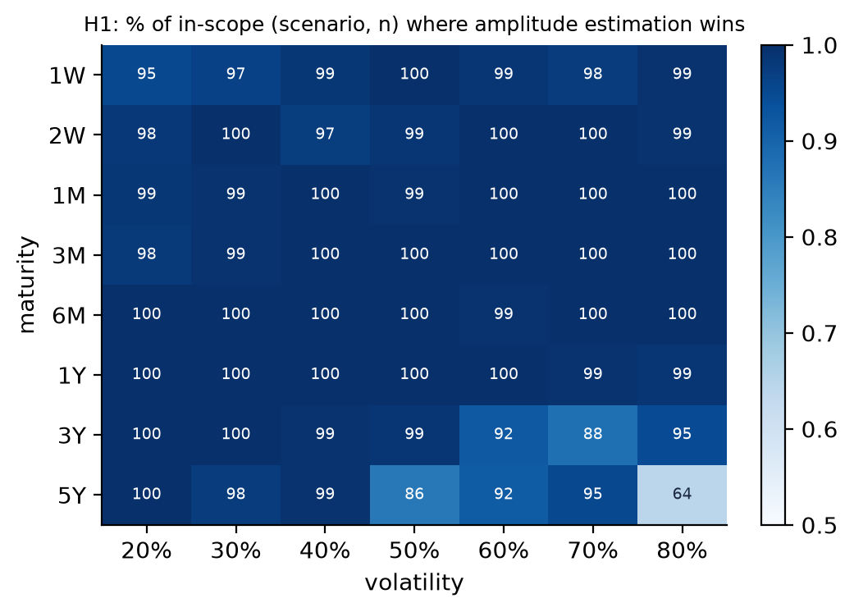
Where it loses.
- Long maturity and high volatility. Of the 193 losses, 109 are at 5Y and 45 at 3Y, and 72 at 80% volatility. Losses also grow with n: 14 at n = 3, 64 at n = 7.
- The cause is the payoff scaling (Document 1, section 11). The price is read as e^(−rT) × largest grid payoff × amplitude. On a wide grid the largest payoff is many times the price, the amplitude is small, and its error is magnified. Monte Carlo on the grid has no such factor.
- Mode errors are present in 38 of the 193 losses.
Crossing budget (n = 5): the smallest budget at which amplitude estimation beats Monte Carlo on the grid.
Budget (calls) | 1,800 | 3,500 | 6,800 | 13,300 | 26,200 | Never
Scenarios | 764 | 708 | 250 | 55 | 14 | 2
In 82% of scenarios, amplitude estimation is ahead from 3,500 calls.

2.6 H2: convergence rate
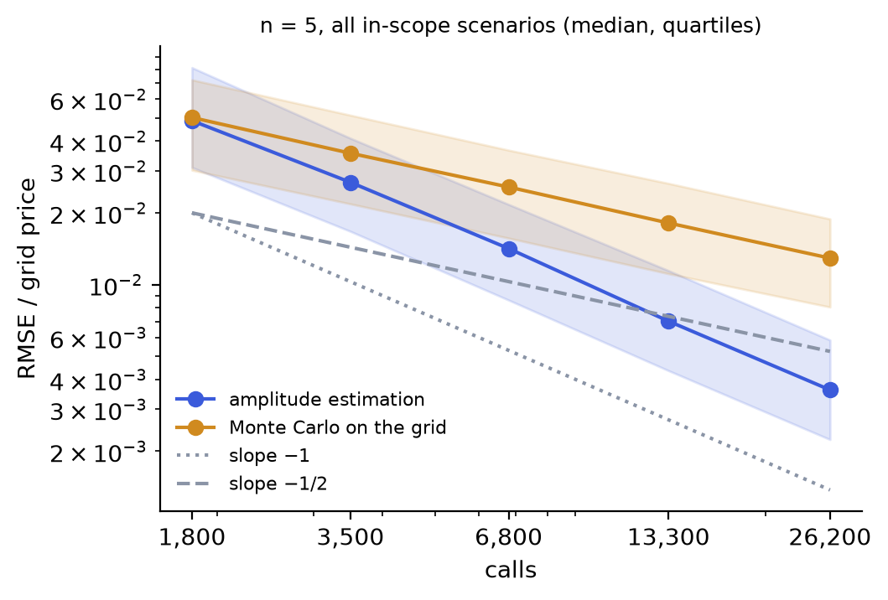
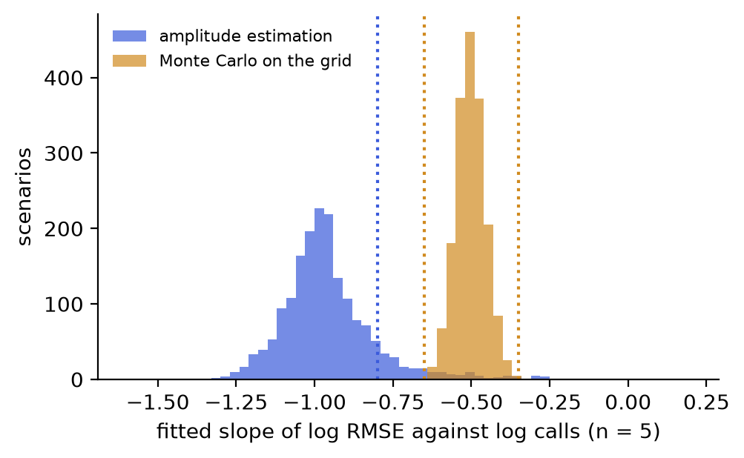
Monte Carlo on the grid (H2-b) behaves exactly as theory predicts. The median slope is −0.50, with quartiles −0.53 and −0.47, and 99.8% of scenarios are in the band. This confirms the benchmark and the fitting procedure.
Amplitude estimation (H2-a) has a median slope of −0.98, with quartiles −1.04 and −0.90: the 1/N rate in the bulk of the scenarios. But 11.0% of scenarios have a slope above −0.8, against the 10% the criterion allows.
- The failures are spread across the grid. By maturity they range from 15 to 43, by volatility from 20 to 39. Limiting to maturities up to 1 year raises the share only to 91.1%. There is no identifiable region, so the verdict is Not validated, not Validated with limits.
- The likely reasons are noise and the low budgets. Each slope is fitted on 5 RMSEs, each estimated from 50 draws (a relative standard error of about 10% each). Over that range, the noise moves the slope by several hundredths. At the low budgets (depth 4: powers 0, 1 and 2 only), MLAE is not yet in its asymptotic regime, and the slope over 1,800 to 26,200 calls mixes the two regimes. A longer ladder or more draws would sharpen the estimate. Neither was planned, and neither has been tried.

2.7 H3: accuracy against Black-Scholes, n = 7
Against Black-Scholes, the RMSE is within max(1% of the price, 0.01) in 88.9% of scenarios overall, and 99.0% of the 1,331 scenarios with maturity up to 1 year. Failures are concentrated where the grid is widest: 69 at 3Y and 117 at 5Y out of 199, and they grow with volatility (70 at 80%).
In 67 of the 199 failures, the discretisation bias alone exceeds the tolerance: no amount of sampling can bring those scenarios within 1% with 128 grid points. The rest come from the payoff scaling described in 2.5.
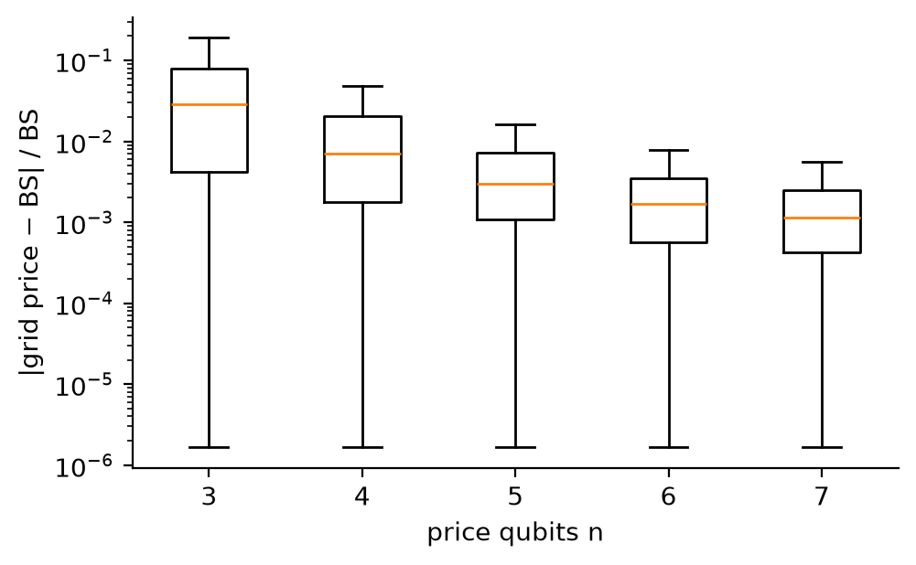
The median relative discretisation bias falls from 2.9% at n = 3 to 0.11% at n = 7.

2.8 H4 and relative efficiency
Against quasi-Monte Carlo (n = 7, both against Black-Scholes), amplitude estimation's RMSE is a median 18 to 20 times larger, at every budget. Amplitude estimation has the lower RMSE in only 4 to 9 of the 1,793 scenarios, depending on the budget. The ratio is roughly constant across budgets: both methods converge at about the same rate, close to 1/N, as stated in advance. The constant favours quasi-Monte Carlo, because amplitude estimation carries the discretisation bias and the payoff scaling, and quasi-Monte Carlo carries neither.
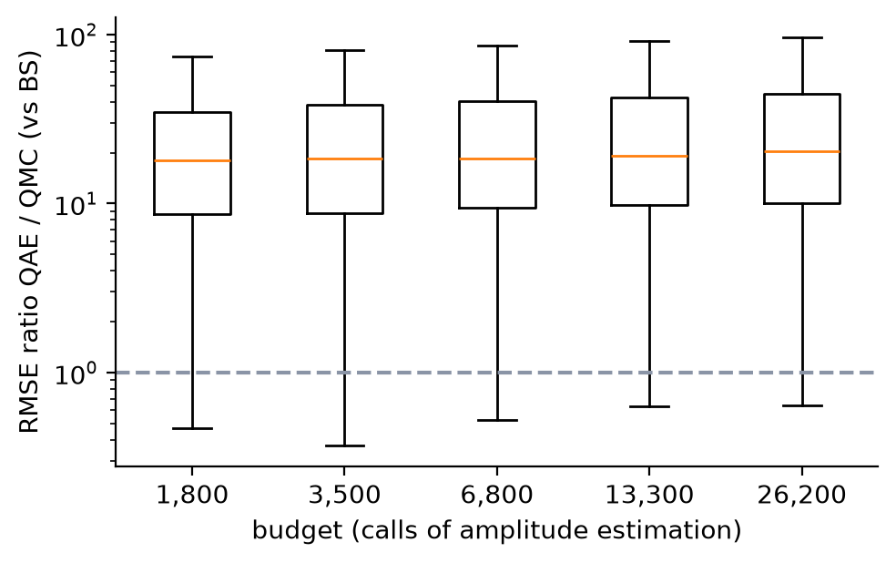
Relative efficiency at the largest budget, E = N_comparator(ε) / N_QAE(ε):
Comparison | Median E | Quartiles | E > 1 | Note
vs Monte Carlo on the grid, n = 5 | 11.2 | 6.7 – 18.1 | 1,759 of 1,793 | N_comparator extrapolated beyond 26,200 calls in those 1,759
vs Monte Carlo on the grid, n = 7 | 10.5 | 6.0 – 17.3 | 1,729 of 1,793 | extrapolated in 1,729
vs quasi-Monte Carlo, n = 7 | 0.028 | 0.014 – 0.050 | 2 of 1,793 | N_comparator extrapolated below the smallest budget (1,024 points) in most scenarios
At the largest budget, plain Monte Carlo would need about 11 times more calls than amplitude estimation to reach the same error on the grid. Quasi-Monte Carlo would need about 36 times fewer. Both figures rely on extrapolating the fitted lines beyond the budgets actually run, so they are indicative.

2.9 Mode errors of MLAE
Mode errors (section 1.5) are rare.
 | Depths 4 to 6 | Depth 7 | Depth 8
Share of draws affected | 0% | 0.0007% | 0.009%
Configurations with at least one | 0 of 8,965 | 3 | 41
The scenario that revealed them (section 1.9) is one of these 41: 1 of its 50 draws. Rare as they are, a single one can dominate an RMSE: they account for 38 of the 193 H1 losses.

2.10 Conclusions
- The circuit does what it claims, up to numerical precision. It reproduces the grid price to a relative 3.4e-9. The Grover identity behind the fast simulation holds to 6.1e-10. The only failure, H0-a, comes from an absolute tolerance that was too tight for 7-qubit synthesis, not from an error in the circuit (2.4).
- The textbook claim is confirmed on the like-for-like comparison. With the same number of calls on the same grid, amplitude estimation beats plain Monte Carlo in 97.8% of cases. On the grid, plain Monte Carlo needs a median 11 times more calls to match it at the largest budget.
- The 1/N rate holds in the bulk, but the pre-registered threshold is missed narrowly. The median slope is −0.98, but 11% of scenarios have a slope above −0.8, against 10% allowed. With the planned setting, the rate cannot be certified scenario by scenario.
- Against Black-Scholes, the kit is accurate to 1% for maturities up to 1 year with 7 price qubits. Beyond that, both the discretisation and the payoff scaling degrade it.
- There is no gain over the best classical sampler. Quasi-Monte Carlo is about 20 times more accurate at the same budget on this one-dimensional problem. That was expected, and it is why a European call is a test bench, not a use case.

2.11 Overall verdict (developer)
Fit for its stated purpose, with limits. The purpose is a reproducible, documented test bench for amplitude estimation on the simplest option.
Point | Status
Correctness of the circuit and the simulation | Established, subject to accepting the relative restatement of H0-a
Advantage in calls over plain Monte Carlo on the same grid | Established
Advantage scenario by scenario at the planned threshold | Not established (H2-a)
Accuracy against Black-Scholes | Up to 1 year only
Advantage over quasi-Monte Carlo | None, as expected
For the independent review and the sign-off to decide:
- whether to accept the restatement of H0-a;
- whether the H2-a result calls for a follow-up campaign: a longer ladder, more draws, or both.

