PROJECT SUMMARY

This project will be based on developing video game that will be featured in lego new york city flagship store.

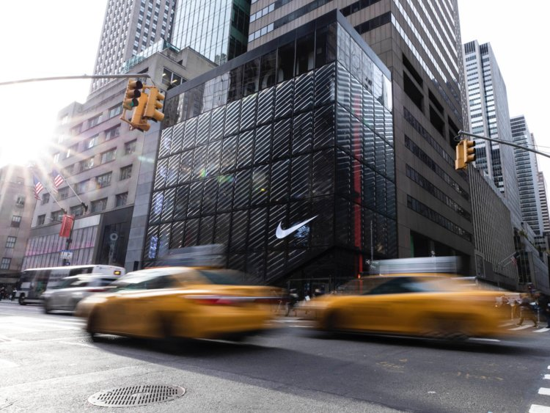

There will be an enormous physical Lego display of a spaceship, and visitors can step inside the big Lego spaceship to assume controls of a miniature video game panel and the video game lets visitors fly the spaceship through a fake universe.

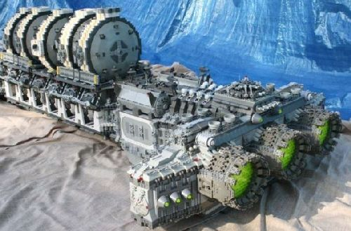

Stakeholders(Project team)

Developer: Emmanuel KALISA
Product manager: Lego
Marketer: Lego
third-party collaborators: Visitor
Builders: John, Jane and Ketty from lego

Goals

It is to build a video game that will let visitors fly the spaceship through a fake lego universe.

Timeline

Steps | Duration | Date
Project analysis | 1 week | January 1
Database structure | 1 month | January to February
Coding | 4 months | February to June
Testing | 2 weeks | June
Solving problems | 1 week | June
 | Total: 6 months

