2016-2016

Traffic simulation

Report

Group members:

MOHEDANO Geronimo

HENRY Romain

EL HILALI Houda

##### **Summary**

1. Introduction 2

2. Importance of such project 3

3. Diagrams 4

3.1. Global sequence diagram 4

3.2. Use case diagram 5

4. Code explanation 6

# Introduction

This project aims to resume the knowledge of agents oriented programing learnt in the IA51.

The project begins first with collecting all the information needed in order to have an idea of which kind of simulation we’ll be doing. Afterwards we’ve decided on how many agents we will be having for our Traffic simulation.

To achieve this project, we’ve used SARL programing language in order to program all the agents and the different parts of the simulation such as the different model classes and the GUI controller, whereas the GUI part is done using Javafx.

For this project, we chose to use Javafx due to the improved GUI components that the graphical library offers. And as we were asked to have a running SARL application SARL was the language used under eclipse IDE.

Our work was managed with the use of the git tool in order to share the improvement of each of us on the project.

# Importance of such project

Computer simulations reproduce the behavior of a system using a mathematical model. Computer simulations have become a useful tool for the mathematical modeling of many natural systems not only in physics but also in human in all the different fields. Simulation of a system is represented as the running of the system's model. It can be used to explore and gain new insights into new technology and to estimate the performance of systems too complex for analytical solutions.

Computer simulations are computer programs that can be either small, running almost instantly on small devices, or large-scale programs that run for hours or days on network-based groups of computers. The scale of events being simulated by computer simulations has far exceeded anything possible (or perhaps even imaginable) using traditional paper-and-pencil mathematical modelling.

Computer simulation developed hand-in-hand with the rapid growth of the computer, following its first large-scale deployment during the Manhattan Project in World War II to model the process of nuclear detonation. It was a simulation of 12 hard spheres using a Monte Carlo algorithm. Computer simulation is often used as an adjunct to, or substitute for, modelling systems for which simple closed form analytic solutions are not possible. There are many types of computer simulations; their common feature is the attempt to generate a sample of representative scenarios for a model in which a complete enumeration of all possible states of the model would be prohibitive or impossible.

Our traffic simulation has also an undenied goal that is to simulate cars behaviour on a road taking in consideration different constraint such as traffic lights and the respect of the different traffic laws.

# Diagrams

## Global sequence diagram

The image below describes the different communications between different actors of the simulation

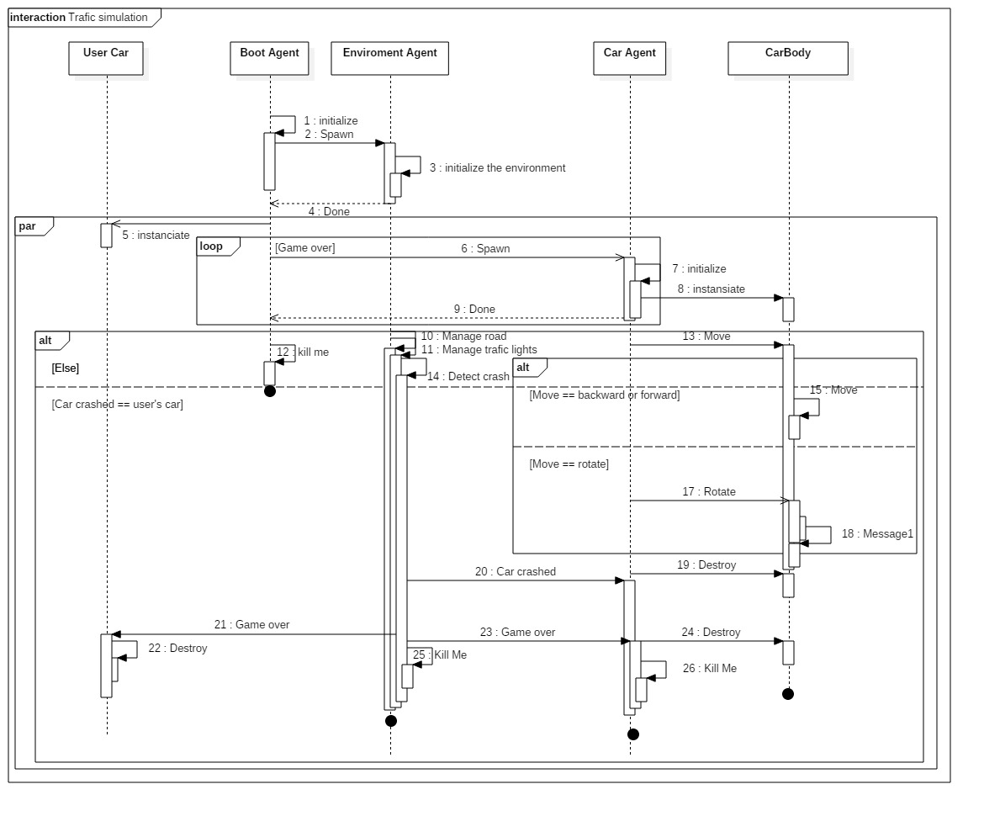

## Use case diagram

For our simulation, we’ve decided to add a game aspect to the simulation. That decision was taken in order to give a better experience to the user and make him a better conductor. The diagram below describes the different activities of the simulation

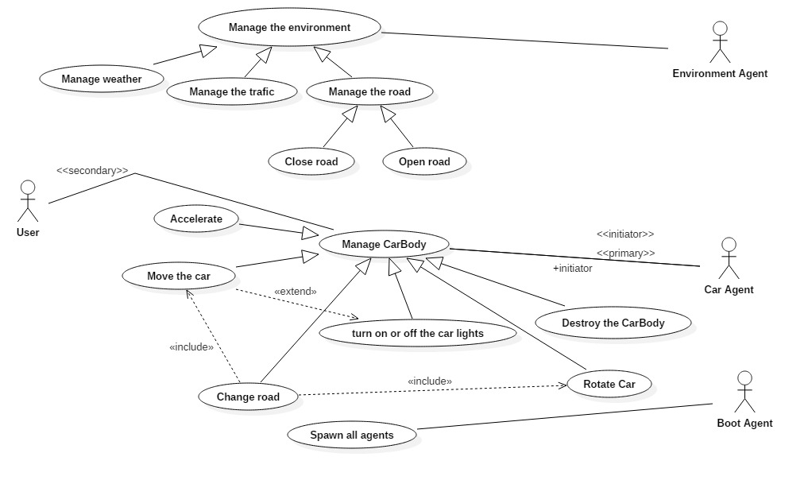

# Code explanation