Maximal elbow torque for task-specific evaluation in normal versus awkward shoulder postures

D. Haering, R. Martineza, XXX, G. Dumont, C. Pontonnier

aLaboratoire de Simulation et Modélisation du Mouvement, Département de Kinésiologie, Université de Montréal, 1700 Rue Jacques-Tétreault, Laval, Québec, Canada;

# Methods

**À rajouter dans la partie traitement**

* Caractéristiques de la matrice torque-angle-velocity (range angle, range velocité, etc.)
* Remplacement des nans par la moyenne des données de la même position
* Description de chaque paramètre et de leur acronyme (P1:P7)

## Statistics

All the statistical tests described in the following paragraphs were conducted on the flexion and extension contractions using a non-parametric method (, ) with the spm1d package (Pataky 2010).

### Model Parameters

A one-way MANOVA (positions) was applied on the model parameters. If the MANOVA reaches significance, separate paired Hotelling’s tests were conducted on each pair of positions. If those tests reach significance, additional paired t-tests were applied on each model parameters.

### Torque-Angle-Velocity Model

The torque-angle-velocity matrix (41 angles by 73 velocities) was flattened into a vector (2993 points) to allow the statistical tests to be conducted using statistical parametric mapping (Pataky 2010). A one-way repeated measures ANOVA (positions) was applied in this vector to compute a critical threshold. Additional paired t-tests were applied on each pair of positions on the significant areas given by the ANOVA.

# Results

## Model Parameters

The one-way MANOVA reaches significance at either flexion and extension contractions ( and , respectively).

### Flexion

[Insert Fig. 1]

Nine out of fifteen paired Hotelling’s tests conducted on flexion contractions (Fig. 1) reach significance ().

[Insert Fig. 2]

Three additional paired t-tests applied on P1 reach significance, zero on P2, three on P3, four on P4, five on P5, two on P6 and four on P7 (details on each comparison available in Fig. 2).

### Extension

[Insert Fig. 3]

Thirteen out of fifteen paired Hotelling’s tests conducted on extension contractions (Fig. 3) reach significance ().

[Insert Fig. 4]

Eight additional paired t-tests applied on P1 reach significance, zero on P2, seven on P3, five on P4, five on P5, two on P6 and nine on P7 (details on each comparison available in Fig. 4).

## Torque-Angle-Velocity Model

### Flexion

[Insert Fig. 5]

The main effect of position from the one-way ANOVA (Fig. 5) reaches significance () in the area that includes angles around 90o (from 68 to 123o) and high positive velocities (from 75 to 180 o). The F-value is constant in this significant area (from 4 to 6).

[Insert Fig. 6]

Only six out of fifteen additional paired t-tests applied on each pair of positions reach significance () in the area given by the ANOVA (Fig. 6). In this area, the elbow torque generated in the F0ER, A90ER and A90IR are significantly lower compared to the F90ER and F180ER positions. Hence, the elbow torque is greater when the glenohumeral joint is at 90o of flexion compared to other positions during flexion contractions at angles around 90o and at high positive velocities.

### Extension

[Insert Fig. 7]

The main effect of position from the one-way ANOVA (Fig. 7) reaches significance () in every combination of angles and velocity, excluding the area around 90o (from 65 to 86o) and low negative velocities (from 0 to -129 o). The F-value reaches its maximum (15) around high velocities (100-180) and angles close to 90o (80-110o).

[Insert Fig. 8]

Thirteen out of fifteen additional paired t-tests applied on each pair of positions reach significance () in the area given by the ANOVA (Fig. 8). Taken together, these tests suggest that the position’s elbow torque generation is in the following order (from greatest to least): F0ER, F90ER, A90IR, F90IR, A90ER, F180ER. Note that F90ER and A90IR are switched when the angle is below 90o. There is little differences around 90o and most differences appear over the full velocity range (10 out of 15) except F0ER vs A90IR, F180ER vs F90IR, A90ER vs F90IR which occur at high positive velocities.

# Figures

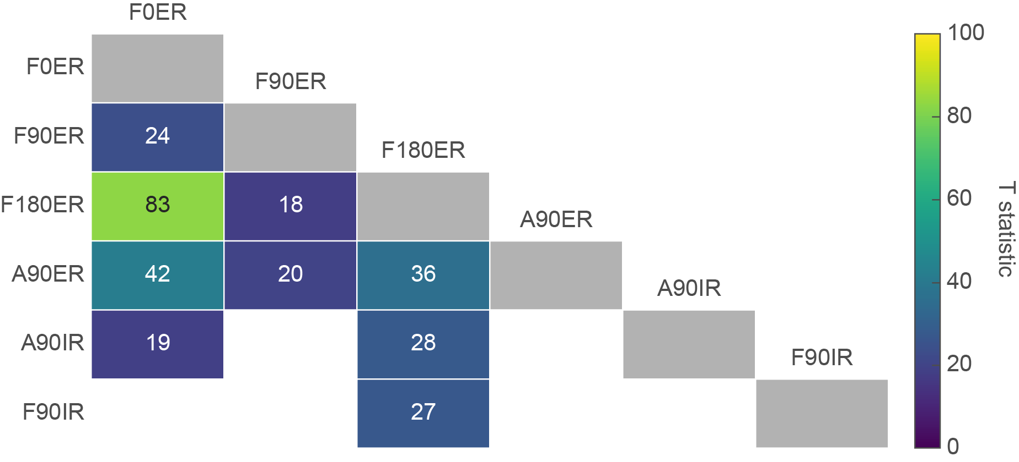

Figure 1. T statistic of Hotelling’s tests conducted on the model parameters of each pair of positions during flexion contractions, with a color gradient associated with the amplitude of the T statistic (empty and white if nonsignificant). The gray rectangles on the diagonal represent an intersection between the same position.

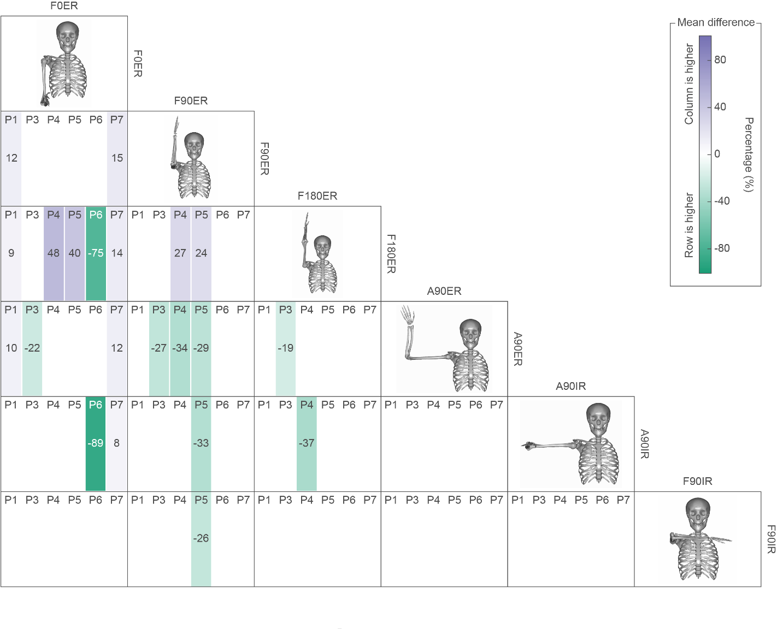

Figure 2. Additional paired t-tests applied on each model parameters (P1 to P7, except P2 which do not reach significance) of each pair of positions during flexion contractions. A colored rectangle is present when the test reaches significance, with a color gradient associated with the amplitude of the difference in percentage between the pair of positions (purple when the parameter of the position in column is higher, green when the parameter of the position in row is higher). A diagram of each position is displayed on the diagonal.

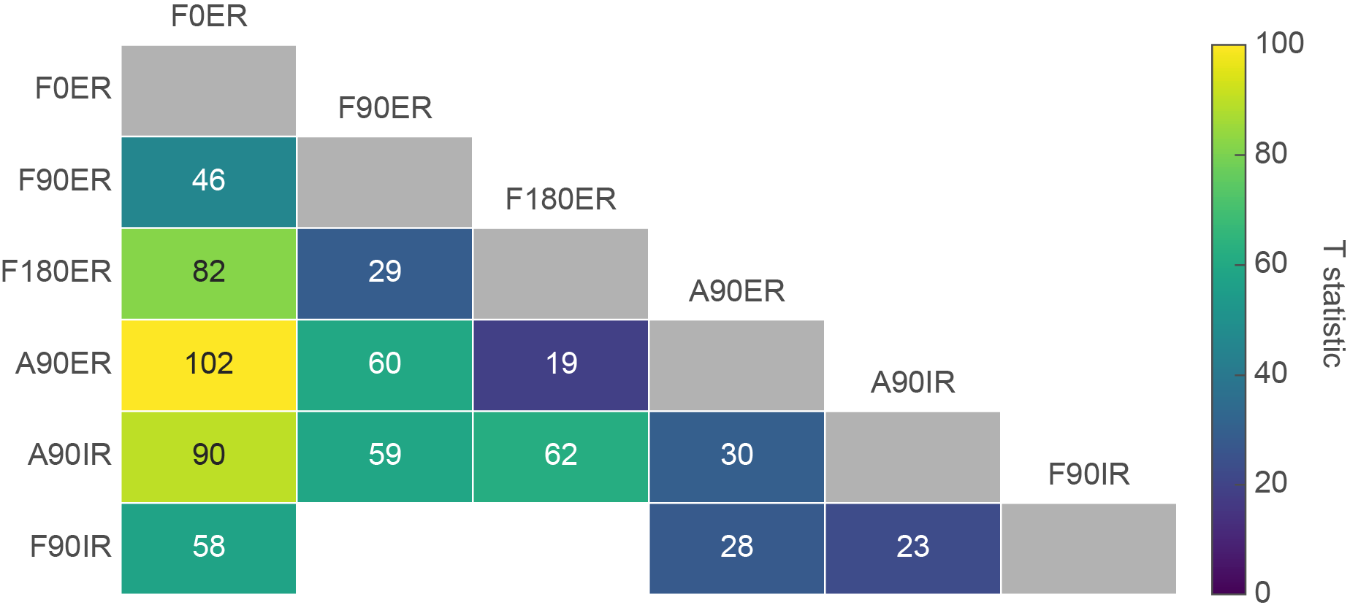

Figure 3. T statistic of Hotelling’s tests conducted on the model parameters of each pair of positions during extension contractions, with a color gradient associated with the amplitude of the T statistic (empty and white if nonsignificant). The gray rectangles on the diagonal represent an intersection between the same position.

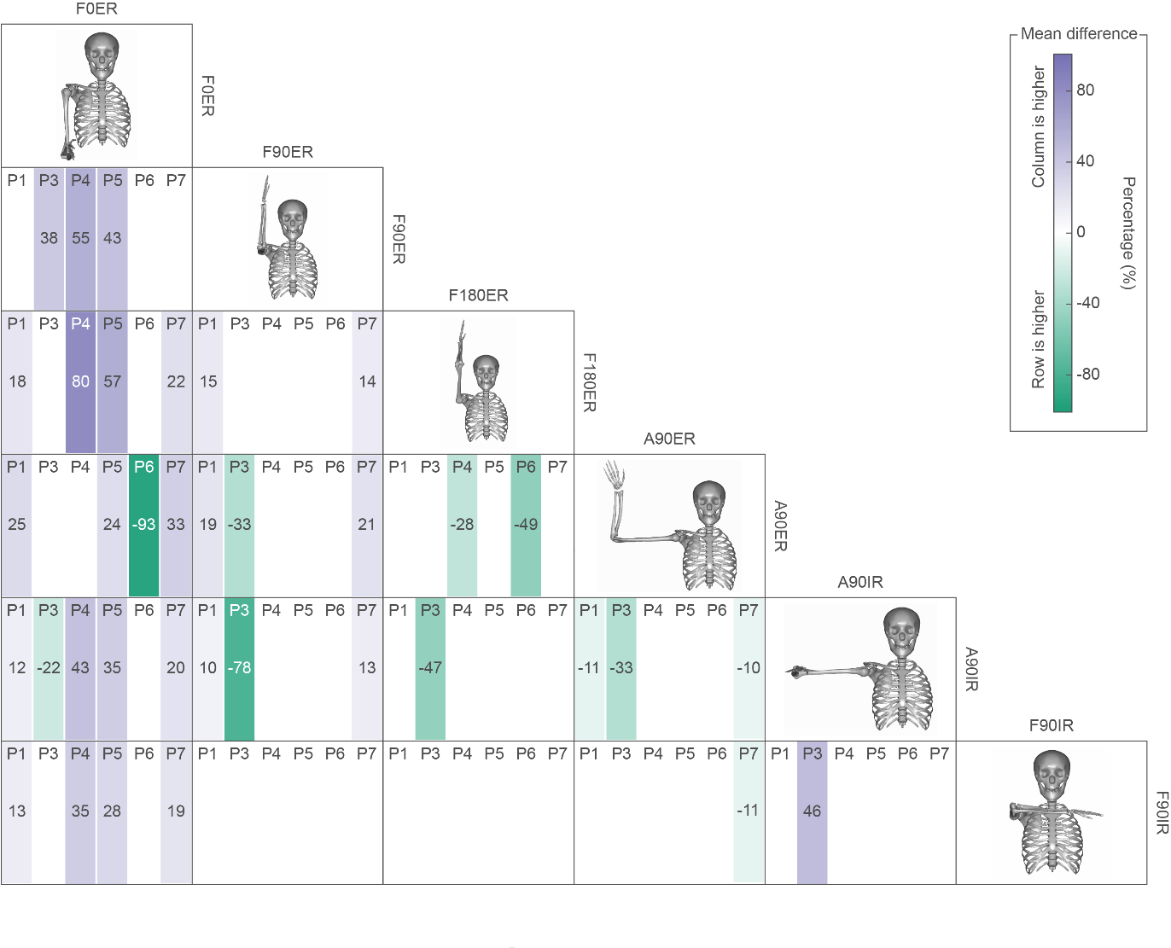

Figure 4. Additional paired t-tests applied on each model parameters (P1 to P7, except P2 which do not reach significance) of each pair of positions during extension contractions. A colored rectangle is present when the test reaches significance, with a color gradient associated with the amplitude of the difference in percentage between the pair of positions (purple when the parameter of the position in column is higher, green when the parameter of the position in row is higher). A representation of each position is displayed on the diagonal.

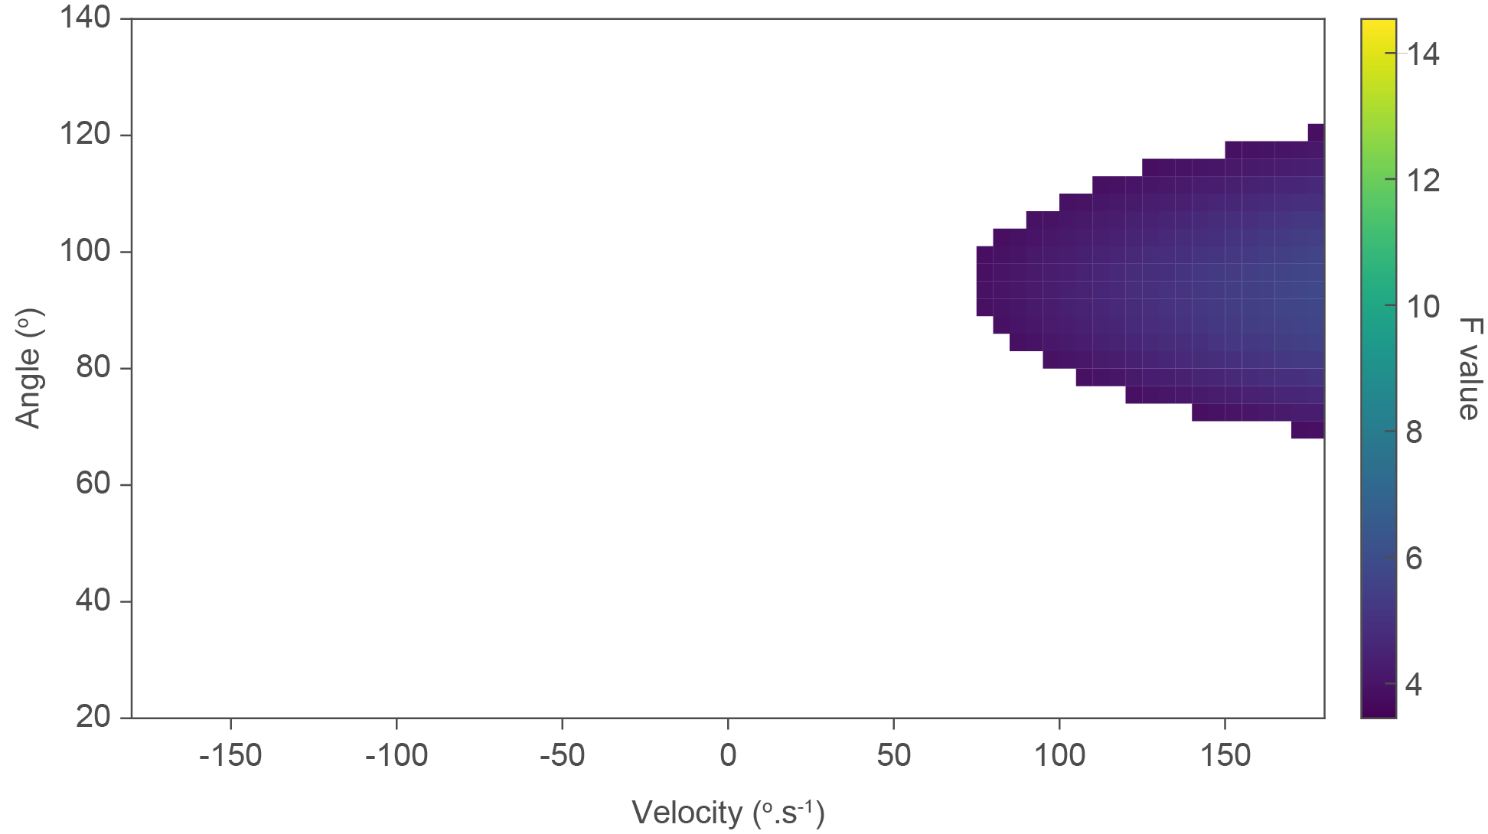

Figure 5. F-value of the ANOVA applied to the torque-angle-velocity model during flexion contractions. A main effect of position is displayed with a colored rectangle on the X-Y space (angle vs velocity), with a color gradient associated with the amplitude of the F-value.

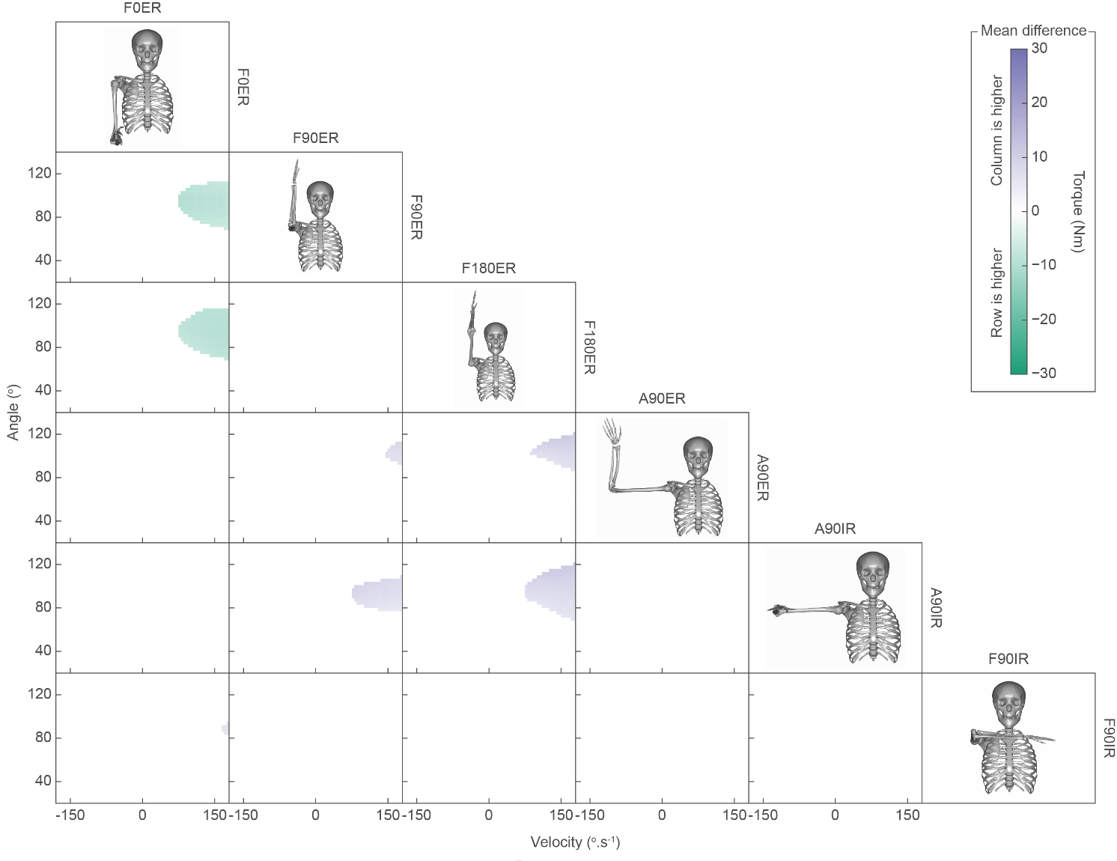

Figure 6. Additional paired t-tests applied on the torque-angle-velocity model of each pair of positions during flexion contractions. A significant difference is displayed with a colored rectangle on the X-Y space (angle vs velocity), with a color gradient associated with the amplitude of the torque difference between the pair of positions (purple when the parameter of the position in column is higher, green when the parameter of the position in row is higher). A representation of each position is displayed on the diagonal.

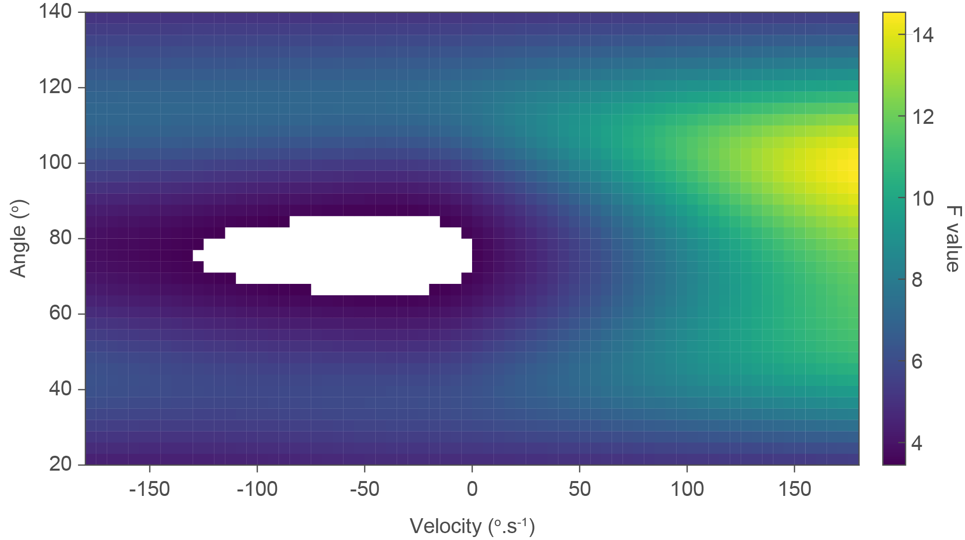

Figure 7. F-value of the ANOVA applied to the torque-angle-velocity model during extension contractions. A main effect of position is displayed with a colored rectangle on the X-Y space (angle vs velocity), with a color gradient associated with the amplitude of the F-value.

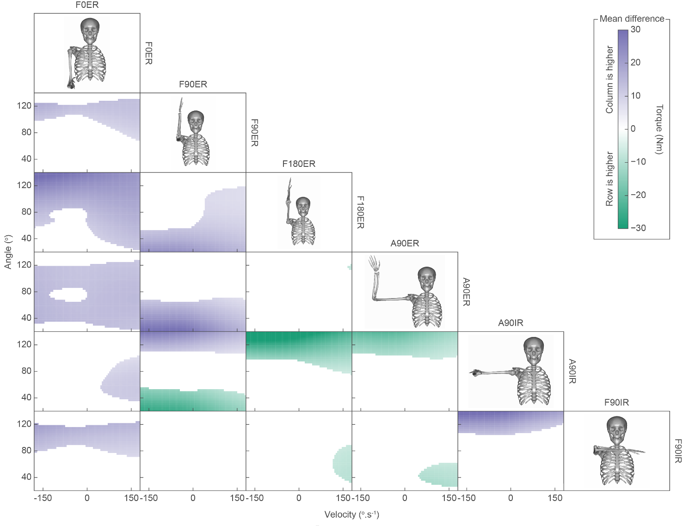

Figure 8. Additional paired t-tests applied on the torque-angle-velocity model of each pair of positions during flexion contractions. A significant difference is displayed with a colored rectangle on the X-Y space (angle vs velocity), with a color gradient associated with the amplitude of the torque difference between the pair of positions (purple when the parameter of the position in column is higher, green when the parameter of the position in row is higher). A representation of each position is displayed on the diagonal.

# References

Pataky, Todd C. 2010. “Generalized N-Dimensional Biomechanical Field Analysis Using Statistical Parametric Mapping.” *Journal of Biomechanics* 43 (10): 1976–82. doi:[10.1016/j.jbiomech.2010.03.008](https://doi.org/10.1016/j.jbiomech.2010.03.008).