IN-HOUSE TRAINING PROJECT REPORT

Take it n GO… – Online Shopping Website


Submitted to:
Ms. Sapna Sinha Submitted by:
Atul Garg – A2305308189
Ashish kalra- A2305308192
Falak Pupneja – A2305308193
Rakesh Sharma- A2305308194
Roma Kaul- A2305308195

Acknowledgement

Keep away from people who try to belittle your ambitions. Small people always do that, but the really great make you feel that you too, can become great.

we take this opportunity to express my sincere thanks and deep gratitude to all those people who extended their wholehearted co-operation and have helped me in completing this project successfully.

First of all, we would like to thank Mr. Shantanu srivastava for helping me like this project was his own
Special thanks to Mr. Akash aggarwal and Mr. kuber kaul. Their inspiring suggestions and timely guidance enabled me to perceive the various aspects of the project in a new light.
We would also thank to my internal project guide Mrs. Sapna Sinha who guided me a lot in completing this project. we would also like to thank my parents & project mate for guiding and encouraging me throughout the duration of the project.

DECLARATION

We all hereby declare that the report of the project entitled “Take it n GO…” has not presented as a part of any other academic work to get my degree or certificate except Amity University for the fulfillment of the requirements for the degree of Master of Computer Application.

Atul Garg Ashish kalra Falak pupneja Rakesh sharma Roma kaul

Contents

1. Introduction …………………………………………………………………………
1.1 Project Detail …………………………………………………………………..
1.2 Objective ……………………………………………………………………

2. System Requirements ………………………………………………………………
2.1 Requirement Analysis ………………………………………………………….
2.2 Project Category ………………………………………………………………..
2.3Software and Hardware Tools …………………………………………………

3. Feasibility Study ……………………………………………………………………

3.1 Technical Feasibility ……………………………………………………………
3.2 Operational Feasibility …………………………………………………………..

4. System Design ……………………………………………………………………….
4.1 Introduction ………………………………………………………………………
4.2 DFD ……………………………………………………………………………...

5 .Implementation ……………………………………………………………………

6. Conclusion ……………………………..…………………………………………..
6.1 Scope .……………………………………………………………………………
6.2 Limitation ..........…………………………………………………………………

7. Appendix ……………………….. …………………………………………………..
7.1 Appendix A ………………………………………………………………………
7.2 Appendix B ………………………………………………………………………

8. Biblioraphy ………………………..………………………………………………..
8.1 References ……………………………………………………………………….
8.2 Bibliography ……………………………………………………………………...

PROJECT DETAIL

The Take it n Go.. is the part of the sample application that provides customers with online shopping. Through a Web browser, a customer can browse the catalog, place items to purchase into a virtual shopping cart, create and sign in to a user account, and purchase the shopping cart contents by placing an order with a credit card.
By integrating information and improving processes, emart will help improve enterprise-wide decision support and operational efficiency. Improved efficiency translates into:
- More resources to support the enterprise .
- Improved customer service
- Web-based and more user friendly interfaces to buyers .

An extremely powerful marketing tool, emart’s ability to suggestively sell alternate and complementary products; e.g. if a customer selects the "standard" version of a product, you can recommend that they also consider the "pro" version or if your customer chooses a pair of pants, you can suggest that they also consider a belt and socks. Simply specify related product skus and optional text in a product’s definition in your Merchant Administrator, and PDG Shopping Cart will up-sell or recommend related products to your customers automatically.

OBJECTIVES

Our Objective
Our objective was to look at online retail from a customer’s point-of-view and determine which
of the biggest US-based ecommerce sites was providing the best customer experience.
A secondary aim was to zero in on key trends and identify opportunities for high-impact
customer experience improvements.

Our Approach

We examined the entire experience. Unlike some studies that focus only on browsing,
we looked at the entire experience from the first moment on the site through selection,
purchase, shipping and returns.

We combined objective measurement with expert subjective analysis. Metrics
have a strong appeal, but in something that involves as many intangibles as the customer
experience measurement can only take you so far. With this in mind, we split our analysis
between straightforward objective grading and the expert opinions of our panelists. (In
poker terms, think of a good objective score as a table stakes and a good subjective
score as a hand that could win you the game.)

We analyzed a large pool of sites defined by a third party.

Objective evaluation criterion

- The interface must use language that is easily understood by target users .
- The interface must use graphics or icons that are easily understood by target users
- Product categories must be well thought out, and intuitive .
- There must be effective decision support tools to guide you through the exploration process .
- The product must be clearly displayed with appropriate visualization tools .
- If customer I have been to the site before, it must remember me and personalize customer’s subsequent experience?
- It is easy to keep track of things customer want to buy .
- Customer need to register in order to make a purchase or access certain content .
- It does have a history of customer’s transactions that he can easily access .

REQUIRMENTS ANALYSYS

SYSTEM STUDY AND PROBLEM FORMULATION

THE EXISTING SYSTEM
The existing system work manually. The existing system has got lot of intricacies within itself and need lot of human effort and paper works. All above the data need to be maintained on ledgers and maintaining this is a tedious and risky process. As the transactions increases, so the data too. So the task of maintaining them increases exponentially. To view a data may need lot of paper to be searched.

Some of the negative aspects of the existing system are as follows:
- Course of action is time consuming. Wherever a need for search arises, the process evolves search through paper records.
- Readability of records is constrained. All the records may not be handled or written by the same person. So the format and style of records differ and hence it is difficult to understand.
- Paper records are easily damaged in course of time. The life time of paper record is unreliable less that it easily gets spoiled.
- Expenditure is high. Manual system needs added man power.
- Prone to corruption by unauthorized users. Securing of manual system is not fully guaranteed. Inaccuracy can be expected. Data can get easily scratched.
- Techniques used are more complicated. Proper techniques are not exposed, so the functioning is intricate.

To overcome these, the proposed system has been suggested.

THE PROPOSED SYSTEM

The proposed system is a computerized one. This has greater accuracy and efficiency. This takes only limited time for calculation.
The proposed system can be used to maintain efficiently the HR Department schedule of any type of company. In larger organizations employees are large. At that time also the proposed system is useful and helpful. HR Management System is not only become a desire of the company but it become the need of the company.
The system includes two users.
- Administrator(HR)
- General User
The user gets into the system using user name and a unique password. Each user has his own accessibility permission to accomplish his task flawlessly.
Advantages of the proposed system are
- Easy access to the data
- The new system is more user friendly, reliable and flexible.
- Pop-up menus to carry out transactions for a new user, and for other alert messages.
- Timely Report generation.

Requirement Analysis

At the heart of system analysis is a detailed understanding of all important facets of business area under investigation. (For this reason, the process of acquiring this is often termed the detailed investigation) Analyst, wirking closely with the employees and managers, must study the business process to answer
these key questions:

- What is being done?
- How is it being done?
- How frequent does it occur?
- How great is the volume of transaction or decisions?
- How well is the task being performed?
- Does a problem exist?
- If a problem exist, how serious is it?
- If a problem exists, what is the underlying cause?

Requirement analysis relies on fact-finding techniques. These include:

- Interview
- Questionnaires
- Record inspection
- On-site observation

IDENTIFICATION OF NEED

In the world we are growing for globalization day by day with the development in IT resources and advancement, by using latest technologies every organization wants to beat its competitors and want to grow. Enterprise Resourceful Planning is the need of today’s organization. Survival on manual system is difficult so, that’s why organization of the corporate world wants to computerize their departments. The modules should be complete database driven and interactive that should provide the proper information about the Placement and Training Organization.

Success of any system depends up to a large extent on how accurately a problem is defined, thoroughly investigated and properly carried out to the choice of solution. Analysis is the only phase in which the requirements for the new system are identified. System analysis is a detailed study of the various operations performed by a system and their relationship within and outside of the system. The question is: what must be done to solve the problem? One aspect of analysis is defining the boundaries of the system and determining whether or not a candidate system should consider other related system. During analysis data are collected on the available files, decision points and transactions handled by the parent system. Data flow diagram, interviews, onsite observations, questionnaires are used as a logical system model and tools to perform the analysis.

In order to reduce the time, there is a need for computerized system that cans retrieve data, insert data, update existing data or delete existing data. These modules are developed wit the aim of reducing time, reducing manpower, reducing cost so that the records can be easily maintained. The volume of work and complexity are increasing year by year. This system reduces complexity and workload.

PRELIMINARY INVESTIGATION

A request to take assistance from information system can be made for many reasons, but in each case some one in the organization initiate the request. When the request is made, the first system activity the preliminary investigation begins. This activity has three parts:
- Request clarification
- Feasible Study
- Request approval
Many requests from employees and users in the organization are not clearly defined. Therefore, it becomes necessary that project request must be examined and clarified properly before considering systems investigation.

The feasibility study is carried out by a small group of people who are familiar with information system techniques, understand the parts of the business or organization that will be involved or affected by the project, and are skilled in the system analysis and design process.
- Request Approval:
It is not necessary that all request projects are desirable or feasible. Some organizations receive so many projects request from employees that only a few of them can be purchased. However, those projects that are feasible and desirable should be put into a schedule.
In some cases, development can start immediately, although usually system staff members are busy on other ongoing projects. When such situation arises, management decides which projects are more urgent and schedule them accordingly. After a project request is approved, its cost, priority, completion time and personal requirements are estimated and used to determine where to add it to any existing project list. Later on, when the other projects have been completed, the proposed application development can be initiated.
Analysis is a process of studying a problem and to find the best solution to that problem. System analysis gives us the target for the design and the implementation. Analysis is one phase, which is important phase for system development lie cycle. System development is a problem solving techniques. Analysis involves interviewing the client and the user. Three people and the existing documents about the current mode of operation are the basic source of information for the analyst.

Analysis is the process of studying a problem to find the best solution to that problem. System analysis gives us the target for the design and the implementation. Analysis is one phase of the very important phase of the system development life cycle. System development is a problem solving techniques. Analyses involve interviewing the client and the user. These people and the existing document about the current mode of operation are the basic source of information for the analyst.
Human Resource Department of the organization controls the manpower planning by recording manpower requirements, grade, job specifications and presently vacancies and strength. It maintains the candidate’s databank for the respective post.

SOFTWARE ENGINEERING PARADIGM

Computer Aided Software Engineering can be as simple as a single tool that support a specific software engineering activity or as complex as a complete “environment “ that encompasses tools, a database, people, hardware, a network, operating system, standards, and myriad other components. Each building block forms a foundation for the next, with tools sitting as the top of the heap. It is interesting to note that the foundation for effective CASE environment has relatively little to do for software engineering tools themselves. Rather, successful environments appropriate hardware and systems software. In addition, the environment architecture must consider the human work patterns that are applied during the software engineering process.

The environment composed of the hardware platform and system support (including networking software, software management, and object management services), the groundwork for CASE. But the CASE environment itself demands other building blocks. A set of portability services provides a bridge between CASE tools and their integration framework and the environment architecture. The integration framework is a collection of specialized programs that enables individual’s CASE tools to communicate one another, to create a project database, and to exhibit the same look and feel to the end user (the software engineer). Portability services allow CASE tools and their integration framework to migrate across different hardware platforms and operating system with out significant adaptive maintenance.

At the low end of the integration spectrum is the individual (point solution) tool. When individual tools can provide tools provide facilities for data exchange, the integration level is improved slightly. Such tools produce output in a standard format that should be compatible with other tools that can read the format. In some cases, the builder of complementary CASE tools work together to form a bridge between the tools (e.g. an analysis and design tool that is coupled with a code generator). Using this approach, the team developed, synergy between the tools separately. Single source integration occurs when a single CASE tools vendor integrates a number of different tools and sells them as a package.

Although this approach is quite effective, the closed architecture of most single source environments precludes easy addition from other vendors.
PROJECT CATEGORY

Category of this project is RDBMS based, n-tier architecture, Distributed environment project with server-side components.
Project can be categorized in two ways:-
- Local Area Network projects.
- Distributed Projects.
Local Area Network projects are those projects where application has to be incorporated in the Local area network of the client i.e within its premises only. In case of LAN, server is not remotely located and client accesses the application through the network. Here the question of platform independence does not arise and we can use the technologies like: Visual Basic, Fox pro, D2k or C, C++, etc.
Distributed projects are those projects where application is remotely situated. In these kinds of projects, application is remotely situated on to the remote server from where client machine accesses the application. WAN and Internet is a kind of distributed application where client machine connects to the remote server and application is downloaded on to the client machine. Here the question of platform independence arises and we use technologies, Java Beans, RMI, etc.

Software and Hardware Tools

Development Environment:
- Operating System: Windows XP
The system will be built on windows compatible environment. The application will be web based developed using Java technology.
- Web Server:
BEA’s WebLogic 8.1 Application Server to serve as Servlet/JSP engine.The system requires WebLogic Application Server for serving the requests for Servlet.
- Client Side Application Software: Java Script, HTML
- Data Base: Oracle 8i
The system requires Oracle as a database; however the system will be ODBC complaint to work on any standard database.
- Client Browsers:
Internet Explorer 5.0 or Netscape Navigator 4.7
The system requires Internet Explorer or Netscape Navigator browser for client side.
- Dream Weaver 8.0
The system will be developed with Java Technologies using J2SE (JDK and JRE). Dream Weaver 8.0/ Front Page 2003 as HTML editor.
Hardware & Software Requirements
Hardware requirement

- Main Processor Pentium IV
- Hard-disk Capaity 8 G.B
- RAM 256 MB
- Monitor V.G.A
- 4.2 Software specification
Software Requirement

- Operating System Window XP

Feasibility Study

A feasibility study is conducted to select the best system that meets performance requirement. This entails an identification description, an evaluation of candidate system and the selection of best system for he job. The system required performance is defined by a statement of constraints, the identification of specific system objective and a description of outputs.

The key consideration in feasibility analysis are :
- Ecoonomic Feasibility :
- Technical Feasibility :
- Operational Feasibility:

Economical feasibility
It looks at the financial aspects of the project. It determines whether the management has enough resources and budget to invest in the proposed system and the estimated time for the recovery of cost incurred. It also determines whether it is worth while to invest the money in the proposed project. Economic feasibility is determines by the means of cost benefit analysis. The proposed system is economically feasible because the cost involved in purchasing the hardware and the software are within approachable. The personal cost like salaries of employees hired are also nominal, because working in this system need not required a highly qualified professional. The operating-environment costs are marginal. The less time involved also helped in its economical feasibility. It was observed that the organization has already using computers for other purpose, so that there is no additional cost to be incurred for adding this system to its computers.

The backend required for storing other details is also the same database that is Sql. The computers in the organization are highly sophisticated and don’t needs extra components to load the software. Hence the organization can implement the new system without any additional expenditure. Hence, it is economically feasible.

Duration of Project:-

Time Duration

For study 15 days
Designing 20 days
For development 90 days
Testing 15 days

Total time 140 days

Operational Feasibility

- The system will be used if it is developed well then be resistance for users that undetermined
- No major training and new skills are required as it is based on DBMS model.
- It will help in the time saving and fast processing and dispersal of user request and applications.
- New product will provide all the benefits of present system with better performance.
- Improved information, better management and collection of the reports.
- User support.
- User involvement in the building of present system is sought to keep in mind the user specific requirement and needs.
- User will have control over there own information. Important information such as pay-slip can be generated at the click of a button.
- Faster and systematic processing of user application approval, allocation of IDs, payments, etc. used had greater chances of error due to wrong information entered by mistake.

Behavioral Feasibility

People are inherent to change. In this type of feasibility check, we come to know if the newly developed system will be taken and accepted by the working force i.e. the people who will use it.

SYSTEM DESIGN

Introduction
System design provides the understandings and procedural details necessary for implementing the system recommended in the system study. Emphasis is on the translating the performance requirements into design specifications. The design phase is a transition from a user-oriented document (System proposal) to a document oriented to the programmers or database personnel.
System design goes through two phases of development:
      - Logical Design
      - Physical Design
A data flow diagram shows the logical flow of the system. For a system it describes the input (source), output (destination), database (data stores) and procedures (data flows) all in a format that meets the user’s requirement. When analysis prepare the logical system design, they specify the user needs at a level of detail that virtually determines the information flow into an out of the system and the required data resources. The logical design also specifies input forms and screen layouts.
The activities following logical design are the procedure followed in the physical design e.g., producing programs, software, file and a working system. Design specifications instruct the user about what the system should do.

Logical and Output Design:
The logical design of an information system is analogous to an engineering blue print of an automobile. It shows the major features and how they are related to one another. The detailed specification for the new system was drawn on the bases of user’s requirement data. The outputs inputs and databases are designed in this phase.
Output design is one of the most important features of the information system. When the outputs is not of good quality the users will be averse to use the newly designed system and may not use the system. There are many types of output, all of which can be either highly useful or can be critical to the users, depending on the manner and degree to which they are used.
Outputs from computer system are required primarily to communicate the results of processing to users, They are also used to provide a permanent hard copy of these results for later consultation. Various types of outputs required can be listed as below:
- External Outputs, whose destination is outside the organisation
- Internal outputs, whose destination is with the organisation
- Operational outputs, whose use is purely with in the computer department e.g., program-listing etc.
- Interactive outputs, which involve the user is communicating directly with the computer, It is particularly important to consider human factor when designing computer outputs. End user must find outputs easy to use and useful to their jobs, Without quality output, user may find the entire system unnecessary and avoid using it. The term “Output” in any information system may apply to either printer or displayed information. During the designing the output for this system, it was taken into consideration, whether the information to be presented in the form of query of report or to create documents etc.

Other important factors that were taken into consideration are:
The End user, who will use the output.
- The actual usage of the planned information
- The information that is necessary for presentation
- When and how often output and their format is needed. While designing output for project based Attendance Compilation System, the following aspects of outputs designing were taken into consideration.
- The outputs (i.e., well formatted table outputs in the screen itself) designed are simple to read and interpret.
- Format of each output was another important point taken into consideration. Output media, for each output appropriate media is decided whether it will be displayed on screen or will be taken to printer or both.
- Other output design related specifications, i.e., how frequently the outputs will be generated, how many pages or sheets approximately it will keep up, what is its planned use and output distribution to users are also taken into account.

These were a few major designing issues, which were taken into consideration, while deciding the output specifications for the system. As direct beneficiary of reports is the user community, they were consulted constantly at every level. Formats and screen design for various reports were identified, taking into account the user requirements. Before finalising these were given to users for any improvement and suggestions. End users issues taken into consideration were Readability, Relevance and Acceptability.

Once all the output reports to be generated by ACS system were identified, they were given to users for their acceptance. For prototyping various outputs, final outputs models were created with dummy data, before they were finalised.

Output Sources:
Output contents originate from these sources:
- Retrieval from a data source.
- Transmission from a process or system activity.
- Directly from an input source.

The information produced in an output can be presented as
- Tabular contents
- Graphic format
- Using Icons

Output Definition:
The output should be defined in terms of:
Types of outputs
- Content-headings, numeric, alphanumeric, etc.,
- Format-hardcopy, screen, microfilm, etc.,
- Location-local, remote, transmitted, etc.,
- Frequency-daily, weekly, hourly, etc.,
- Response-immediate with in a period, etc.,
Data items
The name given to each data item should be recorded and its characteristics described clearly in a standard form:
- Whether alphanumeric or numeric
- Legitimate and specific range of characteristics
- Number of characters
- Positions of decimal point, arithmetic design, etc.,

Input Design:
The input design is the link that ties the information system into the user’s world. Input specifications describe the manner in which data enters the system for processing. Input design features can ensure the reliability of the system and produce results from accurate data, or they can result in the production of erroneous information.

Input Design consists of
- developing specifications and procedures for data preparation
- Steps necessary to put data into a usable form for processing.
- Data entry, the activity of putting data into the computer processing.

Objectives of Input design

Five objectives of design input focus on

- Controlling the amount of input required
- Avoid delay
- Avoiding errors in data
- Avoiding extra steps.
- Keeping the process simple.

Input stages several activities have to be carried out as part of te overall input process. They include some or all of the following.
Data recording (i.e., collection of data)
Data encapsulation(i.e.,transfer of data)
Data conversion(i.,e.,controlling the flow of data)
Data transmission(i.e.,transporting te data)
Data validation(i.e.,checking te input data)
Data correction(i.e.,correcting the errors)

Input Performa were designed, after a careful discussion with users. It was attempted to cover all user requirements. Designed Performa were given to user for any suggestion and final approval.
Various data items were identified and wherever necessary were recorded.
Input designs are aimed at reducing the chances of mistakes of errors. As the human beings are prone to errors there is always a possibility of occurrence of chance of errors. Adequate validation checks are incorporated to ensure error free data storage. Some of the data validation checks applied are as following:
- Redundancy of data is checked. It means the records of primary key do not occur twice.
- Primary key field of any table must not be left blank.
- Wherever items are coded, input code is checked for it’s validly with respect to several checks.
- Utmost care has been taken to incorporate the validation at each stage of the system. E.g. when entering records into employee information table for employee, it is checked that whether the corresponding employee exists in the employee information table etc.,
Enough messages and dialogue boxes are provided while design screen, which does guide user at the time of any errors, or at time of entry. This feature provides a user-friendly interface to native users. It can be emphasized that input deigns of HRRP is so designed that it ensures easy and error free data entry mechanism. Once one is sure of input data the output formatting becomes an routine work.

SOFTWARE DESIGN

The purpose of this phase is to plan a solution for the problem specified by the requirement document. This is first step in moving from the problem domain to solution domain. Designing activity is divided into two parts.

a) System Design
It aims to identify the modules that should be in the system, the specification of these modules and how they interact with each other to produce the desired result.

b) Detailed Design
The internal goal of each of the modules specified in the system design is decided

DATABASE DESIGN
A database is a collection of inter-related data stored with a minimum of redundancy to serve many applications. It minimizes the artificiality embedded in using separate files. The primary objectives are fast response time to enquires, more information at low cost, control of redundancy, clarity and ease of use, accuracy and fast recovery. The organization of data in a database aims to achieve three major objectives, they are data integration, data integrity and data independence. During the design of the database at most care has been taken to keep up the objectives of the database design.

CODE DESIGN

The process of code is to facilitate the identification and retrieve of items of information. The code should be simple and easy to understandable. The codes were designed in such a way that the features such as optimum human – oriented use and machine efficiency are unaffected.
For the code to be designed effectively, the following characteristics were also considered while designing the code.

- Uniqueness
- Versatility
- Stability
- Simplicity
- Consciousness

The code should be adequate for present and anticipated data processing for machine and human use. Care was taken to minimize the clerical effort and computer time required to continue operation.

PROCESS DESIGN
The process can be conceptualized in such a way to keep the methodology of main module process along with some auxiliary task, which will run concurrently with the main program.

The top-down approach is maintained so as to keep track of the process, which satisfies the maintenance reliability testing requirements. The concurrency of the data is checked during data entry, by means of validation check for data in each field.

DATA FLOW DIAGRAM

Data Flow Diagramming is a means of representing a system at any level of detail with a graphic network of symbols showing data flows, data stores, data processes, and data sources/destination.

The data flow diagram is analogous to a road map. It is a network model of all possibilities with different detail shown on different hierarchical levels. This processes of representing different details level is called “leveling” or “partitioning” by some data flow diagram advocates. Like a road map, there is no starting point or stop point, no time or timing, or steps to get somewhere. We just know that the data path must exist because at some point it will be needed. A road map shows all existing or planned roads because the road is needed.

Details that is not shown on the different levels of the data flow diagram such as volumes, timing, frequency, etc. is shown on supplementary diagrams or in the data dictionary. For example, data store contents may be shown in the data dictionary.

Data Flow Diagram (DFD) uses a number of symbols to represent the systems. Data Flow Diagram also known as ‘Bubble Chart’ is used to clarify system requirements and identifying the major transformations that will become programs in system design. So it is the starting point of the design phase that functionally decomposes the requirements specifications down to the level of details.

Terms used in DFD

- Process

A process transforms data values. The lowest level processes are pure functions without side effects. An entire data flow graphics high level process.

Graphical representation:
Graphical Representation: 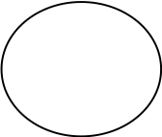

- Data flows
A data flow connects the output of an object or process to input of another object or process. It represents the intermediate data value within a computation. It is represented by an arrow and labeled with a description of data, usually its name or type.
Graphical Representation:

- Actors
An actor is active object that drives the data flow graph by producing or consuming values.

- Data store
A data store is a passive object with in a data flow diagram that stores data for later access.
Graphical Representation:

- External Entity
A rectangle represents an external entity such as a librarian, a library member.
Graphical Representation:
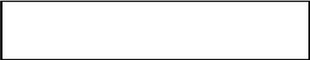

- Output Symbol
This box represented data production during human computer interaction

Graphical Representation:

DFD:

Context Level DFD:
Add & update products, category.
Delivery updates & Query Response

ADMIN
Get Queries.
Check Orders & Check Payments.

E-MART
(ONLINE SHOPING)

CUSTOMER

Browse Products.
Check Order Status Online.
Get Query Response

Add Products to Carts.
Place Orders & Make Payments.
Make Query

First Level DFD:
ADMIN

E-MART
(ONLINE SHOPING)

Check Order Status Online.
Get Query Response

Make Query
Add & update products, category.
Delivery updates & Query Response

Get Queries.
Check Orders & Check Payments.

Order Track

Add Products to Carts.
Place Orders & Make Payments.

Browse Products.

CUSTOMER
Create Account
Update Profile
Get Query Response
Get Payment Reports
Get Orders Reports
Get Delivery Reports

MEMBER
VISITOR

IMPLEMENTATION

Introduction
System implementation is the stage when the user has thoroughly tested the system and approves all the features provided by the system. The various tests are performed and the system is approved only after all the requirements are met and the user is satisfied.

The new system may be totally new, replacing an existing manual or automated system, or it may be a major modification to an existing system. In either case, proper implementation is essential to provide a reliable system to meet organizational requirements. Successful implementation may not guarantee improvement in the organization using the new system (that is a design question), but improper will prevent it.

Implementation is the process of having systems personnel check out and put new equipment into use, train users, install the new application and construct any files of data needed to use it. This phase is less creative than system design. Depending on the size of the organization that will be involved in using the application and the risk involved in its use, systems developers may choose to test the operation in only one area of the firm with only one or two persons. Sometimes, they will run both old and new system in parallel way to com-pare the results. In still other situations, system developers stop using the old system one day and start using the new one the next.
The implementation of the web based or lan based networked project has some extra steps at the time of implementation. We need to configure the system according the requirement of the software.

Aspects of Implementation

The two aspects of implementation are:

- Training Personnel
- Conversion Procedures

TRAINING
Even well designed and technically elegant systems can succeed or fail because of the way they are used. Therefore the quality of the training received by the personnel involved with the system in various ways helps or hinders, and may even prevent, the successful implementation of an information system. Since, Human Resource Recruitment Process is web-based and user friendly, not much effort was required in training process.

CONVERSION:
Conversion is the process of changing from the old system to the new system. There are two methods of handling systems conversion:
- Parallel Run
- Immediate cut-off

Implementation Tools

The project was implemented using Java script,HTML,.The implementation work was carried out in Windows XP/2000 server platform.

Coding
This means program construction with procedural specifications has finished and the coding for the program begins:
- Once the design phase was over,coding commenced
- Coding is natural consequence of design.
- Coding step translate a detailed design representation of software into a programming languae realization.
- Main emphasis while coding was on style so that the end result was an optimized code.

The following points were kept into cosideration while coding:

Coding Style
The structured programming method was used in all the modules the project.It incorporated the following features
- The code has been written so that the definition and implementation of each function is contained in one file.
- A group of related function was clubbed together in one file to include it when needed and save us from the labour of writing it again and again.

Naming Convention:-
- As the project size grows,so does the complexity of recognizing the purpose of the variables.Thus the variables were given meaningful names,whihch would hellp in understanding the context and the purposse of the variable.
- The function names are also given meaningful names that can be easily understood by the user.

Indentation
Judicious use of indentation can make the task of reading and understanding a program much simpler.Indentation is an essential part of a good program.If code id intended without thought itv will seriously affect the readability of the program.

- The higher-level statements like he definition of the variables,constants and the function are intended,with each nested block intended,stating their purpose in the code.
- Blank line is also left between each function definition to make the code look neat.

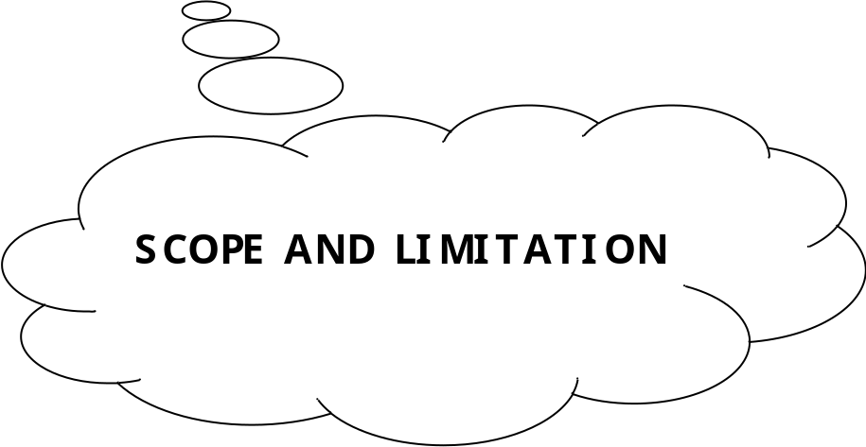

CONCLUSIONS

As evidence of the success of this mission, there are millions of items listed each day in thousands of different categories. There are items for almost any interest that one could imagine, from sheet music to automobiles to hand tools to real estate. And the variety doesn’t stop there. Need a computer? One may find it listed in the proper category, in any configuration from very old and obsolete to the latest greatest machine available. What about antiques? One can find an antique quilt that is up for highest bid, or maybe an old violin, whose beautiful tones have enchanted many though its years. Tickets. Maybe a ticket to the next concert of ones favorite artist or play production. One can even find that special bottle of wine, some aged, exotic cheese, and the perfect ‘mood’ music for that special occasion.

In this instance it may be true that on eBay, they have something for everybody, whatever their tastes may be.

Scope for Future Work

Since this system has been generated by using Object Oriented programming, there are many chances of reusability of the codes in other environment even in different platforms. Also its present features can be enhanced by some simple modification in the codes so as to reuse it in the changing scenario.

The site is made in all possible way to meet the user requirements using latest version of available software and hardware.But as user requirements and operating environment keep changing further extensions can be made on this.In future some more schemas can be added in the “HR Recruitment Process” hence these schemas are to be included in the software developed.
Last but not the least , a shopping cart could have done great !!

Limitations
Since, every system has some limitations so our proposed system is also not untouchable in this regard. Although it includes every kind of features, but it can’t be used in a huge organization where number of networks are very large, because the database used in this system is an average one. Also it doesn’t have different kind of access feature for different users. Though it was planned for this system to be absolutely perfect but everything as such has some limitations, so does the System. Following may be the drawback in this system.

- Though this system is developed as a multi user system but it is not a real time system.
- The interaction with the database, every time they are loaded thus the system tends to be a bit slow.

APPENDIX A:HTML
APPENDIX B:JAVASCRIPT

APPENDIX-A

What is HTML?

HTML(Hyper Text Markup Language): A markup language used to structure text and multimedi documents and to set up hypertext links between documents, used extensively on the World Wide Web. HTML is a display language , not a programming lanfguage. HTML is a markup language(the ML in HTML) that uses a fixed set of markup tags.

- HTML itself is the set of custumizable “markup” tags that are inserted into HTML document govern its format, multimedia content, and hyperlinks. Any HTML viewer can display such documents but they are normally viewed usinga Web browser.

- HTML is a programming language in that an HTML document is a program that, when “run” by a browser, displays its text as hypermedia (multimedia with hyperlinks).

- The “language” HTML is really only a collection of predefined tags which , when inserted into regular text, tell a web browser how to:

  - Format the document and its text.

  - Incorporate i.e. insert a graphic image, video sequence, or sound clip into the displayed document.

  - Link into other locations, in the same document, in another web page, or even on another computer(Server), or

  - Link to other programs written in Java,JavaScript or other languages(called CGI applicatins).

APPENDIX-B

What is JAVASCRIPT?
Javascript is a compact , object-based scripting language.It can provide interactive web pages, validate from data, and make your web page clearer.Javascript is a lightweight interpreted scripting language.The language is most well known for its use in wesites.It was originally developed by Brendan Eich of Netscape Communications.It adds interactive functions to HTML pages, which are otherwise static.Javascript is easier to use than Java, but not as powerful and deals mainly with the elements on the Web page.On the client, JavaScript is maintained as source code embedded into an HTML page.On the Server, it is compiled into byte code(intermediate language), similar o Java pograms.

Features Of JavaScript:-
- JavaScript was designed to add interactively to HTML pages.
- JavaScript is a scripting language-a scripting language is a lightweight programming language.
- A JavaScript is usually embedded directly in HTML pages.
- A JavaScript is an interpreted language(means that script execute without preliminary compilation).
- All major browsers, like Netscape and Internet Explorer, support JavaScript.
Functions Of JavaScript:-
JavaScript gives you the ability to perform the following functions:
- Control document appearance and content
- Control the browser
- Interact with document content
- Interact with the user
- Read and write client state with cookies
- Interact with applets
- Manipulate Embedded Images

Limitations of JavaScript:-

- JavaScript does not have any graphics capabilities
- Client-side JavaScript can not read or write files
- JavaScript does not support networking of any kind
- JavaScript doesn’t have any multithreadind capabilities.

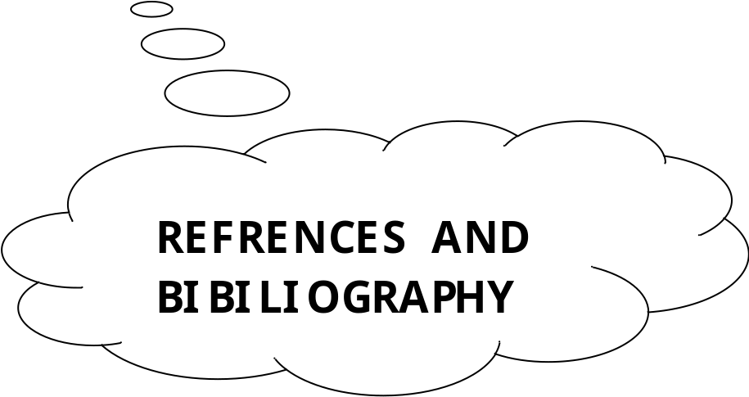

REFERENCES

- http://www.sun.com

- http://www.coreservlets.com

- http://www.serverside.com

- http://www.w3schools.com

- http://www.google.com

BIBILIOGRAPHY

BOOKS

- JSP & Servlets by Marty Hall (SUN Microsystems)

- SYSTEM ANALYSIS AND DESIGN by ELIAS M AWAD.

- SOFTWARE ENGINEERING by IAN SOMMEVILLE.

- GNIX INFO SOFT MATERIALS

- COMPLETE REFERENCE

SNAPSHOTS # 1

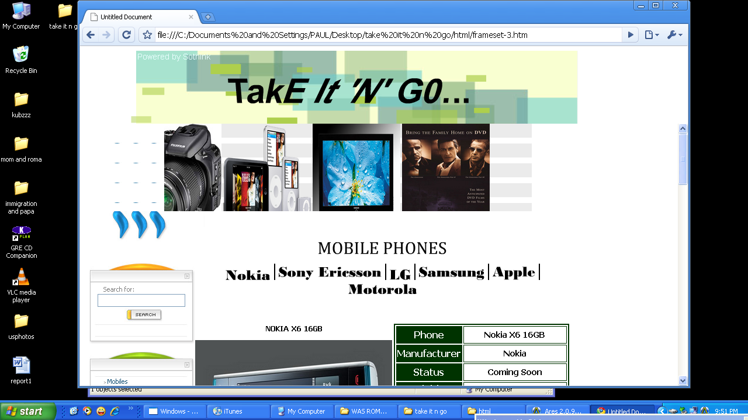

SNAPSHOT # 2

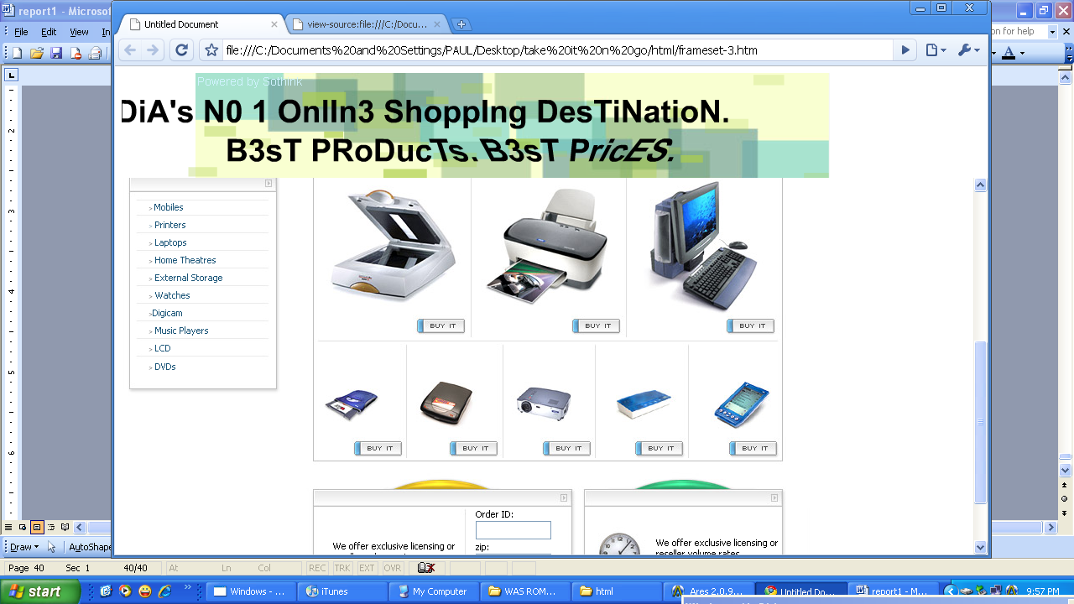

SNAPSHOT # 3

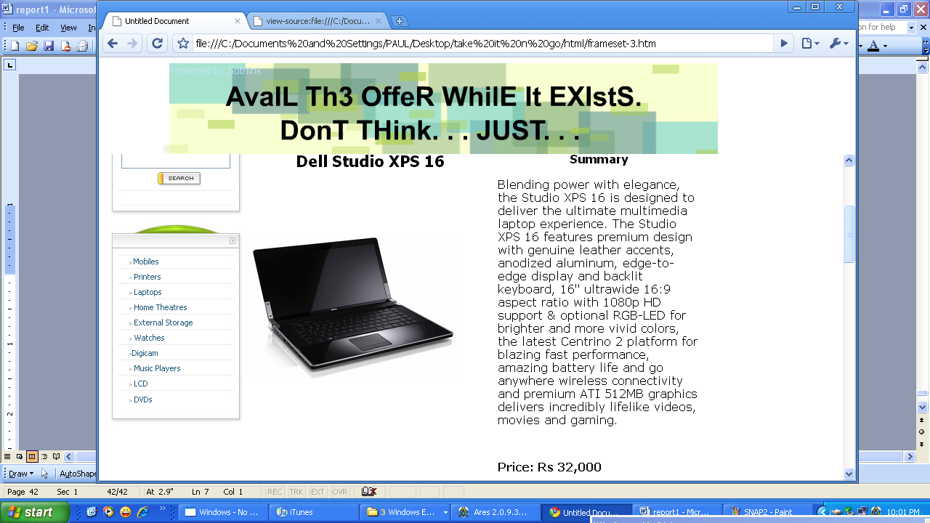

CODING

<Html>
<head><meta http-equiv="Content-Type" content="text/html; charset=windows-1251">
<title>Template</title>
<style>
TD {font-family: tahoma; font-size: 11px;}
A{font-family:tahoma;font-size: 11px;color:000000;font:900;text-decoration:underline}
A:visited {color:ffffff}
A:hover {color:red;}
.bold{font:900}
.right{font-size:12px;font-family:verdana}
a.menu{color:1C5679;font-size:11;text-decoration:none;font:100}
a.menu:hover{color:red}
a.menu:visited{color:1C5679}
body {
background-color: #FFFFFF;
}
.style2 {color: #1c5679}
</style>
<script language="JavaScript">
<!--
function MM_preloadImages() { //v3.0
var d=document; if(d.images){ if(!d.MM_p) d.MM_p=new Array();
var i,j=d.MM_p.length,a=MM_preloadImages.arguments; for(i=0; i<a.length; i++)
if (a[i].indexOf("#")!=0){ d.MM_p[j]=new Image; d.MM_p[j++].src=a[i];}}
}
//-->
</script>
<body leftmargin="0" topmargin="0" rightmargin="0" bottommargin="0">
<table width="828" border="0" cellpadding="0" cellspacing="0">
<tr>
<td height="86" background="images/top.jpg" colspan="2" align="centre"><div align="left">
<center><marquee behavior=alternate DIRECTION=left to right WIDTH=100% Height=150 STYLE="filter:blur(add=2, direction=directions, strength=80)">
<marquee width=600>
<a target="mainFrame" href="mobile.htm"><img src="http://www.softsailor.com/wp-content/uploads/2009/09/Nokia-X6-02.jpg" width="150" height="200" border="0"></a>
<a target="_self" href="printers.htm"><img src="http://www.cyberindian.net/wp-content/uploads/epson-stylus-photo-tx700w-printer.jpg" width="170" height="200" border="0"></a>
<a target="_self" href="laptops.htm"><img src="http://technonewsworld.files.wordpress.com/2010/03/appraisal-of-apple-macb.jpg" width="150" height="200" border="0"></a>
<a target="_self" href="home%20theatres.htm"><img src="http://gadgetophilia.com/wp-content/uploads/2009/03/f.jpg" width="150" height="200" border="0"></a>
<a target="_self" href="externl.htm"><img src="http://nexus404.com/Blog/wp-content/uploads2/2008/03/buffalo-1tb-linkstation-mini-external-hdd.jpg" width="150" height="200" border="0"></a>
<a target="_self" href="watches.htm"><img src="http://www.yankodesign.com/images/design_news/2007/11/30/jasper_rado.jpg" width="150" height="200" border="0"></a>
<a target="_self" href="digicam.htm"><img src="http://www.urban75.org/photos/images/finepix-s100fs-digicam-lg.jpg" width="150" height="200" border="0"></a>
<a target="_self" href="mp3.htm"><img src="http://images.apple.com/quicktime/qtv/specialevent0907/images/ipods_special_event_20070905.png" width="150" height="200" border="0"></a>
<a target="_self" href="lcd.htm"><img src="http://blog.circuspop.com/blog/wp-content/uploads/2009/08/samsung_led_lcd_tv_1.jpg" width="150" height="200" border="0"></a>
<a target="_self" href="dvd.htm"><img src="http://www.allposters.com/IMAGES/109/003_GODFATHER_DVD.jpg" width="150" height="200" border="0"></a>
</marquee></marquee></center>
</div></td>
</tr>
<tr>
<td colspan="2"><img src="images/b1.jpg"></td>
</tr>
<tr>
<td valign="top" width="220">
<table border="0" cellpadding="0" cellspacing="0" width="197">
<tr>
<td><img src="images/comp_solution.jpg" border="0" width="197" height="59" alt=""></td>
</tr>
<tr>
<td><img src="images/search.jpg" border="0" width="197" height="41" alt=""></td>
</tr>
<tr>
<td background="images/back_left1.jpg">
<table border="0" cellpadding="0" cellspacing="0">
<form action=""><tr>
<td style="color:7F7F7F;padding-left:40;font:900">Search for:</td>
</tr>
<tr>
<td style="padding-left:30"><input type="text" name="search" size="15" maxlength="256" style="width:150"></td>
</tr>
<tr>
<td align="center" style="padding-left:40"><input type="image" src="images/search_but.jpg" border="0" width="68" height="24" alt=""></td>
</tr></form>
</table>
</td>
</tr>
<tr>
<td background="images/adv_search.jpg" height="27" align="center"><a href="" style="font:100;text-decoration:none">Advanced Search</a></td>
</tr>
<tr>
<td><img src="images/bottom_left_1.gif" border="0" width="197" height="15" alt=""></td>
</tr>
<tr>
<td><img src="images/categories.jpg" border="0" width="197" height="53" alt=""></td>
</tr>
<tr>
<td background="images/back_left.jpg">
<table border="0" cellspacing="0" cellpadding="0">
<tr>
<td style="padding-left:40"><font style="font-size:7">&gt <a href="mobile.htm" target="_self" class="menu">Mobiles</a><a href="mobile.htm"></a> </font></td>
</tr>
<tr>
<td><img src="images/midl.jpg" border="0" width="197" height="8" alt=""></td>
</tr>
<tr>
<td style="padding-left:40"><a href="printers.htm" target="_self" class="menu"><font style="font-size:7">&gt</font> Printers </a></td>
</tr>
<tr>
<td><img src="images/midl.jpg" border="0" width="197" height="8" alt=""></td>
</tr>
<tr>
<td style="padding-left:40"><font style="font-size:7">&gt</font><a href="laptops.htm" target="_self" class="menu"> Laptops </a></td>
</tr>
<tr>
<td><img src="images/midl.jpg" border="0" width="197" height="8" alt=""></td>
</tr>
<tr>
<td style="padding-left:40"><font style="font-size:7">&gt</font><a href="home%20theatres.htm" target="_self" class="menu"> Home Theatres </a></td>
</tr>
<tr>
<td><img src="images/midl.jpg" border="0" width="197" height="8" alt=""></td>
</tr>
<tr>
<td style="padding-left:40"><font style="font-size:7">&gt</font><a href="externl.htm" target="_self" class="menu"> External Storage </a></td>
</tr>
<tr>
<td><img src="images/midl.jpg" border="0" width="197" height="8" alt=""></td>
</tr>
<tr>
<td style="padding-left:40"><font style="font-size:7">&gt</font><a href="watches.htm" target="_self" class="menu"> Watches </a></td>
</tr>
<tr>
<td><img src="images/midl.jpg" border="0" width="197" height="8" alt=""></td>
</tr>
<tr>
<td style="padding-left:40"><font style="font-size:7">&gt</font><a href="digicam.htm" target="_self" class="menu">Digicam</a></td>
</tr>
<tr>
<td><img src="images/midl.jpg" border="0" width="197" height="8" alt=""></td>
</tr>
<tr>
<td style="padding-left:40"><font style="font-size:7">&gt</font><a href="mp3.htm" target="_self" class="menu"> Music Players </a></td>
</tr>
<tr>
<td><img src="images/midl.jpg" border="0" width="197" height="8" alt=""></td>
</tr>
<tr>
<td style="padding-left:40"><font style="font-size:7">&gt</font><a href="lcd.htm" target="_self" class="menu"> LCD </a></td>
</tr>
<tr>

