**Client: University Health Center**

Mission Statement of the health center:   
  
The university health center aims to provide quality and timely health care to students and university staff at subsidized rates.  
  
**Our Mission Statement:**

Build a Digital database of UMD Health Center to enhance existing services while adding new features to increase the efficiency of record keeping and functionality of the Health Center.

**Our Mission Objectives:**

* To build a generic database for the Health Center
* To maintain information about Doctors serving at the Health Center and about all Patients (Students)
* To provide an updated records database for quick reference of patient history
* To keep track of active and applicable insurance policies and their scope of treatment
* Maintain records of Medicines prescribed to every patient
* Maintain details of the Treatment provided to every Patient in tandem with the Billing and Insurance information.

 1. Internal Functions of Health Center:

1. Acquisition of finance- This determines the monetary flow in the health center of UMD.
2. Purchase of medicines- This function determines the purchase of medicine stock from different manufacturers and determining the quality.
3. Diagnosis and results- The lab test diagnosis and research requires equipment to conduct the research.

2. External functions of Health Center:

1. Diagnosis - Conducting Diagnosis involves finance.
2. Communication mailer and appointment reminders- Keeping in touch with patients to keep a track of their status and informing them about their appointments.
3. Health insurance promotions- Promotion of health insurance of UMD to attract maximum students and UMD employees to buy it.
4. Accounting operations- Generation and managing the bill and payment by the patients/insurance companies.
5. Payroll management- Managing payroll of staff and doctors of the health center.

3. Finalized ERD

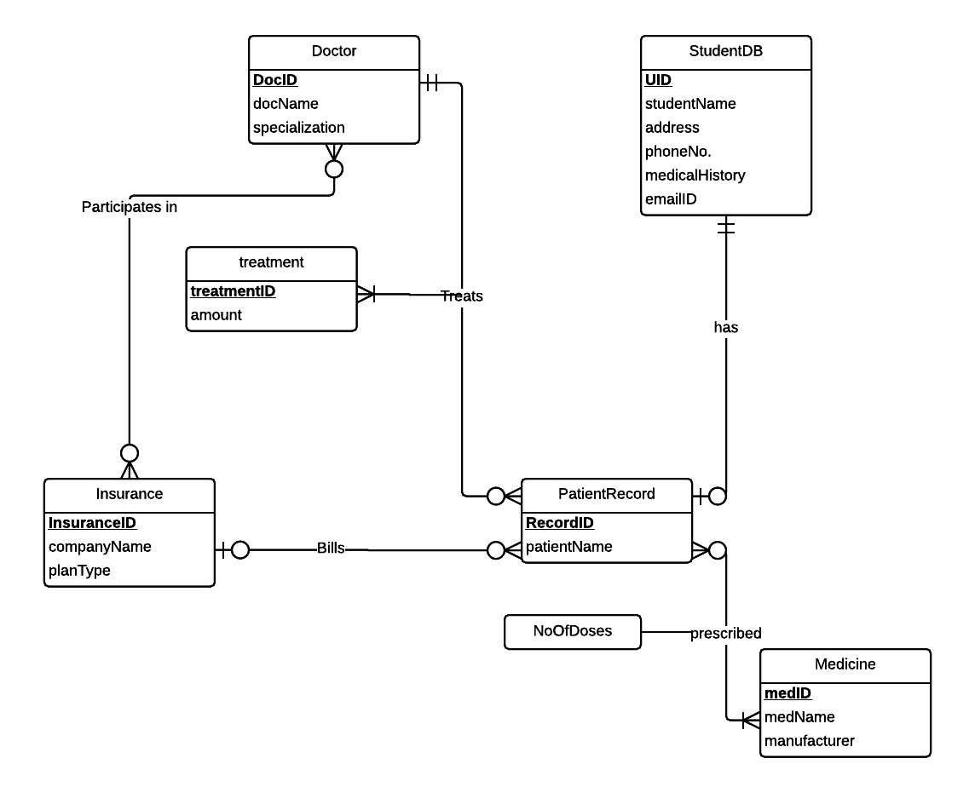

4. ERD into relational schema and identify primary and foreign keys:

ER Schema

Entities, Attributes and Primary Keys

1. Relations:

StudentDB (**uID**, studentName, address, phoneNo, emailId, medicalHistory, *recordID*)

Doctor (**docID**, docName, specialization)

Insurance (**insuranceID,** companyName, planType)

Medicine (**medID**, medName, manufacturer)

PatientRecord (**recordID**, patientName, patientBill, *docID*)

Treatment (**treatmentID**, amount)

Participates In: (***insuranceID*** *,****docID***)

Treats: (***docID, recordID, treatmentID***)

Prescribed: (***recordID, medID*,** NoOfDoses)

5. Functional Dependencies and Normalization

a. Functional Dependencies

uID ➔ studentName, address, phoneNo, emailId, medicalHistory, recordId

docID ➔ docName, specialization

insuranceID ➔ companyName, planType

medID ➔ medName, manufacturer

recordID ➔ patientName, patientBill, docID, treatmentID

treatmentID ➔ amount

recordID, medID ➔NoOfDoses

docID, recordID➔treatmentID

recordID**,** treatmentID➔ docID

1. Normalizaton:

StudentDB (**uID**, studentName, address, phoneNo, emailId, medicalHistory, *recordId*) = 3NF

Doctor (**docID**, docName, specialization) = 3NF

Insurance (**insuranceID** , companyName, planType) = 3NF

Medicine (**medID**, medName, manufacturer) = 3NF

PatientRecord (**recordID**, patientName, patientBill, *docID*) = 3NF

Treatment (**treatmentID**, amount) = 3NF

Participates In: (***insuranceID*,*****docID***) = 3NF

Treats: (***docID, recordID, treatmentID***) = 3NF

Prescribed: (***recordID, medID*,** NoOfDoses) = 3NF

6. Business Rules and Referential Integrity Actions

a.   Business Rules

[R1] If record ID is deleted from the patients record, the record ID in students Database should be set null

[R2] If record ID is updated in patients record, it should be updated in students DB as well.

[R3] If a doctor leaves the UMD health center, it should be set null in the patient’s record that he is treating.

[R4] If docID is updated then patient’s record and insurance record should also be updated.

[R5]  If a doctor leaves the organization, his participating information in insurance should also be deleted.

[R6]  If an insurance is deleted from the database then its participating information should also be deleted.

[R7]  If an insurance is updated it should be updated in participating info as well

[R8]  If a treatment is associated with an admitted patient, it cannot be deleted from the database

[R9]  If recordID, docID, medicine is updated in the database, it should be updated for the patient using it.

[R10]  If a treatment is associated with an admitted patient, it cannot be updated.

[R11]: If a patient is discharged and patient record deleted then prescribed medicine and treatment record will also be deleted

[R12]: If a medicine is being used by a patient, it can’t be deleted from the database

b. Referential integrity:

|  |  |  |  |  |  |  |  |
| --- | --- | --- | --- | --- | --- | --- | --- |
| Relation | Foreign Key | Base Relation | Primary Key | ON DELETE | BUSINESS RULE | ON UPDATE | BUSINESS RULE |
| StudentDB | recordId | PatientRecord | recordId | SET NULL | R1 | CASCADE | R2 |
| PatientRecord | docID | Doctor | docID | SET NULL | R3 | CASCADE | R4 |
| Participates In | insuranceID | Insurance | insuranceID | CASCADE | R6 | CASCADE | R7 |
| Participates In | docID | Doctor | docID | CASCADE | R5 | CASCADE | R4 |
| Treats | docID | Doctor | docID | SET NULL | R3 | CASCADE | R9 |
| Treats | recordID | PatientRecord | recordID | CASCADE | R11 | CASCADE | R9 |
| Treats | treatmentID | Treatment | treatmentID | RESTRICT| NO ACTION | R8 | RESTRICT| NO ACTION | R10 |
| Prescribed | recordID | PatientRecord | recordID | CASCADE | R11 | CASCADE | R9 |
| Prescribed | medID | Medicine | medID | RESTRICT| NO ACTION | R12 | CASCADE | R9 |

7. Sample Data

Doctor

|  |  |  |
| --- | --- | --- |
| docID | docName | Specialization |
| 1 | Dr. Reddy | Cardiologist |
| 12 | Dr. Sharma | Physiotherapist |
| 23 | Dr. Wright | Psychiatrist |

PatientRecord

|  |  |  |  |
| --- | --- | --- | --- |
| recordID | patientName | patientBill | docID |
| 1 | Abhishek Deshpande | 1000 | 11 |
| 7 | John Watson | 1231.21 | 6 |
| 4 | Jim Pit | 534.34 | 3 |

StudentDB

|  |  |  |  |  |  |  |
| --- | --- | --- | --- | --- | --- | --- |
| uID | studentName | Address | phoneNo | emailId | medicalHistory | recordId |
| 123 | Rahul Modi | 9314, Cherry Hill Road, College Park, MD, USA | 12309014311 | [rahul.m@gmail.com](mailto:rahul.m@gmail.com) | diabetic | 1 |
| 420 | Jack Chan | 12 MGM, College Park , MD, USA | 2128798127 | [jchan@gmail.com](mailto:jchan@gmail.com) | High Blood Preasure | 21 |
| 786 | Kevin Gru | 7, Ferris Maner, College Park, MD, USA | 1029091298 | [kgru@gmail.com](mailto:kgru@gmail.com) | None | 61 |

Insurance

|  |  |  |
| --- | --- | --- |
| insuranceID | companyName | planType |
| 121 | Bajaj Allianze | Student Elite |
| 231 | Bajaj Allianze | Student Gold |
| 232 | Care First | Student Silver |

Medicine

|  |  |  |
| --- | --- | --- |
| MedID | medName | manufacturer |
| 22 | cylcopalm | Sanofi Aventis |
| 233 | Tylenol | Ranbaxy |
| 989 | Combiflame | BioRad |

Treatment

|  |  |
| --- | --- |
| treatmentID | amount |
| 22 | $1,000.00 |
| 11 | $1231.21 |
| 7 | $534.34 |

ParticipatesIn

|  |  |
| --- | --- |
| insuranceID | docID |
| 12 | 3 |
| 56 | 4 |
| 23 | 8 |

Treats

|  |  |  |
| --- | --- | --- |
| docID | recordID | treatmentID |
| 3 | 33 | 2 |
| 4 | 12 | 4 |
| 8 | 44 | 6 |

Prescribed

|  |  |  |
| --- | --- | --- |
| recordID | medID | NoOfDoses |
| 33 | 23 | 2 |
| 12 | 67 | 3 |
| 44 | 54 | 1 |