**SETUP – UMD Health Centre**

UMD Health Centre requires the following software to run:

* Visual Studio
* UMD network or VPN cisco client to Connect to it.

**Step 1 : Download Visual studio**

Visual Studio can be downloaded from the following link:

For Windows: <https://www.visualstudio.com/en-us/downloads/download-visual-studio-vs.aspx>

* Choose Visual Studio Community from this link.
* Let the software download.
* Accept Terms and condition and let it install.
* Visual studio is heavy. It may take time.

For Mac: <https://www.visualstudio.com/en-us/downloads/download-visual-studio-vs.aspx>

* Choose Visual Studio Community from this link.
* Let the software download.
* Accept Terms and condition and let it install.
* Visual studio is heavy. It may take time.

**Step 2: [If not in UMD network] Download VPN Client**

For Download: <https://terpware.umd.edu/Windows/Package/2039>

* This software can be found on terpware
* Download software by the name Cisco Any connect
* Put : “ vpn.umd.edu” as server name.
* Click connect

**Step 3: Download the code file.**

* Download the code file from the suite.
* Open the folder.

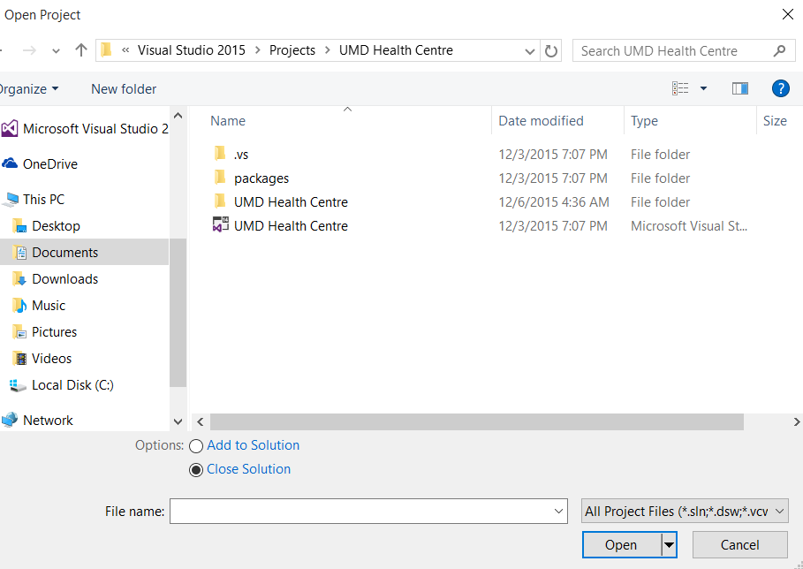

* Click on UMD Health Centre file with Visual Studio Type as shown above.
* If it asks you to choose software, open with “ Visual Studio”

Step 4: Run the Project From Visual Studio

* Once the project opens up in visual studio, your side panel should look something like this:

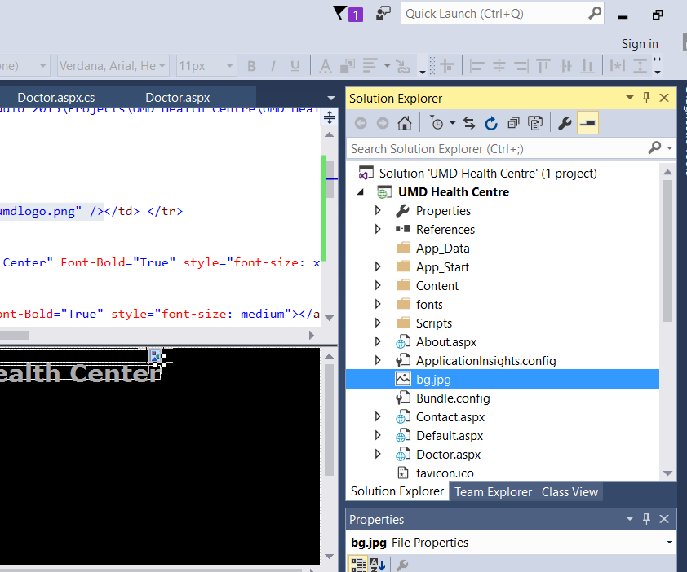

* Once you see this project UMD Health Centre in the solution screen, expand it.
* Look for aspx file HomePage.asp under it

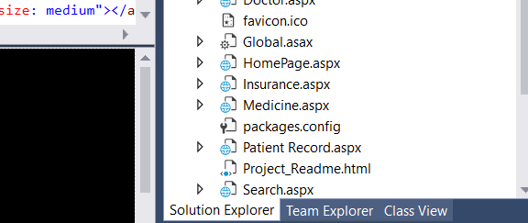

* Double Click on this page.
* Now this file would open and you should be able to see a run button on the top of the screen as shown below.

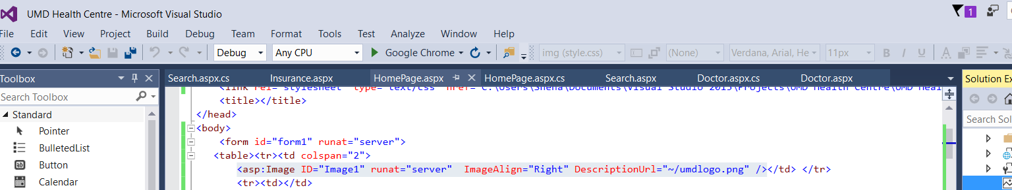

* Click on that and the Homepage hosted on localhost should open up on Google chrome.
* Your window should look something like this:

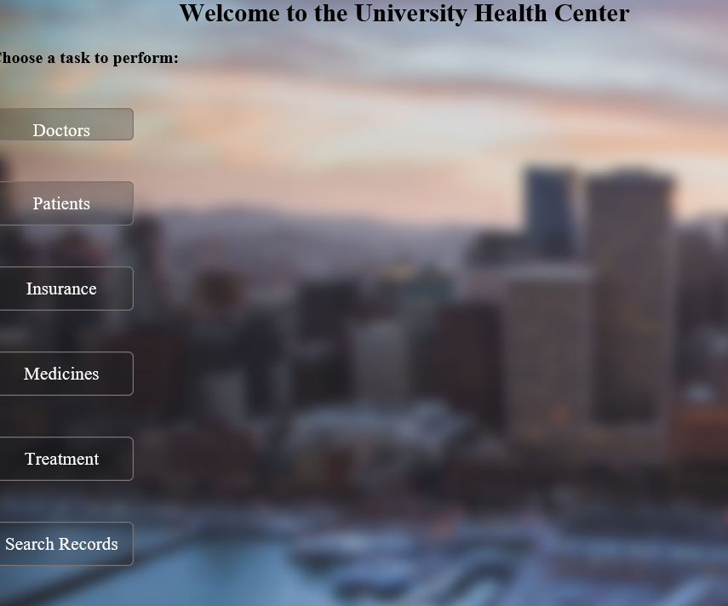

* If you see just the button on blank page then Copy and paste the URL on Internet Explorer.
* Chrome saves old versions in cache and doesn’t run the CSS sometimes.
* The application should run fine on IE.
* Enjoy your experience with UMD health Centre.