

**Niger**

**Data Networks and Infrastructure**

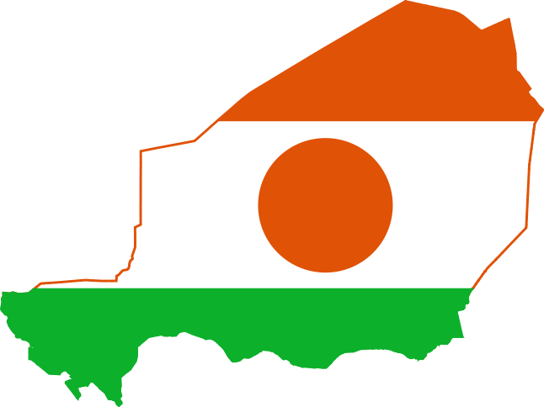

BUDT 758Z - Section 0501

Roma Kaul

Akshar Krishnamurthy

Anshul Uchil

Deepthi Viswanath

**Contents**

**NIGER 3**

**CURRENCY 4**

**LANGUAGE 4**

**EDUCATION 5**

**POLITICAL PROFILE 5**

**ECONOMIC DEVELOPMENT 7**

**LEGAL PROFILE 9**

**REGULATORY OVERVIEW – PRIVATIZATION AND MONOPOLY 10**

**NIGER’S TELECOM INDUSTRY 14**

**Wireless 14**

**Broadband 18**

**Wireline 20**

**RECOMMENDATIONS, SECURITY, SWOT ANALYSIS 23**

**SWOT Analysis 25**

**CYBER SECURITY 27**

**APPENDIX 29**

**CITATIONS 33**

# NIGER

Niger covers a land area of almost 1,270,000 km2, making it the largest country in West Africa, with over 80 percent of its land area covered by the Sahara Desert. The country's predominantly Islamic population of 17,138,707(1) is mostly clustered in the far south and west of the country. The capital city is Niamey, located in the far-southwest corner of Niger.

Niger is a developing country, and is consistently one of the lowest-ranked in the [United Nations](https://en.wikipedia.org/wiki/United_Nations)' [Human Development Index](https://en.wikipedia.org/wiki/Human_Development_Index) (HDI); it was ranked last at 187th for 2013. Niger faces serious challenges to development due to its landlocked position, desert terrain, high fertility rates and resulting overpopulation without birth control, poor education and poverty of its people, lack of infrastructure, poor health care, and environmental degradation. A majority live in rural areas, and have little access to advanced education. (2)

# CURRENCY

The official **Niger currency** is the CFA Franc. (3) The ISO Code of The Niger currency is **XOF** and it is sub-divided into 100 centimes. As the currency of Niger, CFA Franc came into existence around 1945, to replace the existing French franc which had weakened following the Second World War. In case of Niger, it shares the CFA franc with 14 other nations of the world. Exchange rate annual average (2014): USD 1 = XOF 494.32.

# LANGUAGE

 Niger has between 8 and 20 indigenous languages. The discrepancy comes from the fact that several are closely related, and can be grouped together or considered apart.

French, inherited from the colonial period, is the [official language](https://en.wikipedia.org/wiki/Official_language). (4) It is spoken mainly as a second language by people who have received an education. Although educated Nigeriens still constitute a relatively small percentage of the population, the French language is the language used by the official administration (courts, government, etc.), the media and the business community.

The usual categorization of languages of Niger mentions eight national languages (Hausa, Zarma/Songhai, Fulfulde, Tamajeq, Kanuri, Arabic, Gurma, and Tebu).

# EDUCATION

The literacy rate of Niger is among the lowest in the world; in 2005 it was estimated to be only 28.7% (42.9% male and 15.1% female). (2) Primary education in Niger is compulsory for six years. The primary school enrollment and attendance rates are low, particularly for girls. In 1997, the gross primary enrollment rate was 29.3 percent, and in 1996, the net primary enrollment rate was 24.5 percent.

About 60 percent of children who finish primary schools are boys, as the majority of girls rarely attend school for more than a few years. Children are often forced to work rather than attend school, particularly during planting or harvest periods. Nomadic children in the north of the country often do not have access to schools.

# POLITICAL PROFILE

Niger is a large landlocked country in West Africa, situated on the edge of the Sahara desert. It shares with Mali and Chad – two neighboring landlocked countries – the constraints of limited water resources and recurrent drought. (5) Historically a gateway between north and sub-Saharan Africa, parts of Niger came under French rule in the late 1890s. After independence in August 1960 its progress was stymied by political instability and a five-year drought, which devastated livestock and crops. A decade of peace followed, before Niger was racked by political violence once again, with a succession of military coups taking place from the mid 1970’s onwards and at least two major insurgencies by Tuareg rebels in 1990 and 2007. The militant group responsible for the most recent uprising, the Niger Movement for Justice (MNJ), (8) complained that a 1995 peace deal that ended the previous insurgency had never been fully implemented and that the region remained marginalized, while the group demanded greater autonomy and a larger share of uranium revenue. In April 2009 the MNJ and the government held talks in Libya, during which they committed themselves to a ‘total and comprehensive’ peace.

As a reflection of the country’s increasing population, in 2004 the unicameral legislature –The National Assembly – was expanded to 113 deputies elected for a five-year term under a system of proportional representation. In July 1999 voters overwhelmingly approved a new constitution providing for presidential and legislative multi-party elections. The constitution restored a semi-presidential system of government in which the president (elected by universal suffrage for a five-year term) and a prime minister (appointed by the president) share power. Elections took place later in the year and saw Mamadou Tandja elected as president, and the former military man won a subsequent term in the second round of presidential elections in December 2004. After initially promising to step down when his current term was due to come to an end in December 2009, Tandja instead sought a constitutional amendment to overturn the provision barring him from standing for a third term. In late June 2009 the Constitutional Court ruled his plans for a referendum on the matter were illegal; Mr. Tandja reacted by disbanding both the court and parliament, and assumed control by invoking emergency powers. (24) Opposition parties accused him of mounting a coup and foreign governments, including the US and France, voiced grave concern about the developments. The highly-criticized referendum went ahead in early August 2009, endorsing the new constitution and allowing Tandja to rule for a further three years. Fresh National Assembly elections – boycotted by the main opposition parties – were held in October 2009 and saw Tandja’s supporters win an overwhelming victory over independent candidates, securing 76 of the 113 seats.

In February 2010 Tandja was ousted in a military coup, with a senior army officer, Salou Djibo, named head of a military government. The interim administration suspended the constitution, dissolved the cabinet and promised to return Niger to democracy. A new constitution designed to restore civilian rule was approved in a referendum in October 2010, and in January 2011 presidential polls were held to end the year-long military junta. A run-off election between Mahamadou Issoufou and Seini Oumarou was held three months later, with the former – leader of the Social Democratic Party – emerging as the winner with 58% of the vote. Veteran opposition leader Issoufou was sworn in as president in April 2011, appointing Brigi Rafini as prime minister. The political situation remains volatile, however; in July 2011 five soldiers were arrested for allegedly plotting to assassinate President Issoufou and take power in yet another coup, while in May 2013 a double suicide bombing on a military camp and a uranium mine killed dozens of people. The most recent attacks prompted Issoufou to reshuffle his cabinet in August 2013, in a move that increased the number of members from 26 to 37. Ten ministers from the old cabinet were dismissed under the shake-up, while new members from opposition parties were brought in, although the PM was retained and key ministries such as foreign affairs and defense were kept in the hands of the president’s loyalists. The next presidential and legislative elections are scheduled to take place in early 2016.

# ECONOMIC DEVELOPMENT

A vast, arid state on the edge of the Sahara desert, Niger endured austere military rule for much of its post- independence history. The country was rated by the UN as the world’s least developed nation in 2014, due to multiple factors such as food insecurity, lack of industry, high population growth, a weak educational sector and few prospects for work outside of subsistence farming and herding, which contributes about 40% of GDP and provides livelihood for about 90% of the population. A leading producer of uranium, the country also has sizable reserves of oil, although revenues have fallen well short of predictions, mainly because of logistical challenges. Cotton the nation’s main cash crop, suffers erratic production levels partly due to recurring drought and partly to depressed world prices, and along with other countries in the Sahel, Niger suffers persistent food insecurity. Its strategic cereal reserves were wiped out by the prolonged drought in 2004/5, causing a major crisis by the middle of 2005, although the situation improved thanks to international donations and a better harvest in the latter half of the year. Things took a turn for the worse following a poor harvest in 2009, and in mid-2010 aid agencies declared that the severe food shortage – claimed to be the worst in 30 years – had seriously affected around half of the country’s population.

The Nigerien economy grew around 9.5% in 2008, thanks to an excellent harvest that brought about a 25% increase in agricultural production, but the following year GDP contracted by 0.9% in the wake of drought and the subsequent poor harvest, which triggered a severe food crisis. The economy was also damaged by the international community’s decision to cut off non-humanitarian aid in response to Mamadou Tandja’s moves to extend his term as president; nearly half of the government’s budget is derived from foreign donor resources. (6)(7) GDP growth rebounded to 8% in 2010, driven by a bumper harvest, but slowed to around 3% the following year, before hitting 11.1% in 2012, thanks to a new oil project, a good harvest and increased uranium production. According to the International Monetary Fund (IMF), GDP expansion decelerated significantly in 2013 to 4.1%, because of a decline in agricultural output due to below average rainfall and the temporary closure of the largest uranium mine following a terrorist attack. The impact of these negative shocks was partially offset by an increase in oil production from 13,000 barrels per day in 2012 to 19,000 at the end of 2013. After an acceleration to 6.9% in 2014, driven by agriculture and services, the IMF forecasts GDP expansion of 4.4% in 2015, due to a slower growth in agriculture and a lower production in the oil and mining sectors. The IMF’s medium-term economic outlook remains favorable, with growth expected to average 6.5% during 2016-18, driven mainly by the mining sector and an increase in public and private investments.

Inflation topped 12% in 2009 as the food shortage increased prices, but abundant agricultural production from the second half of 2010 has helped to keep the rate in check since then. Average annual inflation was 2.3% in 2013 as the upward pressures on food prices were dampened by a government food aid program, as well as support from development partners. According to the IMF, inflation was negative (-0.9%) in 2014 and remained moderate in 2015, with an average annual rate of 0.1% recorded in August that year, thanks to a good harvest and a government program promoting the sale of cereals at a moderate price, to support vulnerable groups. (22)

# LEGAL PROFILE

The legal system is basically French in civil law, with important customary-law modifications. The High Court of Justice, which is appointed by the National Assembly from among its own membership, is empowered to try the president and members of the government for [crimes](http://www.nationsencyclopedia.com/knowledge/Crimes.html) or offenses committed in performance of their official duties. Defendants and prosecutors may appeal verdicts from lower [courts](http://www.nationsencyclopedia.com/knowledge/Courts.html), first to the Court of Appeals [and then](http://www.nationsencyclopedia.com/knowledge/Natsume_Soseki.html) to the [Supreme](http://www.nationsencyclopedia.com/knowledge/Supreme.html) Court, which sits as the highest court of appeal.

The Constitutional Court has jurisdiction over electoral and constitutional matters, including ruling on the constitutionality of laws and ordinances, as well as compliance with international [treaties](http://www.nationsencyclopedia.com/knowledge/Treaties.html) and agreements. The court is comprised of seven members.

Traditional and customary courts hear cases involving divorce or inheritance. There are no religious courts. Customary courts, located in larger towns and cities, are presided over by a legal practitioner with basic legal training who is advised about local tradition by a local assessor. The actions of chiefs in traditional courts and of the presiding practitioner in customary courts are not regulated by the code provisions. Appeals can be taken from both customary and traditional courts to the formal court system. The government has also established a Court of State Security to try crimes against the state.

# REGULATORY OVERVIEW – PRIVATIZATION AND MONOPOLY

The telecom regulatory board of Niger, earlier known as Multi-sectoral Regulatory Authority (Autorite de Regulation Multisectorielle, ARM) was later on replaced by Authority for the Regulation of Telecommunications and Post (Autorite de Regulation des Telecommunications et de la Poste, ARTP), (11) which was created under Law No. 2012-70 of 31 December 2012(10) and is responsible for regulating the post and telecoms sectors.

The ARTP is comprises of two bodies: the seven-member Council of National Regulation of Telecommunications and Post (CNRTP), which is the policy-making body of the regulator and is also responsible for issuing sanctions and licensing matters; and the Directorate General, which is responsible for the management of strategies, human resources, legal affairs and accounting and finance

In Niger, the telecom network companies need a license, which needs to be approved by ARTP to operate in the public. Free public fixed telephone services and the establishment and operation of independent networks via the public domain; internet interconnection services need to undergo an authorization regime. The requirements for approval is subject to the compliance of the equipment and independent networks with endpoints separated by less than 300m and links with a capacity of less than 2.1Mbps, can be operated and established freely.



**Wireless Regulations**

In 2012, ARTP awarded three 15-year GSM licenses at a cost of USD5.8 million (5) each to three main providers:

1. **Celtel Niger** (now known as Airtel)
2. **Telecel** (now Moov Niger)
3. **SahelCom**

The license is valid for 15 year and is renewable for subsequent five years. Each concession required coverage of the capital Niamey within a year of licensing, Maradi and Zinder within two years and Tahoua and Agadez within three.

A new global license has also been awarded to Orange Group, allowing it provide fixed line, wireless and internet access (including 3G) services. In 2014, after much discussion ARTP provided two 3G licenses Airtel Niger being one of them. It has been awarded a 15-year 3G concession. ARTP is also holding public consultation to seek stakeholder opinion on frequencies for the provision of 4G mobile broadband services. It is unlikely that 4G licenses should be granted no later than 2017, although the lack of a national backhaul network and the limited development of 3G services were highlighted as factors that may delay the 4G launch process.

In 2008, the government aimed to fight the crime being committed through the use of mobile phones. It introduced a regulation requiring all mobile operators to register the details of their pre-paid subscribers.

By April 2013, the government revealed that only around 47% of mobile phone subscribers had registered their details (60% for Orange Niger, 56% for Airtel, 49% for Moov and 23% for SahelCom). In November 2013, due to continuous noncompliance the ARTP deactivated around 1.728 million unregistered mobile lines that had failed to register. It also banned the sale of pre-activated SIMs.

In 2014, ARTP found 4 operators failing to adhere to their license conditions concerning price control mechanisms. Comprising almost 3% of the operators’ total revenue for 2013, Airtel Niger was handed the largest fine of XOF3.04 billion, followed by Orange Niger.

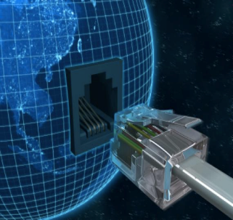**Broadband Regulations**

ARTP has authorized broadband license to 6 big companies for carrying out the services. Namely:

1. State-owned fixed line incumbent Societe Nigerienne des Telecommunications **(Sonitel)**
2. **Orange Niger**, the local unit of Orange Group
3. Pan-African operators **Alink Niger**
4. **Connecteo**
5. **Liptinfor**
6. **Ixcom**

**Wireline Regulations**

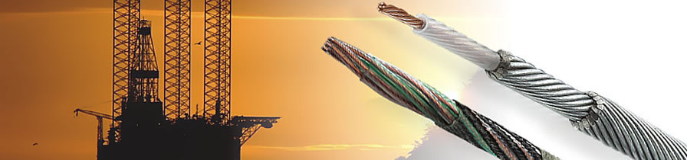In 1999, the Niger government identified two major objectives:

1. The privatization of fixed line incumbent Societe Nigerienne des Telecommunications (**Sonitel**)(12)
2. The introduction of competition

In order to introduce competition, 51% stake in Sonitel was sold to Dataport, comprising of Libyan and Chinese investors, in 2001.

Till 2005 National Telco had the monopoly on fixed lined markets. After 2 years of its monopoly expiring, an element of competition was finally introduced to the sector when Orange Group was awarded permissions to all telecom services, including the provision of local, long-distance and international fixed telephony.

By 2011, Government had started looking for a new buyer for Sonitel, which was scrapped off by summer 2012 when parliament decided to keep Sonitel in government hands.

In 2012, ARTP claimed that there were serious breaches by Dataport, (10) particularly in relation to coverage targets, modernization of switches, and an accumulation of arrears to the universal access fund and non-payment of frequency fees.

In late 2012, Sonitel was granted exclusivity on international calls and on the rollout of fiber-optic infrastructure for a period of five years, but due to protests from Orange and Airtel this was later withdrawn.

In January 2015, a draft decree for incoming and outgoing international traffic was published. Under the proposal, an institution mandated by the government will run the unique gateway, and operators will be required to interconnect their networks to the gateway.

If this be a success, interconnection between different operators will become fairly easy.

# NIGER’S TELECOM INDUSTRY

# 

# Wireless

The mobile market in the in Niger has a wireless penetration of only around 38% at the end of June 2015, roughly half the average rate for Africa but it offers good prospects for future growth with a rising population of approximately 17 million. Annual subscriber growth averaged 70% in the four years to end-2008, before gradually slowing to an average rate of 23% in 2011/12 due to government’s sim registration campaign, which resulted in discontinuation of 1.70 million subscribers. (13)

The four major wireless players in Niger are:

1. **Airtel Niger**
2. **Orange Niger**
3. **Moov Niger**
4. **SahelCom**

**Airtel Niger**

Airtel Niger accounts for around 57.8% Niger’s total wireless subscriber base at mid-2015 (15) it has secured one of three 15-year GSM-900 licenses in December 2000, and was the first of the trio to launch services, inaugurating its network in October 2001 in the capital Niamey. (9) The vendor upgraded the charging platforms across all operations, introducing the latest version of Ericsson’s Charging System, enabling Airtel to offer subscribers new value added services (VAS) such as ‘mobile wallets. One month later Bharti Airtel selected French-US vendor Alcatel-Lucent to upgrade the backhaul networks of the firm’s African subsidiaries with IP/multiprotocol label switching (IP/MPLS) technology to help support growing mobile data use. The upgraded backbone network supports all of Airtel’s African units, as well as providing more robust interconnection to global networks.

Airtel launch a new network, dubbed ‘Africa Connect’, to enhance international connectivity on the continent and support the growing demand for data services in the group’s African markets. Africa Connect consists of integrated fiber and satellite networks, with 42 PoPs throughout Airtel’s African footprint. Airtel offers mobile internet access over its GPRS and EDGE networks, but in a bid to offer faster mobile data rates and new products to its customer base, the company reached an agreement with the government in July 2014 for the acquisition of a 15-year 3G license and the renewal of its 2G concession for a total consideration of XOF34 billion. 3G mobile data services were launched that same month with coverage of major towns and cities, including Say, Tera, Kollo and Tillabery. A wide variety of daily, weekly and monthly 3G packages were on offer at September 2015, ranging from XOF100 for a data allowance of 5MB (valid for one day) to XOF50,000 for 16MB (30 days).

Airtel Niger, Emitac Mobile Solution and Research In Motion (RIM) announced the launch of the BlackBerry solution in Niger in April 2009, while Zain Group expanded its 'Zap' mobile Commerce service (renamed ‘Airtel Money’ following Bharti Airtel’s acquisition) to Niger, Sierra Leone and Malawi in December 2009. In a country where formal banking services are largely restricted to urban areas, Airtel subscribers can use the service to withdraw cash, pay for goods and services, send and receive money, manage their bank accounts, and top up airtime. Since July 2015 Airtel Money customers have been able to transfer money and send remittances to users in three other African countries – the Democratic Republic of Congo, Zambia and Rwanda. The cellco said that the new service will facilitate cross-border payments across the four countries. In early 2013 ‘Airtel Premier’, a high-value customer reward program was further extended to Niger, Malawi and Uganda, following earlier launches in Nigeria, Zambia, Gabon, Burkina Faso and Madagascar.

**Orange Niger**

In November 2007 Orange Group was awarded a unified fixed line, mobile and Internet operating license (referred to locally as a ‘global’ license) for EUR48 million (USD64 million). In June 2008 Orange announced the launch of wireless and Internet services in five towns and cities – the capital Niamey, Zinder, Maradi, Birni-N'Konni and Tahoua – and by the end of that year it had increased coverage to 30 other towns. By the end of December 2014 Orange Niger’s network had been expanded to 75% of the population, up from 53% at the end of 2010. (15)

The main reason for growth of subscriber for Orange was the launch of Niger’s first third generation services in 2011 and downstream speeds of up to 21Mbps were made available from September 2014 with the launch of an upgrade to HSPA+ technology. At September 2015 the cellco’s W-CDMA network was available in a handful of main cities, including Niamey, Say, Dosso, Konni, Maradi, Zinder, Tahoua and Agadez. A number of consumption based mobile broadband packages are on offer, ranging in price from XOF500 for 50MB (valid for a 24-hour period) to XOF 45,000 for 11GB (one month) (16). Looking forward, Orange said it aims to remain Niger’s leading provider of internet services in 2015 and to consolidate its position in the mobile market, primarily by reinforcing its network in the major cities and by continuing to improve service quality. In November 2012 wireless network solutions provider Altobridge completed the first phase of mobile connectivity deployments for Orange Niger in remote regions of the country to communities previously underserved by any form of telecoms service. At that date, over 50 off-grid village communities had been connected, allowing an average of 1,200 people in each location to benefit from mobile telecoms services for the first time. The cellco said that the satellite-based solution would allow it to add new subscribers and introduce new services in a cost-efficient manner. In July 2010 Orange launched its ‘Orange Money’ service in Niger, allowing users to transfer money, pay bills, top up their mobile phones and deposit and withdraw cash from a network of agents around the country. The service is available for all Orange customers whether or not they have a bank account. The Orange Money account is activated free of charge and without any minimum deposit. At mid-2015 Orange Money had roughly 14.2 million customers across its markets in Africa and the Middle East.

**Moov Niger**

Moov has a range of pre-paid and post-paid plans are available, alongside additional services such as SMS, voicemail, international roaming, BlackBerry and mobile data over the company’s GPRS and EDGE networks. In October 2013 Moov Niger launched mobile money service ‘Flooz’ in cooperation with Banque Atlantique Niger. The offering enables customers to use their mobile phones to pay for goods and services, purchase airtime, transfer money to family and friends, withdraw and deposit cash, and manage bank accounts. In March 2015 Moov Niger enhanced its Flooz service by allowing cross-border transactions to Benin, Cote d’Ivoire and Togo. Moov Niger was unsuccessful in its bid for a 3G permit thus greatly hampering its growth and giving way for Orange to overtake it as the 2nd largest provider in Niger.

**SahelCom**

SahelCom, the wholly owned mobile unit of state-owned fixed line incumbent Societe Nigerienne des Telecommunications (Sonitel), launched commercial operations in August 2002. (13) The vast majority of its customers use pre-paid services, with post-paid being predominantly the reserve of corporate customers. The company has upgraded to EDGE technology (exact date unknown), and says it offers mobile Internet access in selected cities. SahelCom claims GSM-900/1800 network coverage of 65% of the population and 45% of the country’s territory (over 36 towns and villages) (23). Although owned by Sonitel, which is a large player in the broadband sector, it cannot compete much in the wireless sector and is largely dominated by Airtel and Orange.

# Broadband

Because of limited backbone capacity, Niger relies on expensive satellite communications, which has resulted in:

1. High local and international telecom costs
2. Limited bandwidth capacity
3. Interoperability problem among carriers

(17) There are few connections to neighboring countries and further to the SAT-3 and Africa coast to Europe (ACE) submarine cables off the coast of West Africa meaning most parts of Niger’s broadband is underdeveloped. A few major cities of Niger Niamey, Maradi, Zinder though are still connected by fiber optic cables to neighboring countries and in turn to the submarine cables. Sonitel and Orange Niger are the two providers that have this connectivity.

As reported by ARTP, there were 1.36 million internet subscriber in Africa in 2012. Telegeography estimates that broadband customer base is around 10,750 with a household penetration of 0.3%, significantly lower than regional penetration of 5%.

The government of Niger has been investing in building a fiber optic backbone network.

Major players in broadband service providers:

1. **Sonitel**
2. **Orange Niger**
3. **Alink Niger**
4. **Liptinfor**

Sonitel introduced its first ADSL service in October 2008 and expanded coverage to 19 cities by December 2011(18). This was followed by launch of Wi-MAX based service network by Orange Niger in July 2008. The prices for the services offered were high, at 45,000 XOF for an uncapped 256 kbps per month. Then other providers emerged offering higher speed internet via technologies like WiLL, fiber optic connectivity. The government of Niger signed a 49.5 XOF billion deal with China to fund the deployment of 2,275km of fiber-optic backbone cable infrastructure, as well as the rollout of an additional 51,000 ADSL lines for Sonitel and 136 mobile base stations for SahelCom in December 2013. 2015 saw the government announcing various deals about beginning construction work to connect various cities using fiber optic backbone cable.

# Wireline

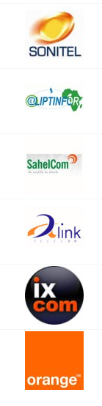There is only a 7% penetration of fixed lines in households (19), as reported by the end of 2014. The significant growth of fixed line services is hampered by the limited investment and competition. As reported by ARTP, the number of fixed lines is growing slowly, reaching 155,840 at 31 December 2014, up marginally from 147,651 twelve months earlier and around 20,000 at the turn of the millennium. There was a monopoly of Sonitel in the fixed line providers till Jan 2005, global license was issued to Orange Group to offer fixed line, wireless and internet services. Due to government intransigence and lack of political will, it took almost three years for first new license to be issued after monopoly of Sonitel ended in Jan 2005. Attempts were made to privatize the telecom company by selling 51% of the company stake to Dataport joint venture between Libyan Arab African Investment Company (LAAICO) and Chinese equipment vendor ZTE. By early 2009 Dataport failed to deliver on any of its promises in respect of rollout of lines, coverage and universal access fund payments. Finally, in February 2009 the authorities renationalized Sonitel, admitting that the privatization had been a complete failure. Similar such attempts were made to privatize Sonitel but they failed due to expectations not met during the contract.

Sonitel deployed its fixed wireless service called Dogonay which has been providing limited mobile services in about 40 cities and localities. Dogonay used WiLL network, providing limited mobility in areas of Niamey and Maradi, and then later expanding its business to 40 other towns.

In 2005, Siemens was contracted to digitize DomSat, allowing Sonitel and wireless sister company SahelCom to connect the capital Niamey with other parts of the country. The following year the same vendor was contracted to provide Sonitel with a high-speed fiber-optic network in Niamey with links to Burkina Faso and Benin and further to the SAT-3 submarine cable. Despite all such services, many towns in Niger still do not have a local telephone exchange, which restricts telecom access to population at large.

Major players in providing wireline services in Niger include **Sonitel, Orange Niger**.

**Sonitel-Societe Nigerienne des Telecommunications**

ADSL service in the cities Agadez, Diffa, Dosso, Maradi, Niamey, Tahoua, Tillabery and Zinder, and by December 2011, coverage was expanded to Birni N’Gaoure, Madaoua, Guidan Roumdji, Aguie, Matameye, Tera, Say, Tanout, Magaria, Kollo and Filingue.

Various attempts were made to nationalize Sonitel but due to failure to meet the responsibilities by various companies, it was decided that Sonitel would be solely run by the state. First attempt was done in December 2001 Libyan Arab African Investment Company (LAAICO) and Chinese equipment vendor ZTE formed a joint venture – Dataport – to acquire a 51% stake in Sonitel and its wholly owned wireless arm SahelCom, paying XOF17.5 billion for the majority holding. On 19 February 2009, however, the Nigerien government announced that it would renationalize the 51% stake in Sonitel held by Dataport, following the joint venture’s alleged poor management and failure to meet the terms of the privatization agreement. Accusations included neglecting to meet a rollout target of 45,000 fixed line subscribers, failure to pay staff and the accumulation of debts of XOF39 billion.

Residential services are offered at XOF 25,000 per month for a speed of 256 kbps. Various speeds were available for business, rated at XOF 50,000 for a speed of 256 kbps, XOF 70,000 for 512 kbps, XOF 135,000 for 1Mbps.

Sonitel also began deploying a fiber optic backbone network linking various cities and a deal was signed with Egypt based company El Sewedy to install new backbones connecting to cities.

**Orange Niger**

Offered WiMAX services and also launched cellular services in five cities, started in July 2008. The Orange Group was awarded a unified fixed line, wireless and internet operating license (referred to locally as a 'global' license) for EUR48 million (USD64 million) in November 2007. It provides a high speed Internet with download speeds of up to 1 Mbps. It charged 45,000 XOF per month for an uncapped 256 kbps connection.

80% of Orange is owned by Orange Group, other parts owned by Mohamed Rissa and Moctar Thiam, African partners.

There are three plans offered: (16)

|  |  |  |
| --- | --- | --- |
| **Plan** | **Speed** | **Cost** |
| Entry level plan – residential | 256 kbps | XOF 45,000 per month  - residential  XPF 57,680 per month - business |
| Intermediate plan | 512 kbps | XOF 83,000 per month – residential  XOF 115,360 per month – business |
| Top connection plan | 1 Mbps | XOF 156,000 per month- residential  XOF 223,510 per month – business |

Pre- and post-paid options are available, priced at XOF 5,150 per month, with the Alcatel D36C phone costing XOF 30,000 at September 2015.

**Other providers**

ALink Niger and Liptinfor Niger are other smaller service providers spread over various cities. Services offered include data transmission, fiber-optic networks, VoIP, video conferencing etc. mainly aimed at business customers. Alink Telecom is a subsidiary of Lokajean Holding.

Liptinfor Niger (21) is a privately owned company, provider of high speed internet access, VSAT solutions, VPNs, VoIP telephony and data security services. The company says it has been present in all major cities of Niger since 2005. It provides internet using WiLL technology, which allows speed up to 5 Mbps starting from 256 kbps.

**FINANCIAL PERFORMANCE**

Sonitel has been in severe debts and has debts of about 40 billion XOF, one of the main reasons for the government trying to privatize it. (25) Orange on the other hand has been doing relatively well and had achieved all of its financial targets for 2014 mainly due to growth in Niger and few other African countries.

# RECOMMENDATIONS, SECURITY, SWOT ANALYSIS

Since Niger has mostly small businesses, there isn’t a great need for high speed Internet. Let us assume that we are sending a file of 10Mbps and the max allowable time for transmission is 1 hour. Therefore speed required=10*1024*8 bits/ (60*60) seconds = 23 kbps. Thus an Internet speed of 100Kbps should suffice but more focus should be on the reliability, price and security measures while choosing internet service providers. Although the minimum requirement is 23 kbps, keeping expansion and growth in mind we should opt for a service provider who will provide a higher speed wherever possible.

38% of the population of Niger has access to wireless connection through “dongle”, using a mobile sim card and it may also provide the required speed (13). We still do not recommend using wireless internet mainly due to its unreliability.  Network providers in Niger failed in the past to meet the requirements laid down by the government. A lot of them started fine but could not provide reliable services due to poor management and over-ambitious projects.

The main location for setting up base should be the capital Niamey. Having a strong backbone network consisting of fiber optics that is also connected to Burkina Faso and Benin and further to the SAT-3 submarine cable. All the entire development plans taking place has included the capital thus making it the obvious preferred choice for setting up base.

DonCo requires, in the most practical sense possible for a developing nation, a location where “always-on” internet access to the “last mile” is most viable. In Niger, as in many emerging nations, most of the service providers target the internet cyber cafe, corporate offices, and public malls for providing service because most households cannot afford to avail these services. Most of these users, subscribers encompassing about 57.8% of internet user, access the internet in Niamey, the main location of focus that we recommend to DonCo as a base for its suppliers. Because of the heavy government involvement and commitment to internet development through the upcoming XOF49.5 billion contract of the government of Niger with China to lay fiber optic backbone cable infrastructure to interconnect Niamey with neighboring cities as well as rollout 51,000 ADSL lines and 136 mobile base stations,  we recommend Niamey as the primary location of DonCo’s supplier’s operations. (17)

In addition, we recommend Zinder, second largest city in Niger after the capital itself as a secondary location base for DonCo suppliers as it has all the latest services and major providers of Niger coverage. Zinder also has international links and thus communication with places outside Niger would be easier. Zinder includes an infrastructure focus to ensure that international bandwidth is available and distributed throughout the country and that the bandwidth is available to achieve economic gains for enterprise.

Our ISP suggestions to DonCo is Orange Niger with highest priority for 5 major cities as it provides WiMax-802.16e service. (17) This technology being faster and more reliable than the others available in these cities makes it our first choice. Orange Niger is also part of the ACE consortium. For the cities like Tahous , Tillabery we recommend Sonitel as the ADSL service provided is reliable and Orange does not provide connection to these cities. The amount of business flowing in and out of these smaller cities should not be high in volume and thus ADSL should suffice even if the company decides to expand.

# SWOT Analysis

**Airtel**

* **Strength**: Largest wireless provider, dominates 58% of the market, available in almost all cities in Niger, fast expanding 3G networks with relatively cheaper packages.
* **Weakness**: Prices are still expensive and expansions are not complete for 3G. Also there have been cases of poor management and failure to abide by contract rules, it has been already fined once for irregularities in charging customers and not meeting conditions. 3G services are also not the most reliable form of Internet.
* **Opportunity**: Since it got its license for 3G, progress has slowed and if it is able to offer faster speeds at better prices it could completely dominate the market.
* **Threat**: License might get taken away due to irregularities and poor services at times.

**Sonitel**

1. **Strength**: Most reliable wireline provider. Provides internet to 40+ cities and currently has contracts with a number of countries to lay fiber optics backbone network in Niamey.
2. **Weakness**: Still depends mostly on copper lines with fiber optic progress being slow. Relatively high costs considering the modest speeds being provided.
3. **Opportunity**: Numerous deals with countries to replace copper lines with fiber optic backbone for main cities and neighboring countries.
4. **Threat**: Repeated failures at privatization due to poor management and failure to meet contractual obligations and lack of competition from other providers.

**Orange Niger**

* **Strength**: They offer Wi-Max, which is the latest technology offered amongst large-scale competitors. They cover largest cities in Niger where maximum internet users are located.
* **Weakness**: Prevalent only in few major cities.
* **Opportunity**: Could expand to more countries, thus creating a larger customer base. Also looking likely to break the monopoly of Sonitel with its customer base and technology provided.
* **Threat**: Customer base not big enough as it has not penetrated the home owner segment yet.

**FUTURE DEVELOPMENTS THAT COULD IMPACT DECISION**

As of this moment Orange Niger is the best choice but any increase in cost could lead to a change in decision also there have been a number of fines against service providers if Orange Niger were to have its license revoked or its duration limited it could also lead to a change to Sonitel. Regarding Sonitel the biggest development to impact our decision would be if it were to become a private company as there have been times where the private companies have failed to meet demands and provide adequate services and if it were to happened we would have to seriously consider a change.

# CYBER SECURITY

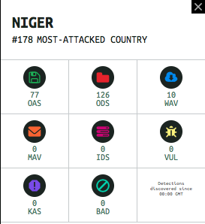Niger has been relatively immune to cyber-attacks as compared to other countries, it currently is the 178th most attacked country in the world in spite of minimal steps taken by the government to counter cyber-attacks with no established cyber security policy and future roadmap in place. Thus although there is little scope for an attack to take place, and even if it does there are few measure to prevent it thus leaving the onus on ourselves to prevent cyber-attacks.

As we do not want unauthorized access to any data provided to an outsourcer in Niger or access to DONCO corporate data systems, access controls and firewalls are of the utmost (20) importance. This will prevent outside intrusions from taking place. All employees should have extensive user training and should be warned about breach of policy as most of the attacks that take place today are due to unintentional human errors. Installing anti-virus software will also prevent most viruses from attacking the system. Lastly encryption will help in maintaining confidentiality of information and prevent eavesdropping.

# APPENDIX

# 

# Wireless Subscriber market distribution

# https://lh6.googleusercontent.com/BgwdcRHMKjyOP4mgIEGvd6PXYvCQGjdrjDocQMphBdSbxFkV2Ut63jknNfC9l7Nm0wS22-TyK90i4sVWEEUtJRtI4f2qv51KVEjCLicimg83-N3LjKzTWV06Ydz5N1gYq8KKXjtZ

# Broadband summary data

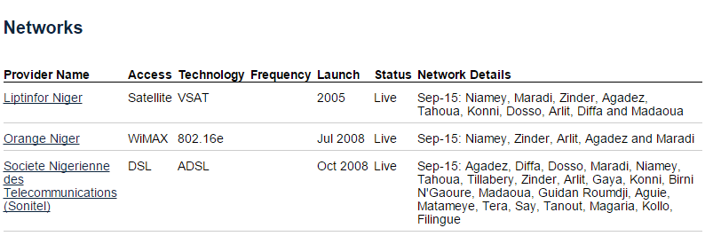

# Summary of Broadband service providers

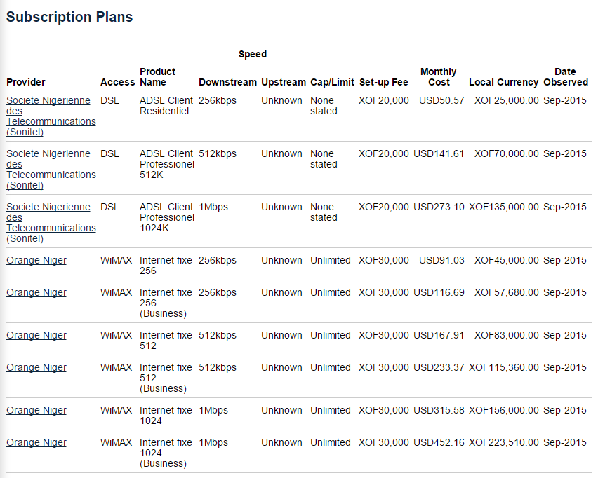

**Summary of Broadband subscription plans**

# https://lh3.googleusercontent.com/NjwYO4c_t-ERXSS4rP3Sb6pe_KJJ3oIH-vJkm5TrypGMHJriOTNN7BOGHfspsODzDpz9FC8pqqNd0cOi0tKOKtqpQi7ckAoHP5IK8VFmixYOAgLTByuq0eX1k5G1mnoZ1MLy8aVmtN6drVBxPSTN growth

# https://lh4.googleusercontent.com/S-37Iz7hSA4nZ0JJjEE_2wbmomHgKyIkqSTGvY-RTrLoSuFC5ogfm2nFKvoEGhM7f4e-HE8GmJPy3i0zt4HLOvEfcKsi6pNIzoTZ6C55wQfx9U0pyCueZnLd3Dq1cl_1l6mI6N0266RRCZRL

# 

# Technologies provided – Wireline

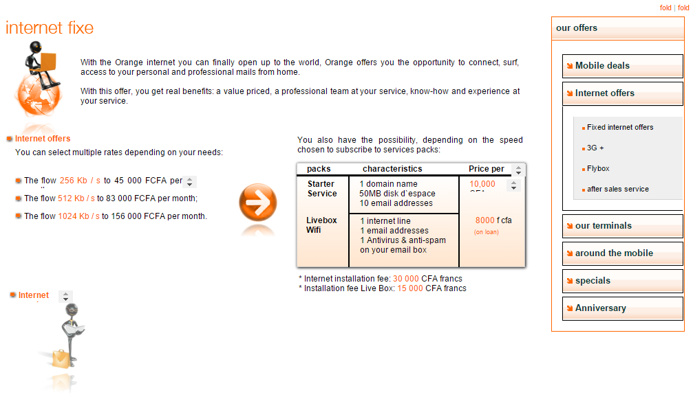

# Orange Niger internet subscription plans

# CITATIONS

(1) <http://www.citypopulation.de/Niger.html>

(2) <https://en.wikipedia.org/wiki/Niger>

(3) <http://finance.mapsofworld.com/economy/niger/currency.html>

(4) <http://www.ethnologue.com/country/NE>

(5) <https://www.telegeography.com/products/globalcomms/data/country-profiles/af/niger/country-overview.html>

(6) <https://www.cia.gov/library/publications/the-world-factbook/geos/ng.html>

(7) <http://www.heritage.org/index/country/niger>

(8) <http://www.bbc.com/news/world-africa-13943662>

(9) <http://www.africa.airtel.com/wps/wcm/connect/africarevamp/Niger/>

(10)https://www.telegeography.com/products/globalcomms/data/country-profiles/af/niger/regulations.html

(11) <http://www.armniger.org/index.php/a-propos-de-l-artp/le-mot-du-dg>

(12) <https://en.wikipedia.org/wiki/SONITEL>

(13)<https://www.telegeography.com/products/globalcomms/data/country-profiles/af/niger/wireless.html>

(14)<http://www.africa.airtel.com/wps/wcm/connect/africarevamp/niger/home/individuel/a-propos-de-nous/>

(15)<http://www.orange.com/en/About/Global-footprint/Orange/countries/Orange-Niger-activities>

(16) <http://www.orange.ne/offreservices.html>

(17)<https://www.telegeography.com/products/globalcomms/data/country-profiles/af/niger/broadband.html>

(18) <http://www.sonitel.ne>

(19)<https://www.telegeography.com/products/globalcomms/data/country-profiles/af/niger/wireline.html>

(20) <https://cybermap.kaspersky.com>

(21) <http://www.liptinfor.net/en/>

(22) <https://en.wikipedia.org/wiki/Telecommunications_in_Niger>

(23) <http://www.internetworldstats.com/africa.htm#ke>

(24) <http://ucblibraries.colorado.edu/govpubs/for/niger.htm>

(25)<https://www.telegeography.com/products/commsupdate/articles/2015/02/17/orange-group-achieves-all-2014-financial-targets/>