 | South East Technological University
Model Answer(s)/Marking Scheme(s) |  |  |  |  | Page |  | 1 |  | of | 2
Course: |  | Various Computing year 2 |  | Sitting |  |  |  | Summer 2023
Subject: |  | Statistics and Probability | Examiner: |  |  | Frank Leonard

Question  1 (a) | Male Female (i) Pr(C) 12/30 0.40  Science 9 9 18 (ii) Pr(F ∩ C) 4/30 0.13  Computing 8 4 12 (iii) Pr(F | S) 9/18 0.50  17 13 30 (iv) Pr(S | F) 9/13 0.69 |  | 2  2  2  2
(b) | Analogous to shared birthday problem  Pr(no repeat when 12 items are selected from 30) = ³⁰P₁₂/30¹² = 0.078 (8%)  Pr(at least some repeats) = 0.922 (92%)  Some grounds for suspicion |  | 2  2  2  2
(c) | 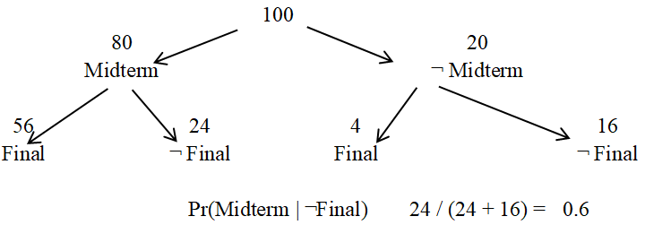 | Part tree dig  Full tree dig | 3  3  3

Question  2 (a) | Let X = # arrivals in 2 hours  X ~ Poi(λ) so Pr(X = k) = P_{k} = e^{-λ}λ^{k}/k!  λ = 4.278 arrivals / 2 hours  Pr(X ≥ 3) = 1 – Pr(X ≤ 2)  = 1 – [P₀ + P₁ + P₂]  = 0.8 | 2  2  2  2  2
(b) | Let Y = # of chartered flights out of next 9  Y ~ bin(9, 0.154) so Pr(X = k) = P_{k} = ⁹C_{k}(0.154)^{k}(0.845)^{9-k}  Pr(Y ≤ 2)  P₀ + P₁ + P₂  = 0.85 | 2  2  2  2
(c) | Let W = disembark time  W ~ N(12.36, 1.8²)  = Pr(10 < W < 17) = Pr(W < 17) - Pr(W < 10)  = Pr(Z < 2.58) – Pr(Z < 1.31)  = 0.9 | 1  2  2  2

Question  3 (a) | - 10!= 3,628,800  - S! x F! x D! x 3! = 4!3!3!3! = 5,184  - S! x F! x D! = 4!3!3! = 864 | 3  2  2
(b) | - ¹⁰C₄ = 110  - 110 - | only one aspect| = 110 – 1 = 109  - ⁴C₄ + ⁶C₄ = 1 + 15 = 16  - ⁴C₂ ⁶C₂ = 90 | 3  3  2  2
(c) | - 26 x 26 x 3 = 2028  - 26 x 25 x 3 = 1950  - Total - ||I*1| - |*I1] = 2028 – 26 – 26 = 1976  - |vowels| + |consonants| = 5² x 3 + 21² x 3 = 1398 | 2  2  2  2

Model Answer(s)/Marking Scheme(s) | Page | 2 | of | 2

Question  4 (a) | Continuous. Discrete. Ordinal. Nominal. Binary. | 5 x 1
(b) | Min. Q1. Median. Q3. Max. | 5 x 2
(c) | - SD is the average variation about the mean  - IQR ~ 140 – 55 = 85 | 3  2
 | - Any two scale + one categorical variable  - Any three scale variables | 3 + 2

Question  5 (a) | - Difference plot + paired t test  - Clustered bar chart + χ² test  - Clustered scale plot (boxplot, hist etc.) + ANOVA  - Scatter plot + correlation  - Clustered scale plot (boxplot, hist etc.) + t test | 2 + 2  2 + 2  2 + 2  2 + 2  2 + 2
(b) | - Statistical significance → difference unlikely to be a quirk of the sample  - Practical importance → context and not a statistical consideration | 3  2

Question  6 (a) | - Each year older for a car considered sees an extra €58 on average being spent on maintenance.  - Expected maintenance ′ = 117,450 – 58(2020) = €290  This car’s maintenance is lower than expected | 3  2  1
(b) | - p value for test that year coefficient ≠ 0 should be < 0.05  - r² gives the proportion of variation in maintenance explained by age. | 3  3
(c) | Year may be the true causation of maintenace cost decreasing with age.  I.e., older people may be buying newer cars | 3  3
(d) | Probability sampling examples: SRS, systematic, stratified etc.  Non-probability sampling examples: Convenience, quota etc.  Inferenece drawn on data acquired using non-probability sampling may not be valid. | 2  2  3

