 | South East Technological University
Model Answer(s)/Marking Scheme(s) |  |  |  |  | Page |  | 1 |  | of | 2
Course: |  | Various Computing year 2 |  | Sitting |  |  |  | Summer 2024
Subject: |  | Statistics and Probability | Examiner: |  |  | Frank Leonard

Question  1 (a) | - ³⁰C₇ = 2,035,800  - ¹⁰C₇ + ⁹C₇ + ¹¹C₇ = 120 + 36 + 330 = 486  - 2,035,800 – 486 = 2,035,314 | 3  3  2
(b) | - 7!= 5,040  - 3! 4! 2! 1! = 288 ( |makes|! x |Hondas|! x |Fords|! x |Toyota|!)  - 3! = 6 (Honda must be in bays 1,3,5,7 → arrange other 3 in 3 bays) | 3  3  3
(c) | - 6⁵ = 7,776  - 6  - 6 x 5 x 4 x 3 x 2 = 720  - 6 x 6 x 6 x 5 x 5 = 3,125 | 2  2  2  2

Question  2 (a) | MTBE = 11.6 so λ = 30/11.6 = 2.586  Let X = # exist from surgery in 30 min. X ~ Poi(2.586). Pr(X=k) = e^{-2.586}2.586^{k}/k!  Pr(X≥3) = 1 – Pr(X≤2) = 1 – [P₀ + P₁ + P₂]  = 0.478  (Pr(X≥2) = 0.72) | 2  2  2  2
(b) | Let Y = # patients requiring prescription. Y ~ bin(9, 0.78). Pr(Y = k) = ⁹C_{k}0.78^{k}0.22^{9-k}  Pr(Y ≥6) = P₆ + P₇ + P₈ + P₉  = 0.815 | 2  2  2
(c) | Let W = # patients seen in a year. W~ N(8859,86²)  Pr(W>9000) = 1- Pr(W<9000)  = 0.051 | 2  2  2
(d) | Pr(W< M) = 0.98 = Pr(^{W-8859}/₈₆)  Pr(Z< 0.43) ~ 0.98 so ^{W-8859}/₈₆ = 0.43  M = 8,896 | 2  2  1

Question  3 (a) | home shop (i) Pr(sh) 15/25 0.60  heated 8 6 14 (ii) Pr(¬ [he ∩ ho]) 1-2/25 0.92  unheated 2 9 11 (iii) Pr(ho ∪ he) 16/25 0.64  10 15 25 (iv) Pr( he | ¬ sh) 8/10 0.80 |  | 2  2  2  2
(b)
 | 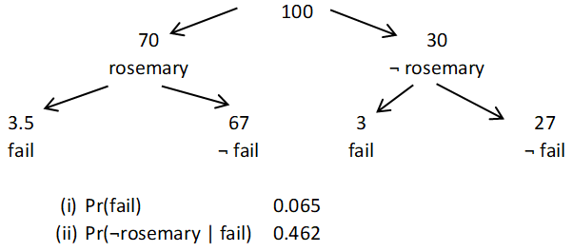 | Part tree dig  Full tree dig | 4  3  2  2
(b) | Pr(no repeats when 8 items are selected from 40) =  1- Pr(at least repeats when 8 items are selected from 40) =  - ⁴⁰P₈/30⁸ = 0.527 |  | 2  2  2

Model Answer(s)/Marking Scheme(s) | Page | 2 | of | 2

Question  4 (a) | Regression equation: salary′ = 15.1 + 0.63 age  salary′(45) = €43.45 k  salary′(45) - salary′(28) = €10.71 k | 2  2  2
(b) | - r² = 0.61 so 61% of variation in salary explained by variation in age  - p value for slope < 0.05 so correlation between vars is stat. significant.  - p value for intercept also stat. significant but this is of no importance | 3  1 + 2  1 + 2
(c) | (i) SRS:? Assign 1, 2, … 84 to main sample. Randomly select without replacement 10.  (ii) convenience sampling? Arbitrarily select any 10 nurses. | 3  3
(d) | Salary might increase with age but it is not because of age.  E.g., experience might be true cause as age and salary both increase with experience | 2  2

Question  5 (a) | Ordinal Nominal Discrete Binary Continuous |  | 5 x 1
(b) | 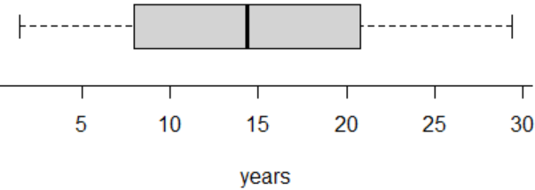  Standard deviation is the average variation of the data from the mean |  | 5 x 2  4
(c) | Cat, Scale, Scale  Scale, Scale, Scale  Cat, Cat | Clustered scatter plot  Bubble plot / marginal plot  Clustered/stacked bar chart | 2  2  2

Question  6 (a) | - Clustered scale plot (boxplot, hist etc.) + t test  - Clustered bar chart + χ² test  - Scatter plot + correlation  - Difference plot + paired t test  - Clustered scale plot (boxplot, hist etc.) + ANOVA | 2 + 2  2 + 2  2 + 2  2 + 2  2 + 2
(b) | Probability plot – line should be straight  Inference test – p value > 0.05 | 1 + 1  1 + 2

