Лабораторна робота №7
з автоматизації проектування комп’ютерних систем
Мазура Романа, ІО-52

Мінімізовані функції
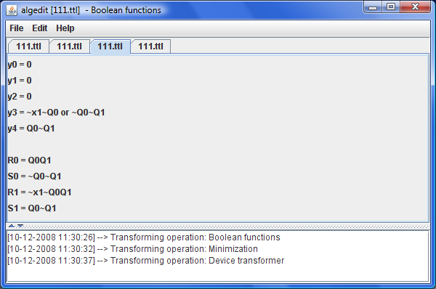

Результат шенерації VHDL-коду.
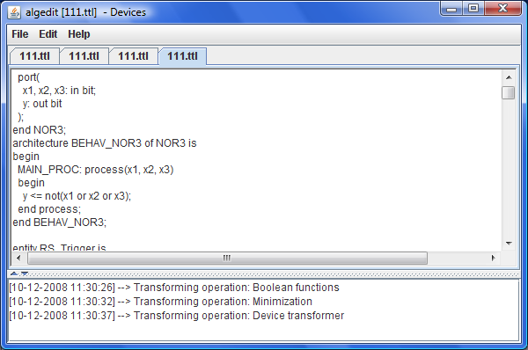
Лістинг (витримки).
/**
*
*/
package org.mazur.algedit.device.util;

import java.util.HashSet;
import java.util.LinkedList;
import java.util.List;
import java.util.Set;

import org.mazur.algedit.device.model.AbstractDevice;
import org.mazur.algedit.device.model.DeviceModel;
import org.mazur.algedit.device.model.Nor;
import org.mazur.algedit.device.model.RSTriger;

/**
* @author Roman Mazur (IO-52)
*
*/
public class DeviceDrawer {
private DeviceModel model;
public DeviceDrawer(final DeviceModel model) {
this.model = model;
}
public static String setToStr(final Set<String> set, final String prefix) {
StringBuilder res = new StringBuilder();
for (String inName : set) {
res.append(inName).append(prefix);
res.append(", ");
}
if (res.length() > 0) { res.delete(res.length() - 2, res.length()); }
return res.toString();
}

@Override
public String toString() {
Set<String> allInputs = new HashSet<String>(), allOutputs = new HashSet<String>(),
allInternals = new HashSet<String>();
List<PortmapInfo> mainPortMaps = new LinkedList<PortmapInfo>();
StringBuilder s = new StringBuilder();
s.append(Nor.baseVHDL());
s.append("\r\n");
s.append(RSTriger.baseVHDL());
s.append("\r\n");
for (AbstractDevice device : model.getMainObject()) {
s.append(device.vhdl());
s.append("\r\n");
PortmapInfo pInfo = device.mainPortMap();
allOutputs.addAll(pInfo.getOutputSet());
allInternals.addAll(pInfo.getInternalSet());
allInputs.addAll(pInfo.getInputsSet());
mainPortMaps.add(pInfo);
}

s.append("entity main is\r\n");
s.append(" port(\r\n");
s.append(" CLK: in bit;\r\n");
s.append(" ").append(setToStr(allInputs, "_in")).append(": in bit;\r\n");
s.append(" ").append(setToStr(allOutputs, "_out")).append(": out bit\r\n");
s.append(" );\r\n");
s.append("end main;\r\n");
s.append("architecture BEHAV_main of main is\r\n");
s.append(" signal ").append(setToStr(allInternals, "_internal")).append(": bit;\r\n");
s.append("begin\r\n");
for (PortmapInfo pInfo : mainPortMaps) {
s.append(pInfo);
}
s.append("end BEHAV_main;\r\n");
return s.toString();
}
}

/**
*
*/
package org.mazur.algedit.transformers;

// …imports

/**
* @author Roman Mazur (IO-52)
*
*/
public class DeviceTransformer implements Transformer<BoolFunctionModel, DeviceModel> {

private int intCounter = 0;

public String getName() {
return "Device transformer";
}

private List<Outable> group(final List<Outable> inputs, boolean k) {
if (inputs.size() == 1) { return inputs; }
List<Outable> result = new LinkedList<Outable>();

if (inputs.size() <= 3) {
Nor nor = new Nor();
nor.setInputs(inputs);
while (nor.getInputs().size() < 3) {
nor.getInputs().add(inputs.get(inputs.size() - 1));
}
nor.setOutName("internal" + intCounter++);
nor.setInternal(true);
if (k) {
result.add(nor);
return result;
}
ArrayList<Outable> ins = new ArrayList<Outable>(3);
ins.add(nor); ins.add(nor); ins.add(nor);
Nor nor2 = new Nor();
nor2.setInputs(ins);
nor2.setOutName("internal" + intCounter++);
nor2.setInternal(true);
result.add(nor2);
return result;
}

int c = 0;
List<Outable> list = null;
for (Outable in : inputs) {
if (c == 0) {
if (list != null) {
result.add(group(list, false).get(0));
}
list = new ArrayList<Outable>(3);
}
list.add(in);
c++;
if (c == 3) { c = 0; }
}
if (c > 0) { result.add(group(list, false).get(0)); }
return group(result, true);
}

private Nor nor(final BoolFunction func) {
if (func.getDisjunction().size() == 0) { return null; }
List<Outable> lastIns = new LinkedList<Outable>();
for (ConjunctionTerm term : func.getDisjunction()) {
List<Outable> inputs = term.getIns();
for (Outable i : inputs) {
((In)i).setInverse(!((In)i).isInverse());
}
lastIns.add(group(inputs, true).get(0));
}
Nor res =(Nor)group(lastIns, false).get(0);
res.setOutName(func.getName() + func.getIndex());
res.setInternal(false);
return res;
}

public DeviceModel transform(final BoolFunctionModel source)
throws TransformException {
List<AbstractDevice> devices = new ArrayList<AbstractDevice>(source.getOutFunctions().size()
+ (source.getTransFunctions().size() >> 1));
for (BoolFunction func : source.getOutFunctions()) {
Nor d = nor(func);
if (d == null) { continue; }
devices.add(d);
}
Iterator<BoolFunction> it = source.getTransFunctions().iterator();
int i = 0;
while (it.hasNext()) {
RSTriger t = new RSTriger();
t.setIndex(i++);
t.setOutName("Q");
t.setR(nor(it.next()));
t.setS(nor(it.next()));
devices.add(t);
}
DeviceModel res = new DeviceModel(source.getName());
res.setMainObject(devices);
return res;
}

}

