Лабораторна робота №5
з автоматизації проектування комп’ютерних систем
Мазура Романа, ІО-52

Побудова таблиці переходів

Початковий граф
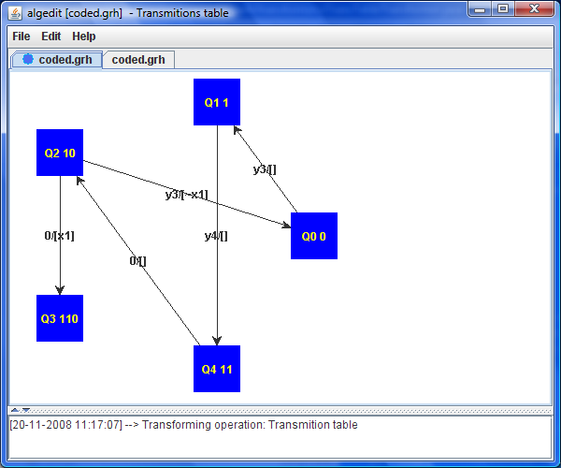

Таблиця переходів
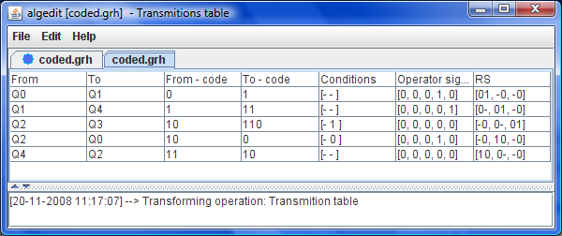
Лістинг (витримки).
/**
*
*/
package org.mazur.algedit.transformers;

import java.util.ArrayList;
import java.util.LinkedList;

import org.mazur.algedit.Transformer;
import org.mazur.algedit.exceptions.TransformException;
import org.mazur.algedit.mili.model.MiliGraphModel;
import org.mazur.algedit.mili.model.MiliTransition;
import org.mazur.algedit.mili.model.MiliVertex;
import org.mazur.algedit.mili.model.MiliTransition.TransmitionCondition;
import org.mazur.algedit.transtable.model.TableRow;
import org.mazur.algedit.transtable.model.TransTableModel;

/**
* @author Roman Mazur (IO-52)
*
*/
public class TransTableTransformer implements Transformer<MiliGraphModel, TransTableModel> {

public String getName() {
return "Transmition table";
}

public TransTableModel transform(final MiliGraphModel source)
throws TransformException {
LinkedList<Entry> entries = new LinkedList<Entry>();
int digitsCount = 0, sCount = 0, cCount = 0;
for (MiliVertex vertex : source.getMainObject()) {
int x = NeighboringCoding.getMinDigitsCount(vertex.getCode());
if (digitsCount < x) { digitsCount = x; }
for (MiliTransition mt : vertex.getOutgoings()) {
Entry entry = new Entry();
entry.row = new TableRow();
entry.transition = mt;
entry.row.setNameFrom("Q" + vertex.getIndex());
entry.row.setNameTo("Q" + mt.getTarget().getIndex());
entry.row.setCodeFrom(vertex.getCode());
entry.row.setCodeTo(mt.getTarget().getCode());
entries.add(entry);
if (sCount < mt.getYSignal()) { sCount = mt.getYSignal(); }
for (TransmitionCondition cond : mt.getConditions()) {
if (cCount < cond.getIndex()) { cCount = cond.getIndex(); }
}
}
}
ArrayList<TableRow> rows = new ArrayList<TableRow>(entries.size());
for (Entry e : entries) {
TableRow row = e.row;
row.setRsFunctions(new TableRow.RSFunction[digitsCount]);
row.setConditionSignals(cCount + 1);
row.setOperatorSignals(sCount + 1);
if (e.transition.getYSignal() >= 0) {
row.getOperatorSignals()[e.transition.getYSignal()] = 1;
}
for (TransmitionCondition cond : e.transition.getConditions()) {
row.getConditionSignals()[cond.getIndex()] = (byte)(cond.isDesc() ? 1 : 0);
}
int old = row.getCodeFrom();
int temp = row.getCodeFrom() ^ row.getCodeTo();
int i = 0;
while (i < digitsCount) {
int oldDigit = old & 1;
if ((temp & 1) == 1) { //changed
row.setRsFunction(i, oldDigit, 1 - oldDigit);
} else {
if (oldDigit == 0) { row.setRsFunction(i, -1, 0); }
else { row.setRsFunction(i, 0, -1); }
}
old >>= 1;
temp >>= 1;
i++;
}
rows.add(row);
}
TransTableModel result = new TransTableModel(source.getName());
result.setMainObject(rows);
result.setCodeDigitsCount(digitsCount);
return result;
}

private static class Entry {
private TableRow row;
private MiliTransition transition;
}
}

