Лабораторна робота №6
з автоматизації проектування комп’ютерних систем
Мазура Романа, ІО-52

Мінімізація функцій

Початкові функції
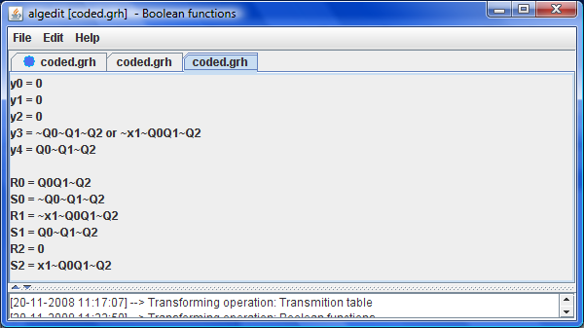

Мінімізовані функції
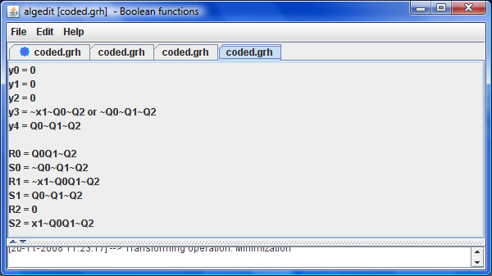
Лістинг (витримки).
/**
*
*/
package org.mazur.algedit.transformers;

import java.util.ArrayList;
import java.util.HashSet;
import java.util.LinkedList;
import java.util.List;

import org.mazur.algedit.Transformer;
import org.mazur.algedit.boolfunc.model.BoolFunction;
import org.mazur.algedit.boolfunc.model.BoolFunctionModel;
import org.mazur.algedit.boolfunc.model.ConjunctionTerm;
import org.mazur.algedit.exceptions.TransformException;

/**
* @author Roman Mazur (IO-52)
*/
public class MinimizationTransformer implements Transformer<BoolFunctionModel, BoolFunctionModel> {

public String getName() {
return "Minimization";
}

private BoolFunction minimize(final BoolFunction func, final String[] names) {
LinkedList<List<ConjunctionTerm>> steps = new LinkedList<List<ConjunctionTerm>>();
ArrayList<ConjunctionTerm> dnf = new ArrayList<ConjunctionTerm>(func.getDisjunction());
steps.push(dnf);
boolean finished = false;
while (!finished) {
List<ConjunctionTerm> terms = steps.peek();
HashSet<ConjunctionTerm> covered = new HashSet<ConjunctionTerm>();
ArrayList<ConjunctionTerm> mergedTerms = new ArrayList<ConjunctionTerm>(terms.size());
for (int i = 0; i < terms.size(); i++) {
ConjunctionTerm t1 = terms.get(i);
for (int j = i + 1; j < terms.size(); j++) {
ConjunctionTerm t2 = terms.get(j);
ConjunctionTerm merged = t1.merge(t2);
if (merged == null) { continue; }
if (t1.isCovered(merged)) { covered.add(t1); }
if (t2.isCovered(merged)) { covered.add(t2); }
mergedTerms.add(merged);
}
}
terms.removeAll(covered);
steps.push(mergedTerms);
finished = mergedTerms.size() == 0;
}
BoolFunction f = new BoolFunction();
f.setIndex(func.getIndex());
f.setName(func.getName());
do {
List<ConjunctionTerm> terms = steps.pop();
for (ConjunctionTerm ct : terms) { ct.recover(names); }
f.getDisjunction().addAll(terms);
} while (!steps.isEmpty());
return f;
}

public BoolFunctionModel transform(final BoolFunctionModel source)
throws TransformException {
BoolFunctionModel result = new BoolFunctionModel(source.getName());
BoolFunctionsTransformer.prepareResult(result, source.getOutFunctions().size(),
source.getTransFunctions().size() >> 1);
String[] names = source.getNames();
for (BoolFunction f : source.getOutFunctions()) {
result.getOutFunctions().set(f.getIndex(), minimize(f, names));
}
int i = 0;
for (BoolFunction f : source.getTransFunctions()) {
result.getTransFunctions().set(i, minimize(f, names));
i++;
}
return result;
}

}

