Лабораторна робота №8
з автоматизації проектування комп’ютерних систем
Мазура Романа, ІО-52

Результат моделювання
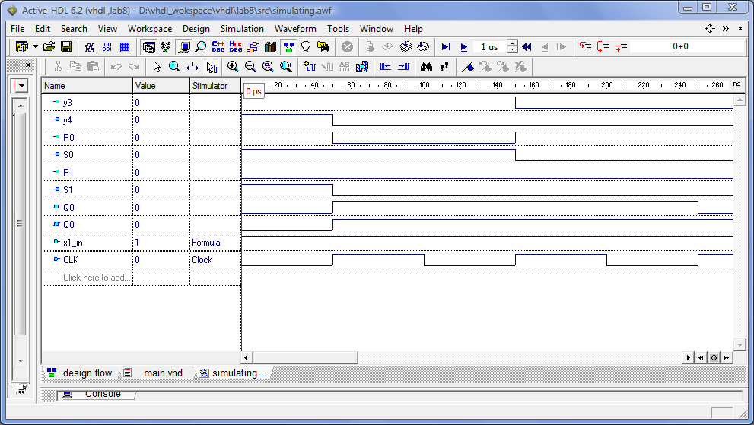

VHDL-код (результат попередньої роботи)

entity NOR3 is
port(
x1, x2, x3: in bit;
y: out bit
);
end NOR3;
architecture BEHAV_NOR3 of NOR3 is
begin
MAIN_PROC: process(x1, x2, x3)
begin
y <= not(x1 or x2 or x3);
end process;
end BEHAV_NOR3;

entity RS_Trigger is
port(
CLK: in bit;
R: in bit := '0';
S: in bit := '0';
Q, nQ: out bit
);
end RS_Trigger;
architecture BEHAV_RS_Trigger of RS_Trigger is
signal Q0: bit := '0';
begin
MAIN_PROC: process(CLK, R, S)
begin
if CLK'event and CLK = '1' then
if R = '1' then Q0 <= '0'; end if;
if S = '1' then Q0 <= '1'; end if;
Q <= Q0;
nQ <= not Q0;
end if;
end process;
end BEHAV_RS_Trigger;

entity y3 is
port(
Q0, Q1, x1: in bit;
y3: out bit
);
end y3;
architecture BEHAV_y3 of y3 is
signal internal2, internal1, internal0: bit;
begin
internal0_entity: entity work.NOR3(BEHAV_NOR3)
port map(
x1 => x1,
x2 => Q0,
x3 => Q0,
y => internal0
);
internal1_entity: entity work.NOR3(BEHAV_NOR3)
port map(
x1 => Q0,
x2 => Q1,
x3 => Q1,
y => internal1
);
internal2_entity: entity work.NOR3(BEHAV_NOR3)
port map(
x1 => internal0,
x2 => internal1,
x3 => internal1,
y => internal2
);
y3_entity: entity work.NOR3(BEHAV_NOR3)
port map(
x1 => internal2,
x2 => internal2,
x3 => internal2,
y => y3
);
end BEHAV_y3;

entity y4 is
port(
Q1, nQ0: in bit;
y4: out bit
);
end y4;
architecture BEHAV_y4 of y4 is
begin
y4_entity: entity work.NOR3(BEHAV_NOR3)
port map(
x1 => nQ0,
x2 => Q1,
x3 => Q1,
y => y4
);
end BEHAV_y4;

entity R0 is
port(
nQ0, nQ1: in bit;
R0: out bit
);
end R0;
architecture BEHAV_R0 of R0 is
begin
R0_entity: entity work.NOR3(BEHAV_NOR3)
port map(
x1 => nQ0,
x2 => nQ1,
x3 => nQ1,
y => R0
);
end BEHAV_R0;

entity S0 is
port(
Q0, Q1: in bit;
S0: out bit
);
end S0;
architecture BEHAV_S0 of S0 is
begin
S0_entity: entity work.NOR3(BEHAV_NOR3)
port map(
x1 => Q0,
x2 => Q1,
x3 => Q1,
y => S0
);
end BEHAV_S0;

entity Q0 is
port(
R_in, S_in, CLK_in: in bit;
Q0: out bit;
nQ0: out bit
);
end Q0;
architecture BEHAV_Q0 of Q0 is
begin
Q_new: entity work.RS_Trigger(BEHAV_RS_Trigger)
port map(
S => S_in, R => R_in, CLK => CLK_in, Q => Q0, nQ => nQ0
);
end BEHAV_Q0;

entity R1 is
port(
Q0, nQ1, x1: in bit;
R1: out bit
);
end R1;
architecture BEHAV_R1 of R1 is
begin
R1_entity: entity work.NOR3(BEHAV_NOR3)
port map(
x1 => x1,
x2 => Q0,
x3 => nQ1,
y => R1
);
end BEHAV_R1;

entity S1 is
port(
Q1, nQ0: in bit;
S1: out bit
);
end S1;
architecture BEHAV_S1 of S1 is
begin
S1_entity: entity work.NOR3(BEHAV_NOR3)
port map(
x1 => nQ0,
x2 => Q1,
x3 => Q1,
y => S1
);
end BEHAV_S1;

entity Q1 is
port(
R_in, S_in, CLK_in: in bit;
Q1: out bit;
nQ1: out bit
);
end Q1;
architecture BEHAV_Q1 of Q1 is
begin
Q_new: entity work.RS_Trigger(BEHAV_RS_Trigger)
port map(
S => S_in, R => R_in, CLK => CLK_in, Q => Q1, nQ => nQ1
);
end BEHAV_Q1;

entity main is
port(
CLK: in bit;
x1_in: in bit;
y3_out, y4_out: out bit
);
end main;
architecture BEHAV_main of main is
signal Q0_internal, Q1_internal, nQ0_internal, nQ1_internal, S1_internal, R1_internal, S0_internal, R0_internal: bit;
begin
y3_entity: entity work.y3(BEHAV_y3)
port map(
Q0 => Q0_internal,
Q1 => Q1_internal,
x1 => x1_in,
y3 => y3_out
);
y4_entity: entity work.y4(BEHAV_y4)
port map(
Q1 => Q1_internal,
nQ0 => nQ0_internal,
y4 => y4_out
);
R0_entity: entity work.R0(BEHAV_R0)
port map(
nQ0 => nQ0_internal,
nQ1 => nQ1_internal,
R0 => R0_internal
);
S0_entity: entity work.S0(BEHAV_S0)
port map(
Q0 => Q0_internal,
Q1 => Q1_internal,
S0 => S0_internal
);
Q0_entity: entity work.Q0(BEHAV_Q0)
port map(
CLK_in => CLK,
R_in => R0_internal,
S_in => S0_internal,
Q0 => Q0_internal,
nQ0 => nQ0_internal
);
R1_entity: entity work.R1(BEHAV_R1)
port map(
Q0 => Q0_internal,
nQ1 => nQ1_internal,
x1 => x1_in,
R1 => R1_internal
);
S1_entity: entity work.S1(BEHAV_S1)
port map(
Q1 => Q1_internal,
nQ0 => nQ0_internal,
S1 => S1_internal
);
Q1_entity: entity work.Q1(BEHAV_Q1)
port map(
CLK_in => CLK,
R_in => R1_internal,
S_in => S1_internal,
Q1 => Q1_internal,
nQ1 => nQ1_internal
);
end BEHAV_main;

