Лабораторна робота №4
з автоматизації проектування комп’ютерних систем
Мазура Романа, ІО-52

Сусіднє кодування.

Початковий граф
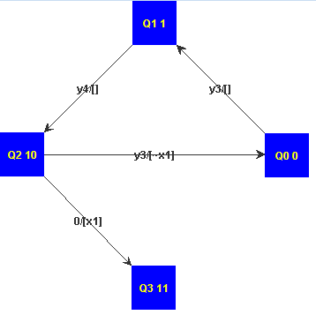
Граф після сусіднього кодування
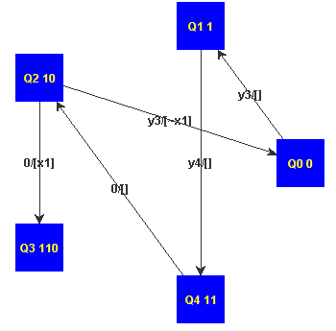

Початковий граф
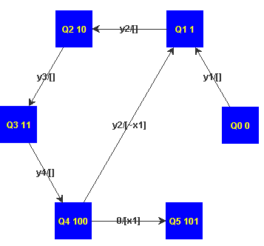
Граф після сусіднього кодування
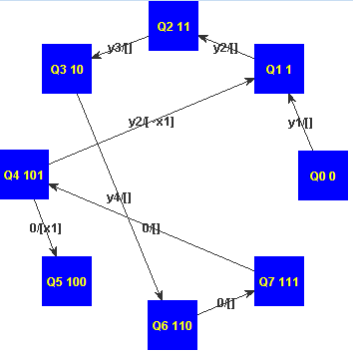
Лістинг (витримки).
/**
*
*/
package org.mazur.algedit.transformers;

import java.util.ArrayList;
import java.util.Collections;
import java.util.HashSet;
import java.util.List;

import org.mazur.algedit.Transformer;
import org.mazur.algedit.exceptions.TransformException;
import org.mazur.algedit.mili.model.MiliGraphModel;
import org.mazur.algedit.mili.model.MiliTransition;
import org.mazur.algedit.mili.model.MiliVertex;

/**
* @author Roman Mazur (IO-52)
*
*/
public class NeighboringCoding implements Transformer<MiliGraphModel, MiliGraphModel> {

/** Max count of digits. */
private static final int MAX_DIGITS = 6;

private Template currentTemplate;
private MiliGraphModel result;
private HashSet<MiliVertex> visited = null;

private int futureCount = 0;

public String getName() {
return "Neigboring coding";
}

public static int getMinDigitsCount(final int vCount) {
if (vCount == 0) { return 0; }
int v = vCount;
int res = 0;
while ((v & (1 << 31)) == 0) { v <<= 1; res++; }
return 31 - res;
}

private void setVertexToResult(final MiliVertex mv) {
if (mv.getIndex() < result.getMainObject().size()) {
result.getMainObject().set(mv.getIndex(), mv);
} else {
result.getMainObject().add(mv);
}
}

private MiliVertex getVertexFromResult(final int index) {
if (index < result.getMainObject().size()) {
return result.getMainObject().get(index);
}
return null;
}

private void saveVertexPosition(final MiliVertex vertex, final int number, final List<Integer> outNumbers) {
MiliVertex v = getVertexFromResult(vertex.getIndex());
if (v == null) {
v = new MiliVertex();
v.setIndex(vertex.getIndex());
setVertexToResult(v);
}
v.setCode(currentTemplate.codes[number]);
int index = 0;
for (MiliTransition mt : vertex.getOutgoings()) {
MiliTransition newMt = new MiliTransition();
MiliVertex dest = getVertexFromResult(mt.getTarget().getIndex());
if (dest == null) {
dest = new MiliVertex();
dest.setIndex(mt.getTarget().getIndex());
dest.setCode(currentTemplate.codes[outNumbers.get(index)]);
}
newMt.setSource(v);
newMt.setTarget(dest);
newMt.setConditions(mt.getConditions());
newMt.setYSignal(mt.getYSignal());
setVertexToResult(dest);
v.getOutgoings().add(newMt);
index++;
}
}

private boolean isNeighbore(final int c1, final int c2) {
int temp = c1 ^ c2;
int res = 0;
while (temp != 0) {
res += (temp & 1);
temp >>= 1;
}
return res == 1;
}

private MiliTransition getResultTransition(final MiliVertex from, final MiliVertex to) {
MiliVertex rFrom = result.getMainObject().get(from.getIndex());
for (MiliTransition t : rFrom.getOutgoings()) {
if (t.getTarget().getIndex() == to.getIndex()) { return t; }
}
return null;
}

private boolean setVertex(final int templateVertexNumber, final MiliTransition transition, final MiliVertex vertex) {
if (visited.contains(vertex)) {
return isNeighbore(result.getMainObject().get(vertex.getIndex()).getCode(), transition.getSource().getCode());
}
visited.add(vertex);
System.out.println(vertex);
List<Integer> templateVertexNumbers = currentTemplate.findNeighborePlace(templateVertexNumber);
int presentCount = 0;
for (MiliTransition mt : vertex.getOutgoings()) {
if (visited.contains(mt.getTarget())) { presentCount++; }
}
if (templateVertexNumbers.size() < vertex.getOutgoings().size() - presentCount) {
visited.remove(vertex);
return false;
}
saveVertexPosition(vertex, templateVertexNumber, templateVertexNumbers);
int index = 0;
HashSet<MiliVertex> setted = new HashSet<MiliVertex>();
for (MiliTransition mt : vertex.getOutgoings()) {
boolean visit = visited.contains(mt.getTarget());
int rotateCnt = 0;
boolean success;
do {
currentTemplate.configureMask(templateVertexNumbers, vertex.getOutgoings().size());
int number = -1;
if (!visit) { number = templateVertexNumbers.get(index); }
success = setVertex(number, getResultTransition(vertex, mt.getTarget()), mt.getTarget());
if (!success && !visit) { Collections.rotate(templateVertexNumbers, 1); rotateCnt++; }
} while (!success && !visit && rotateCnt < templateVertexNumbers.size());
if (!success) {
currentTemplate.configureMask(templateVertexNumbers, 0);
visited.removeAll(setted);
visited.remove(vertex);
if (futureCount < currentTemplate.codes.length) {
futureCount++;
MiliVertex additionalVertex = new MiliVertex();
additionalVertex.setIndex(futureCount - 1);
MiliVertex temp = new MiliVertex();
temp.setIndex(additionalVertex.getIndex());
if (futureCount < result.getMainObject().size()) {
result.getMainObject().set(temp.getIndex(), temp);
} else {
result.getMainObject().add(temp);
}
transition.setTarget(temp);
MiliTransition t = new MiliTransition();
t.setTarget(vertex);
additionalVertex.getOutgoings().add(t);
if (!setVertex(templateVertexNumber, transition, additionalVertex)) {
futureCount--;
result.getMainObject().remove(additionalVertex.getIndex());
return false;
}
return true;
}
result.getMainObject().remove(vertex.getIndex());
return false;
}
setted.add(mt.getTarget());
if (!visit) { index++; }
}
return true;
}

private MiliGraphModel t(final MiliGraphModel source) throws TransformException {
int count = NeighboringCoding.getMinDigitsCount(source.getMainObject().size());
MiliTransition transition = new MiliTransition();
MiliVertex vertex = source.getMainObject().get(0);
transition.setTarget(vertex);
boolean done = false;
result = new MiliGraphModel(source.getName());
visited = new HashSet<MiliVertex>();
while (!done && count < NeighboringCoding.MAX_DIGITS) {
currentTemplate = new Template(count);
visited.clear();
result.setMainObject(new ArrayList<MiliVertex>(source.getMainObject().size()));
futureCount = source.getMainObject().size();
done = setVertex(0, transition, vertex);
if (!done) {
result.setMainObject(new ArrayList<MiliVertex>(source.getMainObject().size()));
futureCount = source.getMainObject().size();
visited.clear(); done = setVertex(1, transition, vertex);
}
count++;
}
if (done) { return this.result; }
throw new TransformException("Too many vertexes.");
}

public MiliGraphModel transform(MiliGraphModel source) throws TransformException {
return new NeighboringCoding().t(source);
}

private class Template {
private int dCount;
private int[] codes = null;
private boolean[] mask = null;
private int[][] connectivity = null;
private void setConnection(final int i, final int j, final int x) {
connectivity[i][j] = (connectivity[j][i] = x);
}
private Template(final int dCount) {
this.dCount = dCount;
int size = 1 << dCount;
codes = new int[size];
mask = new boolean[size];
connectivity = new int[size][size];

for (int i = 0; i < size; i++) {
codes[i] = i ^ (i >> 1);
mask[i] = false;
}
for (int i = 0; i < size >> 1; i++) {
int s = i << 1;
int inc = s;
for (int j = 0; j < dCount; j++) {
inc += 1 << j;
inc %= size;
setConnection(s, inc, 1);
}
}
}
public void configureMask(List<Integer> code, int outsCount) {
for (int i = 0; i < code.size(); i++) {
mask[code.get(i)] = i < outsCount;
}
}

public List<Integer> findNeighborePlace(final int templateVertexNumber) {
int touchedCount = 0;
mask[templateVertexNumber] = true;
List<Integer> res = new ArrayList<Integer>(dCount);
for (int i = 0; i < connectivity.length && touchedCount < dCount; i++) {
if (connectivity[templateVertexNumber][i] == 1) {
touchedCount++;
if (!mask[i]) {
res.add(i);
}
}
}
return res;
}
}
}

