Лабораторна робота №3
з автоматизації проектування комп’ютерних систем
Мазура Романа, ІО-52

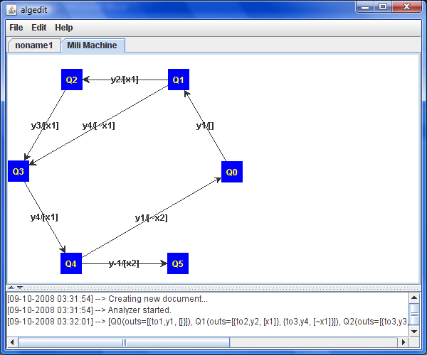

Лістинг (витримки).

package org.mazur.algedit.utils;

import java.util.HashMap;
import java.util.LinkedList;
import java.util.List;

import org.mazur.algedit.alg.AbstractVertex;
import org.mazur.algedit.alg.BeginVertex;
import org.mazur.algedit.alg.ConditionVertex;
import org.mazur.algedit.alg.EndVertex;
import org.mazur.algedit.alg.VertexType;
import org.mazur.algedit.mili.MiliTransmition;
import org.mazur.algedit.mili.MiliVertex;

/**
* @author Roman Mazur (IO-52)
*
*/
public class GraphTransformer {

/** Next vertex code. */
private int nextVertexCode = 0;

public List<MiliVertex> toMiliGraph(final BeginVertex begin) {
final LinkedList<MiliVertex> result = new LinkedList<MiliVertex>();
Crawler crawler = new Crawler(begin, new AbstractCrawlHandler() {
private Crawler c;
private LinkedList<ConditionPair> alts = new LinkedList<ConditionPair>();
private HashMap<AbstractVertex, MiliVertex> beforeVertexes = new HashMap<AbstractVertex, MiliVertex>();
private MiliVertex lastMiliVertex;
private AbstractVertex lastVertex;
private ConditionVertex lastCondition;

private void add(final AbstractVertex v) {
System.out.println("lastCond = " + lastCondition);
add(v, lastCondition);
}

private void add(final AbstractVertex v, final ConditionVertex cond) {
MiliVertex mv = new MiliVertex();
mv.setCode(nextVertexCode++);
result.add(mv);
System.out.println("before " + lastMiliVertex);
if (lastMiliVertex != null) {
MiliTransmition t = new MiliTransmition();
t.setSource(lastMiliVertex);
t.setTarget(mv);
if (v.getType() == VertexType.OPERATOR) {
t.setYSignal(v.getSignalIndex());
}
if (cond != null) {
t.addCondition(cond.getSignalIndex(), cond == lastCondition);
}
lastMiliVertex.getOutgoings().add(t);
}
beforeVertexes.put(v.getStraightVertex(), mv);
lastMiliVertex = mv;
System.out.println("after " + lastMiliVertex);
}

@Override
public void processVertex(AbstractVertex v) {
if (v.getType() == VertexType.CONDITION) {
lastCondition = (ConditionVertex)v;
} else {
if (lastVertex == null || lastVertex.getType() != VertexType.CONDITION) { lastCondition = null; }
}
if (v instanceof BeginVertex || v.getType() == VertexType.OPERATOR) {
add(v);
return;
}
if (v instanceof EndVertex) {
if (!beforeVertexes.containsKey(v)) { add(v); }
return;
}
lastVertex = v;
}
@Override
public void processCondition(ConditionVertex v) {
alts.push(new ConditionPair(v, lastMiliVertex));
}
@Override
public void newBrunch(AbstractVertex v) {
ConditionPair cp = alts.pop();
lastMiliVertex = cp.prev;
MiliVertex target = beforeVertexes.get(v);
if (target != null) {
MiliTransmition t = new MiliTransmition();
t.setSource(lastMiliVertex);
t.setTarget(target);
if (v.getType() == VertexType.OPERATOR) {
t.setYSignal(v.getSignalIndex());
}
t.addCondition(cp.cv.getSignalIndex(), false);
lastMiliVertex.getOutgoings().add(t);
lastMiliVertex = target;
} else {
add(v, cp.cv);
}
}
@Override
public void setCrawler(Crawler c) {
this.c = c;
}
});
crawler.crawl();
return result;
}

private class ConditionPair {
private ConditionVertex cv;
private MiliVertex prev;
public ConditionPair(final ConditionVertex cv, final MiliVertex prev) {
this.cv = cv;
this.prev = prev;
}
}

}

