Lab 2

HTML Table and Form

1. Generate following table using appropriate HTML tags and elements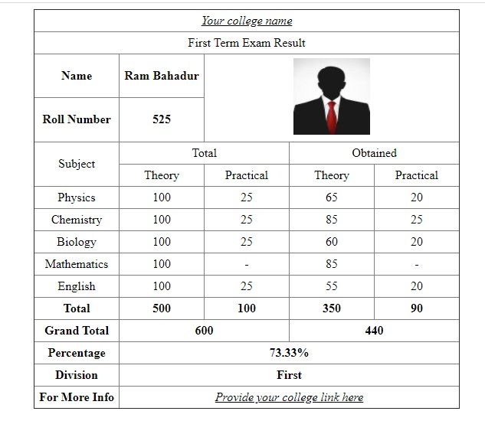
2. Use HTML elements to prepare the following page. 