* **Display feature points**.

Red circles are displayed on the face at the positions of the face features. The circles are rendered using the context.arc function.

* **Display dominant emoji**.

First, I loop over all features and find the feature points with min and max X,Y coordinates. The dominant emoji is displayed at the point with (maxX, minY) coordinates. The size of the emoji font is equal to 1/3 of (maxX – minX). Emojis are displayed using the context.fillText function.

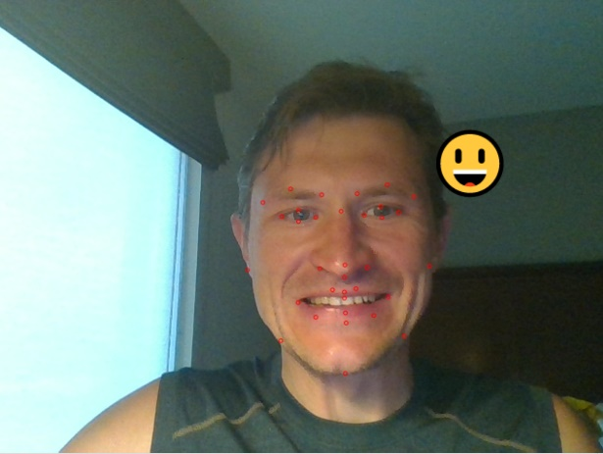

* **Show random emoji to mimic**.

A random emoji is obtained and set in the function getRandomEmoji. A random number between 0 and (emojis.length – 1) is generated and used as an index to the emoji array. The target emoji is displayed on the page in the updateGame function.

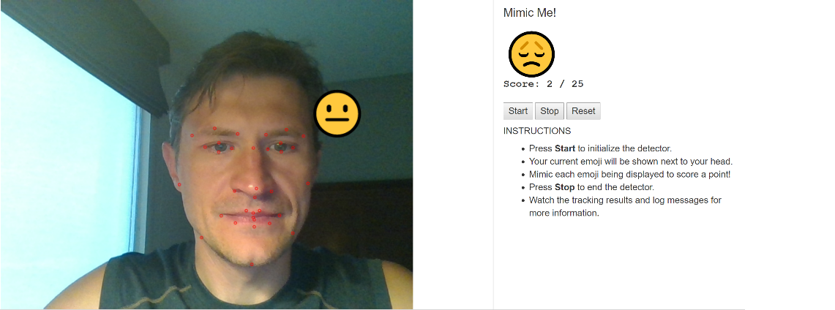

* **Match with current player expression**.

The function updateGame checks the player’s facial expression and if it matches the target emoji, the function increments the Correct counter.

* **Reset and shows a new emoji**:

This is also done in the function updateGame. Also, the timeout for a current target emoji is 5 seconds: if the player cannot mimic the current target emoji, a new random emoji is generated and shown.

The function initGame initializes/resets the state of the game: resets the global variables (Correct, Total, Emoji) and sets the timeout function, updateEmoji. It is called in the Start and Reset button handlers.