Author: Bonnie Lau

WSIB

CLaims journey to the Cloud onboarding

# Introduction

***Welcome to the Claims Journey to the Cloud!***

*We are genuinely delighted to have you join us on this exciting venture. This program is a cornerstone of our ongoing transformation efforts in the claims sector. Your expertise, creativity, and dedication are essential to realizing our vision and delivering impactful results.*

*During your onboarding process, you'll be introduced to the key objectives, milestones, and team members you'll be working closely with. We'll ensure you have the necessary tools, resources, and support to smoothly integrate into your role and start contributing to the project immediately.*

*Our mission is to foster a collaborative and inclusive environment where every idea and effort is valued. We believe that your unique skills and perspective will greatly enhance our team. We look forward to achieving great things together.*

*In the following onboarding program, we'll delve into the foundational concepts of technology transformation to the cloud. You'll gain a clear understanding of what moving to the cloud entails, key development concepts, a fundamental understanding on the importance of testing, what is testing and its role in ensuring a quality product is delivered to the marketplace and much more. We'll explore key benefits for going to the cloud including scalability, which allows systems to grow and manage increasing demands seamlessly. You'll learn about cost efficiency, as cloud technology enables pay-as-you-go models that optimize spending. We hope you are excited as we are to have you!*

***Welcome aboard!***

*-Siobhan de Graaf, VP of Claims Transformation*

Contents

Introduction 1

Understanding key concepts 3

What is a program? 3

How is a program different from a project? 3

Why does this matter? 3

What is the cloud? 3

Some ways the cloud is used: 3

Why does this matter? 4

What is Guidewire? 4

How did we get here? (Bonnie) 4

Previous programs prior to Claims Journey to the Cloud 4

Why was the program started? 5

Current projects underway in the program 5

How projects fit together 6

Introduction to project processes 6

Proposed Onboarding Reading Schedule 7

# Understanding key concepts

[Claims Journey Program WIP - Target Operating Model - Draft.pptx](https://wsib-my.sharepoint.com/:p:/g/personal/bonnie_lau_wsib_on_ca/EZQmuEvJErdBsRL9dnQpwrQBCVosFA3Gm__xGdyjQAW5Dg?e=EYbANT)

[Claims Journey Program WIP - Target Operating Model - Draft.pptx](https://wsib-my.sharepoint.com/:p:/g/personal/bonnie_lau_wsib_on_ca/EZQmuEvJErdBsRL9dnQpwrQBCVosFA3Gm__xGdyjQAW5Dg?e=EYbANT)

[Hello test test test](https://www.fhfgear.com/?srsltid=AfmBOoqQW8i8jAqqovRIl8YLA5cTiPOd8Os7BxBfhgMebTJAPLlfE9Zl)

This section provides *foundational* knowledge to understanding what a ***program*** is for those new to project work and a brief introduction the main technology .

## What is a program?

A program is like a big *umbrella* that covers several related projects. These projects all work together toward a larger, long-term goal. Think of it as a big roadmap for transformation. For example, the Claims Journey to the ~~Cloud program involves multiple pro~~jects (like migrating data, training employees, and improving processes) to improve how claims are managed.

### How is a program different from a project?

* **Program:**  Focuses on the big picture and long-term outcomes (e.g., transforming claims processes using the cloud).
* **Project:** Focuses on a specific deliverable within a set timeline (e.g., migrating claims data to the cloud).

### Why does this matter?

Programs help ensure that all the moving parts (projects) align to achieve broader business goals, such as better customer experiences and more efficient operations.

## What is the cloud?

The "cloud" refers to servers and services that are accessed over the internet instead of being stored on your local computer or company’s on-site servers. It’s like renting a giant online storage space where you can store, process, and manage data and applications without worrying about hardware.

When people talk about "going to the cloud," it means they are using online services instead of keeping everything on their own computers/phones/devices.

### Some ways the cloud is used:

* **Storage:** Save files, databases, and backups in a secure and scalable location. Many of us already use the cloud in personal lives, whether it be Dropbox, Google Drive or iCloud. All of these examples, enable us to securely save files online (i.e. documents, photos).
* **Processing power:** Run applications and perform tasks without needing powerful hardware on-site. Instead of installing programs on your computer, you can use these programs/applications virtually. Think Google Sheets or Microsoft Word, where as the user, you can use these programs without downloading them. You just simply click on the icon and can start working virtually.
* **Collaboration:** Teams can access files and tools from anywhere, making remote work seamless.

### Why does this matter?

Using the cloud allows organizations to:

* **Be flexible:** Scale up or down based on needs.
* **Save costs:** Reduce expense for on-site servers and maintenance.
* **Increase security:** Protect data with advanced encryption and access controls.
* **Improve accessibility:** Enable employees to work and access data from anywhere

## What is Guidewire?

Guidewire is a comprehensive software platform designed specifically for property and casualty (P&C) insurers to manage their core operations, including claims, policy administration, and billing. At WSIB, we refer to Guidewire’s suite of products (ClaimCenter, BillingCenter, PolicyCenter) as **ACES**.

Throughout this document:

* **Guidewire** refers to the vendor partner at WSIB that provides the software.
* Guidewire ClaimCenter refers to the software that powers the claims management system in ACES. It helps us manage the entire claims lifecycle, from initial claim intake and registration to closure.

At WSIB, Guidewire ClaimCenter has been highly customized to address the unique needs of worker’s compensation claims.

# How did we get here? *(Bonnie)*

This section aims to contextualize how we got to where we are today.

## Previous programs prior to Claims Journey to the Cloud

WSIB has been on journey to understand how they can better serve employers and injured workers within Ontario, through leveraging different technologies. Through the past decade, WSIB has come a long way.

**From 2014 – 2017**, WSIB embarked on a program known as ACES *()* successfully migrated onto the Guidewire Suite of products – simply put, WSIB committed to using Guidewire as the foundational technology to how business is run; using guidewire to manage claims, employer accounts, and different billing functions.

**From 2018-2021** – WSIB embarked on a program known as Core Modernization Services (CSM for short). The goal of this program was to move Claimcenter to the Cloud. However, due to “xx”, the program was not successful in moving Claimcenter to the Cloud.

**Now** – WSIB is now committing to making it easier for to receive Guidewire updates by moving to the cloud along with co-creating a product that is based on Worker’s insurance. Hence, the raison-d’etre for **Claims journey to the Cloud.**

## Why was the program started?

Claims Journey to the Cloud started because:

1. WSIB wants to modernize our legacy (old) systems
2. WSIB wants to be on a product that is geared towards Worker’s insurance; we realize that we weren’t able to take advantage of the new innovations guidewire was introducing because we weren’t on the cloud. Simply put, because ACES is so customized, moving to the cloud was complex
3. WSIB wants to move to the cloud.
4. WSIB wants to look internally at our own processes and reimagine what is possible within the confines of certain boundaries

For more information on what exactly Claims Journey to the Cloud is and particularly what the program entails, please go to this section

## Current projects underway in the program

There are quite a few initiatives that are underway as part of this program. Below are a few pieces of work that we will deliver as part of this program that are currently underway.

**Return to Work Scheduler and Email Automation**

There are two projects that will be delivered in 2025 as quick wins for the program. These two initiatives include:

1. Improving the experience of a scheduling tool for employers, employees and internal WSIB staff (See Return to Work Scheduler)
2. Creating a more efficient way for Employers to receive documents from WSIB (See email Automation

**Process and Service Redesign**

Our program is working to make things better for our customers and improve how we do things inside WSIB.

*Digital and Customer Experience*

This stream is about understanding the customer to create a better experience for them. Some of the activities in this stream of work include; research and interviews to be able to design a better experience for our employers and injured workers. ((see more in xx for more details)

*Process Design*

**Process Design** about figuring out how we can make our own processes better and match them with the Guidewire product. We use the research from Stream 1 to help us find the best way to create new processes. ((see more in xx for more details)

**Strategic Partnership with Guidewire**

A strategic partnership with guidewire to understand how they can tailor their product to be more geared towards worker’s compensation. This is the precursor and prerequisite for Co-innovation with Guidewire. (see more in xx for more details)

Co-Innovation with Guidewire

This is a joint-partnership with guidewire where guidewire will develop their product to cater to worker’s compensation organizations and companies (see more in xx for more details)

## How projects fit together

Each project is a piece of the puzzle, and when they all come together, they create a wholistic picture of the program.

Digital and Customer experience is the research that feeds into service design and process design. Process design will help inform the co-innovation work that will be completed with guidewire.

# Introduction to project processes

This section provides an overview of how projects work within the Claims Journey to the Cloud program. It explains the key stages of a project lifecycle, the roles involved, and the tools you’ll use to collaborate effectively. Even if you’re new to project work, this guide will help you understand how your contributions fit into the bigger picture.  
How projects work

Projects are structured efforts designed to achieve specific outcomes within a defined timeframe. In the Claims Journey to the Cloud program, projects are the building blocks of the overall transformation. Here are the typical stages of a project lifecycle:

**Initiation**

* + Define the project’s objectives and scope.
* Identify stakeholders and gather initial requirements.
* Example: Setting goals for migrating claims data to the cloud.

**Planning**

* Create a detailed plan outlining timelines, deliverables, and resources.
* Identify risks and dependencies.
* Example: Developing a step-by-step roadmap for training employees on Guidewire ClaimCenter.

**Execution**

* Carry out project tasks according to the plan.
* Collaborate across teams to deliver key milestones.
* Example: Configuring Guidewire to align with WSIB’s worker’s compensation requirements.

**Monitoring and Controlling:**

* Track progress, resolve issues, and ensure the project stays on schedule and within scope.
* Adjust plans as needed based on feedback and performance metrics.
* Example: Addressing challenges during system testing phases.

**Closure**

* Complete final deliverables and hand over results.
* Conduct a project review to capture lessons learned.
* Example: Finalizing the migration of claims data and documenting insights for future projects.

*Organization Structure (Business)*

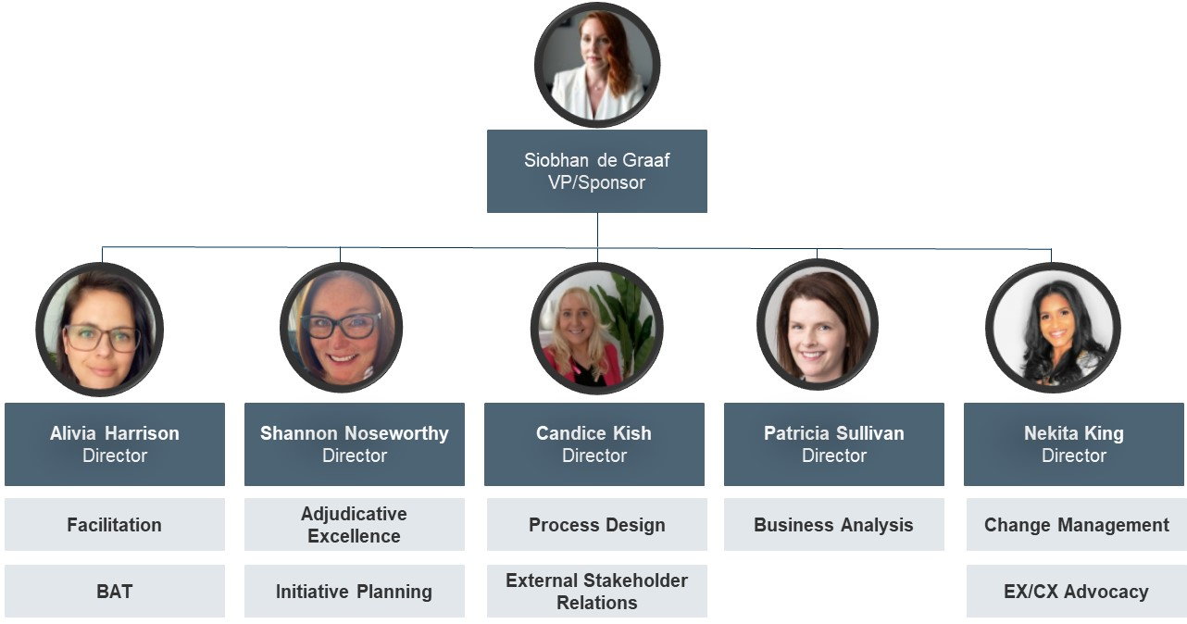

[Claims Journey Program WIP - Target Operating Model - Draft.pptx](https://wsib-my.sharepoint.com/:p:/g/personal/bonnie_lau_wsib_on_ca/EZQmuEvJErdBsRL9dnQpwrQBCVosFA3Gm__xGdyjQAW5Dg?e=EYbANT)

# Proposed Onboarding Reading Schedule

|  |  |  |  |
| --- | --- | --- | --- |
| **Item** | **Link** | **Description** | **Onboarding Schedule** |
| GW Strategic Partnership SOW | [Guidewire SOW](https://wsib-my.sharepoint.com/personal/bonnie_lau_wsib_on_ca/Documents/Guidewire%25252520SOW.pdf) | The SOW for the Partnership including key deliverables, dates and financial deadlines | Week 1- Day 2 |
| Functionality and Domains | [Domains](https://wsib.sharepoint.com/sites/projects/CJ/Shared%25252520Documents/Forms/AllItems.aspx?id=/sites/projects/CJ/Shared%25252520Documents/GW%25252520Zoom%25252520Recording/Business%25252520Sessions&viewid=db3c8015-dd41-47e7-b040-b89d258fa75a) | This includes all sessions the Business SMEs conducted with Guidewire to help them understand 1) current state and 2) known future state. Please note: these are **NOT** requirements | Week 1- Day 2 |
| GW Strategic Partnership Deliverables | [Sharepoint](https://wsib.sharepoint.com/sites/projects/CJ/Shared%25252520Documents/Forms/AllItems.aspx?id=/sites/projects/CJ/Shared%25252520Documents/GW%25252520Deliverables&viewid=db3c8015-dd41-47e7-b040-b89d258fa75a) | This includes the deliverables Guidewire is delivering for the strategic partnership. This will directly inform co-innovation partnership. | Week 1- Day 3 |
| Claims Journey to the Cloud – Governance | [Governance](https://wsib.sharepoint.com/:p:/s/projects/CJ/ESHso4ZpeY1KqHb9KcQGTQQBrhSXTS9WOtTQeYD4HU4scw?e=MtpogU) | This is the proposed governance model that still needs final approval. | Week 1- Day 4-5 |
| TOM Draft Model | [Claims Journey Program WIP - Target Operating Model - Draft.pptx](https://wsib-my.sharepoint.com/:p:/g/personal/bonnie_lau_wsib_on_ca/EZQmuEvJErdBsRL9dnQpwrQBCVosFA3Gm__xGdyjQAW5Dg?e=EYbANT) | This is a Draft Target Operating Model that is attached to demonstrate the concepts involved. | Week 1- Day 4-5 |