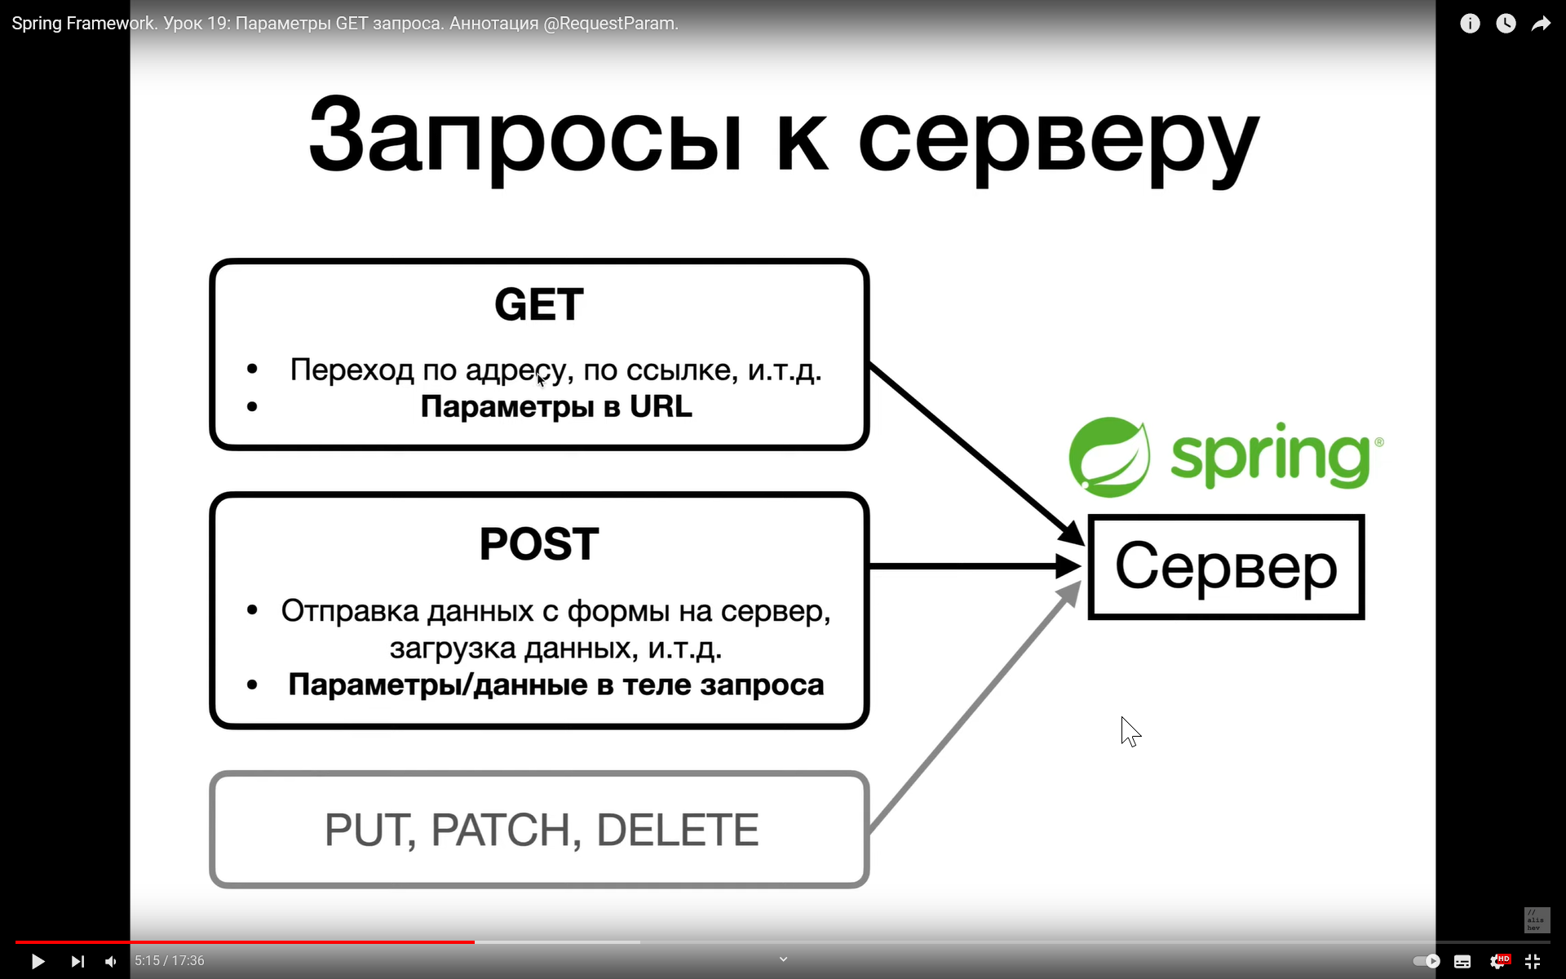

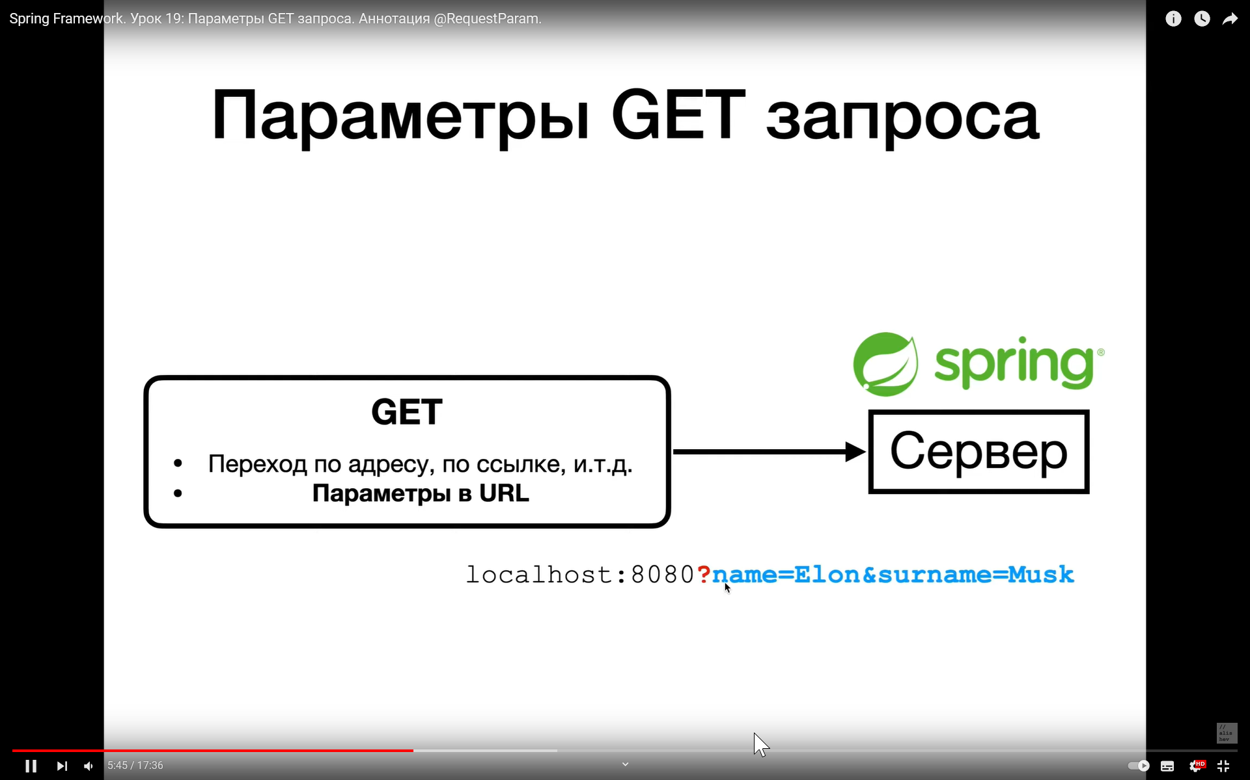

# Fragen

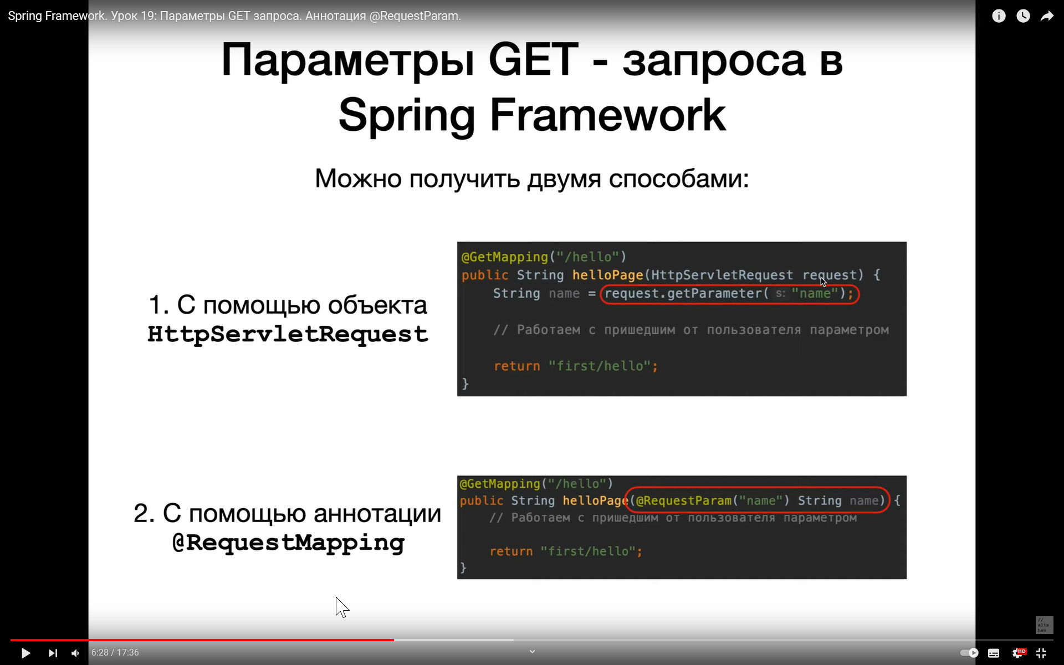

Wie werden die Parameter Get Request in dem spring Framework erhalten. Wir bekomen den Wert des Parameters aus dem get Request.

1. Mit dem Objekt HttpServletRequest
2. Mit der Annotation @RequestMapping



?name=Tom&surname=Janes

Die Annotation RequestParam wartet, dass wir in der URL die Parameter übergeben und wenn es diese Parameter in der URL nicht gibt, ruft diese Anotation den Fehler auf. Ansonsten muss man

required = false schreiben

This controller is concise and simple, but there is plenty going on. We break it down step by step.

The @GetMapping annotation ensures that HTTP GET requests to /greeting are mapped to the greeting() method.

[@RequestParam](https://docs.spring.io/spring/docs/current/javadoc-api/org/springframework/web/bind/annotation/RequestParam.html) binds the value of the query string parameter name into the name parameter of the greeting() method. This query string parameter is not required. If it is absent in the request, the defaultValue of World is used. The value of the name parameter is added to a [Model](https://docs.spring.io/spring/docs/current/javadoc-api/org/springframework/ui/Model.html) object, ultimately making it accessible to the view template.

The implementation of the method body relies on a view technology (in this case, [Thymeleaf](http://www.thymeleaf.org/doc/tutorials/2.1/thymeleafspring.html)) to perform server-side rendering of the HTML. Thymeleaf parses the greeting.html template and evaluates the th:text expression to render the value of the ${name} parameter that was set in the controller.The following listing (from src/main/resources/templates/greeting.html) shows the greeting.html template:

