ROMANCHAM
Complete Operating Guide
From Vendor & Item Master to P&L — with a worked café example and full module linkage
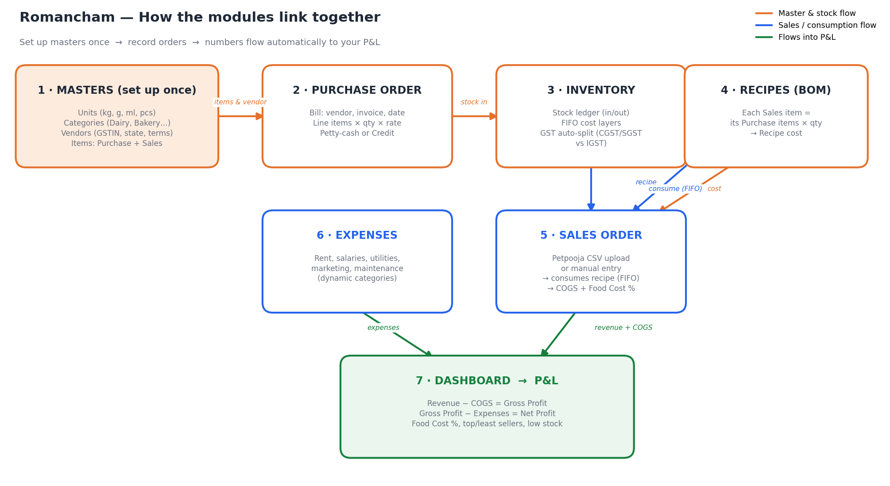

The one-line summary
Set up your masters once (Units, Categories, Vendors, Items). After that you only record two kinds of orders — Purchases (stock in) and Sales (stock out) — and every number you need (stock value, food cost %, gross profit, net profit) is calculated for you and shown on the Dashboard / P&L.

0. How it all connects (read this first)
Romancham is built as a chain. Each module feeds the next, so you never type the same number twice:
Module | What it does & where its data goes
1. Masters | Your reference lists — Units, Categories, Vendors and Items. Everything else picks from these.
2. Purchase order | You record a supplier bill. This adds stock and remembers what you paid (the cost).
3. Inventory | Auto-updated from purchases using FIFO. Also splits GST into CGST/SGST or IGST.
4. Recipes (BOM) | You define what each menu item is made of. This turns purchase costs into a per-dish cost.
5. Sales order | You upload the POS CSV (or enter manually). This consumes stock via the recipe and computes COGS.
6. Expenses | Your running costs (rent, salaries, etc.).
7. Dashboard / P&L | Pulls Revenue (Sales) − COGS (Recipes×Sales) = Gross Profit, minus Expenses = Net Profit.

The golden rule of setup order
Build masters top-down: Units → Categories → Vendors → Items → Recipes. An Item needs a Unit and Category to exist first; a Recipe needs its Items first; a Purchase needs a Vendor and Items first. Follow the order and nothing will be missing when you need it.

The worked example we’ll follow
To make the linkage concrete, we’ll set up one small café and follow its numbers all the way to a monthly P&L.
Detail | Value
Business | Strictly Desserts — café, Anna Nagar, Chennai
GST state code | 33 (Tamil Nadu)
Menu (Sales items) | Cappuccino – sold at ₹120 · Chocolate Brownie – sold at ₹150
Buys from (Vendor) | Chennai Fresh Supplies (also state 33 → CGST + SGST)
Operating days / month | 26

Step 1 · Units of Measure (UOM)
Units are how you count things. Create the base units you buy and cook in. Go to Units (UOM) → type a name + short form → Add.
Unit | Short
Kilogram | kg
Gram | g
Litre | ltr
Millilitre | ml
Pieces | pcs
Tip: buy in big units (kg, ltr) but cook in small units (g, ml). Romancham converts between them, so a recipe using “150 ml” correctly draws down stock you bought in litres.

Step 2 · Categories
Categories group your items for reports and filtering. Go to Categories → add each one. You can Edit or Delete any category later (deleting is safe — past records keep their history).
Category | Used for
Dairy | Milk, butter, cream
Bakery | Flour, cocoa, sugar
Beverages | Coffee, tea, syrups
Packaging | Cups, boxes, bags
Expense categories are separate and managed on the Expenses page (Rent, Salaries, Utilities…).

Step 3 · Vendors (suppliers)
A Vendor is anyone you buy stock from. Go to Vendors → + Add Vendor. The vendor’s state code is important — it decides how GST is split on every bill from them.
Field | What to enter (example)
Vendor name | Chennai Fresh Supplies
GSTIN | 33ABCDE1234F1Z5 (optional, 15 chars)
State code | 33 → same as your branch, so bills use CGST + SGST
Phone / Email | Contact details (optional)
Payment terms (days) | 0 = pay now (petty cash), 30 = 30-day credit
Why the vendor state matters (GST)
Same state as your branch (33 = 33) → tax is split CGST + SGST (half each).
Different state (e.g. vendor 29, you 33) → tax is charged as IGST (full rate).
Romancham does this split automatically when you post a purchase — you never calculate it by hand.

Step 4 · Item master (Ingredients)
Items live under Ingredients. Every item has a Type:
- Purchase item — something you BUY (Milk, Flour, Coffee). It has stock and a cost.
- Sales item — something you SELL (Cappuccino, Brownie). It has a menu price and a recipe.
For each item pick its Unit, Category, default Vendor, and default GST %. This is what auto-fills your purchase and recipe screens later.

Purchase items for our café (with their cost)
Item | Category | Base unit | GST % | Cost (ex-GST)
Milk | Dairy | ml | 5% | ₹0.06 / ml (₹60/ltr)
Coffee beans | Beverages | g | 5% | ₹1.20 / g (₹1,200/kg)
Flour | Bakery | g | 5% | ₹0.04 / g (₹40/kg)
Sugar | Bakery | g | 5% | ₹0.045 / g (₹45/kg)
Butter | Dairy | g | 12% | ₹0.50 / g (₹500/kg)
Cocoa | Bakery | g | 18% | ₹0.80 / g (₹800/kg)

Sales items (menu)
Sales item | Menu price | Recipe defined in Step 6
Cappuccino | ₹120 | Milk 150 ml + Coffee 18 g
Chocolate Brownie | ₹150 | Flour 60 g + Sugar 40 g + Butter 30 g + Cocoa 15 g

Step 5 · Order management — Purchase orders (stock IN)
A Purchase records a supplier bill. Go to Purchases → + New Purchase. Pick the vendor, invoice no, date, and whether it’s Petty cash (paid now) or Credit (pay later per the vendor’s terms). Then add line items — choosing the product auto-fills its category, unit, GST % and last price.
Here is a real opening bill from Chennai Fresh Supplies. Notice each item can carry a different GST rate, and the CGST/SGST split is automatic:
Item | Qty | Rate | Value | GST | Line total
Milk | 20 ltr | ₹60 | ₹1,200 | 5% = ₹60 | ₹1,260
Coffee beans | 2 kg | ₹1,200 | ₹2,400 | 5% = ₹120 | ₹2,520
Flour | 10 kg | ₹40 | ₹400 | 5% = ₹20 | ₹420
Sugar | 10 kg | ₹45 | ₹450 | 5% = ₹22.50 | ₹472.50
Butter | 5 kg | ₹500 | ₹2,500 | 12% = ₹300 | ₹2,800
Cocoa | 3 kg | ₹800 | ₹2,400 | 18% = ₹432 | ₹2,832
TOTAL |  |  | ₹9,350 | ₹954.50 | ₹10,304.50
When you save (post) this purchase, Romancham automatically does three things:
- Adds the quantities to Inventory (stock goes up).
- Creates FIFO cost layers — it remembers you paid ₹0.06/ml for this batch of milk, so later costing is exact.
- Splits the GST (here CGST + SGST because the vendor is in state 33, same as you).
Petty cash vs Credit — the purchase-order lifecycle
Petty cash: money left immediately. Use for daily market buys.
Credit: the bill is recorded now but paid later, according to the vendor’s payment-terms days. This is how you track what you owe suppliers.
Either way, stock and cost update the moment you post — payment timing does not change your inventory.

Step 6 · Inventory (FIFO) — what you now have
You don’t enter anything here — Inventory is the running result of Purchases (in) and Sales (out). After the bill above, the Inventory screen shows:
Item | In hand | Stock value (FIFO) | Status
Milk | 20,000 ml | ₹1,200 | Healthy
Coffee beans | 2,000 g | ₹2,400 | Healthy
Butter | 5,000 g | ₹2,500 | Healthy
… | … | … | …
FIFO = First In, First Out. When you sell, the oldest stock is consumed first, at the price you actually paid for that batch. That is what makes your food cost accurate instead of a guess. If stock falls below an item’s reorder level, it shows as Low Stock on the Dashboard.

Step 7 · Recipes (BOM) — turning cost into per-dish cost
A Recipe links a Sales item to the Purchase items it consumes. Go to Recipes and, for each menu item, add its ingredients and quantities. Romancham multiplies each quantity by its FIFO cost to get the recipe cost.

Cappuccino
Ingredient | Qty | Unit cost | Line cost
Milk | 150 ml | ₹0.06/ml | ₹9.00
Coffee beans | 18 g | ₹1.20/g | ₹21.60
Recipe cost / cup |  |  | ₹30.60

Chocolate Brownie
Ingredient | Qty | Unit cost | Line cost
Flour | 60 g | ₹0.04/g | ₹2.40
Sugar | 40 g | ₹0.045/g | ₹1.80
Butter | 30 g | ₹0.50/g | ₹15.00
Cocoa | 15 g | ₹0.80/g | ₹12.00
Recipe cost / brownie |  |  | ₹31.20
These per-unit costs are the engine of your Food Cost %. Change a purchase price and the recipe cost updates the next time you buy — no spreadsheets to maintain.

Step 8 · Order management — Sales orders (stock OUT)
Sales are how revenue and consumption enter the system. Two ways, both on the Sales page:
- Upload Petpooja CSV — export your day’s sales from the POS and drop the file in. Re-uploading the same day replaces that day (no duplicates).
- Add a sale manually — for one-off sales without a POS export.
When a sale is posted, Romancham reads the item’s recipe, depletes the ingredients from inventory (oldest FIFO layers first), and records the COGS. Over a full month our café sells:
Item | Units | Price | Revenue | COGS
Cappuccino | 1,040 | ₹120 | ₹1,24,800 | ₹31,824
Chocolate Brownie | 780 | ₹150 | ₹1,17,000 | ₹24,336
TOTAL | 1,820 |  | ₹2,41,800 | ₹56,160
Food Cost % = COGS ÷ Revenue = ₹56,160 ÷ ₹2,41,800 = 23.2% (Healthy — target is under 30%).

Step 9 · Expenses (running costs)
Expenses are everything that isn’t stock. Go to Expenses → pick a category, amount, date and payment method. Manage your own categories with “Manage expense categories”. Our café’s month:
Expense category | Amount
Rent | ₹40,000
Salaries | ₹80,000
Utilities (EB, water) | ₹12,000
Marketing (Instagram, creatives) | ₹8,000
Maintenance | ₹5,000
Miscellaneous | ₹3,000
TOTAL EXPENSES | ₹1,48,000

Step 10 · Dashboard → the P&L
Everything now rolls up automatically. This is the monthly P&L Romancham produces from the data you entered above — not a single figure was typed twice:
Profit & Loss (monthly) | Amount
Revenue (from Sales) | ₹2,41,800
− COGS (Recipes × Sales, FIFO) | ₹56,160
= Gross Profit | ₹1,85,640
− Operating Expenses | ₹1,48,000
= Net Profit | ₹37,640
Food Cost % | 23.2%
Net Margin | 15.6%

Key concept: Purchases ≠ COGS (this trips up most owners)
The Dashboard shows a “Purchases” figure (cash you spent buying stock this month, say ₹70,000). That is NOT your cost of goods sold.
COGS (₹56,160) is only the stock you actually consumed through sales. The rest (₹13,840) is still on your shelves as inventory value — an asset, not an expense.
Your P&L uses COGS, so profit reflects what you truly used, not what you happened to buy that month.

The linkage map — where every field flows
A field-by-field view of how one entry ripples through the whole system:
You enter… | in module… | and it flows to…
Unit (ml, g) | Units | Items, Purchases, Recipes (unit conversion)
Vendor state code | Vendors | GST split on every purchase (CGST/SGST vs IGST)
Item + GST % | Ingredients | Purchase auto-fill, Inventory, Recipe cost
Purchase line rate | Purchase order | FIFO cost layer → Recipe cost → COGS
Purchase qty | Purchase order | Inventory in-hand + stock value
Recipe qty | Recipes | Per-dish cost, and stock consumed per sale
Sale (CSV/manual) | Sales order | Revenue, Inventory out, COGS, Food Cost %
Expense amount | Expenses | Net Profit on the P&L

Your day-to-day rhythm

Once (setup)
- Units → Categories → Vendors → Items → Recipes. Do it in that order and you’re done.

Every day
- Enter any supplier bills as Purchases.
- Upload the day’s Petpooja CSV under Sales (or add manual sales).

Every week
- Check Low Stock on the Dashboard and reorder.
- Log Expenses as they happen (rent, salaries, utilities).

Every month
- Set the Dashboard date range to the month and read your P&L.
- Export the Sales and Purchases registers to CSV for your accountant or Power BI.

Tips & troubleshooting
- Food Cost % looks wrong? Check the recipe quantities and the item’s base unit — a g/ml mix-up is the usual cause.
- Stock not moving on sales? The sold item needs a recipe; without one, there’s nothing to consume.
- GST split looks off? Confirm the vendor’s state code vs your branch state.
- Numbers empty on the Dashboard? That’s normal until you’ve entered at least one purchase and one day of sales.
- Deleting a category/vendor/unit is safe — it archives the record; past bills keep their names and history.

Romancham · romancham.vercel.app

