Authors: Roman Alexandru (romanalex1994@gmail.com)

Document Number: UC01

Version: 0.0.1

Publish Date: 19.03.2018

|  |  |  |  |  |  |
| --- | --- | --- | --- | --- | --- |
| **Record of Processing** | | | | | |
| No. | Version | Date | Status | Who | Description |
| 1 | 0.0.1 | 19.03.2018 | Initial |  | First draft |
| 2 |  |  |  |  |  |
| 3 |  |  |  |  |  |
| 4 |  |  |  |  |  |
| 5 |  |  |  |  |  |
| 6 |  |  |  |  |  |
| 7 |  |  |  |  |  |

|  |  |  |  |  |
| --- | --- | --- | --- | --- |
| **Record of Approval** | | | | |
| No. | Version | Date | Who | Description |
| 1 | … | … | … |  |
| 2 |  |  |  |  |
| 3 |  |  |  |  |
| 4 |  |  |  |  |
| 5 |  |  |  |  |
| 6 |  |  |  |  |
| 7 |  |  |  |  |

|  |  |  |  |
| --- | --- | --- | --- |
| **Recipients of Document** | | | |
| No. | Version | Date of Distribution | Recipients |
| 1 | … | … |  |
| 2 |  |  |  |
| 3 |  |  |  |
| 4 |  |  |  |
| 5 |  |  |  |
| 6 |  |  |  |
| 7 |  |  |  |

Table of Contents

1 Streaming and interactive robot 4

1.1 Brief Description 4

1.2 Primary Actor 4

1.3 Stakeholders and Interests 4

1.4 References 4

1.4.1 Streaming and interactive robot Glossary 4

2 Flow of Events 5

2.1 Basic Flow 6

2.1.1 User checks if the system displays real-time streaming. 6

2.1.2 The system displays the real-time streaming from the robot. 6

2.1.3 User presses keys to control the robot. 6

2.1.4 The system responds and sends commands to be performed by the robot 6

2.2 Alternative flow 6

2.2.1 The robot does not have batteries. 6

2.2.2 The robot is out of wireless range. 6

3 Special Requirements 7

3.1 Ability to rotate 360 degrees 7

4 Preconditions 7

4.1 User must be full awareof the wireless range the robot operates. 7

4.2 User must check the robot's batteries. 7

5 Postconditions 7

5.1 The position of the robot in the environment changes. 7

6 Extension Points 7

7 Technology and Data Variation List 7

8 Open Questions 7

Add items in the basket and checkout

# Online food delivery

## Brief Description

The purpose of this document is to capture the flow of events that an actor must follow in order to use the website.

## Primary Actor

The primary actor is represented by each user that wants to order some food online.

## Stakeholders and Interests

The restaurant which wants to buy this product.

## References

### Online food delivery Glossary

# Flow of Events

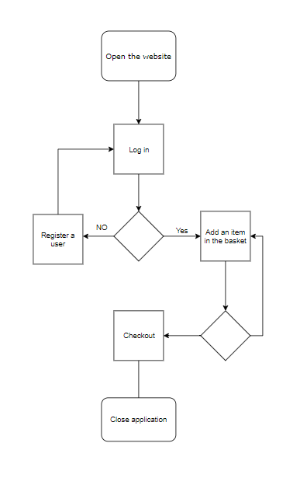

## Basic Flow

Use-Case Start

This use case starts when the actor wants to order food online.

### User enters the website and tries to log in.

### System detects if the user is valid or not

### User adds an item in the basket

### The user can checkout or add another item in the basket.

Use-Case End

The user ends the application. 2.1.2.1.1, 2.1.3.1.1, 2.1.3.2.1, 2.1.4

## Alternative flow

### The user does not have an account. 2.1.2

Alternative Flow Starts

The user has to create an account.

### The user wants to add another item in the basket

Alternative Flow Starts

The user has to browse the menu again and add an item in the basket.

# Special Requirements

## Ability to calculate the average delivery time

The user wants to be aware of the time interval in which the order will arrive.

# Preconditions

NAN

# Postconditions

NAN

# Extension Points

NAN

# Technology and Data Variation List

NAN

# Open Questions

NAN