Yasmine (Yet Another Station Metadata INformation Editor)
V3.0.1

User Guide

Contents
Introduction 4
Top Menu 4
XMLs 4
User Library 6
Settings 9
XML Container Editor – How to create/add new elements 9
Add a Network 11
Add a Network from the User Library 12
Add a Network with the Network Wizard 13
Add a Default Network 24
Editing existing elements and fields 25
Editing Station elements. 28
Edit Response 28
Response Wizard 32

Figure 1 - Top Level View 3
Figure 2 - User Library 5
Figure 3 - User Library Builder 6
Figure 4 - Example Stations Library 7
Figure 5 - Example Channels Library 7
Figure 6 - Settings 8
Figure 7 - XML Container Editor 9
Figure 8 - Adding a Network 10
Figure 9 - Select a Network 11
Figure 10 - Network Wizard 12
Figure 11 - Station wizard panel 13
Figure 12 - Station wizard panel (cont.) 14
Figure 13 - Channel wizard panel 15
Figure 14 – Channel wizard reminder 16
Figure 15 - Channel wizard 17
Figure 16 - Channel wizard 18
Figure 17 - Channel wizard 18
Figure 18 - Channel wizard 19
Figure 19 - Channel wizard 20
Figure 20 - Channel wizard (second sample rate) 21
Figure 21 - Channel wizard (second sample rate) 22
Figure 22 - Builder mode to examine contents of new Channel 23

Introduction
Yasmine is a general purpose tool for creating, editing and writing station metadata information in FDSN stationXML format. It was developed jointly by the Incorporate Research Institutions for Seismology (IRIS) and the French Seismological and Geodetic Network (RESIF).

Top Menu

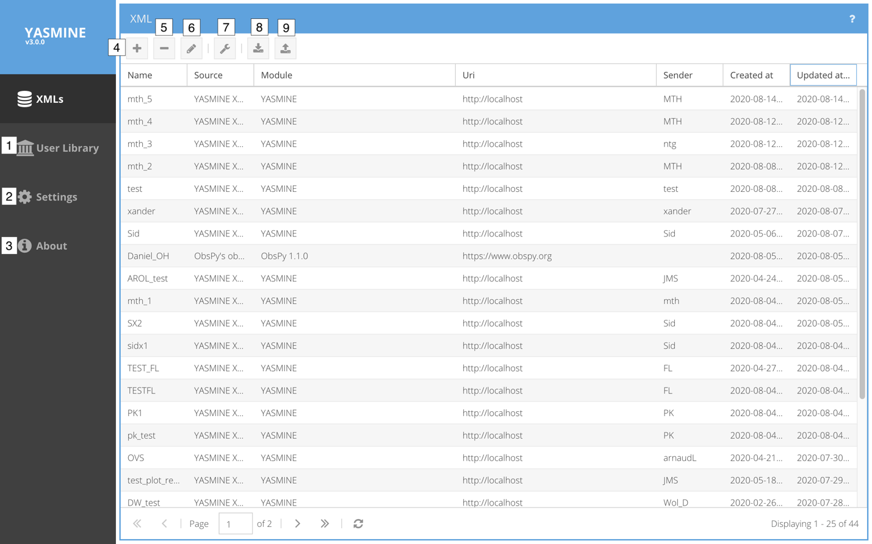
Figure 1 - Top Level View

XMLs
Figure 1 shows the top level Yasmine view with numbering to be discussed in the text.
Along the left-hand side panel are top level navigation buttons. Along the top panel are buttons for creating/importing/deleting StationXML files. The main panel shows the list of all XML containers that currently exist in the Yasmine server’s database. Note that clicking on any column label toggles the row sort between ascending/descending order.

1. User Library
Clicking User Library takes you to a list of user created template libraries that can be accessed in order to insert a previously saved Network | Station | Channel element into a new XML container.

2. Settings
The settings page configures the behavior of Yasmine for the entire server. It can be used to specify which fields are mandatory for each StationXML node, etc.

3. About
Author, License and Latest Build Stamp information for Yasmine tool.

4. Create XML 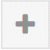
Click here to start a new XML container

5. Delete XML 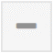
Select an existing XML container in the list and then click here to delete it (permanently removes it from the database).

6. Edit XML 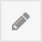
Select an existing XML container and click here to begin editing it.
Alternatively, simply double-click the XML container.

7. XML Builder 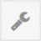
Open selected StationXML file for editing (same as double clicking a StationXML file)

8. Import XML 
Click to select an existing StationXML file on the local drive to upload as a new XML container.

9. Export XML 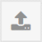
Select existing XML container and click Export XML to write it out as StationXML file

User Library

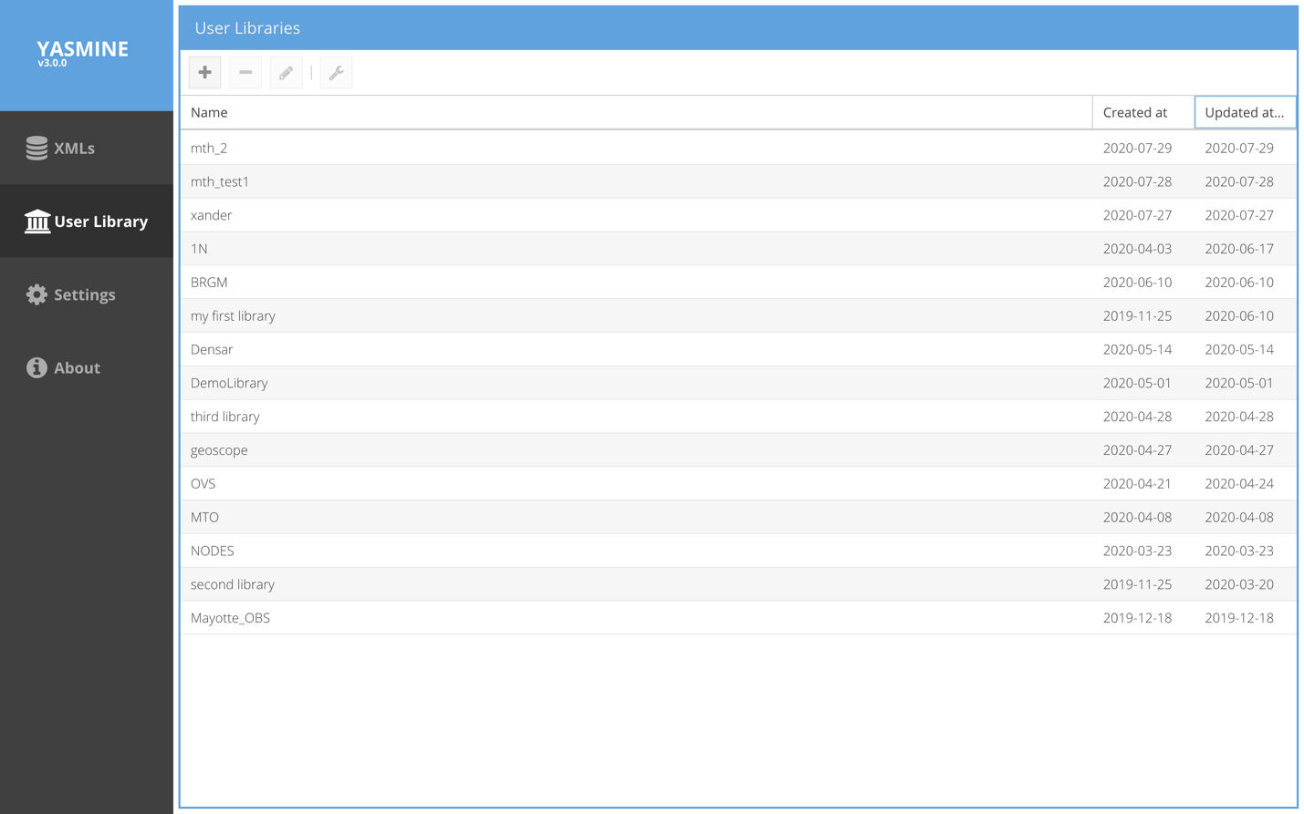
Figure 2 - User Library
The user library stores XML containers that users may create in order to store retrievable examples of StationXML elements (Networks, Stations, Channels (with or without Responses)). These elements can be used as templates from which to generate new elements. While they are normally accessed via dropdown menu from within the XMLs -> Build mode, they can also be accessed directly from the User Library for viewing.

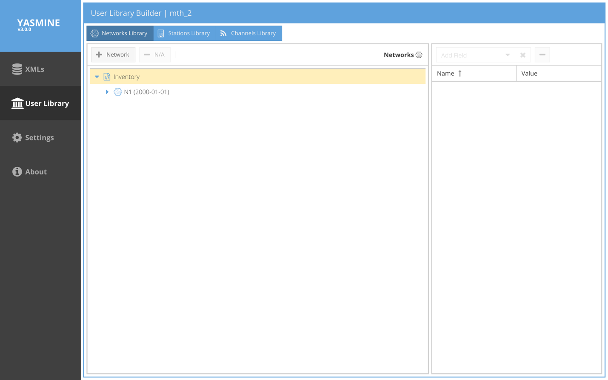
Figure 3 - User Library Builder

The user library functions much like the XML containers themselves; it can be opened by double-clicking. The user library has 3 divisions: Networks Library, Stations Library, Channels Library. While editing an XML container, if the user adds an existing Network node to their user library, the Network node and any children it contains (e.g., Stations, Channels, Responses) will be added into the Networks Library. Alternatively, if the user selects a single Channel to add to their user library, it will be added (along with its Response if any) to the Channels Library. Thus, an existing Channel may be copied into one or all of the library divisions; in the case of Networks Library and Stations Library, it will be a child of a Network/Station parent node.

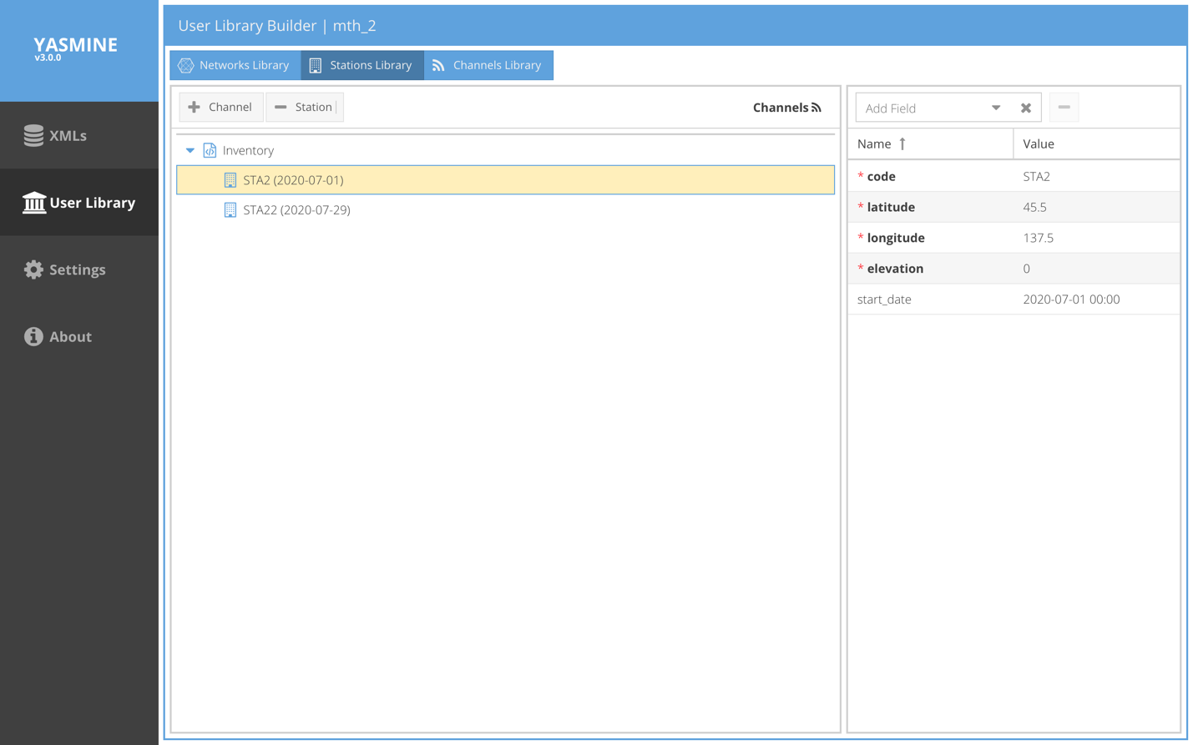
Figure 4 - Example Stations Library

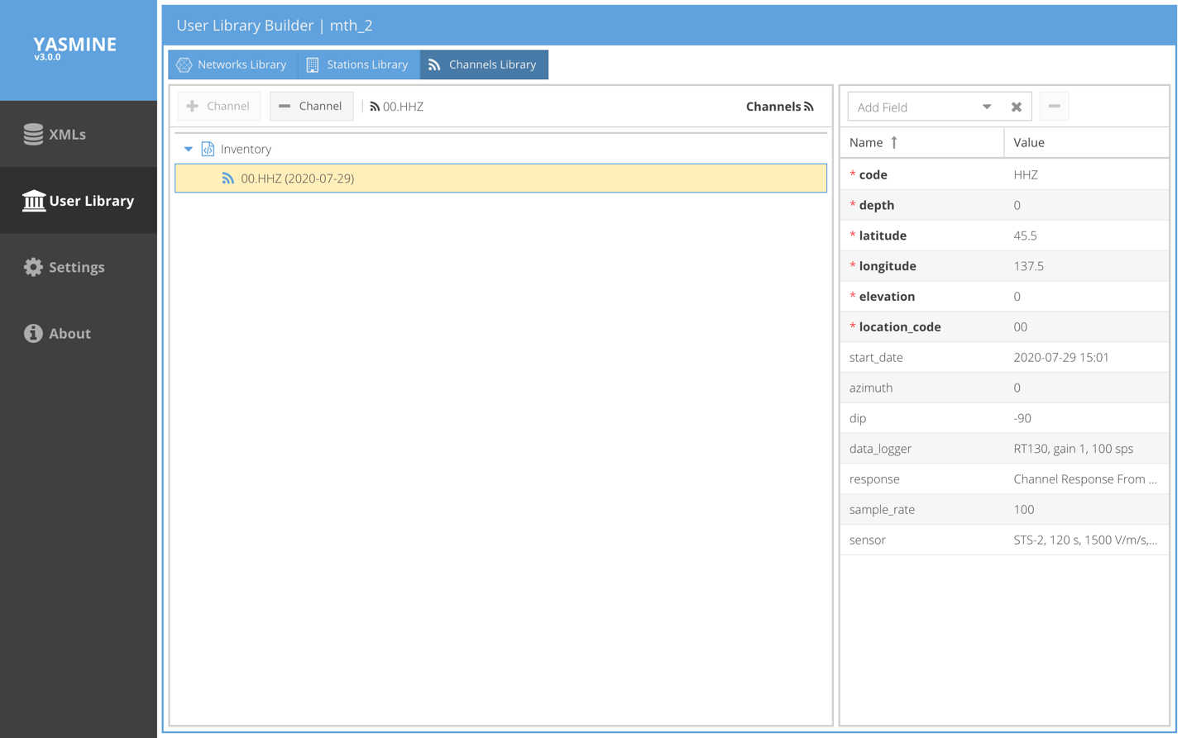
Figure 5 - Example Channels Library

Settings

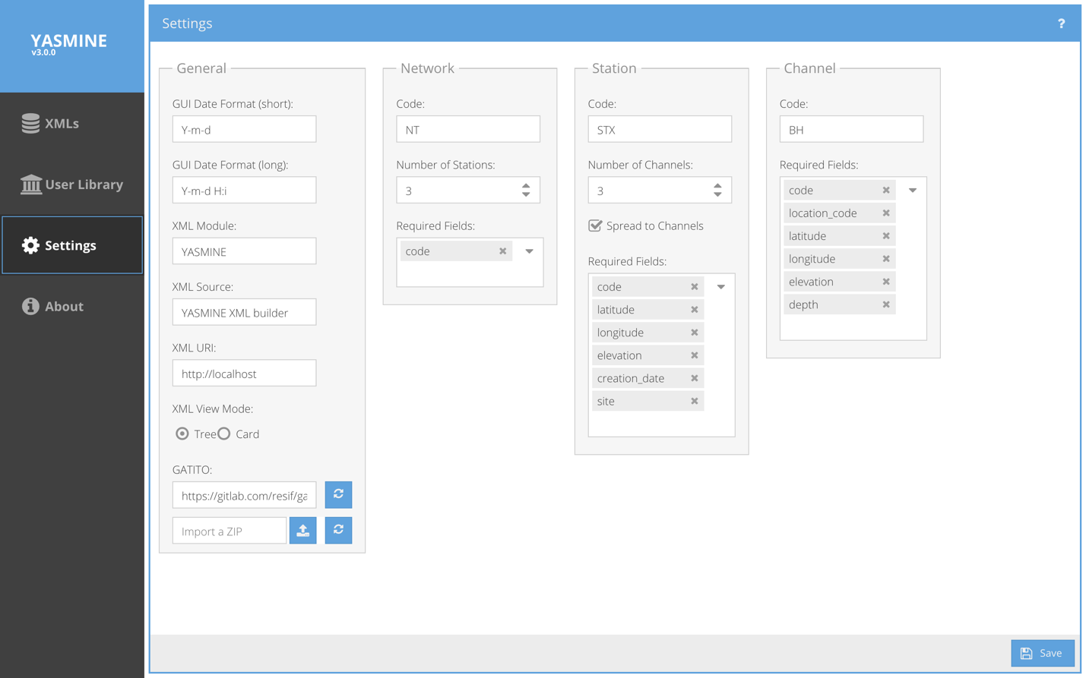
Figure 6 - Settings

The Settings page allows the user to configure settings for general properties (e.g., time/date format), XML (navigation) view (Tree vs. Card) as well as settings for each of the StationXML basenode elements (Network, Station, Channel). The text boxes indicate what values (e.g., network code) will be used whenever a user on the system opts to add a default node (Network, Station, Channel). These can then be edited by the user. In addition, the Settings allows the user to specify which elements are required for each node. Note that here, “required” means that whenever the tool is used to create one of these elements, the fields selected here will appear with the node by default. In order to add additional fields, the user may use the dropdown boxes to find the field(s) to add to the required items. Conversely, fields may be removed from the required list by ‘x-ing’ them from the list. Note: fields that are truly required (e.g,are specified as required in the FDSN StationXML schema), such as Station code, latitude, longitude, etc., cannot be removed here or in the GUI editor.

XML Container Editor – How to create/add new elements

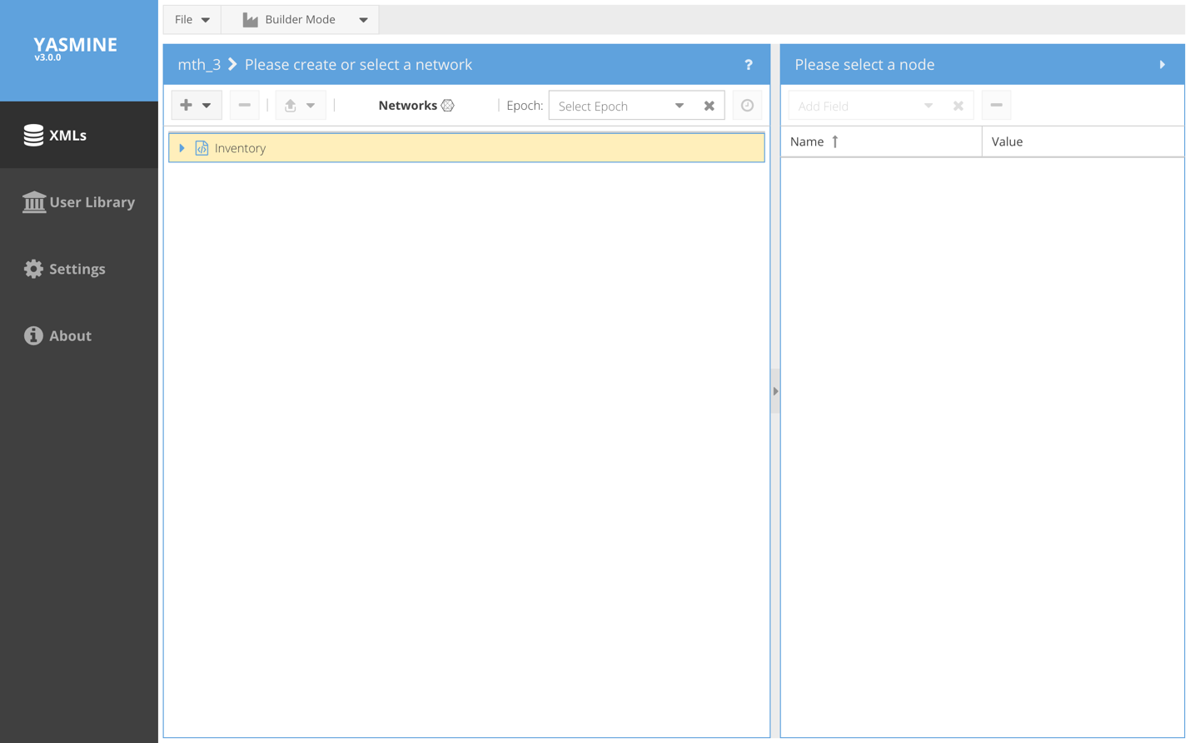
Figure 7 - XML Container Editor

When an XML container name is double clicked, the container is opened in edit mode. If this is a new container, it will only contain an empty Inventory container.

Add a Network
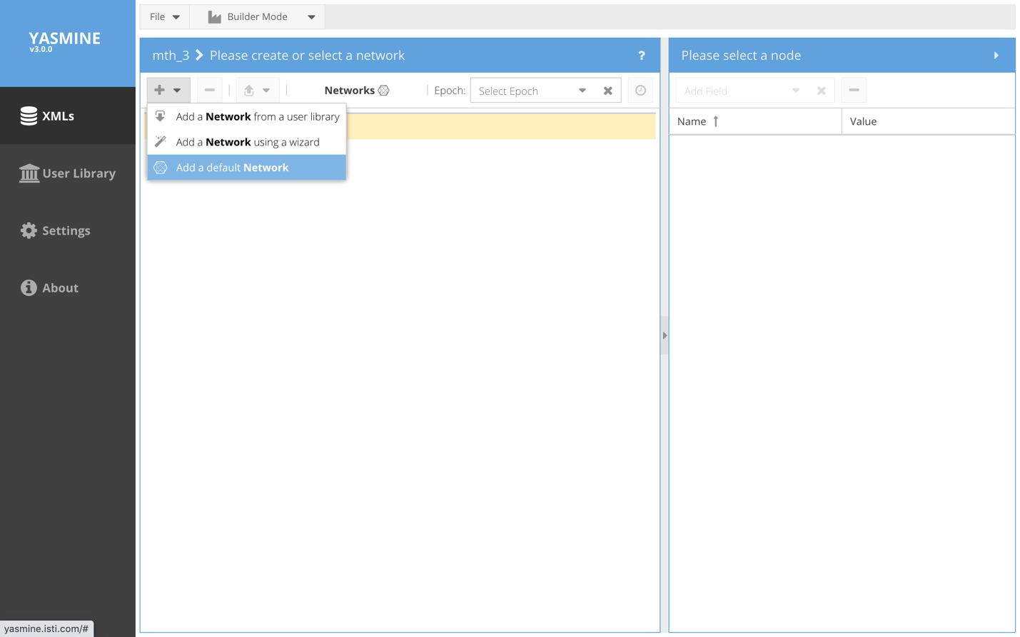
Figure 8 - Adding a Network
By clicking the + button the user is presented with 3 ways of adding a new Network node:
- Add a Network from a user library (discussed above)
- Add a Network using a wizard
- Add a default Network

Add a Network from the User Library
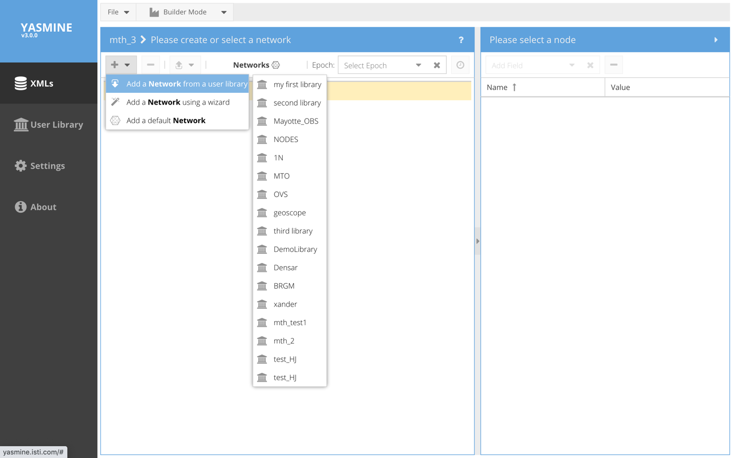
Figure 9 - Select a Network
- Add a Network from a user library – Locate the desired user library in the drop down list and navigate to a network node to copy/paste.

Add a Network with the Network Wizard
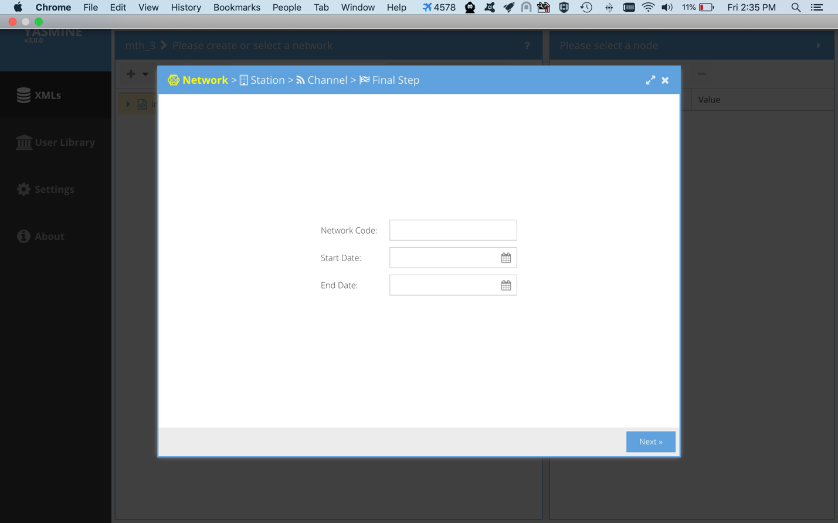

Figure 10 - Network Wizard
- Add a Network using a wizard

This option begins the Network Wizard which will prompt the user to create a new Network + Station + Channel(s) (optionally with Responses). Anything created here can be edited later from the main menu. Note that the Network Code is required; the GUI will not let you proceed until it is filled out.

Next > Takes you to the Station wizard panel (below)
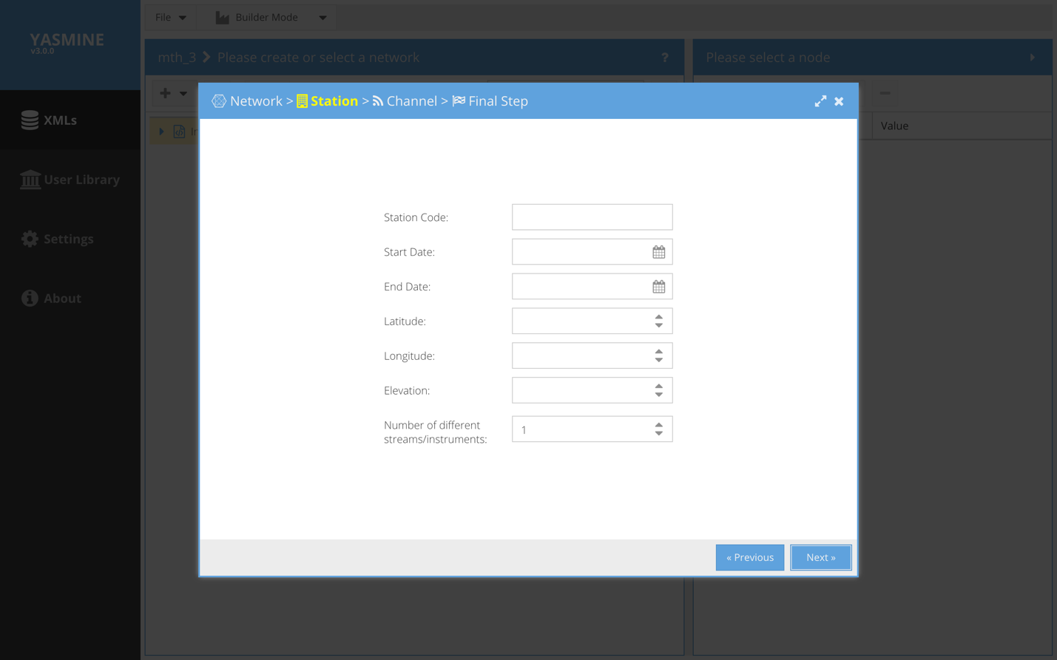
Figure 11 - Station wizard panel

The Station Code, Latitude, Longitude and Elevation are required; the GUI will render these boxes in red if you try to go on (Next) without filling them out.

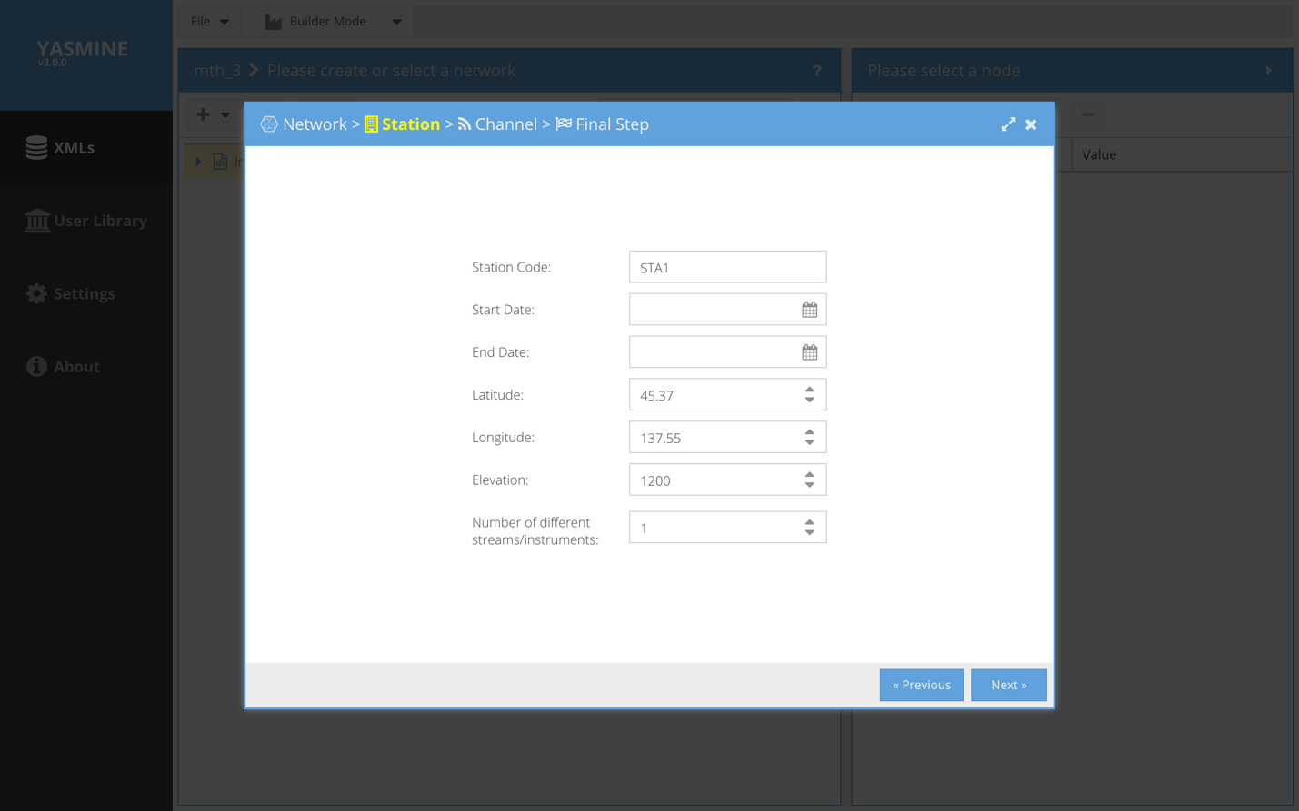
Figure 12 - Station wizard panel (cont.)
The final option is used like location code – you can specify different groups of channels this way.

Next

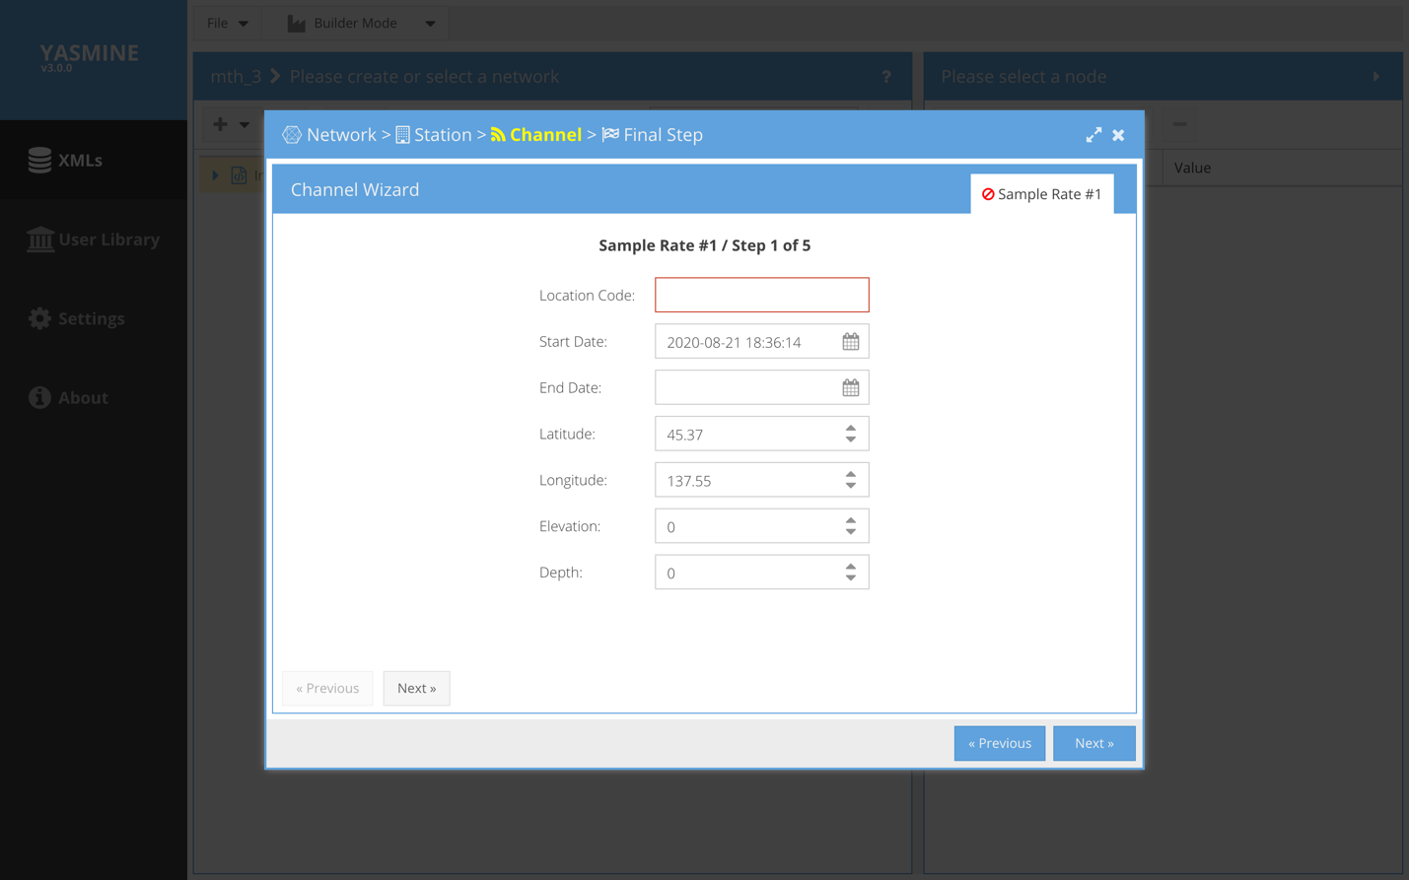
Figure 13 - Channel wizard panel
Now we are presented with the Channel Wizard. Note that the Latitude, Longitude and Elevation have been pre-populated for us using values from the Station. If we hit Next before filling out the Location Code, its box will render in red to remind us that it is required.

Next

There are 2 sets of <<Previous | Next >> buttons in this GUI. We must complete the Channel Wizard sequence (left-hand side Next) before the wizard will permit us to go forward using the righthand side Next button. If we try to do the latter prematurely it will remind us to complete the Channel Wizard all the way first (see below).
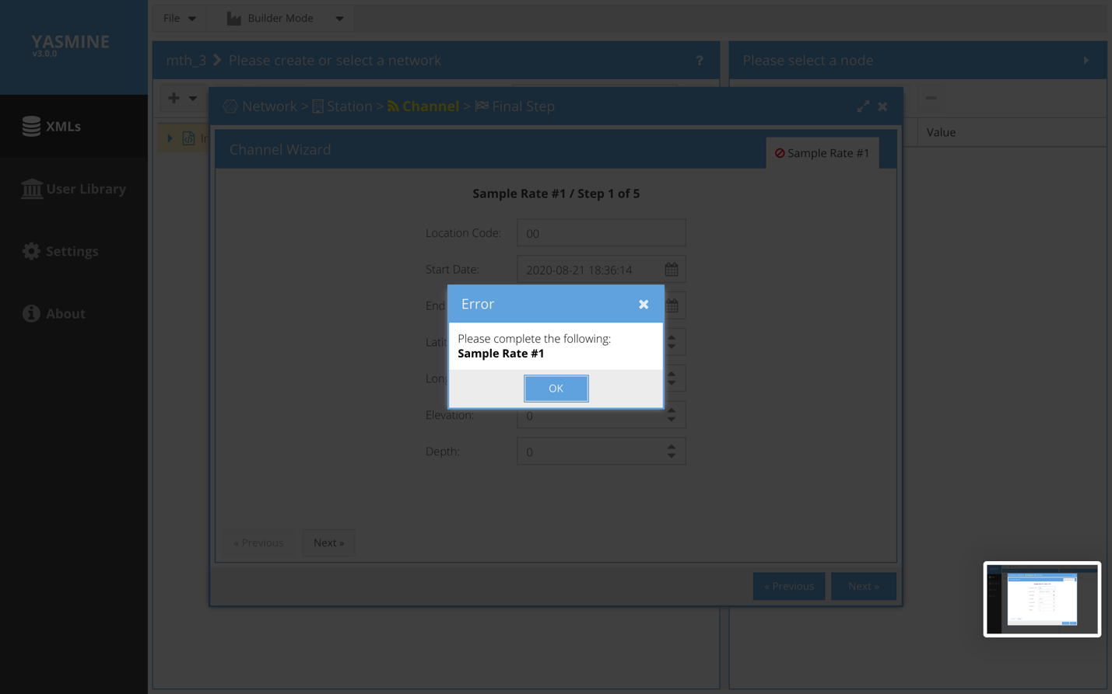
Figure 14 – Channel wizard reminder

Next
The Channel Wizard asks if we want to use the Response Wizard to create responses for the channels we create. This can be done later so we select “I don’t need a response” to move on.

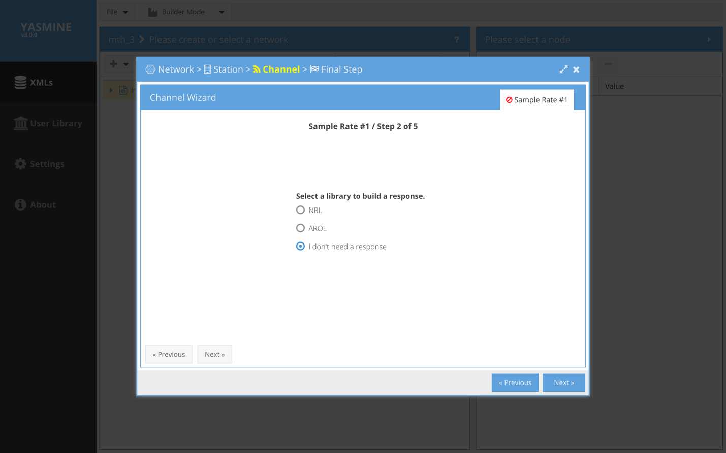
Figure 15 - Channel wizard

Next

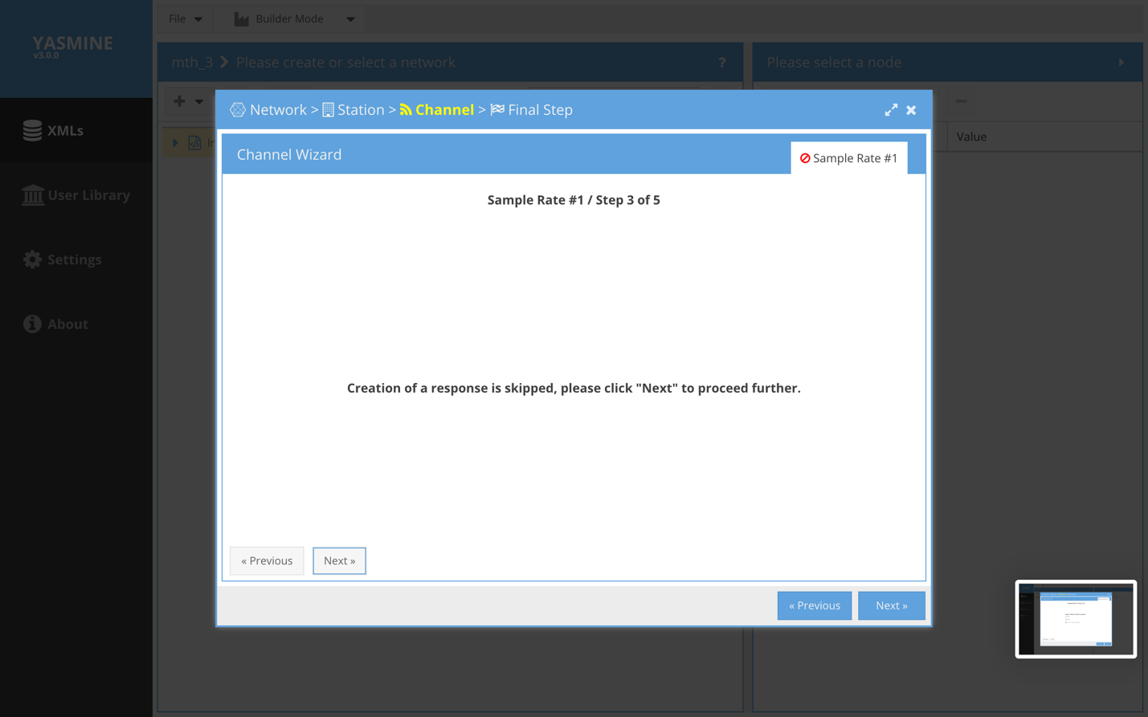
Figure 16 - Channel wizard

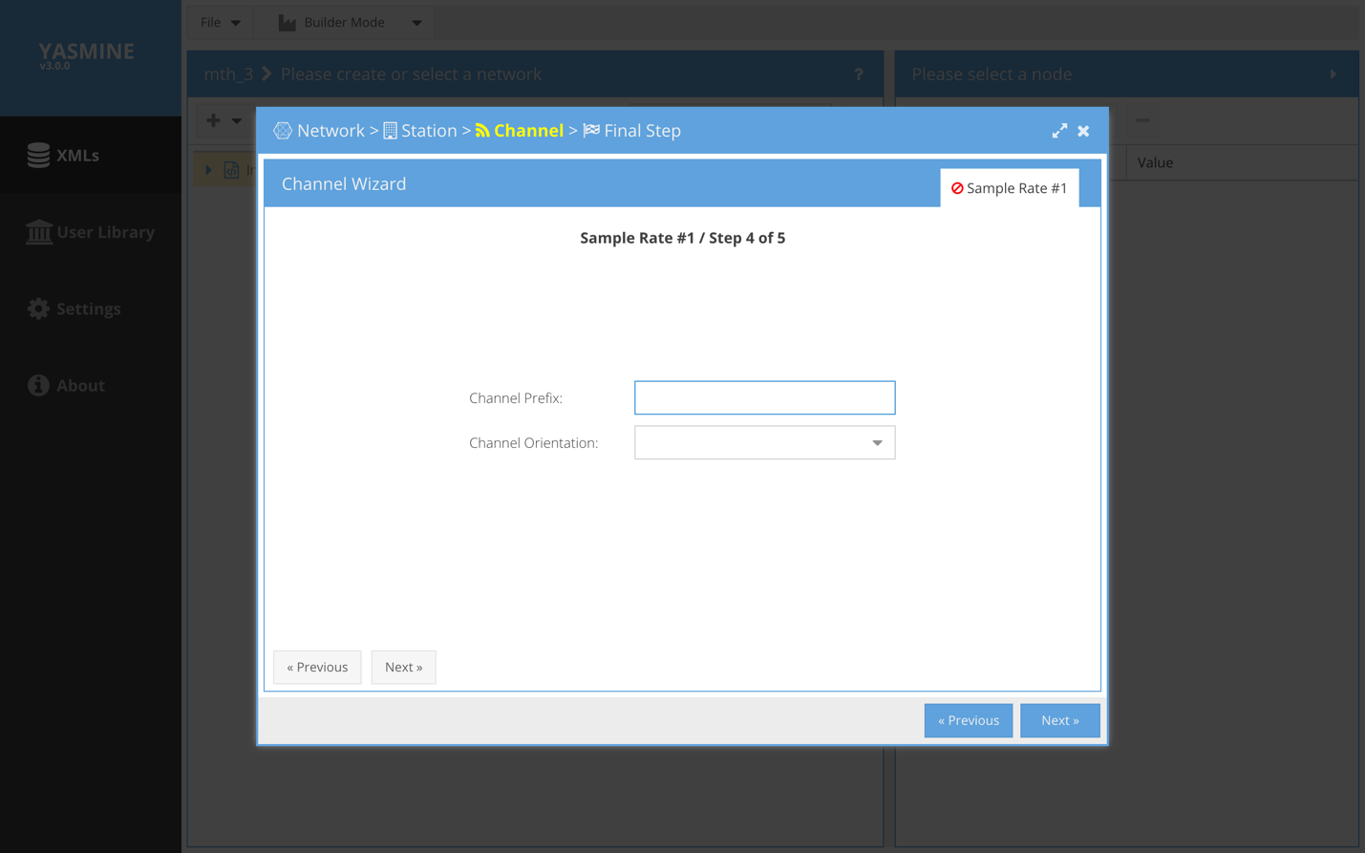
Figure 17 - Channel wizard
At this point we are prompted for a prefix for our channel(s). Common choices are “BH”, “LN”, etc.

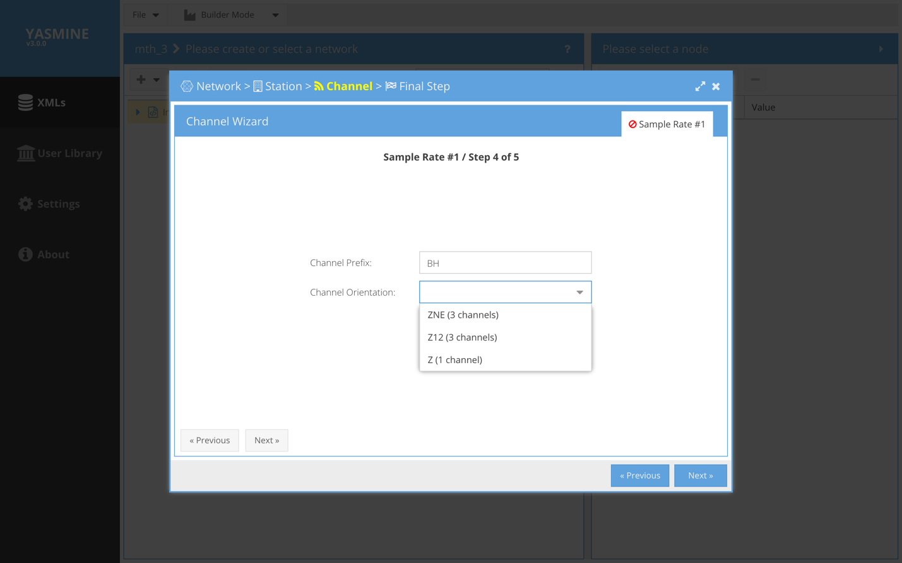
Figure 18 - Channel wizard
And we are prompted for our channel orientations, which will determine the number and naming convention of the channel(s) created.

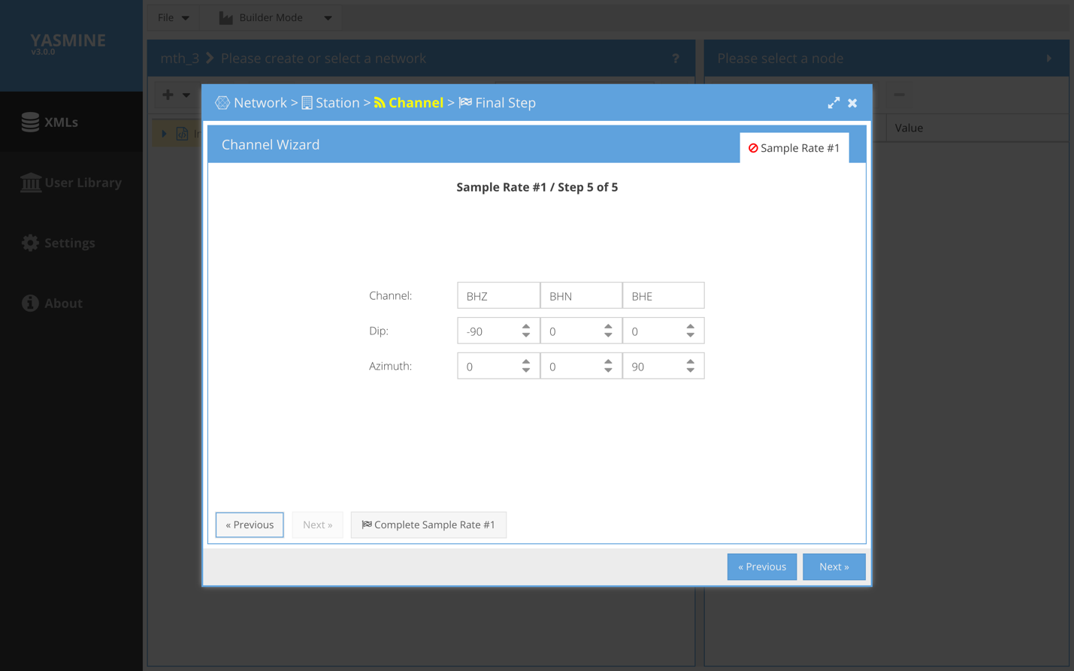
Figure 19 - Channel wizard

Finally we are at the Final Step of the Channel Wizard which shows us a summary of the channel(s) created.

Click Complete Sample Rate #1 to move on.
This just advances us out of the Channel Wizard. Had we selected to create more than 1 channel stream (location code), this would advance us to edit the next stream parameters.

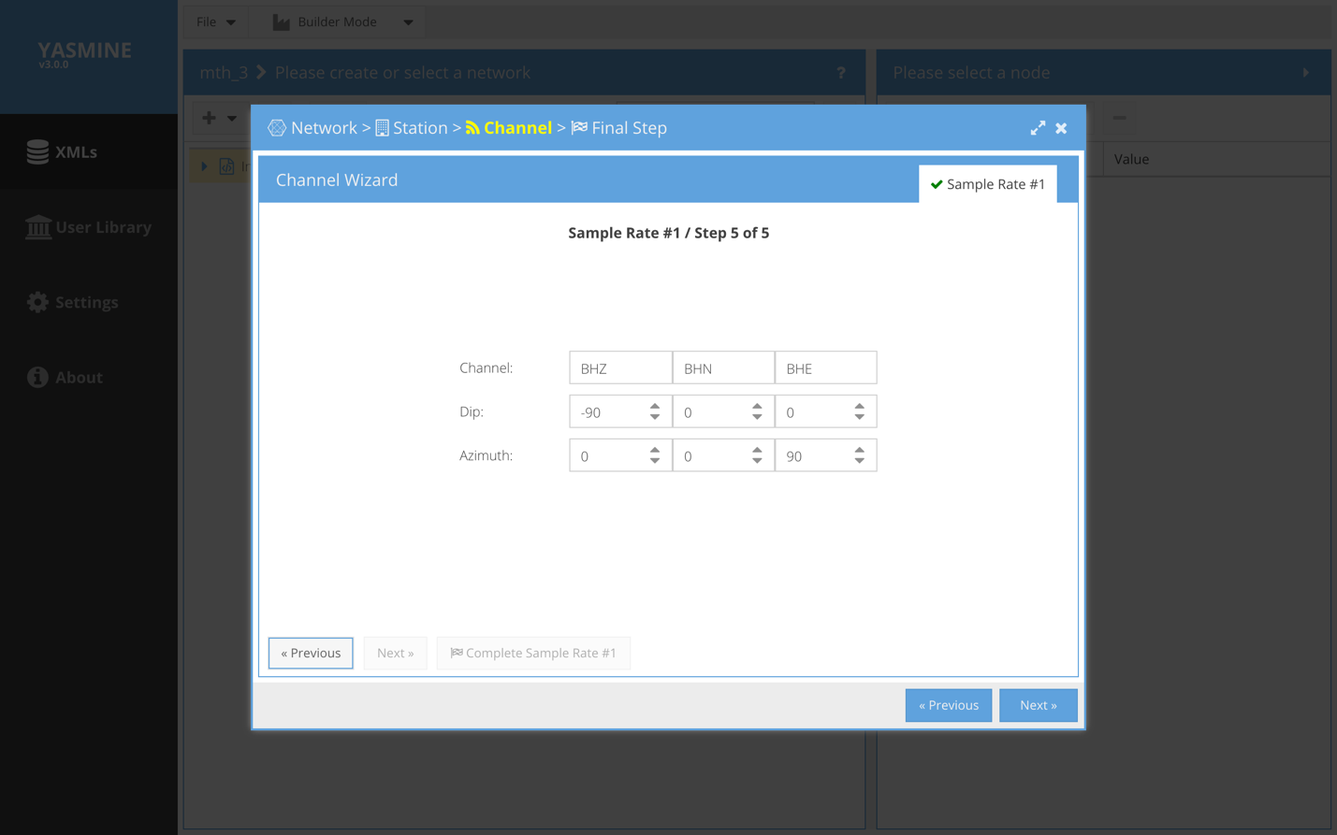
Figure 20 - Channel wizard (second sample rate)

Next

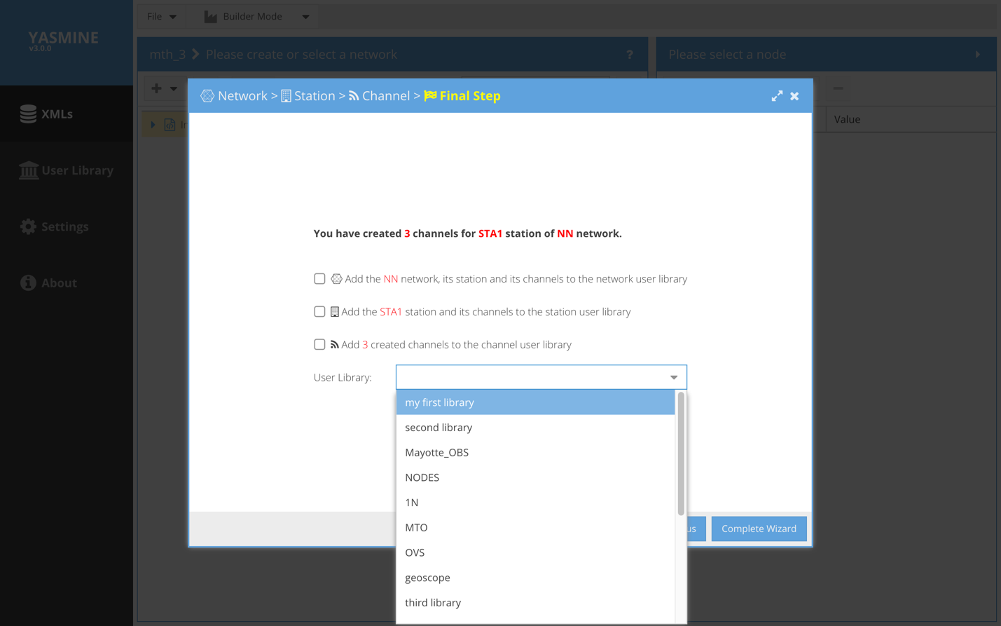
Figure 21 - Channel wizard (second sample rate)
We are asked if we want to add the just created Network + Station + Channel(s) to a specified user library (to use later as templates). We don’t, so we click Complete Wizard to exit the Network > Station > Channel wizard and return to the opened XML container view (below).

Add a Default Network
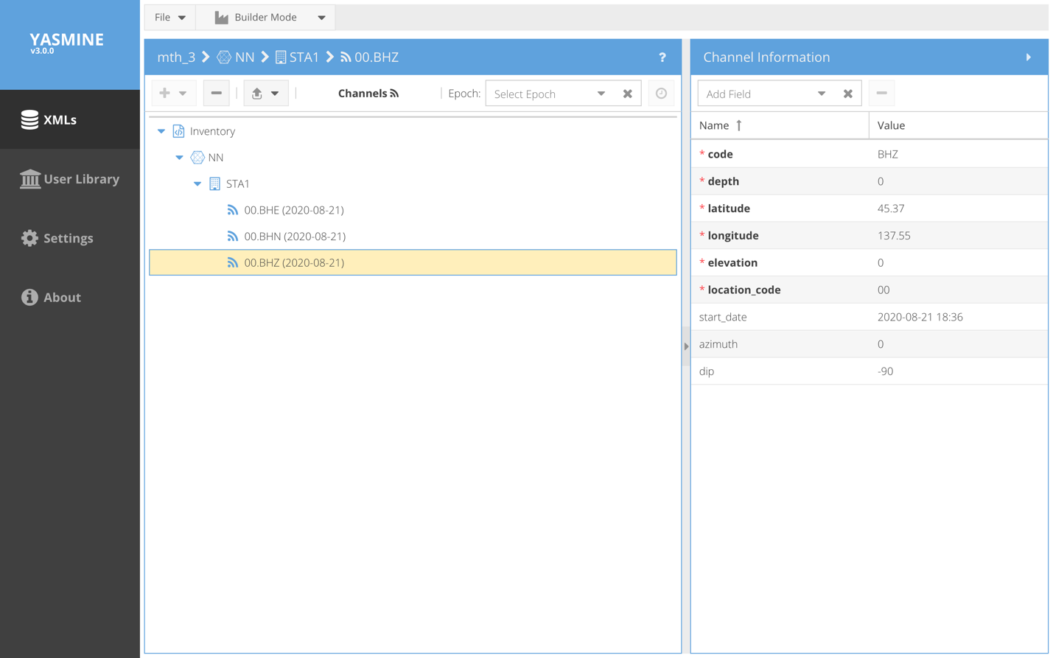
Figure 22 - Builder mode to examine contents of new Channel
By opening up the tree we can see the network, station, channel(s) we created.

- Add a default Network

This will automatically add a skeleton Network node as specified in the Settings page. For instance, it will add a Network with the Settings default Network Code and inside it, will create the specified number of default Stations, each containing the specified number of default Channels, each with the fields specified in Settings. These nodes can then be opened and edited as discussed below.

Editing existing elements and fields
XML Container Editor – How to edit existing elements and fields

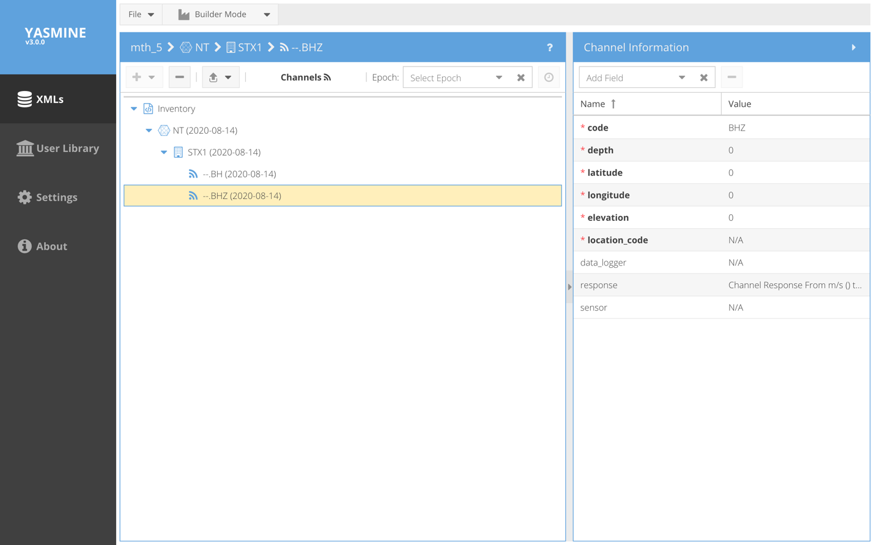
Figure 23 - XML Container Editor

By double clicking on the name of the XML container, we open it and are able to edit it. The left-hand side navigation (tree or card view) allows us to drill down the StationXML basenode we wish to work with. Note the “breadcrumb” in the blue header tells us where we are in the XML hierarchy, e.g., XML container > Network > Station > Channel.
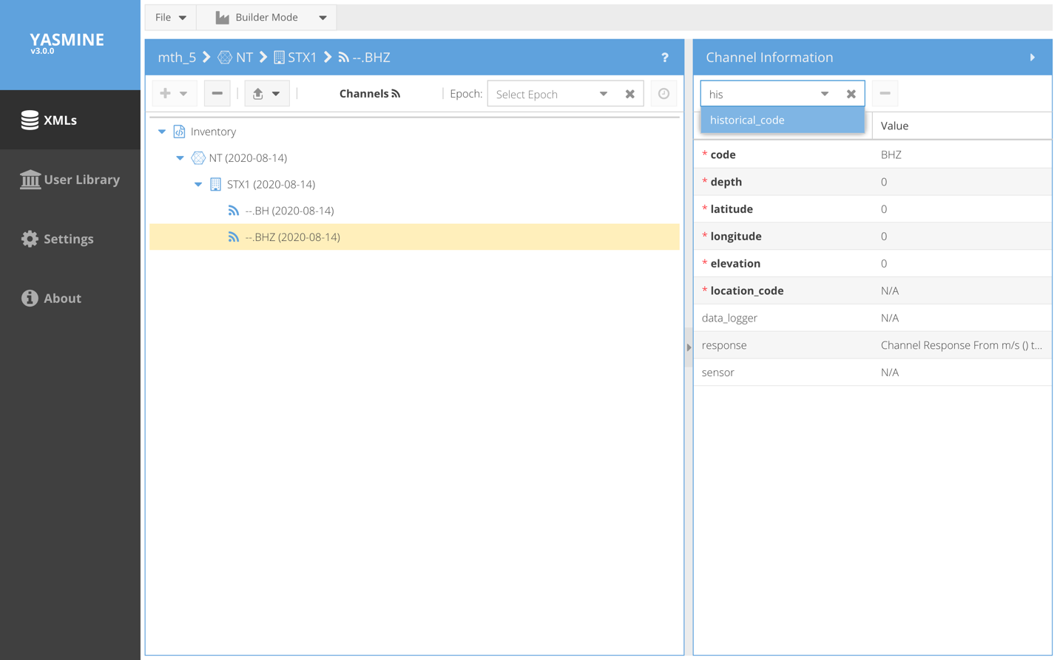
Figure 24 - XML Container Editor

The right-hand panel lists the detail view of whatever StationXML basenode element we have selected on the left. Note that all of the default fields that were specified in the Settings page for this element, are shown by default. Any additional fields that this element contains are also displayed. To add additional fields, the user may use the dropdown box at the top of the righthand panel and enter the first few letters of the field to be added. To see all the available fields for this basenode element, click and expand the dropdown.

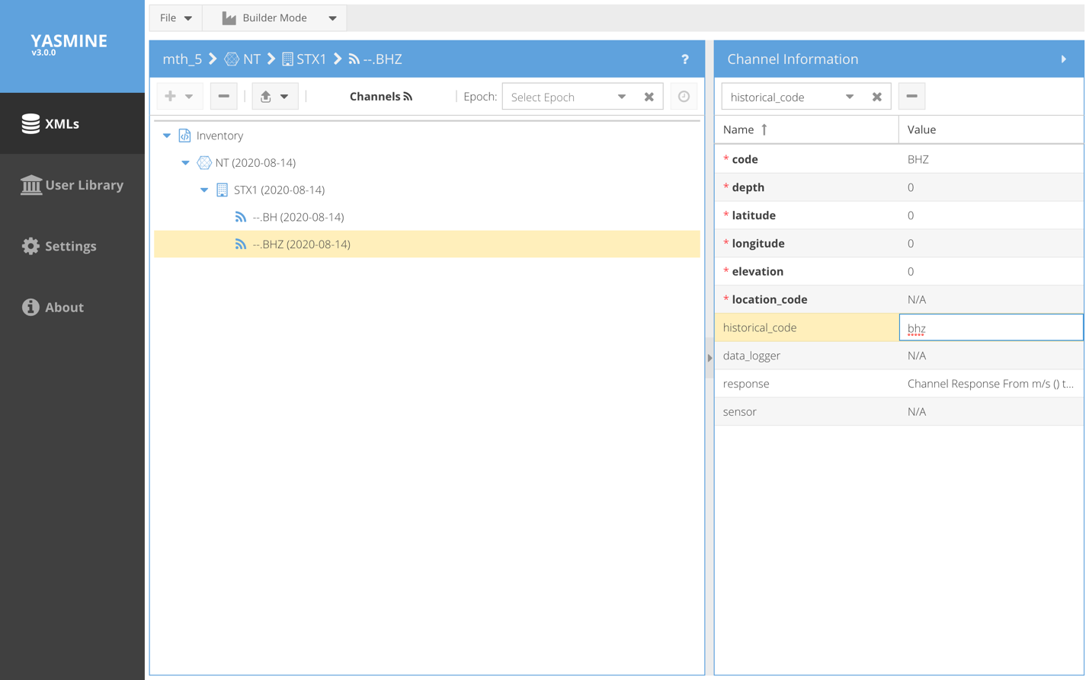
Figure 25 - XML Container Editor

Once the field has been added, its value may be edited by clicking on the cell under the righthand Value column. Hit return to save the changes.

Editing Station elements.

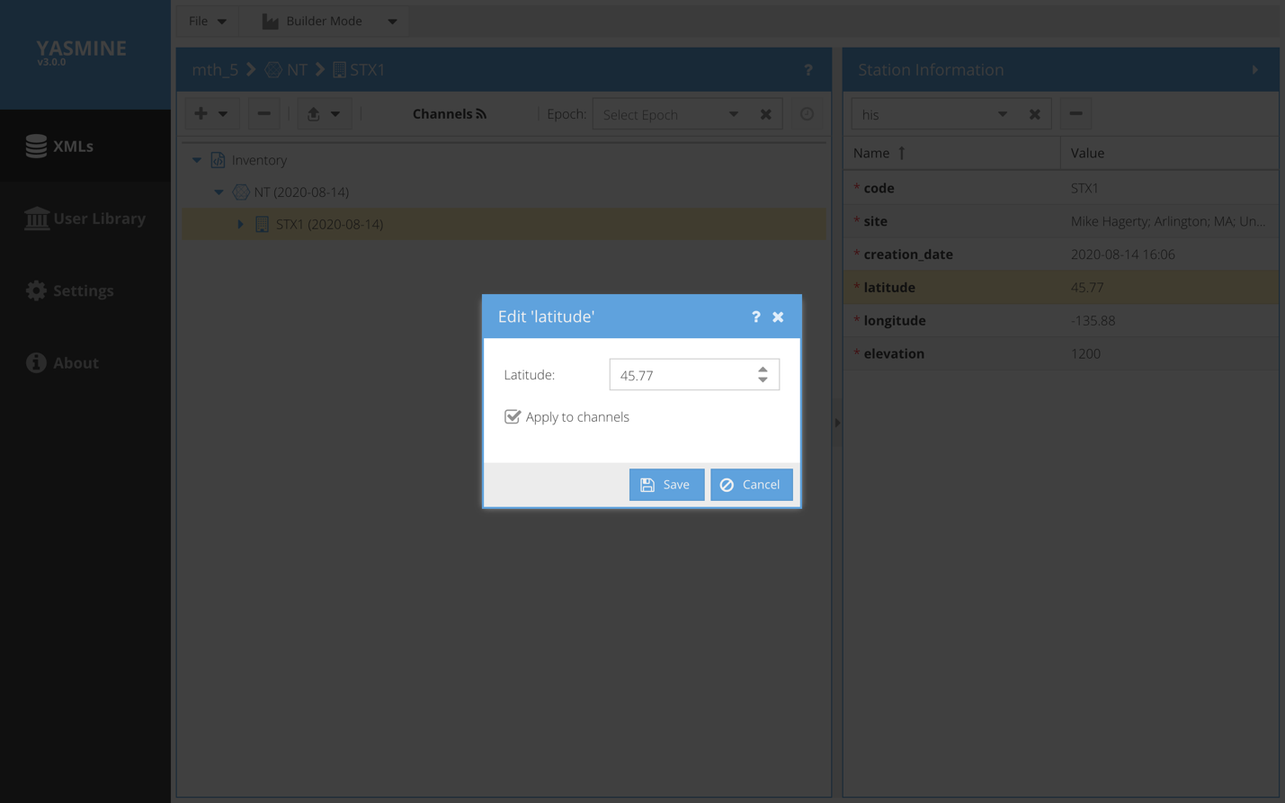
Figure 26 - Editing Latitude (for Station and Channels)
When editing the value of certain Station element fields (e.g., latitude, longitude, elevation) that also appear in Channel elements, the user may select the “Apply to channel” checkbox (checked by default) to apply the change to any channels contained by the station. User must click Save for any changes to take effect.

Edit Response
Clicking on the value of the channel > response field is a little different than all other fields in that it pops up a panel with a plot of the instrument response. This plot is part of the Response Wizard (discussed more below).

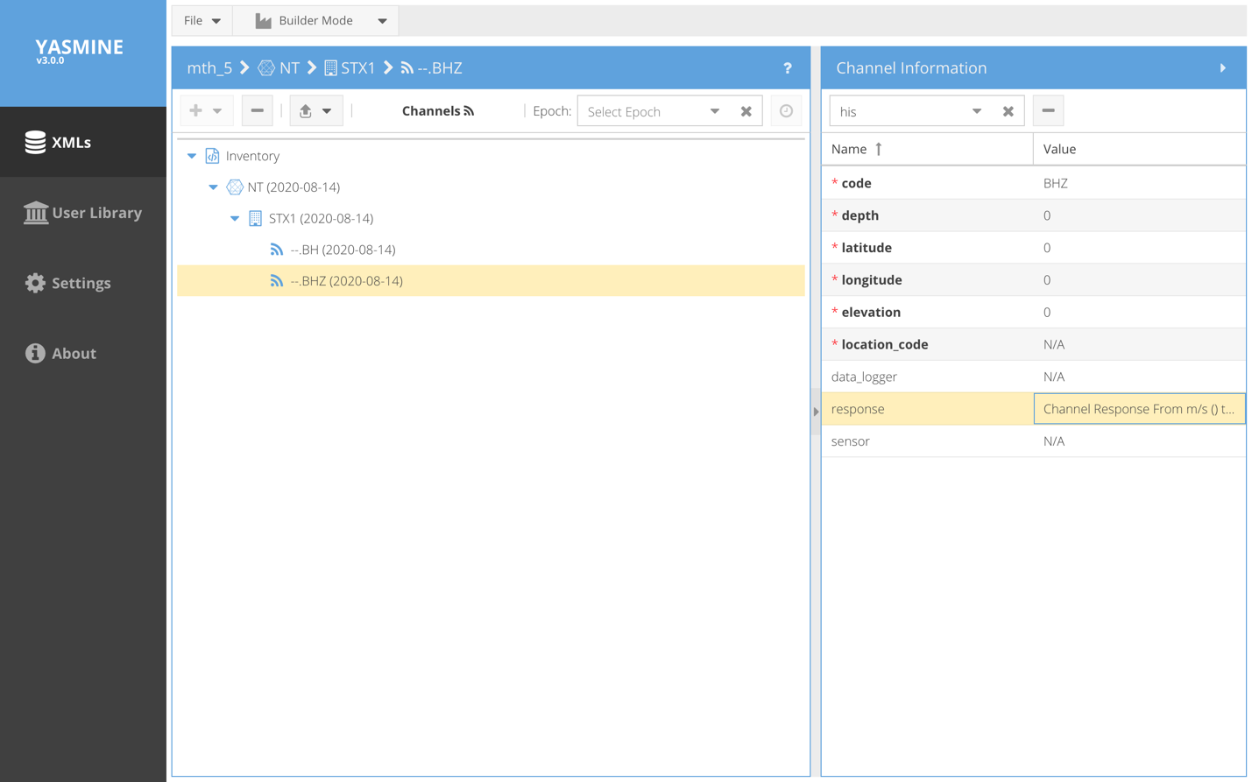
Figure 27 - Edit Reponse

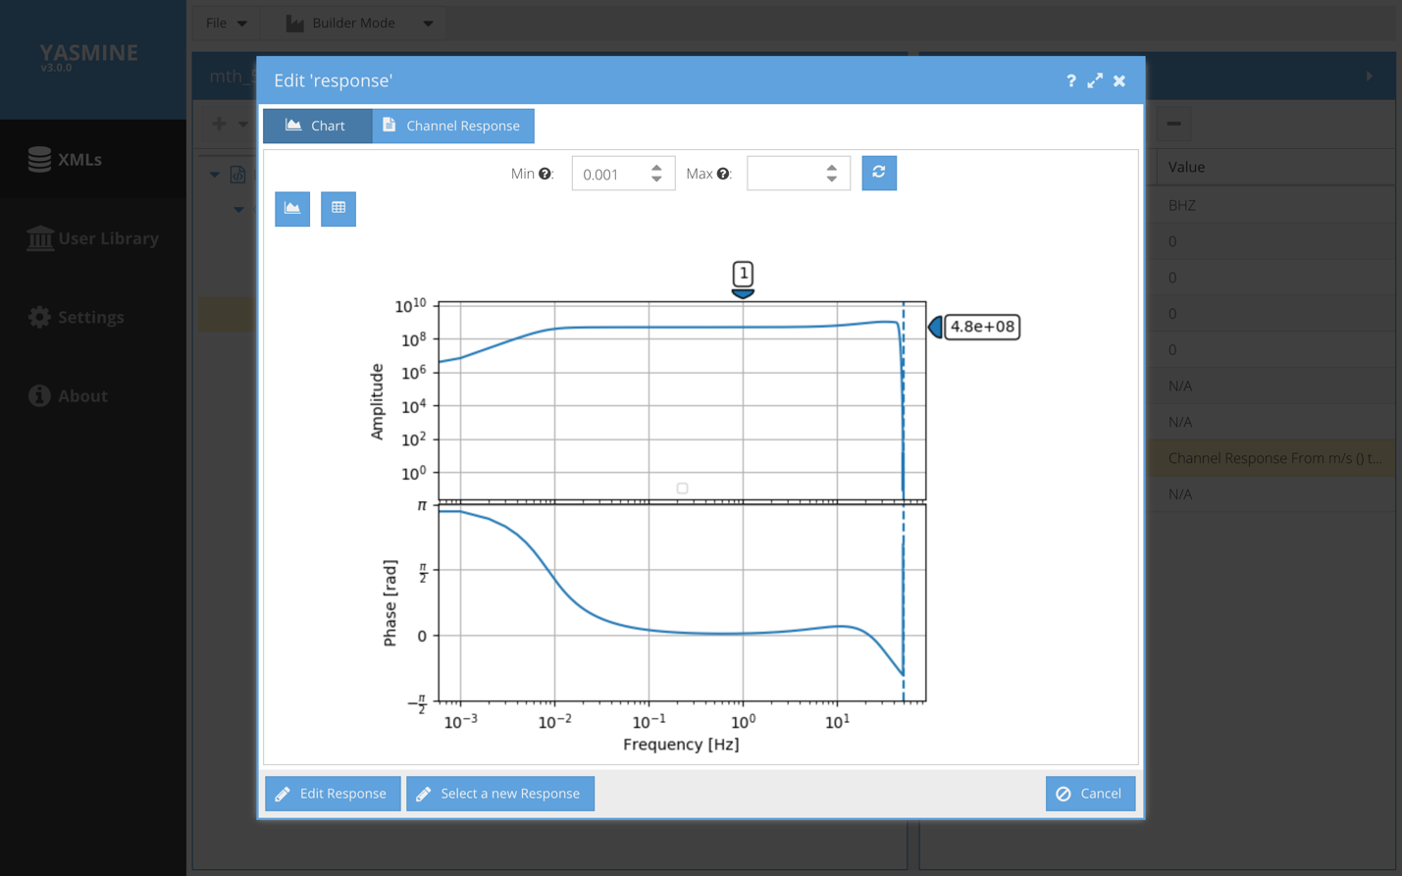
Figure 28 - View Response Curves
The Chart plot shows a plot of the amplitude and phase of the instrument response for this channel. The amplitude response shows a label on the righthand side with the overall sensitivity and a label on the top axis that shows the frequency at which the sensitivity was calculated. By default the response is plotted from .001Hz to the Nyquist frequency. The frequency range may be changed by entering new min/max values at the top and clicking the redraw button.

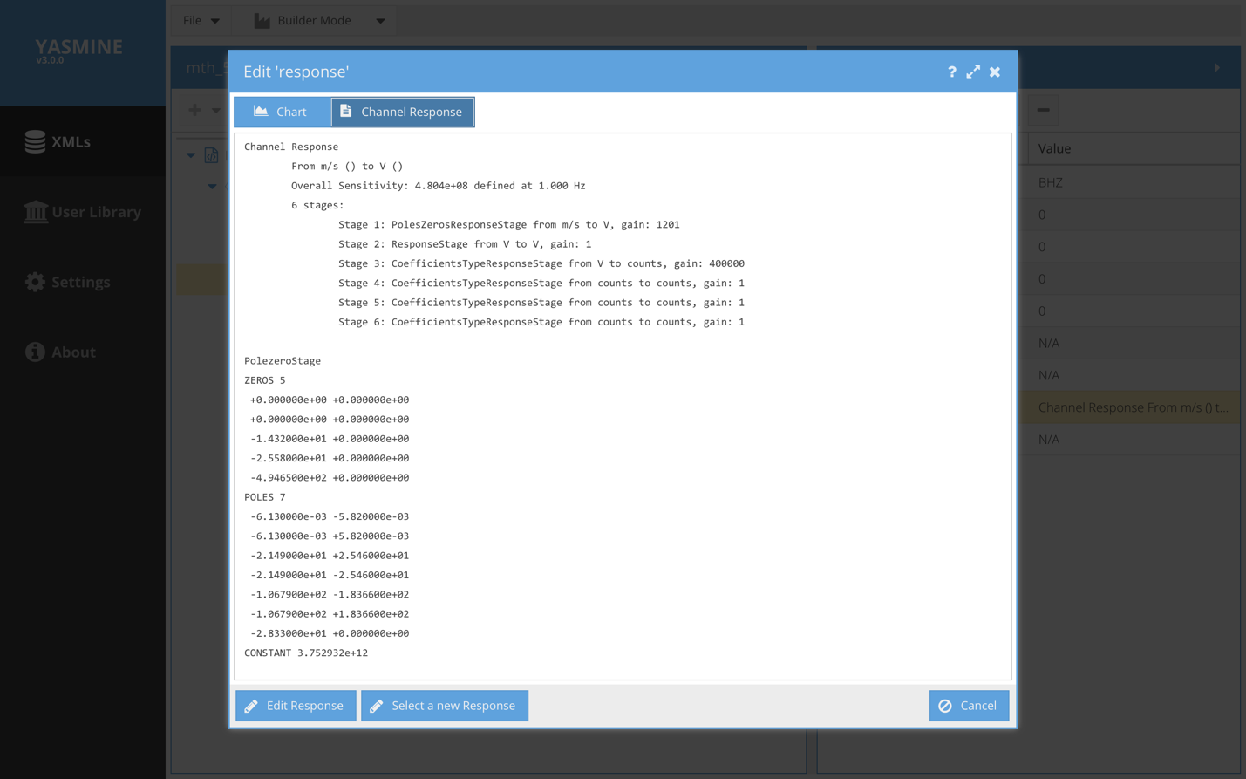
Figure 29 - Examine Response Stages
By selecting the Channel Response button, the GUI displays a summary of the full instrument response stages, followed by the equivalent response in SAC polezero format.

By selecting the Edit Response button in the lower left of the GUI, the response may be edited directly in a general XML editor. Caution: There is no sophisticated checking behind the scenes to make sure you are correctly adding the coefficients of a FIR filter for example, and it is very easy to break the response if you don’t know exactly what you’re doing.

The figure below shows how to make a basic edit to the value of the first stage gain.

Using the + and – buttons, a user may insert (delete) a node within the XML hierarchy.
Again, this should only be done in expert mode.
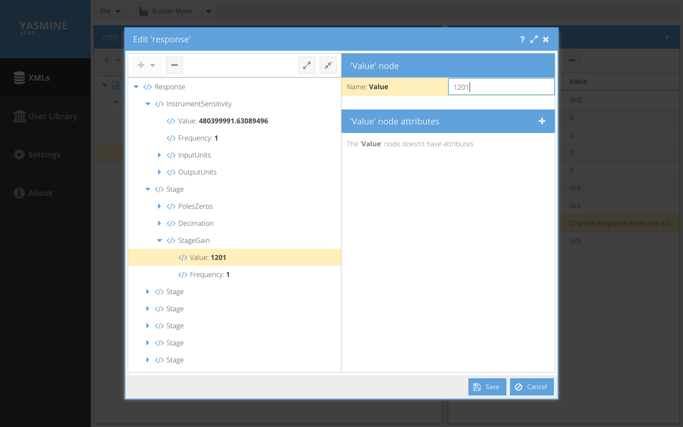
Figure 30 - Response Editing

Response Wizard
Yasmine has a built in instrument response wizard for creating Response objects that may be attached to Channels. There are different ways to enter the Response Wizard but all are ultimately using the same wizard:
- Select a New Response – if you are in the response Chart view, you may click this button to enter the response wizard and select a new response.
- From any upper level wizard (Network, Station or Channel), if you follow it to the channel level, it will ask you if you want to attach a response using the response wizard
- When first adding a response field to a channel element using the dropdown tab, it will automatically open up the response wizard

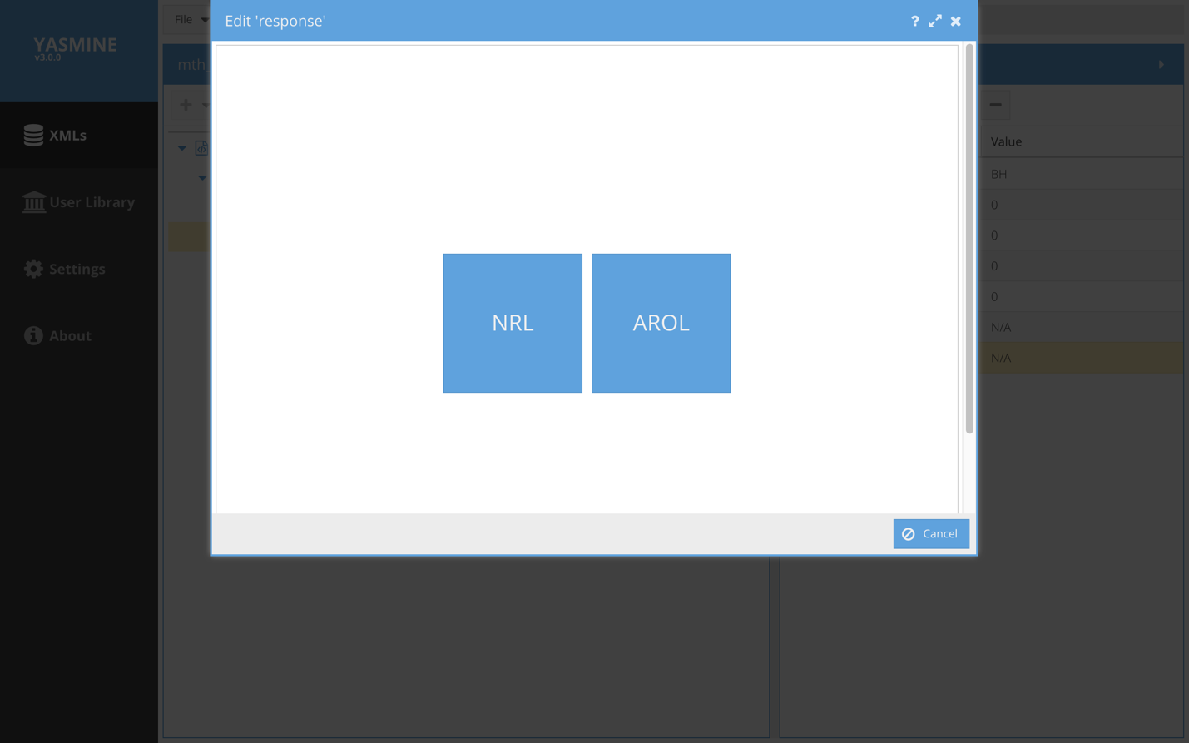
Figure 31 - Response Wizard (NRL or AROL)

The first panel of the response wizard asks the user to select the library from which to obtain the sensor + datalogger responses. At this time, the options are the IRIS Nominal Response Library (NRL) and RESIF’s Atomic Response Library (AROL).
Here we select AROL.

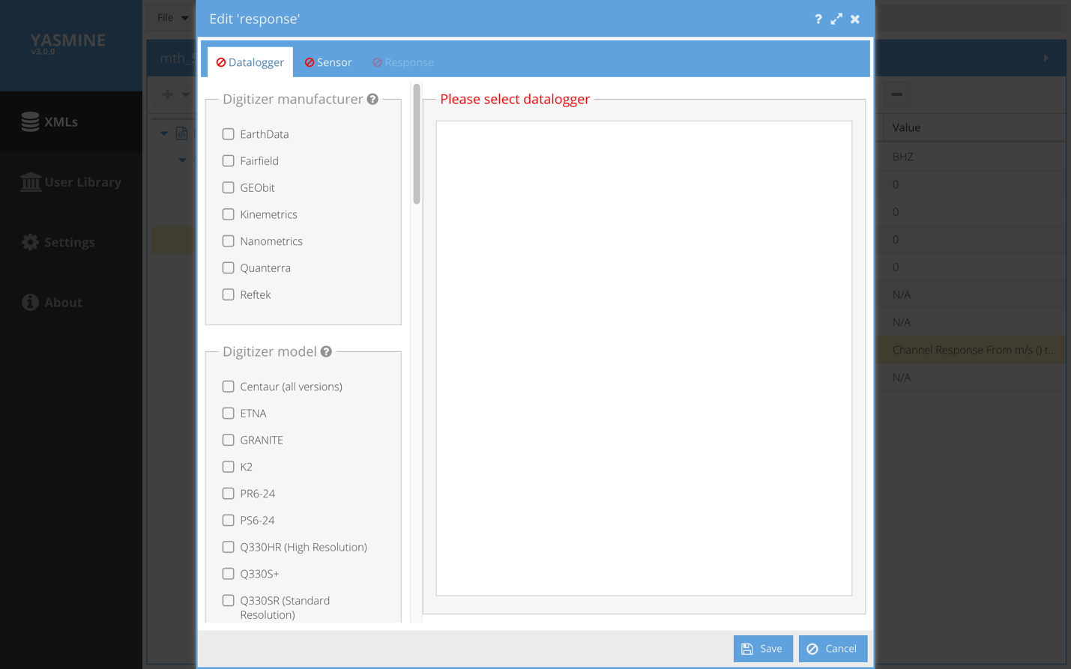
Figure 32 - AROL response wizard
The user is prompted to select the Datalogger.
When enough of the search criteria have been selected so that a unique datalogger is resolved within the library, the Datalogger tab X turns into a green checkmark and a summary of the datalogger appears in the rightside panel.

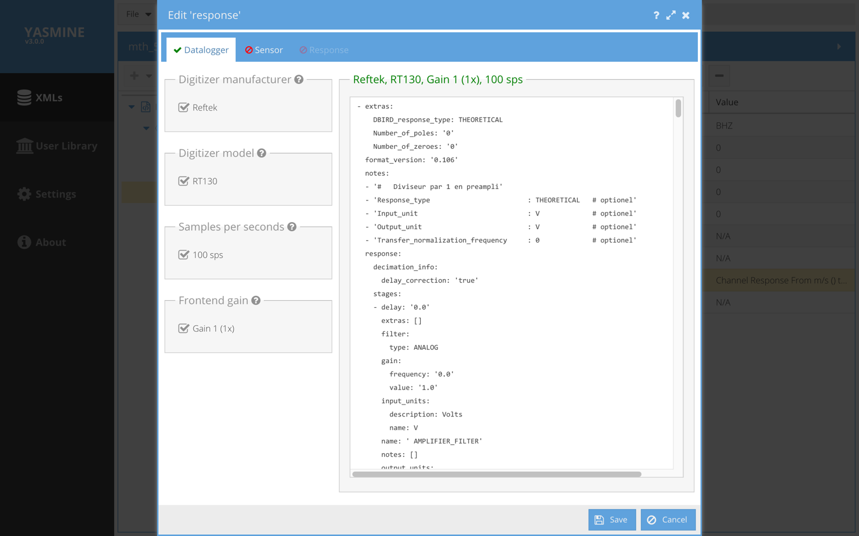
Figure 33 - AROL response wizard - Datalogger selector and summary
At this point the Sensor has not been selected so both the Sensor and Response tabs show the red X mark. Click on the Sensor tab to select the sensor from the AROL library. Once the sensor is fully selected, both its tab and the Response tab have changed to green checkmarks.

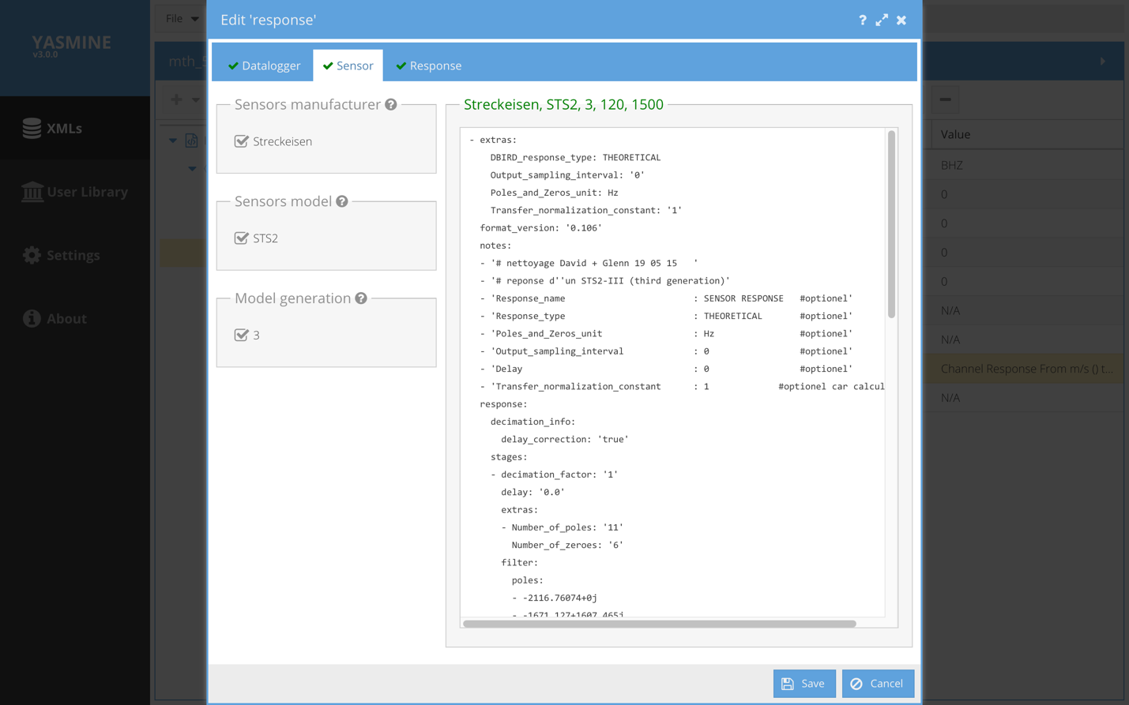
Figure 34 - AROL response wizard - sensor and summary
Clicking on the Response tab shows the response plot.

Click Save to save the response to the previously selected channel.

At this point, GUI focus returns to the channel we were editing. And a summary of the selected instrument response appears in the value column of the response field in the detail view. By selecting this value we return to the response plot window we saw earlier. From here we may view and interact with the response plot, edit the response, and download the response either as a spreadsheet (.csv) or as a plot (.png).

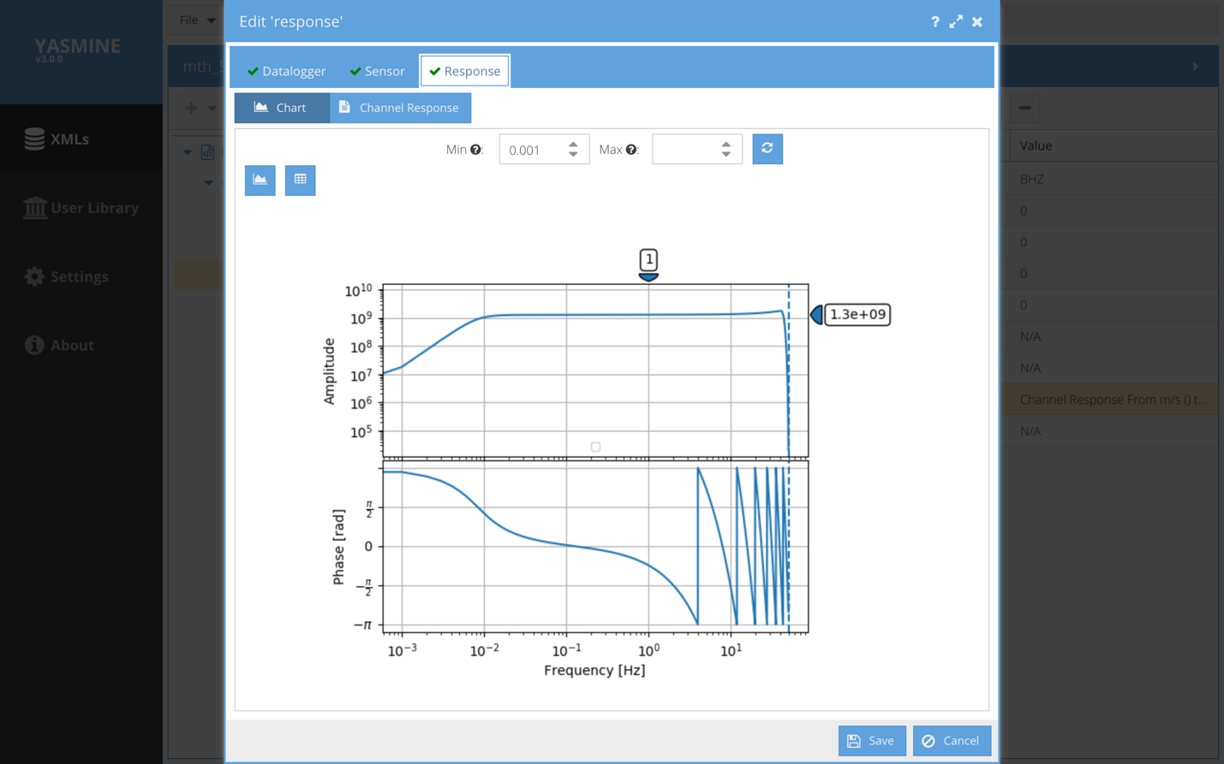
Figure 35 - AROL response wizard - examine results

The X button downloads the response plot as a png file.
The Y button downloads the instrument response as a csv file (frequency, amplitude, phase).

Response Comparison mode
In addition to YASMINE’s builder mode, it also has a response comparison mode. You enable this mode when editing a response but selecting it in the top menu bar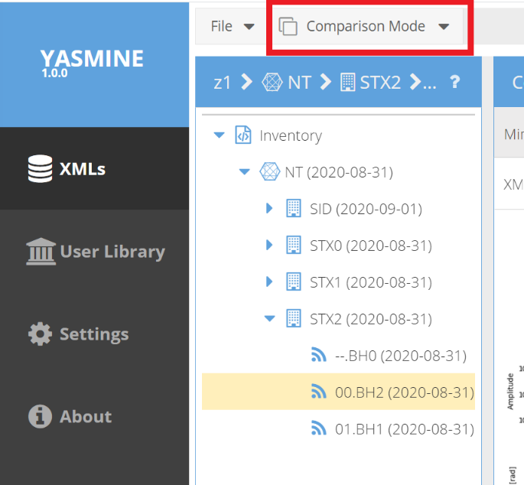
Figure 36 - Switching to Comparison Mode
Once you have Comparison Mode enabled, in the tree view select your SNCL from the tree. This will display the selected response curve on the left side and present you with an option of selecting a different StationXML file to compare against.

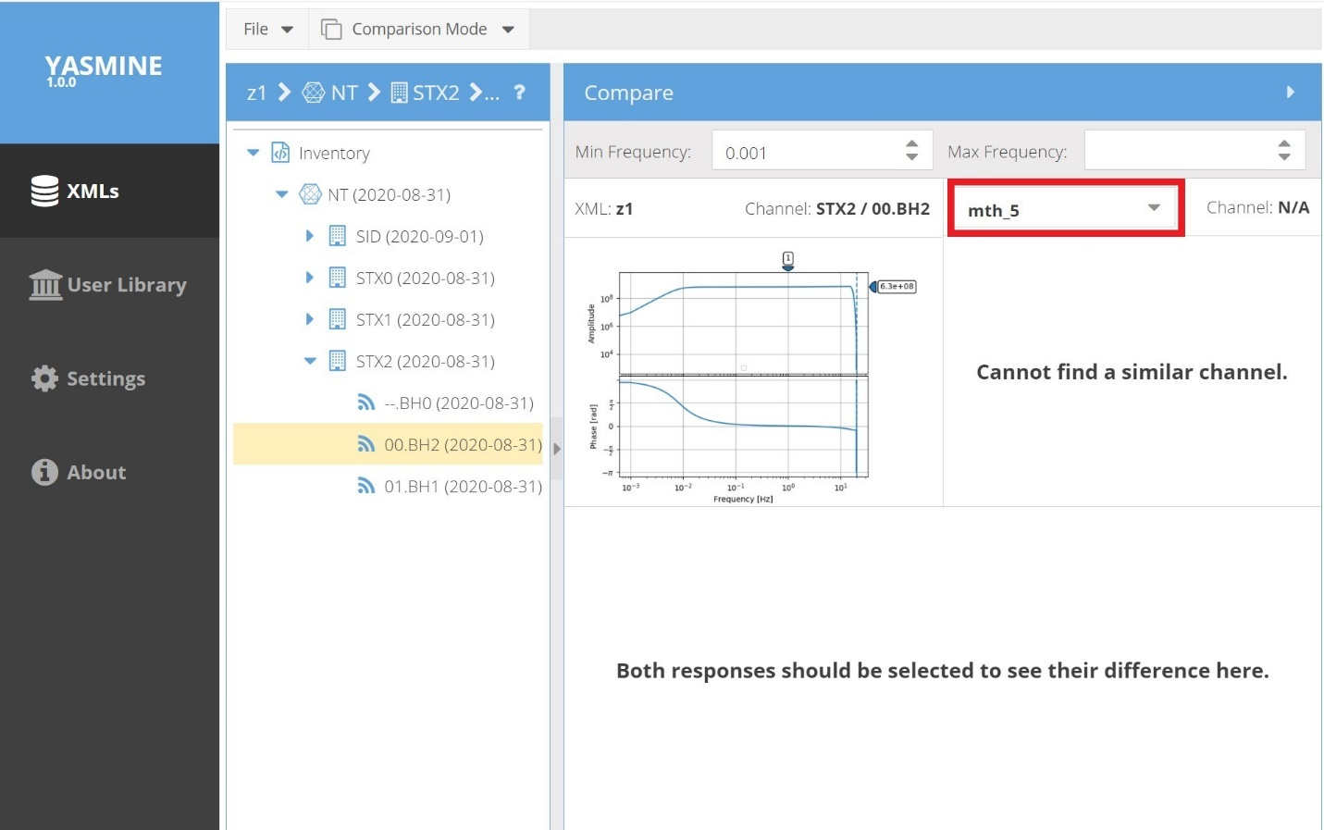
Figure 37 - Comparison mode
At this point you may select a second StationXML file in the upper right and once you find another StationXML file with the same SNCL, both will be drawn, as will be a graph showing their differences.

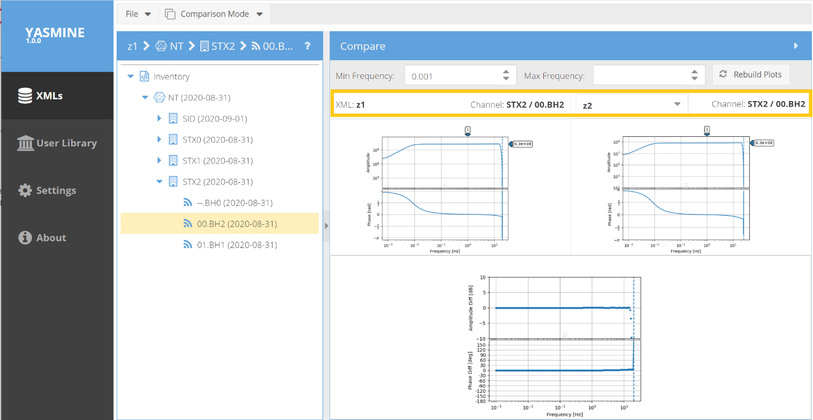
Figure 38 - Comparison Mode displaying two responses that differ very slightly (Sample Rate is different)

