- Old Republic International (ORI)(https://www.oldrepublic.com/) Chicago

- The corporate structure of Old Republic International Corporation is that of a holding company that owns numerous operating subsidiaries. The parent company itself does not directly sell insurance products; instead, it controls and coordinates the activities of its subsidiary companies.
Overall Corporate Structure: According to the company’s most recent Form 10-K (Exhibit 21: Subsidiaries of the Registrant): Old Republic operates through well over one hundred subsidiary entities (130–140 corporate entities depending on counting method). Among these are twenty-seven regulated insurance subsidiaries that conduct underwriting operations. The parent company owns most subsidiaries at 100% ownership, though a few are partially owned (for example some at 85%).
These subsidiaries collectively conduct all operational activities of the company.
Geographic Distribution: From the list of subsidiaries in Exhibit 21, the companies are incorporated or operate primarily in: United States (majority of entities; organized in states such as Delaware, Illinois, Vermont, Pennsylvania, Texas, California, and others). Canada (several subsidiaries such as Dependable Life Insurance Company and Old Republic Insurance Company of Canada)
Overall, Old Republic’s subsidiaries conduct business across the United States, Canada, and U.S. territories, covering all fifty states and Canadian provinces through their insurance operations. Organizational Segments: The subsidiaries are grouped into several major operating groups under the parent holding company:
Specialty Insurance Group (largest segment): Includes many underwriting companies such as BITCO General Insurance Corporation and Great West Casualty Company. Title Insurance Group: Includes companies such as Old Republic National Title Insurance Company and related title service firms. Other supporting subsidiaries: Risk management companies Agency companies. Technology and service subsidiaries. These subsidiaries manage underwriting, title services, claims management, and related insurance operations.
Example Subsidiaries: Examples listed in Exhibit 21 include:
- BITCO General Insurance Corporation
- BITCO National Insurance Company
- Old Republic Insurance Company
- Great West Casualty Company
- Old Republic National Title Insurance Company
- Old Republic Surety Company
- Old Republic Insurance Company of Canada
Summary
In summary, Old Republic International has a complex holding-company corporate structure consisting of 130–140 subsidiaries, including twenty-seven primary insurance underwriting companies. These entities operate primarily in the United States and Canada, organized into major segments such as Specialty Insurance and Title Insurance, with most subsidiaries fully owned by the parent company.

- Data Flow Diagram (DFD) illustrates how information moves through a system, identifying where data originates, how it is processed, and where it is stored or transmitted. For a large insurance holding company such as Old Republic International, the data flow would involve multiple subsidiaries, customers, intermediaries, and regulatory bodies.
External Data Sources: The data flow begins with several external entities that provide input to Old Republic’s operating subsidiaries. These include policyholders, insurance agents and brokers, financial institutions, and regulatory authorities. Customers submit applications for insurance policies, provide personal and financial information, and file claims. Agents and brokers transmit underwriting requests and policy documentation to the insurance subsidiaries. Financial institutions may send payment confirmations, premium financing data, or escrow information in the case of title insurance operations. Regulators receive compliance reports and financial filings while also providing regulatory requirements and reporting standards back to the company.
Data Input and Processing: Incoming data is received through multiple channels such as online applications, internal agency management systems, email, and enterprise portals. The information first enters the policy administration systems maintained by Old Republic’s subsidiaries. These systems validate and categorize the data. For example, underwriting systems evaluate applicant risk profiles using demographic information, claims history, and financial data. At this stage, several internal processes occur:
Underwriting analysis determines eligibility and risk level.
Policy issuance processing generates policy documentation and premium schedules.
Claims intake and evaluation processes incident reports and supporting documentation.
The processed data is then stored in centralized enterprise databases or subsidiary-specific systems. Internal Data Movement: Once stored, information flows between several internal departments and systems. Policy and claims data move to accounting and financial reporting systems, which track premiums, reserves, and claims payments. Risk management teams access the same data to evaluate exposure across the company’s portfolio. Because Old Republic operates through numerous subsidiaries, data also moves between corporate and subsidiary systems. For example, underwriting subsidiaries send operational and financial performance data to corporate management systems for consolidation and strategic analysis. This information contributes to financial disclosures and reporting. Data Storage and Security: Critical information is maintained in secure data repositories, including policy databases, claims management systems, and financial reporting platforms. These systems must comply with insurance industry regulations and data protection standards. Access controls, authentication mechanisms, and monitoring systems help ensure that only authorized personnel can access sensitive policyholder information. Data Outputs: Finally, processed information is distributed to several destinations. Policyholders receive policy documents, billing statements, and claims determinations. Agents and brokers receive updates on underwriting decisions and policy status. Corporate leadership receives financial performance dashboards and risk reports compiled from subsidiary operations. Regulatory authorities receive compliance filings and statutory financial reports.

Summary
Overall, the data flow within Old Republic International begins with external stakeholders providing information, moves through underwriting, policy administration, claims management, and financial systems, is stored within secure enterprise databases, and produces reports, policies, and regulatory filings. Because the company operates through many subsidiaries, data also flows vertically between operating companies and the corporate parent for reporting, oversight, and strategic management.

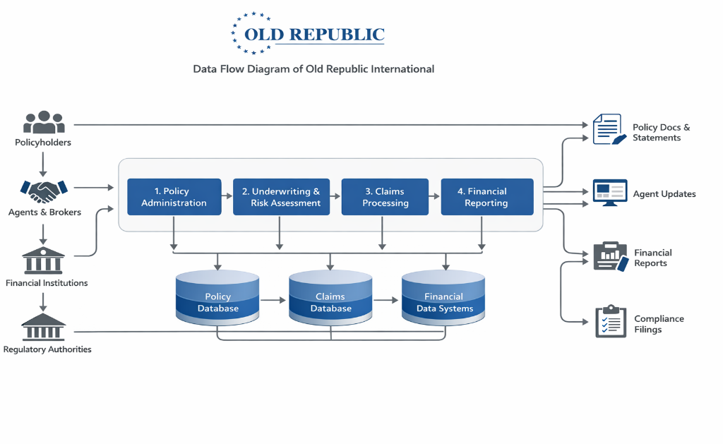
- Critical Business Process Data Flow – Old Republic International
  - Policyholder / Customer
  - Insurance Agents and Brokers
  - Policy Administration System
  - Underwriting and Risk Assessment Systems
  - Claims Management System
  - Financial and Accounting Systems
  - Regulatory Authorities

- End-to-End Data Flow Summary
- Customer → Agent/Broker
Customer submits personal and financial information.
- Agent/Broker → Policy Administration System
Application data enters the insurer’s internal systems.
- Policy System → Underwriting Systems
Risk analysis and pricing decisions are generated.
- Underwriting → Policy Issuance
Approved policies are created and stored.
- Customer → Claims System
Claims information enters the network when incidents occur.
- Claims System → Financial Systems
Payments and reserves are recorded.
- Financial Systems → Regulators
Compliance and financial reports exit the network.

- Information Security Risk Analysis (Old Republic International)
What is Risk?
According to NIST SP 800-30, risk is the potential for harm to an organization when a threat exploits a vulnerability, resulting in negative impacts to confidentiality, integrity, or availability of information.
In cybersecurity terms, risk is typically understood as the combination of:
Threat likelihood System vulnerability
Potential organizational impact: For a large insurance company like Old Republic International, risk primarily relates to the protection of customer data, financial records, and operational systems that support underwriting, claims processing, and regulatory reporting.
Example of Risk: One realistic risk for Old Republic International involves unauthorized access to policyholder information stored in internal insurance systems.
For example, if attackers gain access to the company’s policy administration database, they could obtain sensitive information such as:

Social Security numbers
addresses
financial data
insurance claim records

The impact could include identity theft, regulatory penalties, reputational damage, and financial losses. Because insurance companies hold large volumes of sensitive data, they are attractive targets for cybercriminals. What, is a Threat? (With Example)
A threat is any event or actor that has the potential to cause harm to an organization’s information systems by exploiting vulnerabilities.
Threats can come from several sources, including external attackers, internal employees, or environmental events.
Example Threat: A phishing attack targeting company employees. Cybercriminals may send fraudulent emails that appear to come from internal systems or trusted partners. If an employee enters their login credentials into a fake website, attackers could gain access to internal insurance systems and customer databases.
This type of threat is common in financial and insurance organizations.
Example of a Vulnerability: A vulnerability is a weakness that can be exploited by a threat. For Old Republic International, one potential vulnerability is the complex IT environment created by its many subsidiaries. Because the company operates through numerous insurance entities, some subsidiaries may rely on older or inconsistent IT systems.
Potential vulnerabilities could include legacy policy administration systems.
inconsistent security configurations across subsidiaries delayed software patching or updates. These weaknesses could allow attackers to exploit system flaws or gain unauthorized access through compromised credentials.
Risk Assessment Approach: NIST SP 800-30 describes three primary approaches to risk assessment:
Qualitative
Quantitative
Semi-quantitative
If conducting a risk assessment for Old Republic International, the semi-quantitative approach would be the most effective. Why, Semi-Quantitative?
The company operates a large and complex insurance enterprise with many subsidiaries.
It must evaluate risk across multiple systems and business units. A purely qualitative approach may not provide enough structure for prioritizing risks.
A fully quantitative approach requires precise monetary loss data that may not always be available. A semi-quantitative assessment allows the organization to assign numerical scores to likelihood and impact, helping leadership prioritize cybersecurity investments while still maintaining flexibility in the analysis. Reference
National Institute of Standards and Technology. Guide for Conducting Risk Assessments (NIST Special Publication 800-30). U.S. Department of Commerce.

DATE | ACTIVITY | TIME
3/09/2026 | Syllabus Quiz | 0.25
3/09/2026 | Watch Videos | 1.00
3/10/2026 | Readings | 2.50
3/13/2026 | Discussion Boards | 1.50
3/15/2026 | Assignment | 3.00

