**Задание 16.1**

01234123452345634567

**Задание 16.2**

002036

**Задание 16.3**

01512

**Задание 16.4**

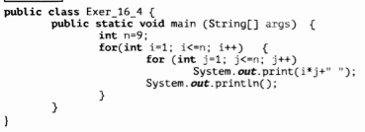

**Задание 16.5**

public class Main

{

public static void main(String[] args) {

for (int i=10; i <= 99; i++){

if (i%2 == 0)

System.out.print(i + " ");

}

System.out.println(" ");

for (int j= 10; j <=99; j++) {

if (j % 3 == 0)

System.out.print(j + " ");

}

System.out.println(" ");

for (int q= 10; q <=99; q++) {

if (q % 4 == 0)

System.out.print(q + " ");

}

System.out.println(" ");

for (int s= 10; s <=99; s++) {

if (s % 5 == 0)

System.out.print(s + " ");

}

}

}

**Задание 16.6**

**public class Main**

**{**

**public static void main(String[] args) {**

**for (int a = 0; a <= 100; a++){**

**for (int b = 0; b <= 100; b++){**

**if((((a * 10) + (b * 5)) == 100) && ((a + b) == 100))**

**{**

**System.out.printf(**

**"%2d * 10 = %3d\n" +**

**"%2d * 5 = %3d\n",**

**a, (a * 10),**

**b, ((int) (b * 5))**

**);**

**System.out.println("\nНа 100 рублей можно купить:\n-----------------------------");**

**System.out.println(a + " корову\n" + b + " быков\n");**

**}**

**}**

**}**

**}**

**}**

**Задание 16.7**

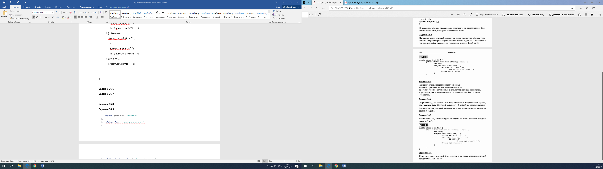

**Задание 16.8**

public class Main {

public static void main(String[] args)

{

int sum = 0;

int n = 75;

for (int i = 1; i<=n; i++)

{

System.out.print(i+": ");

for (int j = 1; j <= i; j++){

if (i % j == 0) {

System.out.print(j + " ");

sum += j;

}

}

System.out.print("Sum = "+sum);sum=0;

System.out.println();

}

}

}