**Задание 16.9**

public static void main(String[] args)

{

Scanner keyboard = new Scanner(System.in);

int n = keyboard.nextInt();

int k = 1;

String plus;

for (int i = 1; i <= n; i++)

{

plus = Integer.toString(i);

for (int j = 1; j <= k; j++)

{

if (k % j == 0)

{

plus = plus + "+";

}

}

k++;

System.out.println(plus);

}

}

**Задание 16.10**

public static void main(String[] args)  
{  
 int n = 100000;  
 int count;  
 int sum;  
 for (int i = 1; i <= n; i++)  
 {  
 sum = 0;  
 count = 0;  
 for (int j = 1; j < i; j++)  
 {  
 if (i % j == 0)  
 {  
 sum += j;  
 count++;  
 }  
 }  
 if (i == sum)  
 {  
 System.*out*.println(i);  
 }  
 }  
}

**Задание 16.11**

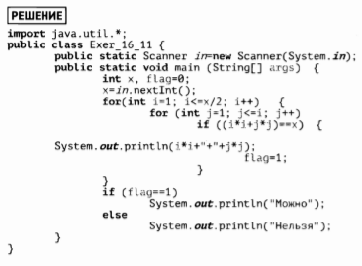

**Задание 16.12**

public class Main {

public static void main(String[] args)

{

int n = 10000;

int gg = 0;

int sumone, summax = 0, sumtbd;

for (int i = 1; i <= n; i++)

{

sumone = 0;

for (int j = 1; j < i; j++)

{

if (i % j == 0)

{

sumone += j;

}

}

if (sumone > summax)

{

summax = sumone;

gg = i;

}

}

System.out.println(gg + " | " + summax);

}

}

**Задание 16.13**

**Задание 16.14**

public class Main {

public static void main(String[] args)

{

int n = 100;

Boolean tr = false;

int sum = 0;

int count = 0;

for (int i = 10; i < n; i++)

{

for (int j = 2; j < i/2; j++)

{

if (i % j == 0) {

tr = false;

break;

} else {

tr = true;

}

}

if (tr)

{

count++;

sum += i;

System.out.println(i);

}

}

System.out.println("Количество = " + count + " Сумма = " + sum);

}

}

**Задание 16.15**

