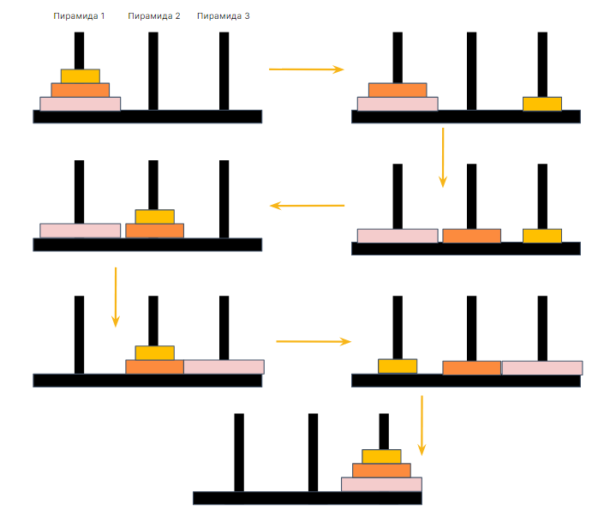

=== javascript  
function hanoi (n, start, end, temp) {

const stack = [];

stack.push({ n, start, end, temp });

while (stack.length > 0) {

const { n, start, end, temp } = stack.pop();

if (n === 1) {

console.log(`Перемещаем диск ${n} с ${start} на ${end}`);

} else { stack.push({ n: n - 1, start: temp, end, temp: start });

stack.push({ n: 1, start, end, temp });

stack.push({ n: n - 1, start, end: temp, temp: end });

} } }

const n = 3;

const startPeg = '1';

const endPeg = '2';

const tempPeg = '3';

hanoi (n, startPeg, endPeg, tempPeg);

=== java

public class Tower {

public static void main(String[] args) {

int num = 3;

towerOfHanoi(num, 'A', 'C', 'B');

}

public static void towerOfHanoi (int num, char from, char to, char help) {

if (num == 1) {

System.out.println("Take disk from tower " + from + " to tower " + to);

return;

}

towerOfHanoi(num - 1, from, help, to);

System.out.println("Take disk from tower " + from + " to tower " + to);

towerOfHanoi(num - 1, help, to, from);

}