  - SECURITY OPERATIONS

Security Monitoring
Foundation
  - Deployment & Operational Handover Report


TETRION
Four Minds. Infinite Possibilities.
Wazuh 4.14.7 / Windows & Linux endpoint coverage
Prepared for Tetrion
Prepared by Roman Rzayev
15 October 2026
TET-SOC-001 | Version 1.0

  - 01 / MANAGEMENT OVERVIEW

Executive summary
Tetrion's security monitoring foundation brings a Windows workstation and an Ubuntu web server into one Wazuh monitoring platform. The supplied implementation record shows a running Wazuh 4.14.7 single-node stack, successful dashboard access and two active endpoint agents.
Windows Sysmon is installed with a community configuration, and Apache serves its default page on the Linux endpoint. Short bidirectional connectivity checks succeed between all three systems. These results establish the initial platform and endpoint-enrollment baseline.
Capability | Recorded result
Central monitoring | Three Wazuh containers Up; dashboard loads.
Endpoint coverage | win-client and ubuntu-web Active on 4.14.7.
Windows telemetry readiness | Sysmon64 Running; event ingestion still requires proof.
Web-service readiness | Apache Running; default page opens.
Operational acceptance | Controlled event validation, recovery and hardening evidence outstanding.

Management decision
Proceed with completion and acceptance testing. Do not treat the platform as production accepted until telemetry delivery, recovery, credentials and isolation controls are verified.
This is an evidence-based deployment report prepared for Tetrion. It is not a live audit of the original machines; the review is limited to the supplied screenshots and implementation notes.

  - 02 / REPORT NAVIGATION

Contents & document control
Executive summary / Scope / Architecture / Deployment / Validation / Operations / Evidence register / Evidence annex
Use the PDF for fixed pagination; Word pagination depends on the installed fonts.
Field | Value
Document ID | TET-SOC-001
Version / issue date | 1.0 / 15 October 2026
Prepared for / prepared by | Tetrion / Roman Rzayev
Subject | Security Monitoring Foundation - Deployment Report
Status | Implementation recorded; acceptance actions open
Handling | Internal technical record; repository copy contains selected implementation evidence.
Source roles: Week1_SOC_Lab (1).docx defines the acceptance baseline; faridexiyetimbrat.docx supplies implementation notes and 29 screenshots. ED-Lab04-Executive-Report.pdf is a visual layout reference only. Its company identity, findings, targets and assessment claims are not carried into this report.

  - 03 / SCOPE & INTERPRETATION

Scope and assessment basis
The scope is a three-system VMware environment: one Ubuntu monitoring server, one Ubuntu web endpoint and one Windows endpoint. The implementation uses a host-only network for internal communication and a second NAT interface on the monitoring server.
Included | Outside the demonstrated scope
VM resources, addressing and ICMP reachability | Comprehensive routing, firewall and time-synchronization audit
Wazuh stack startup and dashboard access | Continuous uptime, load testing and production high availability
Agent enrollment and point-in-time Active state | End-to-end validation of all required security events
Sysmon and Apache installation evidence | Incident response automation and attack detection effectiveness
Evidence labels are intentionally precise. Recorded means a capture directly supports the stated observation. Partial means the capture supports only part of a requirement. Open means the supplied material does not establish completion. These labels are not results of new tests against the original systems.

Implementation variance
The endpoint resource allocations differ from the supplied baseline, and the Linux network captures show dynamically assigned addresses. These differences are documented rather than normalized into an assumed compliant configuration.
The report date is the document issue date, not an assertion about the date of every source capture. No passwords, private keys, certificates or invented operational measurements are included.

  - 04 / SYSTEM DESIGN

Architecture & asset inventory
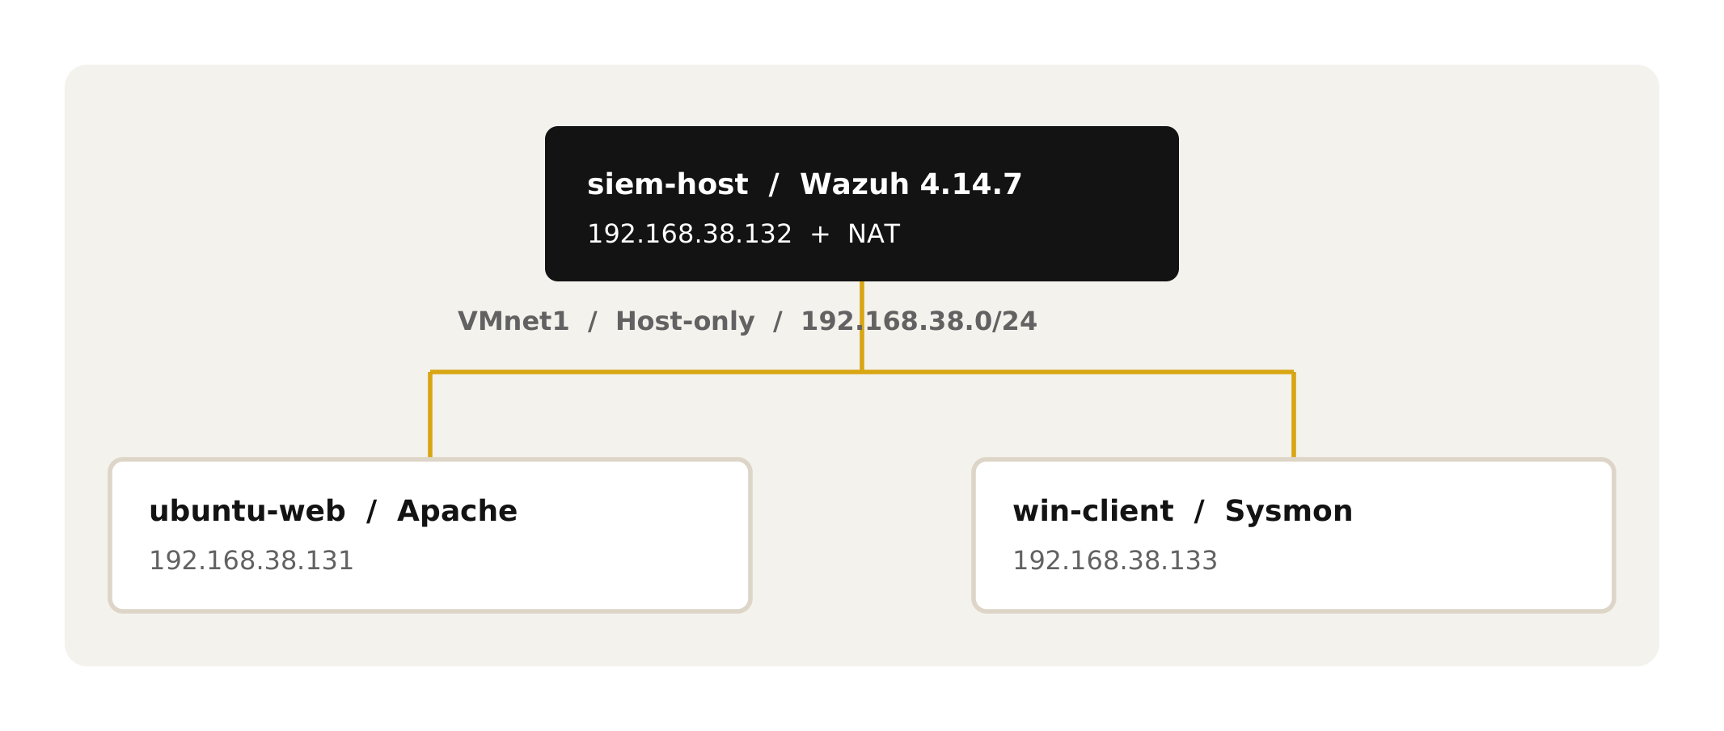
Asset / IP | Recorded resources | Role
siem-host  192.168.38.132 | 16 GB / 6 vCPU / 500 GB | Wazuh server; NAT also present
ubuntu-web  192.168.38.131 | 4 GB / 2 vCPU / 500 GB | Ubuntu 22.04; Apache; agent
win-client  192.168.38.133 | 4 GB / 4 vCPU / 60 GB | Windows 10 Enterprise Evaluation; agent; Sysmon
The screenshots associate the server with ens36 on 192.168.38.132/24 and ens33 on 192.168.121.156/24. The latter is the recorded NAT-side address and may change. VMnet1 DHCP is enabled; Linux interfaces carry the dynamic flag. Static assignment or reservation is therefore not established.
Recorded RAM allocation totals 24 GB, compared with the 22 GB baseline. Ubuntu has 4 GB instead of 2 GB; Windows has 4 vCPUs instead of 2 and a 60 GB disk instead of 80 GB. Both Linux virtual disks show 500 GB. The images do not establish physical disk consumption or available host capacity.

  - 05 / PLATFORM IMPLEMENTATION

Deployment & telemetry design
The implementation clones the official wazuh-docker repository at v4.14.7, generates deployment certificates, and starts the single-node stack using Docker Compose. The visible services are wazuh.manager, wazuh.indexer and wazuh.dashboard; all three use 4.14.7 images and show Up status in the container listing.
Filebeat runs as part of the manager image in this deployment. A typical event path is: endpoint source -> Wazuh agent -> manager decoding and rule evaluation -> Filebeat alert forwarding -> indexer storage -> dashboard search. This is the expected design; the supplied captures do not trace one controlled event through every stage.
Component | Operational responsibility
Agent | Collect configured endpoint logs and forward them to the manager.
Manager | Decode events, evaluate rules and produce alerts.
Filebeat / indexer | Forward alert records and index them for search.
Dashboard | Authenticate analysts and present indexed monitoring information.
Windows enrollment first shows a service-start error and then a successful WazuhSvc start. A later inventory verifies win-client Active. Linux systemctl output verifies wazuh-agent Running; the final inventory verifies ubuntu-web Active. Both agent versions match the 4.14.7 manager line.

Visibility boundary
Sysmon64 Running proves installation, not ingestion. A Wazuh event containing the Microsoft-Windows-Sysmon/Operational channel, endpoint name and Event ID is still needed to demonstrate the Windows telemetry pipeline.

  - 06 / OPERATIONAL ASSURANCE

Validation & acceptance priorities
Control | What the evidence establishes | Next verification
Connectivity | All six directed peer checks receive replies. | Record current clocks, routes and final adapter state.
Web service | Apache active; default page displayed. | Record the browser host and a dated HTTP response.
Agent coverage | Two Active endpoints on v4.14.7. | Recheck after stack restart and server reboot.
Security events | Dashboard overview only; no controlled-event records. | Generate and capture the five event cases below.
Credential control | Login is shown; password rotation is not. | Use the Docker deployment password-change procedure.
Required event cases are a failed SSH login, a sudo command, Linux local-user creation, a Windows process launch observed through Sysmon, and a failed Windows logon. Each needs the agent name, timestamp, rule description, rule level and screenshot. No rule IDs or levels have been invented in this report.

Priority before acceptance
Confirm persistent addressing and endpoint isolation; rotate default credentials; demonstrate five event cases and Sysmon ingestion; complete restart/reboot persistence checks; record memory and snapshots.
A short ping test proves sampled IP reachability. An Up container status proves a process was running at capture time. Neither alone establishes end-to-end security monitoring, sustained service health or recoverability.

  - 07 / OPERATIONAL HANDOVER

Startup, shutdown & recovery
The following is the operating procedure for the recorded architecture. It is derived from the visible deployment path and normal Compose behavior; it has not been executed against the original VMs during this document review.
- Start siem-host first. Confirm the internal interface is on 192.168.38.132/24 and that vm.max_map_count meets the Wazuh indexer prerequisite (at least 262144).
- In the existing single-node deployment directory (recorded as /root/wazuh-docker/single-node), run docker compose up -d, then docker compose ps and inspect service logs if startup fails. Keep deployment credentials local.
- Open the configured dashboard URL over HTTPS from the operator workstation. Verify authentication and index availability. Assess the deployment certificate warning using its actual issuer and subject; do not disable TLS verification as a routine workaround.
- Start ubuntu-web and win-client. Verify Apache, Wazuh agent services and Sysmon64. Confirm both agents become Active and generate one authorized test event that appears in the dashboard.
- For shutdown, stop endpoint workloads and shut down the endpoints first. On siem-host use docker compose stop before shutting down the VM. Do not use docker compose down -v or delete persistent volumes.
- For recovery acceptance, record an agent inventory and a uniquely identifiable test alert, restart the stack, then reboot siem-host. Confirm the same agents and pre-existing alert remain searchable after each operation.
Record docker stats --no-stream at idle, the exact image versions, snapshot names and Windows evaluation expiry. Stop/start, reboot persistence and memory measurements remain unverified until their outputs are retained.

  - 08 / EVIDENCE-LED HANDOVER

Evidence register & next actions
The following annex retains all 29 embedded screenshots in source order, with one observation per figure. Every screenshot sits in a consistent 493 x 205 pt frame, is fitted proportionally without cropping, and retains its original embedded pixel data. Smaller captures cannot recover detail absent from the original.
Evidence range | Coverage
E01-E07 | VMware resources, host-only network and interface addresses
E08-E10 | Peer reachability in all three directions
E11-E14 | Sysmon installation and Apache service
E15-E20 | Wazuh release, certificates, containers and dashboard
E21-E26 | Windows and Linux enrollment and Active inventory
E27-E29 | System naming commands and Windows identity context
For review at source resolution, use evidence/screenshots/ in the accompanying repository. evidence/manifest.json records dimensions and SHA-256 digests. The editable document is a companion; the PDF is the fixed-layout presentation master.

Close-out deliverables
Complete the acceptance matrix in docs/acceptance.md using new screenshots and outputs from the actual VMs. The retrospective journal distinguishes observations from unrecorded troubleshooting; missing events and measurements must be supplied by execution, not reconstruction.
Official technical references: documentation.wazuh.com/current/deployment-options/docker/wazuh-container.html; docs.docker.com/engine/install/ubuntu/; learn.microsoft.com/sysinternals/downloads/sysmon; github.com/SwiftOnSecurity/sysmon-config. These are implementation references, not claims that all documented steps were performed.

  - EVIDENCE ANNEX

Compute provisioning

E01 | Windows endpoint resources
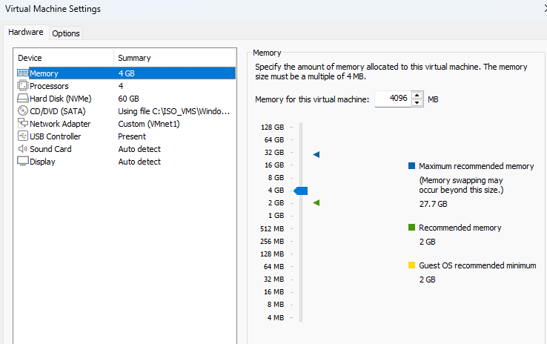
Figure E01. VMware settings show 4 GB RAM, 4 vCPUs, a 60 GB disk and Custom (VMnet1) networking.

E02 | Linux endpoint resources
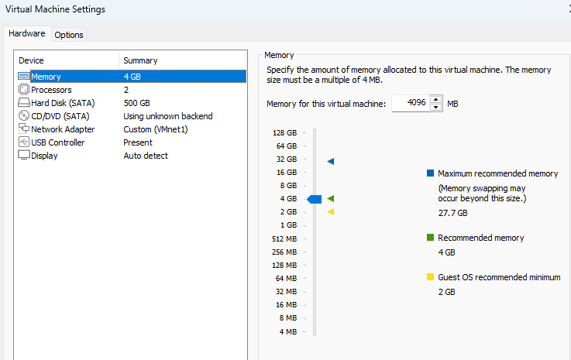
Figure E02. VMware settings show 4 GB RAM, 2 vCPUs, a 500 GB disk and Custom (VMnet1) networking.

  - EVIDENCE ANNEX

Server & virtual networking

E03 | Monitoring server resources
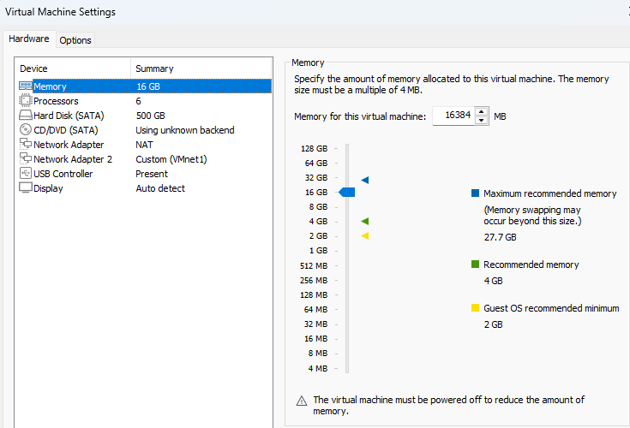
Figure E03. VMware settings show 16 GB RAM, 6 vCPUs, a 500 GB disk, NAT and Custom (VMnet1) adapters.

E04 | Virtual network configuration
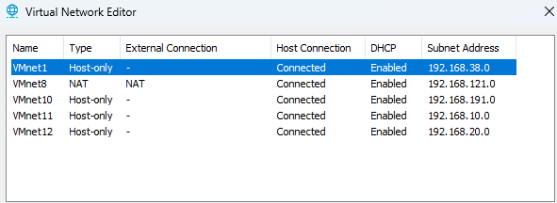
Figure E04. VMnet1 is Host-only on 192.168.38.0; DHCP is enabled. VMnet8 provides a separate NAT network.

  - EVIDENCE ANNEX

Endpoint addressing

E05 | Windows address configuration
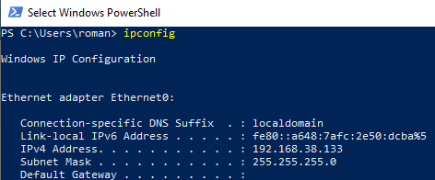
Figure E05. The Windows endpoint reports 192.168.38.133 with subnet mask 255.255.255.0 and no displayed default gateway.

E06 | Linux endpoint address configuration
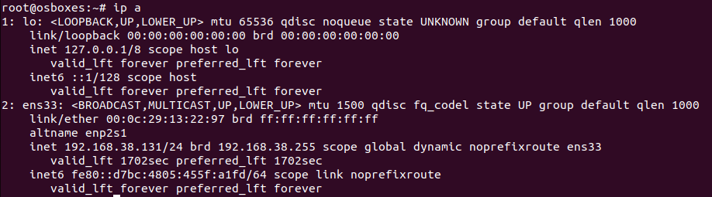
Figure E06. The Linux endpoint reports 192.168.38.131/24. The dynamic flag means static addressing is not demonstrated.

  - EVIDENCE ANNEX

Server network & reachability

E07 | Monitoring server interfaces
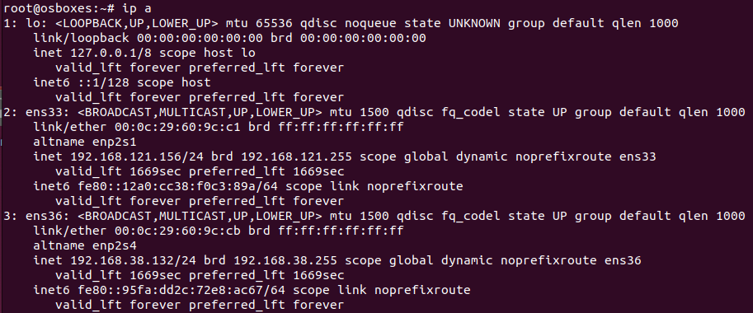
Figure E07. The server reports 192.168.38.132/24 on ens36 and NAT address 192.168.121.156/24 on ens33; both are marked dynamic.

E08 | Server-to-endpoint reachability
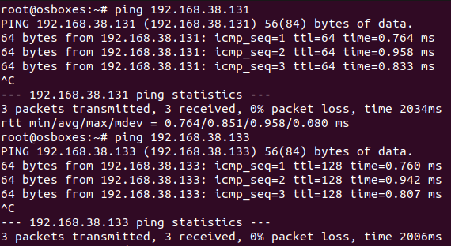
Figure E08. The monitoring server receives three replies from each endpoint, with 0% packet loss in both short tests.

  - EVIDENCE ANNEX

Peer connectivity

E09 | Linux-to-peer reachability
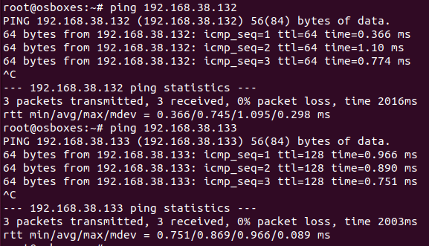
Figure E09. The Linux endpoint receives three replies from the server and three from Windows, with 0% packet loss.

E10 | Windows-to-peer reachability
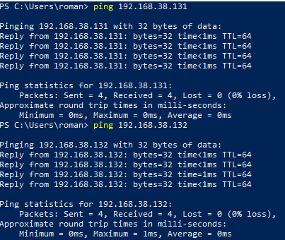
Figure E10. Windows receives four replies from the Linux endpoint and four from the server, with 0% packet loss.

  - EVIDENCE ANNEX

Endpoint service preparation

E11 | Windows Sysmon installation
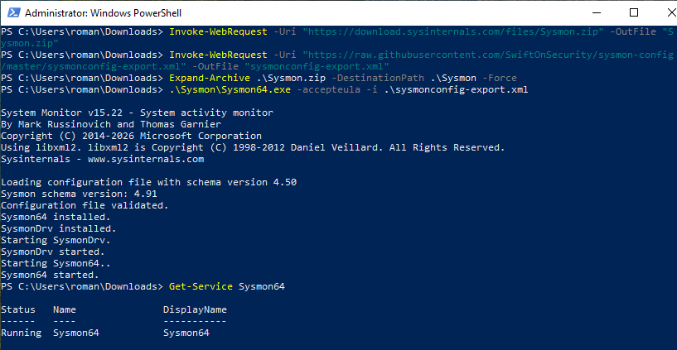
Figure E11. Sysmon v15.22 loads the SwiftOnSecurity configuration; the Sysmon64 service is Running. Dashboard ingestion is not shown.

E12 | Apache package installation
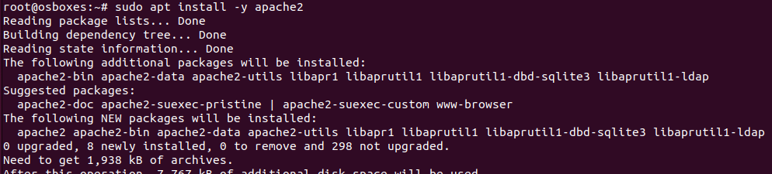
Figure E12. APT output shows installation of Apache packages on the Linux endpoint; this capture is an installation stage.

  - EVIDENCE ANNEX

Web-service readiness

E13 | Apache service state
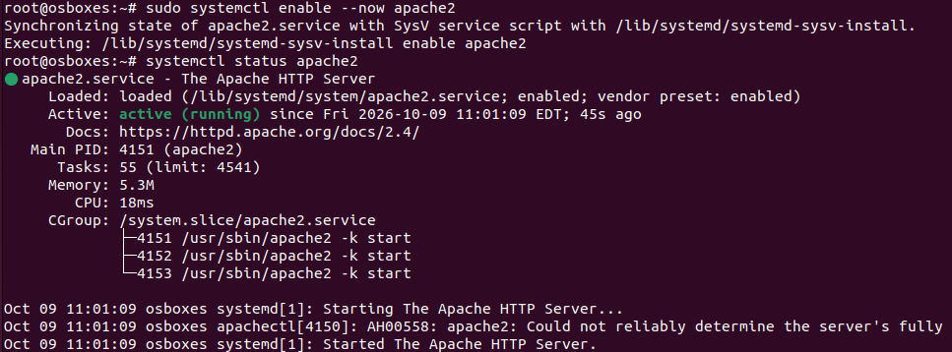
Figure E13. Apache is enabled and active (running). A ServerName warning is visible; the service remains running.

E14 | Web-service functional check
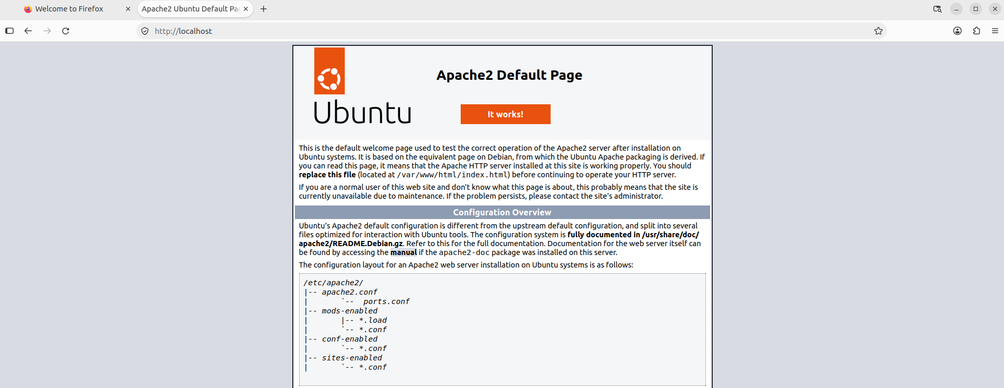
Figure E14. A browser displays the Apache2 Ubuntu Default Page at the Linux endpoint address. Browser host identity is not independently shown.

  - EVIDENCE ANNEX

Wazuh release & certificates

E15 | Pinned Wazuh source
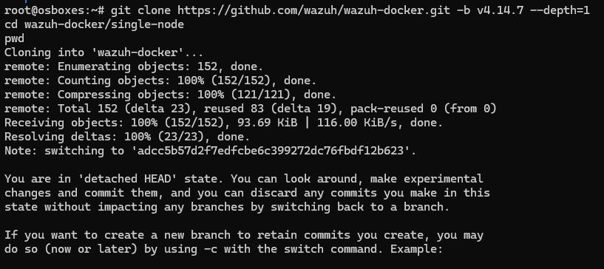
Figure E15. The recorded git clone selects wazuh-docker tag v4.14.7. Detached HEAD is expected for a release tag.

E16 | Certificate-generation preparation
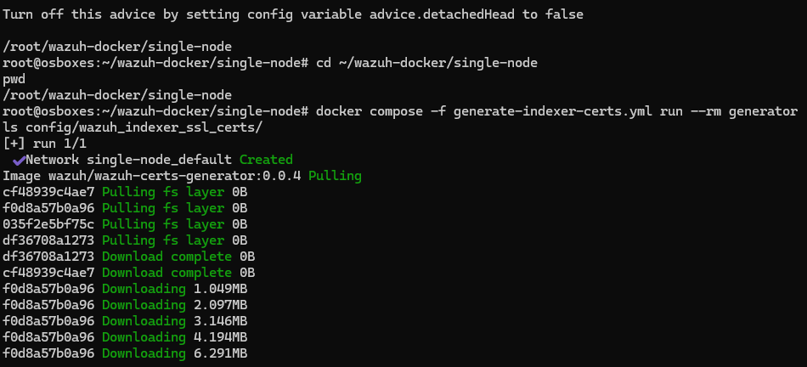
Figure E16. The certificate-generation Compose command pulls the Wazuh certificate-tool image for the single-node deployment.

  - EVIDENCE ANNEX

Certificate completion & runtime

E17 | Certificate-generation result
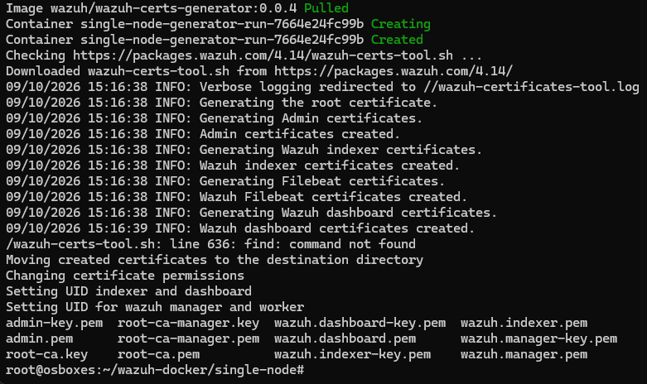
Figure E17. The tool reports certificates created for indexer, manager, Filebeat and dashboard, and moves them into the deployment directory.

E18 | Running single-node stack
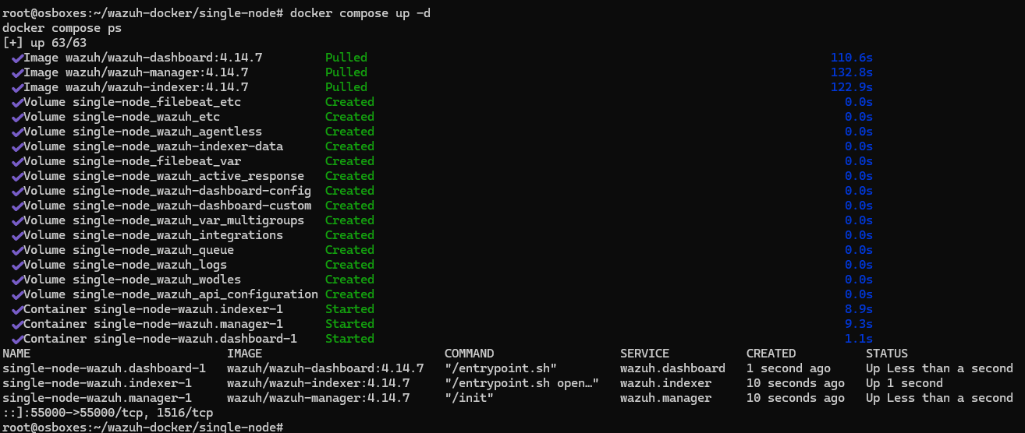
Figure E18. Docker Compose lists the dashboard, indexer and manager with 4.14.7 images and Up status. This is a point-in-time startup check.

  - EVIDENCE ANNEX

Dashboard access

E19 | Dashboard sign-in page
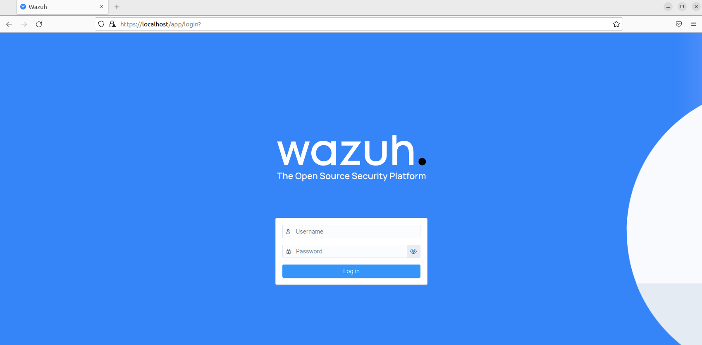
Figure E19. The Wazuh sign-in page is accessible in a browser. This does not prove a password change or certificate trust configuration.

E20 | Authenticated dashboard
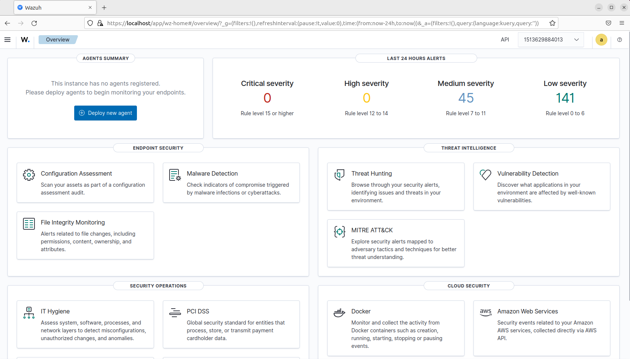
Figure E20. The Wazuh overview loads after authentication and shows security-event summary widgets. These are not the five required controlled tests.

  - EVIDENCE ANNEX

Windows agent enrollment

E21 | Windows enrollment settings
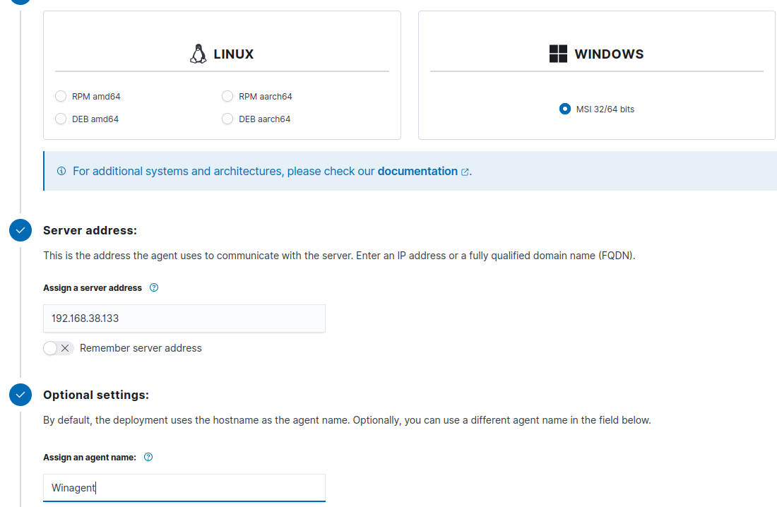
Figure E21. The dashboard deployment wizard selects Windows and the manager address 192.168.38.132 for an agent installation.

E22 | Windows agent service start
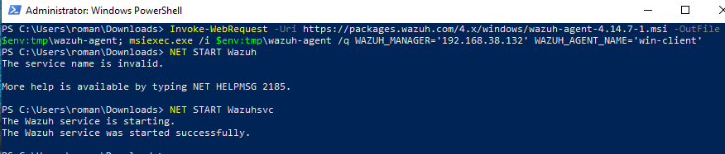
Figure E22. The agent install command names win-client. An initial NET HELPMSG 2185 response is followed by a successful WazuhSvc start.

  - EVIDENCE ANNEX

Windows inventory & Linux enrollment

E23 | Windows agent active
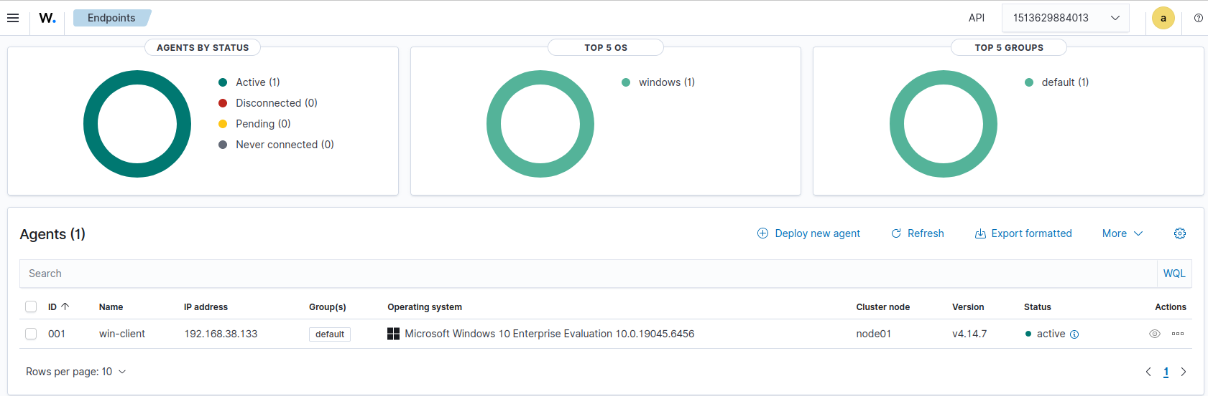
Figure E23. The inventory lists win-client at 192.168.38.133, agent v4.14.7, with active status.

E24 | Linux enrollment settings
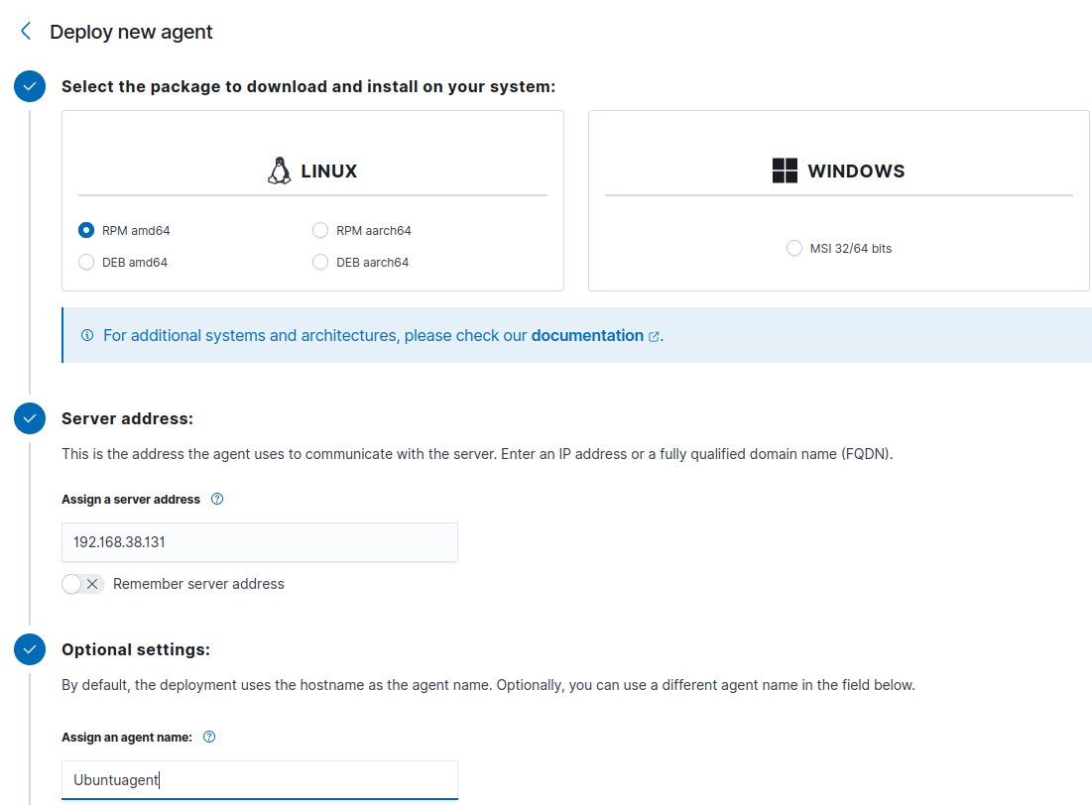
Figure E24. The dashboard deployment wizard selects Linux and the same monitoring-server address.

  - EVIDENCE ANNEX

Linux service & endpoint coverage

E25 | Linux agent service state
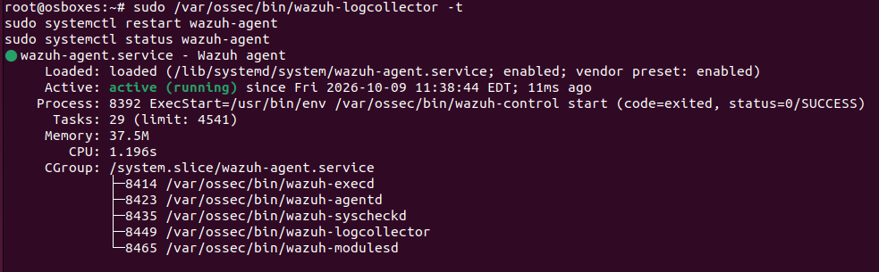
Figure E25. systemctl reports wazuh-agent enabled and active (running), with agent processes visible.

E26 | Two active monitored endpoints
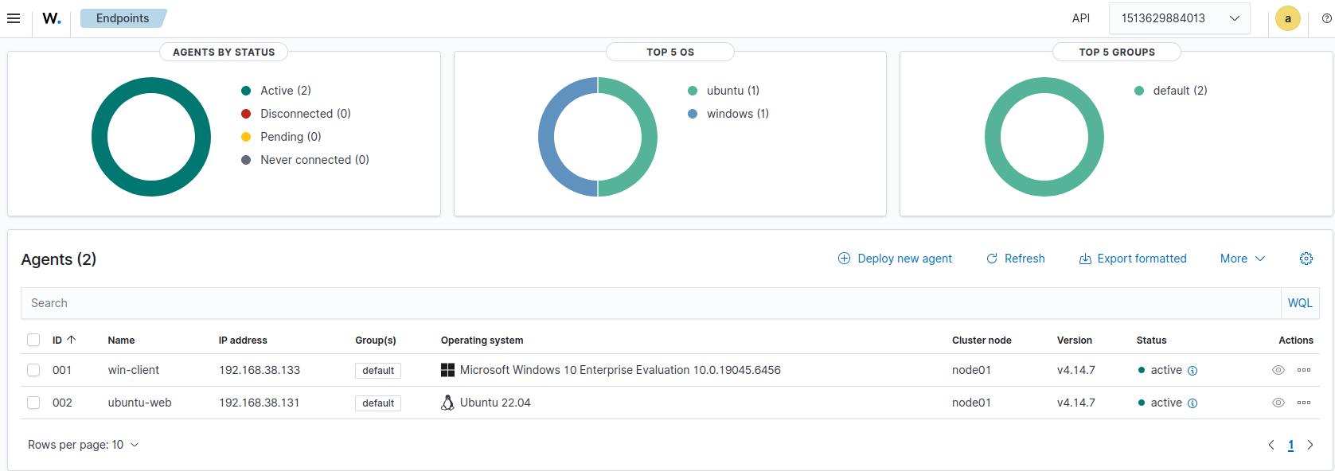
Figure E26. The inventory lists win-client and ubuntu-web as active, both on v4.14.7. The Linux endpoint is Ubuntu 22.04.

  - EVIDENCE ANNEX

Asset naming

E27 | Monitoring-server naming
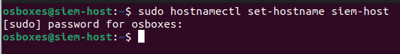
Figure E27. The hostnamectl command sets the server hostname to siem-host. A separate post-change hostname query is not shown.

E28 | Linux endpoint naming
Figure E28. The hostnamectl command sets the Linux endpoint hostname to ubuntu-web.

  - EVIDENCE ANNEX

Windows identity context

E29 | Windows hostname context
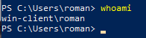
Figure E29. whoami returns win-client\roman, supporting the Windows computer-name context.

