Assignment 2

Question 3

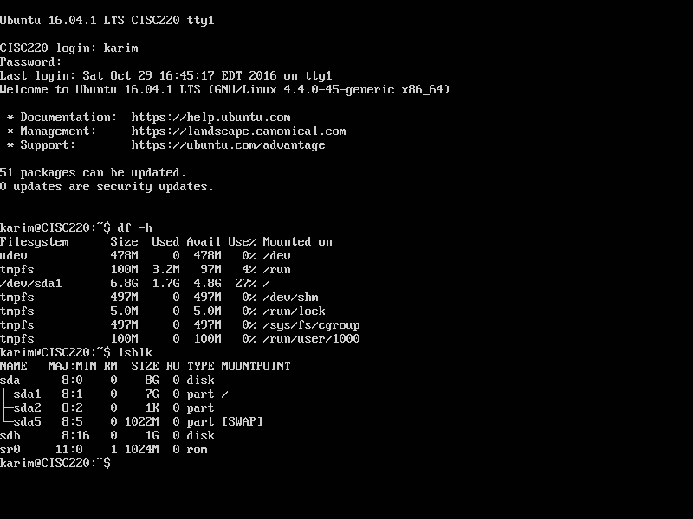Screenshot 1:

The *lsblk* command shows the new hard disk and it is named **sdb**.

Screenshot 2:

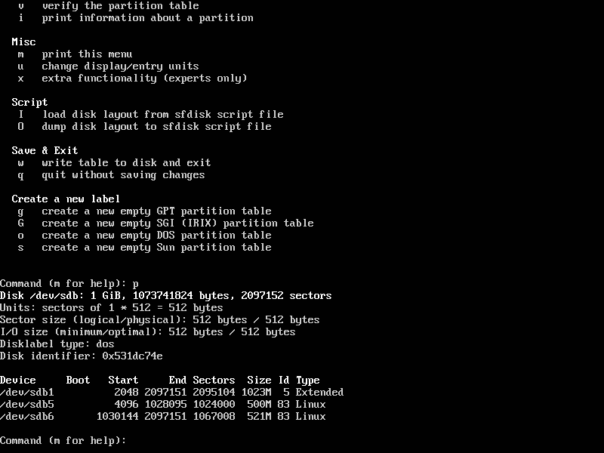

Screenshot 3:

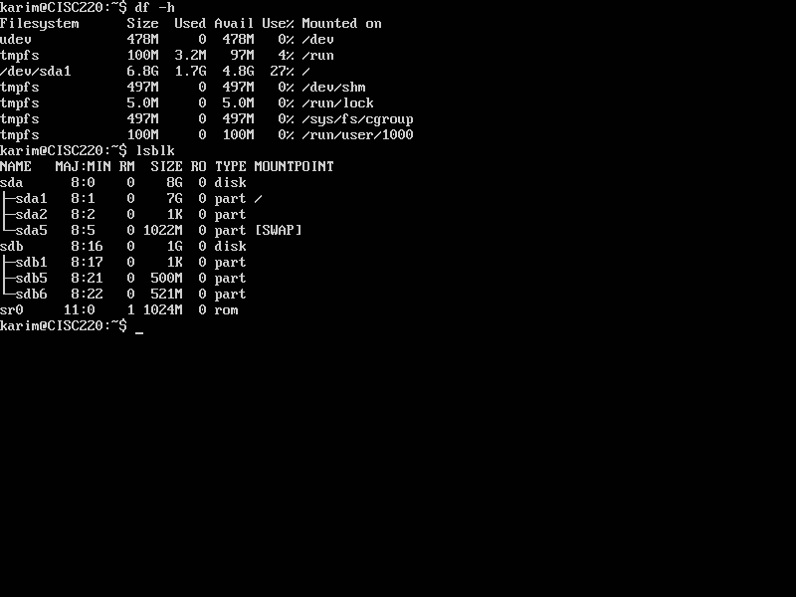

The *lsblk* command shows the hard disk and it is still named **sdb** (the partitions are shown also using the *lsblk* command).

Screenshot 4: