Cancel

In the TEI: (the xslt will be looking for this)

Code an id “edited” for the paragraph / stanza where the change was made – the place that was edited

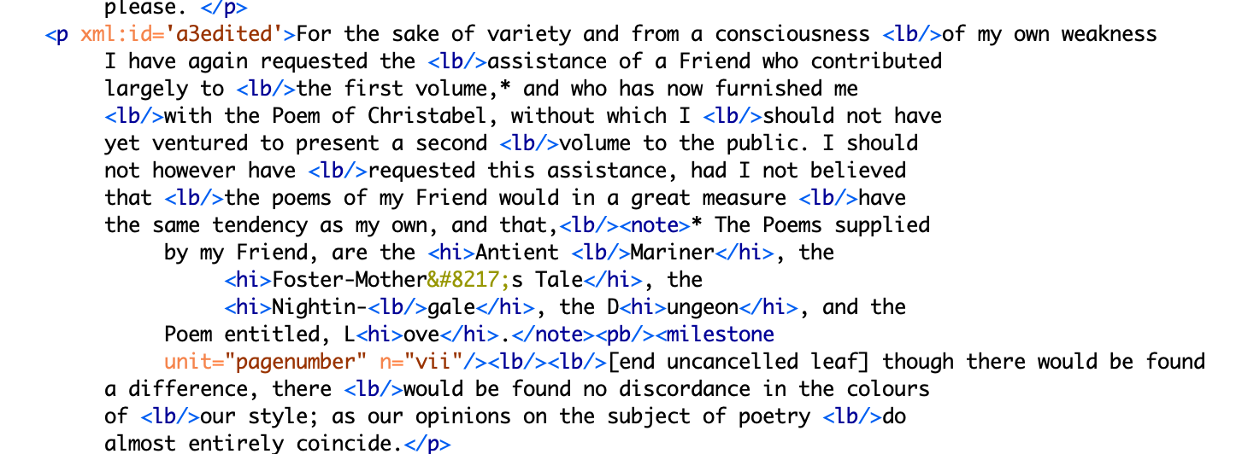

Then, give a corresponding id to the new version, the edited version – it is a change, and has Change //case sensitive // in it (the xslt will be looking for that as well.

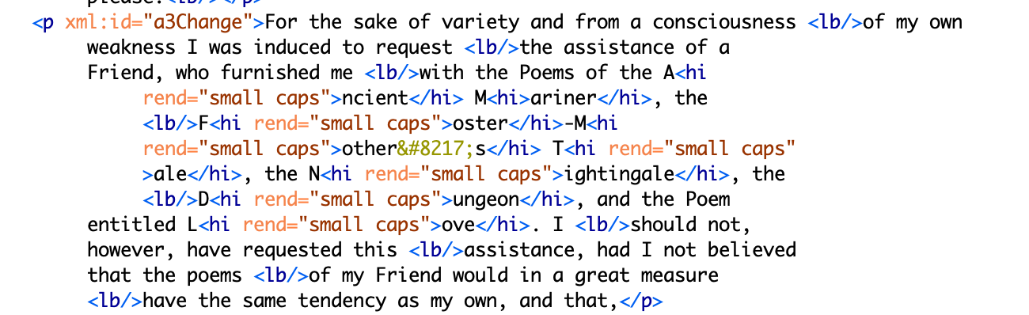

That change appears inside a div marking the changed leaf if printed in the volume as well.
