Car renting application

Analysis and Design Document

Student:Roman Tudor & Schiop Radu

**Group:30234**

Revision History

|  |  |  |  |
| --- | --- | --- | --- |
| **Date** | **Version** | **Description** | **Author** |
| <dd/mmm/yy> | <x.x> | <details> | <name> |
|  |  |  |  |
|  |  |  |  |
|  |  |  |  |

Table of Contents

I. Project Specification 4

II. Elaboration – Iteration 1.1 4

1. Domain Model 4

2. Architectural Design 4

2.1 Conceptual Architecture 4

2.2 Package Design 4

2.3 Component and Deployment Diagrams 4

III. Elaboration – Iteration 1.2 4

1. Design Model 4

1.1 Dynamic Behavior 4

1.2 Class Design 4

2. Data Model 4

3. Unit Testing 4

IV. Elaboration – Iteration 2 4

1. Architectural Design Refinement 4

2. Design Model Refinement 4

V. Construction and Transition 5

1. System Testing 5

2. Future improvements 5

VI. Bibliography 5

# Project Specification

*[Present the project specification]*

# Elaboration – Iteration 1.1

# Domain Model

The diagram presented below represents the base concept of the system, it’s first form that is going to be implemented and/or modified.

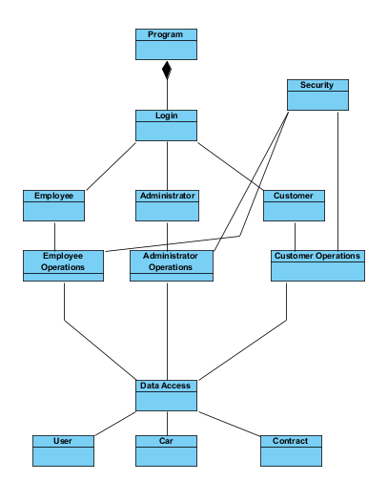

# Architectural Design

## Conceptual Architecture

The system architecture is based on the **3-Tier** architecture model. A 3-tier application is an application program that is organized into three major parts, each of which is distributed to a different place or places in a network. The three parts are:

* The graphical user interface (GUI)
* The business logic
* The database and the database manager programs (Picture1)

We chose to implement this kind of architecture because of it’s main advantages, advantages that

are important in domains like security, later development or encapsulation. Some of these advantages are:

* Managing data is independent from the physical storage
* Since the client doesn’t have direct access to the database business logic is more secure
* It is possible to make changes to any tier, without affecting the other two tiers. (e.g. You can totally replace the GUI without modifying any other part of the code

More specific, for our system the tier will implement as follows:

**Graphical User Interface -** this tier will implement the design of the application interface, the login window , the regular user window, where user can search and rent cars and the administrator window where he can make CRUD operations on employees. Also this tier will deal with how the user will see eventual errors and exceptions with pop-up messages and different type of error display.

**Business Logic** - this tier will implement all the operations that the application does, beside database operations. Operations like searching, or the operations included in the renting process will be implemented here. This tier is “the middle tier”, it will take data from the database tier, process it and transmit it to the GUI tier to be shown to the user.

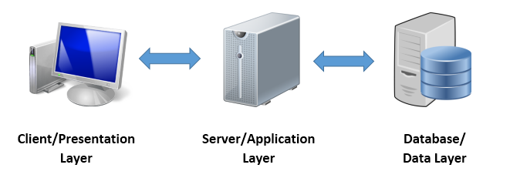 **Database Tier –** this tier will implement all the operation that the application needs for working with the database. More specific it will implement the connection to the database and operations like retrieving , deleting or updating data in the database.

[Picture 1]

## Package Design

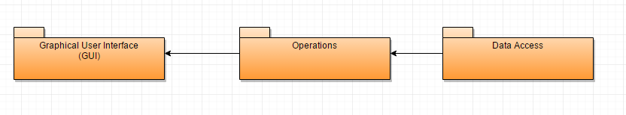

[Package Diagram]

## Component and Deployment Diagrams

[Deployment Diagram]

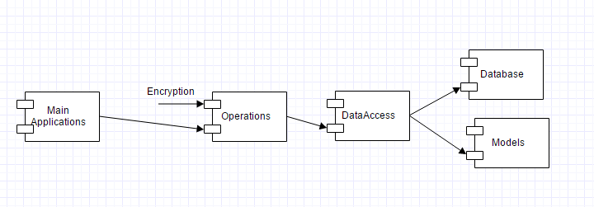

[Component Diagram]

# Elaboration – Iteration 1.2

# Design Model

## Dynamic Behavior

*[Create the interaction diagrams (1 sequence, 1 communication diagrams) for 2 relevant scenarios]*

## Class Design

*[Create the UML class diagram; apply GoF patterns and motivate your choice]*

# Data Model

*[Create the data model for the system.]*

# Unit Testing

*[Present the used testing methods and the associated test case scenarios.]*

# Elaboration – Iteration 2

# Architectural Design Refinement

*[Refine the architectural design: conceptual architecture, package design (consider package design principles), component and deployment diagrams. Motivate the changes that have been made.]*

# Design Model Refinement

## *[Refine the UML class diagram by applying class design principles and GRASP; motivate your choices. Deliver the updated class diagrams.]*

# Construction and Transition

# System Testing

*[Describe how you applied integration testing and present the associated test case scenarios.]*

# Future improvements

*[Present future improvements for the system]*

# Bibliography

Picture 1 : taken from <http://4.bp.blogspot.com/> at 4/5/2017