1. Download Virtual Box App for Windows and install it

2. Download Ubuntu Server ISO file

3. Download DocuWiki

4. Start the Virtual Box application

5. Configure network following screenshots below (Windows 7 base PC):

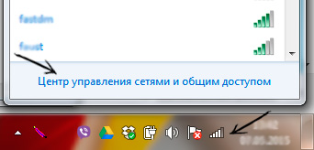

Then select "Local Area Connection":

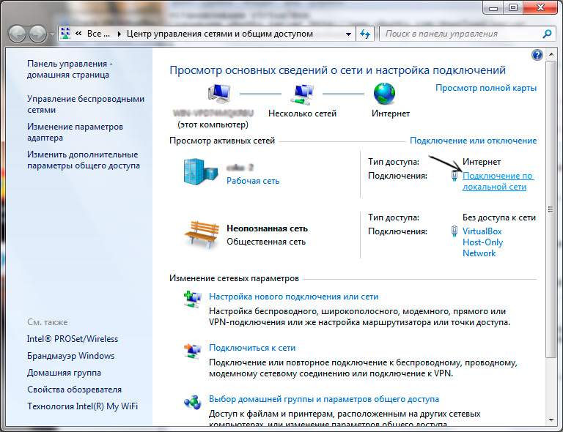

Select “Properties”

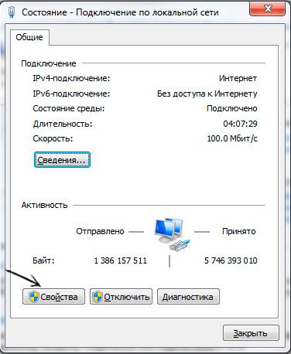

Note the "VirtualBox Bridged Networking Driver" checkbox must be active (checked), select the "Access" tab:

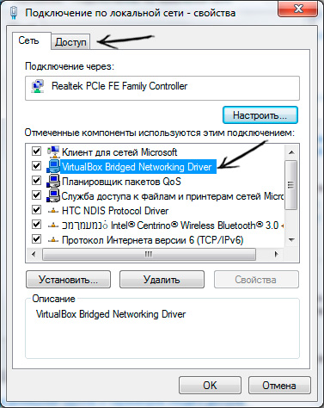

Check the box "Allow other network users to use this computer's Internet connection", and in the "Home network connection" drop-down list, select "VirtualBox Host-Only Network":

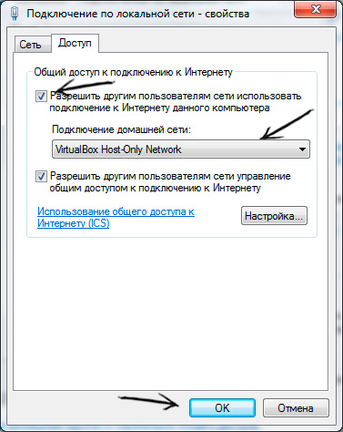

Then click the "Ok" button. Then a window will appear warning that the "VirtualBox Host-Only Network" adapter will be assigned the IP address in my case it was 192.168.56.1:

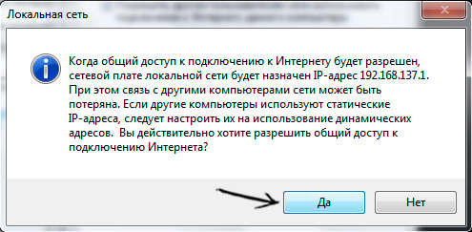

Remember this address and click on the "Yes" button. Close the "Local Area Connection" status window and open the "VirtualBox Host-Only Network" network properties:

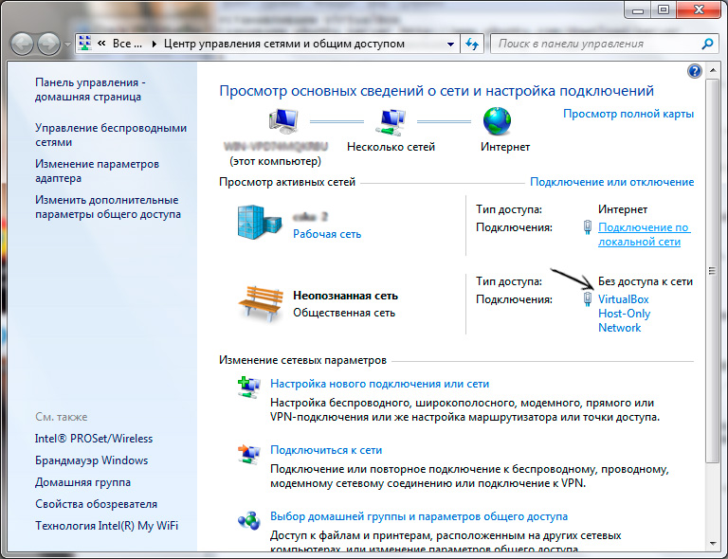

Click on the "Properties" button and check the "VirtualBox Bridget Networking Driver" box for this network adapter:

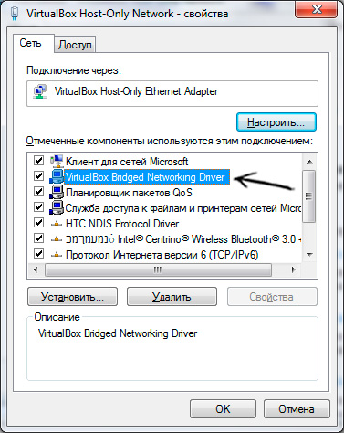

Then click on the "Ok" button and close the network connections window.

6. Create 4 Ununtu Server VMs using Virtual Box, named:

* db - for database (username/pw | dr/1234)
* wiki - for docuwiki (username/pw | dr/1234)
* web - webserver based on Joomla CMS) (username/pw | dr/1234)
* zabbix – for monitoring system master

Next steps describes all steps for separate VMs (we think that all of them are running)

FOR THE DB SERVER

Login via root and do next

1. *apt update*
2. *apt install net-tools mysql-server –y (MySql server and net-tools installation)*
3. *ufw enable (Activate Firewall)*
4. *ufw allow mysql (allow remote access to the mysql server)*
5. *systemctl start mysql (Stary the mysql service)*
6. *systemctl enable mysql* (setup automatic launch of mysql servise after server reboot)
7. *nano /etc/mysql/mysql.conf.d/mysqld.cnf*: ( add next line to this file “bind-address = 0.0.0.0” to enable remote access from all IP-addresses)
8. *systemctl restart mysql – restart mysql service*
9. *mysql –u root*
10. *CREATE DATABASE joomla CHARACTER SET UTF8 COLLATE UTF8_BIN;*

*CREATE USER 'joomla'@'%' IDENTIFIED BY 'joomla';*

*GRANT ALL PRIVILEGES ON joomla.* TO 'joomla'@'%';*

*FLUSH PRIVILEGES;*

*quit;*

1. Type *ifconfig* and remember IP-address from the output. In my case it is 192.168.56.105. It will be used to connect to the database from the web-server and wiki-server. So

FOR THE WEB SERVER

SETUP AND CONFIGURE NGINX

1. *apt install nginx*
2. *systemctl start nginx.service*
3. *systemctl enable nginx.service*
4. *apt install software-properties-common*
5. *add-apt-repository ppa:ondrej/php*
6. *apt update*
7. *sudo apt install php7.4-fpm php7.4-common php7.4-mysql php7.4-gmp php7.4-curl php7.4-intl php7.4-mbstring php7.4-xmlrpc php7.4-gd php7.4-xml php7.4-cli php7.4-zip*
8. Change /etc/php/7.4/fpm/php.ini file:

file_uploads = On

allow_url_fopen = On

short_open_tag = On

memory_limit = 256M

cgi.fix_pathinfo = 0

upload_max_filesize = 100M

max_execution_time = 360

1. *sudo nano /etc/nginx/sites-available/joomla*
2. Copy the content below and save into the file created above.

server {

listen 80;

listen [::]:80;

root /var/www/html/joomla;

index index.php index.html index.htm;

server_name example.com www.example.com;

client_max_body_size 100M;

autoindex off;

location / {

try_files $uri $uri/ /index.php?$args;

}

# deny running scripts inside writable directories

location ~* /(images|cache|media|logs|tmp)/.*.(php|pl|py|jsp|asp|sh|cgi)$ {

return 403;

error_page 403 /403_error.html;

}

location ~ .php$ {

include snippets/fastcgi-php.conf;

fastcgi_pass unix:/run/php/php7.4-fpm.sock;

fastcgi_param SCRIPT_FILENAME $document_root$fastcgi_script_name;

include fastcgi_params;

}

}

After saving the file above, run the commands below to enable the new site, then restart Nginx server.

*sudo ln -s /etc/nginx/sites-available/joomla /etc/nginx/sites-enabled/*

*sudo systemctl restart nginx.service*

DOWNLOAD JOOMLA DISTR

*cd /tmp*

*wget https://downloads.joomla.org/cms/joomla3/3-10-1/joomla_3-10-1-Stable-Full_Package-zip*

*sudo unzip -d /var/www/html/joomla /*

Run command below to allow www-data user to own the Joomla directory

*sudo chown -R www-data:www-data /var/www/html/joomla/*

*sudo chmod -R 755 /var/www/html/joomla/*

Open your web-browser and go to (in my case) 192.168.56.1/joomla and go through installation procedure. When intsallation will ask you about Database connection in host field enter the db VMs IP-address (192.168.56.103 in my case), and use DB-name, username and password from the steps above (in my case it was DB-name: joomla, username: joomla, passwd: joomla).

To install DokuWiki follow the installation unstructions <https://www.dokuwiki.org/install:ubuntu> and don’t forget to change nginx configuration file (<https://www.dokuwiki.org/install:nginx>)