Comment for testing

1. **Right settings**

I did attache right settings at first.

Please use this settings at fisrt, and please adjust by your request.

settings.set

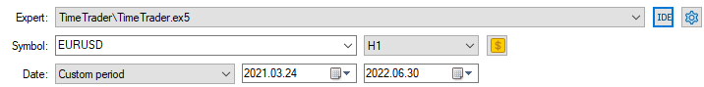

It works event(840030015) that you set

It is backtest result.

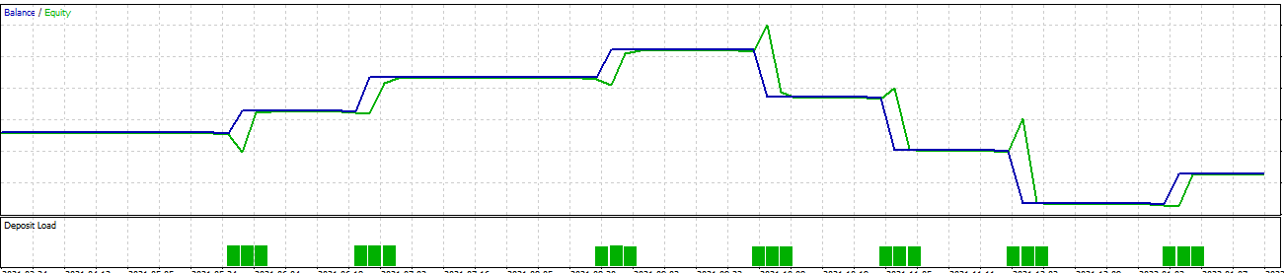

If you don’t get same result, I hope you check your works with PrepareNews.ex5 at first.

You need get this comment from chart before use strategy tester.

It need only once . You need attach PrepareNews.ex5 to live chart before use strategy tester.

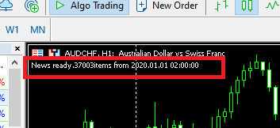

1. **Index to get range**

We did index bar to zero (0) for specific time.

And the bar have negative index before specific time and the bar have positive index after specific time.

It was adjusted in stage 2. Please look diagram.

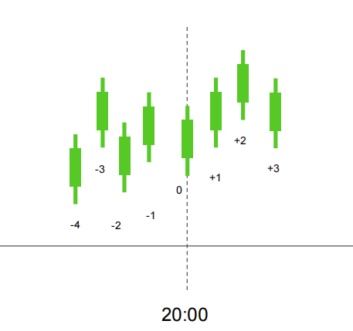

So we need set range for tp and breakout range to negative index.I did adjust these to -5,-2

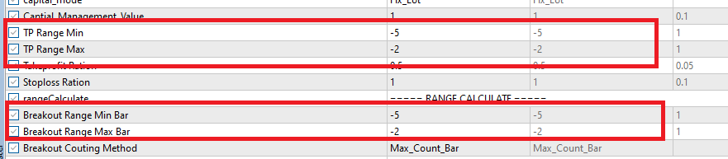

1. **Breakout period**

Our ea work for day trading. It check new trader per daily with specific time.

So breakout period need in same day with every specific time.

So if we put big number for Breakout Period Min/Max, it overnight and cant take trade. I dd adjust it to 2/5. It mean check break out within 2-5 bars after news released.



1. **Buy/Sell Filter by COMPARE_DIRECTION**

So the ea have a filter by COMPARE_VALUE_DIRECTION.

If don’t have break out in calculated direction ,the ea don’t take trade in this time.

I hope you compare your setting with right settings.

Best regard.