Usage of TimeTrader 0.2

1. **Contain files.**

- preparenews.ex5 : ea for prepare news under strategy tester

- TimeTrader.ex5 : ea to trade.

1. **Prepare news local file**

To use strategy tester with news data, it need run a expert advisor ( PrepareNews.ex5 ) in another chart.

In live it dose not need.

It need run once only.

If ea got news prepared , it will show some comment as like as this.

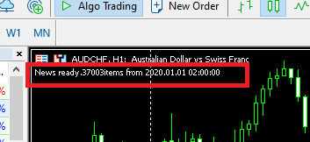

It mean strategy tester can use events released from 2020.01.01

1. **“Calendar Event ID”**

The user can get “calendar event id” from mql5 community

- select event from mql5 calendar

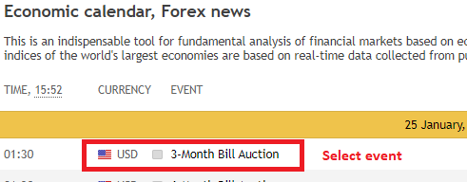

- go to widget

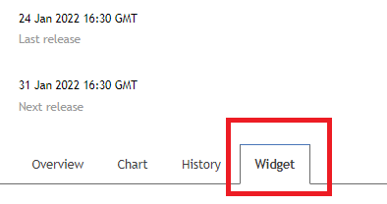

- get event id (for exampe 840220005)

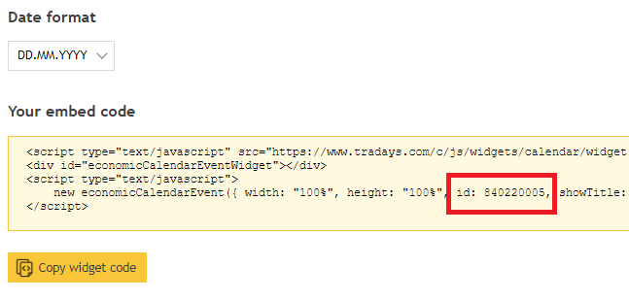

1. Multi event time id

User can input multi event id with “;”. but ea will take only one event id per day.

If user want to place multiple order in a day, it need run another mt5 terminal.

1. Default news

I did set default new to “United States Nonfarm Payrolls”. event id is 840030016.

It released at 2022.1.7 at last.