Usage for backtester

1. **Run MT5 with administrator always.**

Please run mt5 with administrator right always.**[important]**

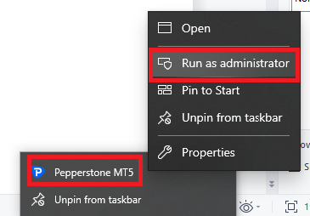

1. **Prepare source**

**After run mt5 with administrator, MT’s Data folder changed.**

- Extract TimeTrader.rar to [MQL5 Data folder]\\MQL5\\Experts\\TimeTrader

- Copy SaveEvent.mq5 to [MQL5 Data folder]\\MQL5\\Scripts\\TimeTrader

- Compile SaveEvent.mq5

1. **Prepare event data**

- Please run SaveEvent

SaveEvent is script , not expert.

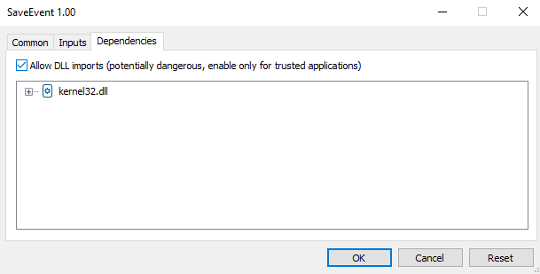

Please input event_id and dateFrom, dateTo to backtest in input form.

folderTimeTrader is folder name of Timetrader.

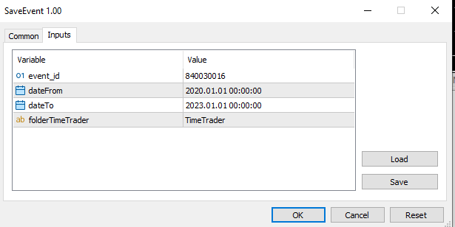

1. **Compile TimeTrader**

After Prepare event data, it generate new source file that have event data.

You need recompile TimeTrader.

Please check eventdata.mqh have actual event datas.

1. **Backtest in Strategy tester with clouds**

You can now backtest with clouds network with calendar mode.

If you don’t use clouds mode then please set localMode = true from input param.