**Report for executor with polygon.**

1. **Implemented Dex**

Uniswap,Quickswap,SushiSwap,PolicatSwap.

Polydex.fi is aggregator.It execute transaction with sushi or quick internally.So I did remove this from list.

1. **Project Folders**

- hardhat

This folder contain smart contract to execute transaction with polygon

- executor

This folder contain simple UI to execute signal.

1. **Run UI**

- Please install latest nodejs

- Please install this command from executor folder.

npm install

npm start

It will open <http://localhost:3000> and show UI.

1. **UI usage**

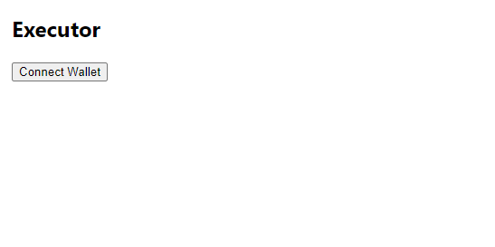

You need to connect with your metamask at first .

Please change network to polygon.

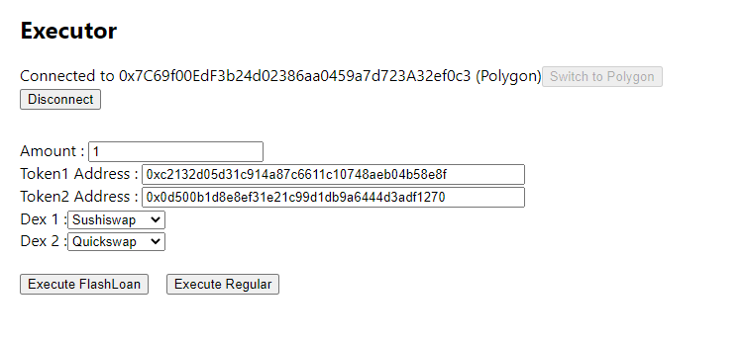

Token address for swap

Token address to start

Amount to start execute