LABVIEW
Laboratory Safety Simulation
Technical, Coding, Maintenance, and Customization Guide


Version 1.0 | Complete browser-based build

Contents
Section | Topic
1 | Purpose and audience
2 | Package structure
3 | How the game works
4 | HTML structure
5 | CSS and visual design
6 | JavaScript architecture
7 | How to change level content
8 | How to replace images and move hazard markers
9 | How to change scoring and timing
10 | How to add a new level
11 | Testing and troubleshooting
12 | Publishing and maintenance
13 | Quick change reference

Fastest way to edit
Most routine changes only require editing the levels array near the top of script.js. Images are replaced in the assets folder; colors are controlled in the :root section of style.css.

1. Purpose and audience
This guide documents the complete LABVIEW laboratory hazard game. It is written for content owners, trainers, safety reviewers, and developers who need to operate, modify, test, or publish the game without rebuilding it from scratch.

What the game includes
- Five progressively unlocked laboratory hazard levels
- Realistic local laboratory images that work offline
- Object-specific interactive hazard markers
- Evidence collection, decision questions, scoring, and feedback
- Flashlight, PPE check, zoom, timer, sound, and final answer review
- Responsive layouts for desktop, tablet, and mobile browsers
Safety review required
Before deployment, verify all questions, answers, and response guidance against the organization’s approved laboratory procedures and chemical-specific requirements.

2. Package structure
Path | Purpose | Normally edited when
index.html | Defines screens, buttons, labels, and application layout. | Changing screen structure or fixed interface text.
style.css | Controls colors, spacing, responsive behavior, animations, and hotspot appearance. | Changing visual theme, dimensions, or mobile layout.
script.js | Stores level data and controls game state, scoring, navigation, timer, answers, and review. | Changing scenarios, questions, scoring, or behavior.
README.md | Contains short operating and level-mapping instructions. | Updating release notes or basic launch guidance.
assets/lab.jpg | Home-screen laboratory background. | Replacing the landing-page image.
assets/spill.jpg | Level 1 scene. | Replacing the chemical spill image.
assets/fire.jpg | Level 2 scene. | Replacing the fire image.
assets/waste.jpg | Level 3 scene. | Replacing the waste image.
assets/labels.jpg | Level 4 scene. | Replacing the label/pictogram image.
assets/eyewash.jpg | Level 5 scene. | Replacing the eyewash image.

Launch procedure
1. Extract the ZIP
Keep index.html, style.css, script.js, README.md, and the assets folder together.
2. Open the game
Double-click index.html or open it through a current browser.
3. Do not separate files
The relative paths assume that the assets folder is beside index.html.

3. How the game works
Stage | Player action | Code effect
Home | Selects Enter Laboratory. | renderMap() builds the level cards and show("map") changes screen.
Mission map | Selects an unlocked level. | load(i) loads level data, scene image, marker coordinates, and timer.
Inspection | Clicks the marker on the hazard object. | identify() records evidence and enables Identify Hazard.
Decision | Selects one answer and submits. | advance() compares selected index against correct index.
Feedback | Reads the explanation. | Correct receives 100; incorrect receives 0; next level unlocks.
Final review | Reviews all five responses. | renderReview() lists player answer, correct answer, points, and feedback.

State model
let S = {
level: 0, score: 0, done: [], stage: 0,
selected: null, answers: {}, timer: null,
time: 60, sound: true, light: false
};
S is the single in-memory game state. Reloading the page resets the game because no database or browser storage is used.

4. HTML structure
index.html contains all screens in one page. JavaScript toggles the active class instead of loading separate pages.
Element | Role
#home | Landing screen and general laboratory background.
#map | Level cards and completion progress.
#mission | Interactive image viewport, marker, tools, evidence, questions, and action button.
#finish | Final score and answer review.
#help | How-to-play modal dialog.
#hotspot | Clickable marker placed over the relevant hazard object.
#photo | Scene image loaded from the current level.

Simple fixed-text change
<!-- Before -->
<button class="primary" id="start">ENTER LABORATORY</button>
<!-- After -->
<button class="primary" id="start">START SAFETY TRAINING</button>

5. CSS and visual design
style.css uses reusable CSS variables at the top of the file. Edit these values to change the theme consistently.
:root {
--cyan: #28d3f5;
--cyan2: #a3f3ff;
--navy: #020d16;
--panel: #061b2a;
--line: #22546e;
--text: #eefbff;
--muted: #9cb6c5;
--green: #48e2a2;
--red: #ff6171;
}
Change | CSS selector/property
Main accent color | :root --cyan and --cyan2
Correct/incorrect colors | :root --green and --red
Hotspot size | #hotspot width and height
Marker pulse speed | #hotspot animation and @keyframes pulse
Desktop image/side-panel ratio | .missionGrid grid-template-columns
Mobile breakpoint | @media(max-width:1000px) and @media(max-width:580px)
Landing image | .hero background URL

6. JavaScript architecture
Function | Responsibility
show(id) | Hides all screens and displays one requested screen.
renderMap() | Creates level cards, locked state, and completion percentage.
load(i) | Loads one level, places its image and hotspot, resets controls, and starts timer.
identify() | Marks the hotspot as found, displays evidence, and enables progression.
advance() | Moves inspection to decision, then decision to feedback, then to next level/result.
renderReview() | Builds final answer-review cards for every level.
reset() | Clears progress, answers, score, and returns to home.
tone(ok) | Creates a brief browser-generated sound without audio files.

The levels array
Each object in levels is a complete content record for one mission. The array order is the level order.
{
name: 'Chemical Spill',
image: 'spill.jpg',
hot: [42, 61],
inspect: 'The identifier is positioned...',
evidence: 'Tipped chemical container...',
question: 'What should be done first?',
answers: ['Answer A', 'Answer B', 'Answer C', 'Answer D'],
correct: 1,
feedback: 'Alert others, avoid contact...'
}
Important index rule
The correct value is zero-based: 0 = answer A, 1 = B, 2 = C, and 3 = D. This is the most common source of answer-key errors.

7. How to change level content
1. Open script.js
Use Visual Studio Code, Notepad++, or another plain-text editor.
2. Find const levels
The five scenario objects appear at the beginning of the file.
3. Edit only the intended fields
Keep commas, quotation marks, brackets, and braces intact.
4. Verify the answer key
Set correct to the array position of the safest response, starting from zero.
5. Save and refresh
Save script.js, then refresh index.html in the browser.
Field | What to enter | Example
name | Short level title | Chemical Spill
image | Exact filename inside assets | spill.jpg
hot | Horizontal and vertical percentages | [42, 61]
inspect | Inspection instruction | The identifier is positioned on...
evidence | Text displayed after marker click | Tipped chemical container...
question | Decision question | What should be done first?
answers | Four quoted choices inside brackets | ['A','B','C','D']
correct | Zero-based correct answer index | 1 means the second answer
feedback | Explanation shown after submit | Alert others, avoid contact...

8. Replace images and move hazard markers

Replace a scene image
1. Prepare the image
Use a landscape image with the relevant hazard clearly visible. Keep enough space for the side panel.
2. Use a simple filename
Example: spill-new.jpg. Avoid spaces and special characters.
3. Copy it into assets
Place the file in the assets folder.
4. Update script.js
Change image: 'spill.jpg' to image: 'spill-new.jpg'.
5. Test marker alignment
Open the level at desktop and mobile widths and reposition hot if necessary.

Understand hotspot coordinates
The hot field uses percentages of the viewport: the first number moves the marker from left to right; the second moves it from top to bottom.
hot: [42, 61]
// 42 = 42% from the left
// 61 = 61% from the top
Desired movement | Change
Move right | Increase the first number.
Move left | Decrease the first number.
Move down | Increase the second number.
Move up | Decrease the second number.

Recommended adjustment method
Change coordinates by 2 to 5 points at a time, save, refresh, and test. Keep the marker centered on the exact object referenced by the question.


Level 1 scene: place marker on the spill or tipped container.
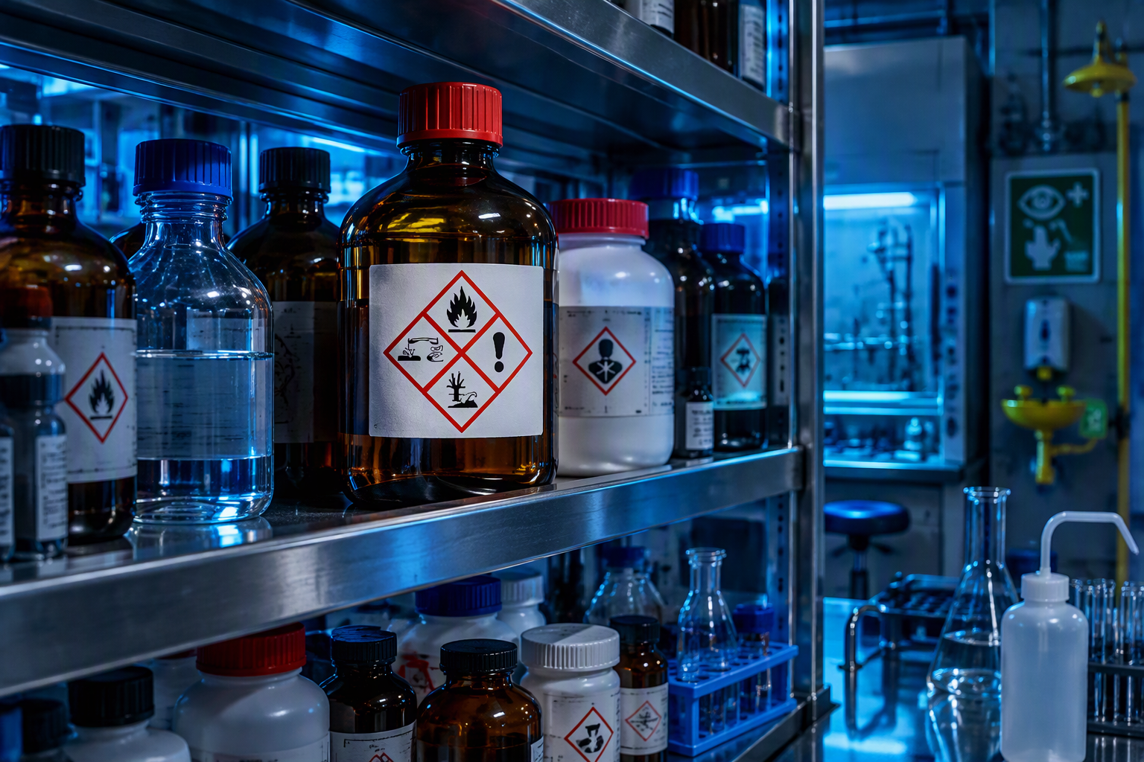
Level 4 scene: place marker directly on the front pictogram.
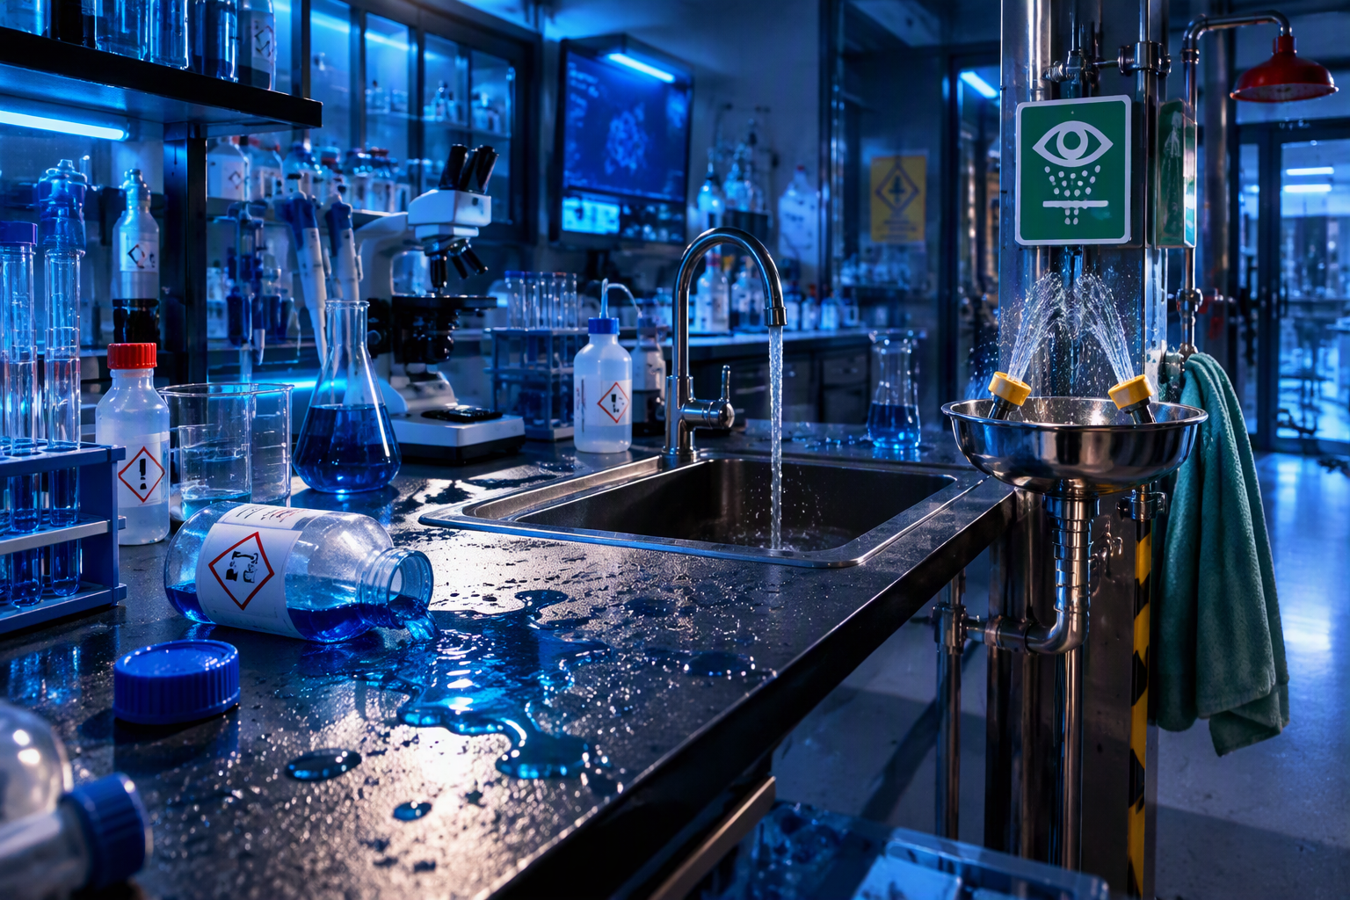
Level 5 scene: place marker on the eyewash station.

9. Change scoring and timing

Scoring
if (!S.done.includes(S.level)) {
if (ok) S.score += 100;
S.done.push(S.level);
}
Change 100 to another correct-answer value. Incorrect answers receive zero because there is no else statement adding points. Update the /500 label in index.html if the maximum score changes.

Timer
S.time = 60;
$('#timer').textContent = '60';
Change both values to the same number. The current timer reaches zero and stops; it does not automatically fail the player or submit an answer.

10. Add a new level
1. Add the image
Copy the new level image into assets.
2. Duplicate a level object
Copy one complete object inside the levels array and paste it before the array’s closing bracket.
3. Change every content field
Update name, image, hot, inspect, evidence, question, answers, correct, and feedback.
4. Add a comma correctly
Every object except the last must end with a comma.
5. Remove hard-coded five-level assumptions
Update /5 in index.html, the progress calculation in renderMap(), the final-level checks in advance(), and /500 in the final score label.
// Example for six levels
const total = levels.length;
const pc = S.done.length / total * 100;
const isLast = S.level === levels.length - 1;
Development recommendation
For easier future expansion, replace hard-coded values such as 5, 4, 20, and 500 with calculations based on levels.length.

11. Testing and troubleshooting
Problem | Likely cause | Correction
Blank page or buttons do nothing | JavaScript syntax error. | Open browser developer tools, check Console, and inspect the last edited commas, quotes, braces, or brackets.
Image does not appear | Filename or path mismatch. | Confirm exact filename and that the file is under assets.
Wrong image appears | Incorrect image field or overwritten asset. | Check each level’s image value and unique file.
Marker is misplaced | hot coordinates do not match the image crop. | Adjust first/second percentages and retest responsive layouts.
Correct option marked wrong | Incorrect zero-based correct index. | Use 0=A, 1=B, 2=C, 3=D.
Level stays locked | Previous level was not completed. | Submit the prior level once; renderMap reads S.done.
Score increases during review | Review logic changed or completion guard removed. | Keep !S.done.includes(S.level) around scoring.
Changes do not show | Browser cache. | Hard-refresh the browser or reopen index.html.

Release test checklist
- ☐ Open the game from the extracted folder with the internet disconnected.
- ☐ Confirm all five map thumbnails match their level names.
- ☐ Confirm every marker sits on the exact object described.
- ☐ Submit one correct and one incorrect answer; verify 100 and 0 points.
- ☐ Complete all levels and verify the final review shows all responses.
- ☐ Test at desktop width and a narrow mobile-width browser window.
- ☐ Confirm sound toggle, flashlight, PPE check, zoom, timer, review levels, and play again.

12. Publishing and maintenance

Publishing options
- Shared/network folder: users open index.html after extracting the package.
- Internal web server: copy the folder contents to a static website directory.
- Learning portal: upload as a web package only if the platform supports plain HTML/CSS/JavaScript assets.

Version-control practice
- Keep an untouched released ZIP.
- Make changes in a separate working folder.
- Record changed levels, images, coordinates, questions, and answer keys.
- Name releases consistently, for example LABVIEW-Game-v1.1.zip.
- Retest the complete game after any script.js change.

Security and privacy
The current build is a client-side static application. It does not transmit or persist player names, scores, or answers. If tracking is added later, perform the organization’s privacy, security, and records review before deployment.

13. Quick change reference
Need to change | File | Search for
Level title/question/answers | script.js | const levels
Correct answer | script.js | correct:
Scene image | script.js and assets | image:
Marker position | script.js | hot:
Correct score | script.js | S.score += 100
Timer duration | script.js | S.time = 60
Final maximum score | index.html | /500
Colors | style.css | :root
Marker size | style.css | #hotspot
Landing text | index.html | Enter the lab
Final review layout | script.js / style.css | renderReview / .reviewItem

Backup before editing
Copy the working folder before each change. If the browser stops working, compare the latest edited file with the backup and check the browser Console first.

