


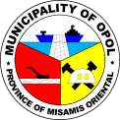
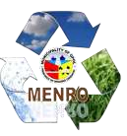




Republic of the Philippines

Province of Misamis Oriental

MUNICIPALITY OF OPOL

--
o0o
--

Office of the Municipal
Environment and Natural Resources

C

E

R

T

I

F

I

C

A

T

I

O

N

TO WHOM IT MAY CONCERN;

THIS IS TO CERTIFY that:

MR.
_____________________

And

MS.
_____________________

From
___________
,
Opol, Misamis Oriental had planted two (2)
Mangrove Trees at Marine Sanctuary, Luyongbonbon, Opol, Misamis
Oriental.

Issued upon the request of the soon
-
to
-
be couple mentioned above in
support to their marriage application.

Given this
____

day of
________

2026
, at the Municipal Environment

and Natural Resources Office, Opol, Misamis Oriental.

ENGR. RANDOLPH Q. HALLASGO

MENRO

Paid Under :
_________

OR No.
:

_________

Date Issued :
_________

Place Issued :

OPOL, MIS. OR.

