Urban Air Quality Analytics with Python
BDA112 Assignment 2 | Group: [number] | Members and IDs: [add details]

1. Introduction and project objective
Urban air-quality measurements can help environmental teams identify pollution patterns and decide where further monitoring is needed. This project studies nitrogen dioxide (NO₂) measurements from a published OpenAQ-derived dataset. It explores three monitoring stations and predicts the next hourly reading at the Paris station. The intended users are an environmental monitoring team who need a clear, practical example of how Python can support analysis. The project does not estimate personal exposure or provide public health advice.
The main question is whether recent NO₂ readings and simple calendar features can improve one-hour-ahead predictions. The project also asks how the observed distributions differ between stations, how Paris readings vary by reported hour and weekday, and whether data quality limits the conclusions. The target is a continuous concentration in micrograms per cubic metre (µg/m³). Therefore, Linear Regression and Random Forest regression are compared with a simple persistence baseline. Success means reducing average prediction error on a later period that was not used to fit or select the model.

2. Evaluation and justification of tools
Python was selected because it supports cleaning, charts and machine learning in one reproducible workflow. Jupyter combines code, written explanations and outputs, making the steps easier for group members and markers to follow [3]. However, running cells in the wrong order can leave old results in memory. Restarting the kernel and running every cell is therefore part of the final review. A spreadsheet could display the small dataset, but Python makes repeated lag creation and consistent model comparisons easier to reproduce.
pandas was used for CSV import, date conversion, missing-value checks, hourly indexing and grouped summaries [1]. Its labelled tables reduce the chance of mixing up columns. NumPy was used for numeric calculations and the sine and cosine features that represent a repeating daily cycle [7]. These libraries are suitable for a small dataset held in memory. A distributed platform would introduce extra setup without a clear benefit for this project.
Matplotlib was selected for labelled boxplots, histograms and time-series charts [8]. It offers direct control over axes, units and figure sizes, although interactive tools would be more convenient for a live dashboard. scikit-learn provides both regression algorithms and consistent evaluation functions [4]–[6]. Linear Regression is relatively easy to explain, while Random Forest handles more complex relationships at the cost of transparency. Git or dated shared versions should record the group’s actual revisions and reviews. No student contribution is inferred from an AI-generated file.

3. Dataset acquisition and scope
The source is air_quality_no2.csv in the pandas project repository, retrieved on 4 September 2026 [2]. pandas identifies it as an OpenAQ sample from FR04014 in Paris, BETR801 in Antwerp and London Westminster [1]. It is a historical teaching extract, not a new download from the complete OpenAQ archive. The file contains 1,035 rows and four columns: the reported datetime and one NO₂ column per station. Its reported dates run from 7 May to 21 June 2019. The notebook embeds the recovered CSV snapshot and checks its SHA-256 hash, so a separate data file or API key is unnecessary.

4. Data quality assessment and preprocessing
The raw file was kept separate from the cleaned table. Dates were converted to datetime values, and all three measurement columns were checked as numeric. The assessment found no exact duplicate rows, invalid dates, invalid numeric strings or negative concentrations. The code also checks for conflicting duplicate timestamps and stops for review if they occur. These checks are included even when the current file contains no such errors, because the same workflow should identify them in a later dataset.
Missing values required more attention. The original station columns contain 940 missing Antwerp cells, 31 missing Paris cells and 66 missing London cells. There are also 46 entirely absent hourly timestamps. Reindexing from the first to the last reported timestamp creates a grid of 1,081 hours. This exposes missing timestamps and makes a one-row lag equal exactly one hour. Without this step, a previous row could be several hours earlier, producing misleading forecasting features.
Table 1. Observed readings and missingness on the complete hourly grid.
Station | Observed | Missing hours | Coverage
Antwerp | 95 | 986 | 8.79%
Paris | 1004 | 77 | 92.88%
London | 969 | 112 | 89.64%
Paris was chosen for modelling because it has the highest coverage, as shown in Table 1. Antwerp’s many gaps make it unsuitable for the same hourly forecasting exercise. Missing readings were not replaced with zero or a whole-dataset mean. Either choice would invent pollution measurements and could reduce genuine variation. Instead, modelling uses only timestamps with an observed Paris target and observed readings at all required lags. This transparent complete-case approach loses information and may underrepresent disrupted periods, but avoids pretending that imputed targets are real observations.
There are seven zero readings in Paris and twelve in London. These were retained because no quality flag in this extract identifies them as errors. Likewise, the interquartile range rule flagged one Antwerp, 32 Paris and 30 London readings as unusually high or low relative to their station distributions. These are statistical flags, not proof of incorrect measurement. All flagged observations were retained because a genuine pollution episode may be an important event. The notebook separately calculates a training-only IQR check; no test-derived threshold changes the model data.
The wide CSV does not include timezone metadata or the original provider quality flags. The analysis keeps timestamps on the source’s reported clock and does not call them UTC. Calendar summaries must therefore be interpreted as reported-clock patterns, not verified local rush-hour effects. Cross-station measurements are not used together as forecasting inputs. A deployment would require the original metadata and correctly aligned timezones. The snapshot hash verifies the embedded recovered CSV, rather than claiming byte-for-byte identity with upstream line endings.

5. Exploratory data analysis and findings
Paris has an observed mean of 27.74 µg/m³, a median of 24.15 and a standard deviation of 15.29. Its values range from zero to 97.00. The mean exceeds the median, and the histogram shows a longer upper tail, indicating that occasional high readings raise the average. Antwerp’s mean is 25.78 and London’s is 24.78 µg/m³. These station averages use different sets of available times, so they should not be treated as a fair ranking of the three cities.
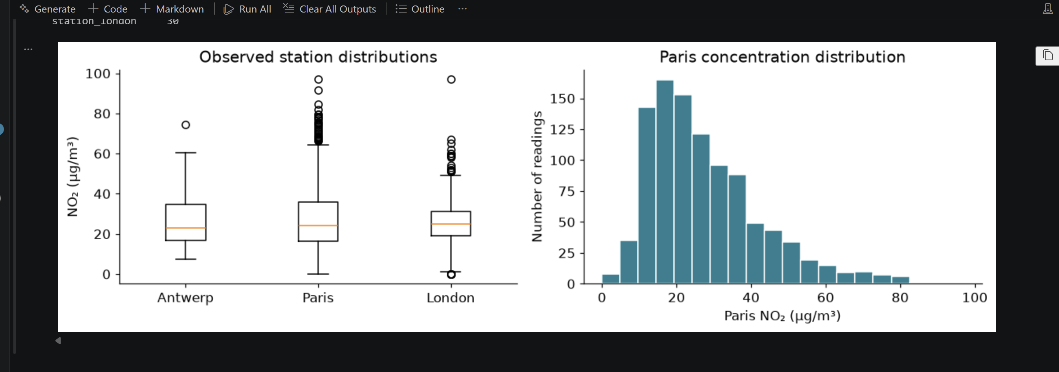
Figure 1. Station distributions and Paris histogram using observed values.
Figure 1 shows substantial overlap between the distributions and occasional high readings at each station. The small Antwerp sample is especially important when interpreting its boxplot. A separate daily chart in the notebook includes a station-day only when at least 18 hourly readings are available. This 75% coverage rule reduces the chance of presenting a partial day as a reliable daily average. Missing days remain gaps rather than being connected by invented measurements.
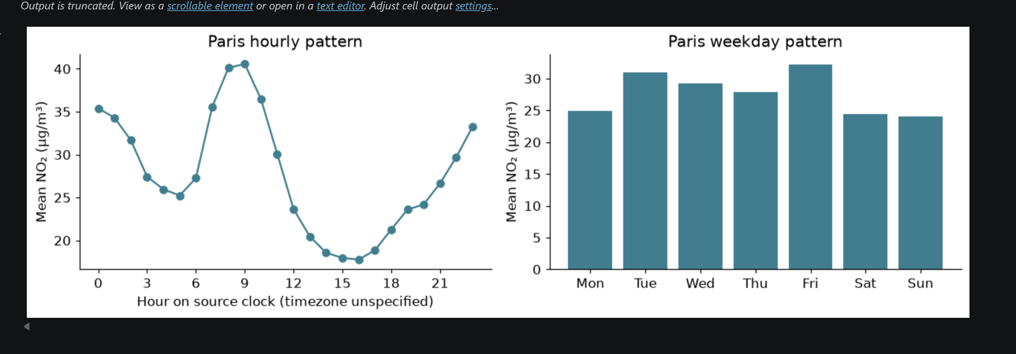
Figure 2. Paris means by reported hour and weekday; counts appear in the notebook.
In Figure 2, Paris has its highest reported-hour mean at 09:00, about 40.57 µg/m³, and its lowest at 16:00, about 17.77. Friday has the highest weekday mean, 32.24, while Sunday has the lowest, 24.07. These differences suggest useful calendar features, but do not prove that work schedules or traffic caused them. Weather and emissions data would be needed to investigate those explanations. The analysis covers only part of two months, so neither seasonal patterns nor long-term trends can be established.

6. Predictive models and evaluation
Both models predict the Paris concentration at time t using readings at t−1, t−2 and t−24 hours, the sine and cosine of the reported hour, and a weekend indicator. For example, a 10:00 prediction uses the readings at 09:00, 08:00 and 10:00 the previous day. The current target is never included as an input. Sine and cosine preserve the repeating daily cycle, so midnight is close to 23:00 rather than being treated as the opposite end of an ordinary numeric scale.
The hourly timeline is divided chronologically: the first 60% for training, the next 20% for validation and the final 20% for testing. Removing rows with missing targets or lags leaves 595 training, 178 validation and 147 test observations, or 920 complete rows. In total, 161 grid rows are unavailable for modelling. The final eligible test observation is 19 June at 00:00, earlier than the dataset’s end because later rows lack required values. No random shuffle or future interpolation is used.
Linear Regression estimates an additive relationship between the inputs and target [4]. Random Forest averages 300 regression trees, with maximum depth 8, minimum leaf size 5 and random seed 42 [5]. These settings were specified before evaluation. The persistence baseline uses the previous hourly value as its prediction. This is a useful comparison because closely spaced measurements can be similar even without machine learning. Random Forest was selected using validation MAE: 4.553, compared with 4.892 for Linear Regression and 5.219 for persistence.
Table 2. Final performance on the same 147 later test observations.
Model | MAE (µg/m³) | RMSE (µg/m³) | R²
Persistence | 5.684 | 8.300 | 0.787
Linear Regression | 5.116 | 7.300 | 0.835
Random Forest | 4.919 | 7.486 | 0.827
Both fitted models were refitted on the combined training and validation data before the final test. MAE measures average absolute error, while RMSE gives greater weight to large errors. R² compares squared error with predicting the test-set mean [6]. Precision and recall are unsuitable because this task predicts concentrations rather than categories. Table 2 shows that Random Forest has the lowest test MAE, improving on persistence by 13.46%. It is preferred for the stated average-error objective, while Linear Regression has better RMSE and R². The forest is therefore not best on every measure.
The selected forest’s refit-training MAE is 3.73, below its test MAE of 4.92. This gap supports further checks for overfitting and changing conditions. Both models tend to miss some sharp movements, as shown by the notebook’s prediction plots. Evaluation represents rolling one-hour-ahead forecasts: each earlier actual reading is available before the next prediction. It does not represent predicting an entire week from one starting point, and statistical certainty is limited by the short test period.

7. Limitations and practical recommendations
The main limitation is representativeness. One short historical extract cannot describe current pollution conditions, a full year or all neighbourhoods in a city. Paris was chosen because of coverage, which makes the model useful for this station but does not demonstrate transfer to another location. All observations come from existing measurements rather than a controlled experiment. The reported differences are associations, and this project cannot identify which source caused a pollution increase.
Missing data can create selection bias if outages occur during unusual pollution events. Excluding incomplete targets and lags avoids fabricated values, but it does not solve this bias. The extract also lacks weather, traffic counts, emissions information and instrument quality flags. Its unspecified timezone limits calendar interpretation. Zero readings and extreme values remain uncertain until checked with the original provider. These issues should be addressed before treating the model as operational evidence.
First, the monitoring team should obtain a longer dataset with known timezones, clear station metadata and quality-control flags. It should monitor completeness by station and investigate extended gaps, especially where hourly predictions are required. The same cleaning rules should be documented and applied to future updates. High readings should be reviewed against provider records rather than automatically removed, because cleaning away genuine peaks would weaken the practical purpose of an air-quality analysis.
Second, the team should extend the forecasting inputs with relevant weather and traffic information when those data are available. Only values that would be known at the prediction time should be included. Testing should then be repeated across several later periods and additional stations. Model selection should still happen before the final test is inspected. Comparing each new version with persistence will show whether the extra complexity produces a consistent practical improvement.
Third, any pilot should track both MAE and RMSE. Average accuracy matters for routine monitoring, while larger errors may matter more during sudden pollution changes. The preferred model can therefore depend on the monitoring objective. Predictions should be presented with observed readings and missingness information, rather than as certain facts. Public alerts or regulatory conclusions would require suitable standards, validated data and a much stronger evaluation than this classroom example provides.

8. Collaboration, responsible AI and conclusion

References
[1] pandas development team, “How do I create plots in pandas?.” Accessed: Sep. 20, 2026. [Online]. Available: https://pandas.pydata.org/docs/getting_started/intro_tutorials/04_plotting.html
[2] pandas development team, “air_quality_no2.csv, pandas source repository.” Accessed: Sep. 20, 2026. [Online]. Available: https://github.com/pandas-dev/pandas/blob/main/doc/data/air_quality_no2.csv
[3] Project Jupyter, “Project Jupyter.” Accessed: Sep. 20, 2026. [Online]. Available: https://jupyter.org/
[4] scikit-learn developers, “LinearRegression.” Accessed: Sep. 19, 2026. [Online]. Available: https://scikit-learn.org/stable/modules/generated/sklearn.linear_model.LinearRegression.html
[5] scikit-learn developers, “RandomForestRegressor.” Accessed: Sep. 19, 2026. [Online]. Available: https://scikit-learn.org/stable/modules/generated/sklearn.ensemble.RandomForestRegressor.html
[6] scikit-learn developers, “Metrics and scoring: quantifying the quality of predictions.” Accessed: Sep. 20, 2026. [Online]. Available: https://scikit-learn.org/stable/modules/model_evaluation.html
[7] NumPy developers, “NumPy: the absolute basics for beginners.” Accessed: Sep. 19, 2026. [Online]. Available: https://numpy.org/doc/stable/user/absolute_beginners.html
[8] Matplotlib developers, “Quick start guide.” Accessed: Sep. 19, 2026. [Online]. Available: https://matplotlib.org/stable/users/explain/quick_start.html

Appendix A. AI usage declaration and verification

Appendix B. Group contribution and version record
Complete this appendix using actual work. The tasks below are a proposed allocation, not a claim that they have been completed. Add or remove rows to match the group size. Attach or link genuine evidence of collaborative contributions.
Task | Actual member/ID | Date/version | Peer reviewer
Dataset and source review | [add] | [add] | [add]
Cleaning and EDA checks | [add] | [add] | [add]
Model and metric checks | [add] | [add] | [add]
Report and slide review | [add] | [add] | [add]
Presentation rehearsal | [add] | [add] | [add]
Git repository or dated shared-version link: [add actual link]
Meeting dates and decisions: [add genuine records]
Completed milestones: [add dates, owners and evidence]
Final group approval and cover-page completion: [add after review]

