Dear user,

This is a program created to detect faces from webcam on your device.

It was created using OpenCV package what enables us to connect pre-trained face detection model to our project.

To be sure that this program will work fine on your computer, please, make sure that opencv-python module is installed.

If not, please, use following commands:

For Windows users:

pip install opencv-python

For MacOS users:

pip3 install opencv-python

Where this code could be used?

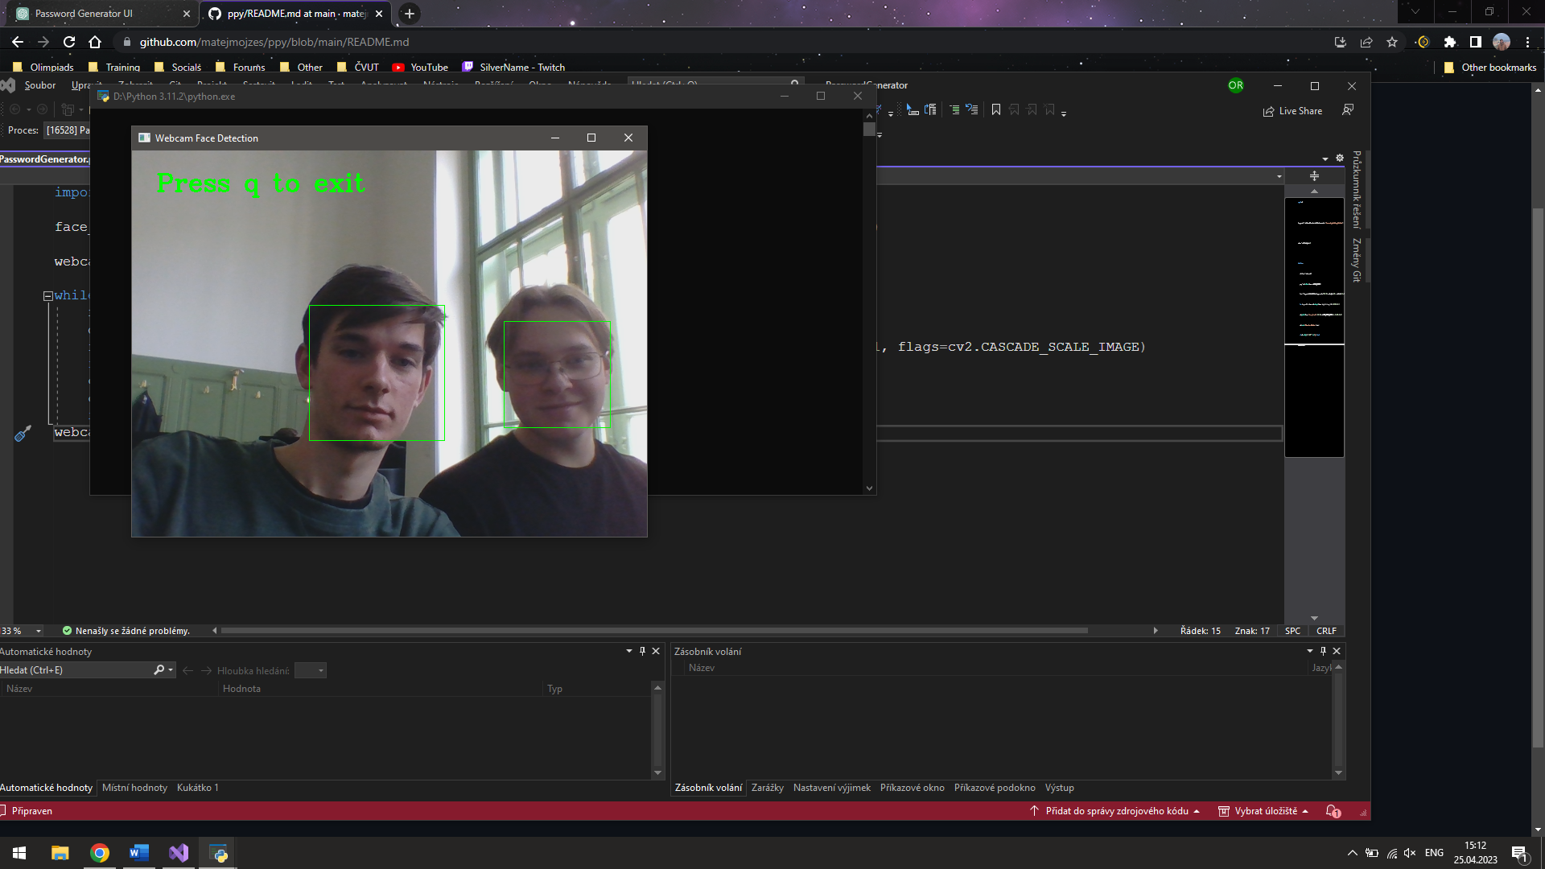I think that it would be helpful in school process, to detect children’s attendance on online lessons.

An example of its working.

Thank you for attention!