INSERT INTO Shippers (ShipperID, ShipperName, Phone) VALUES (7, 'Novaya pochta', '[(503)555-5555](tel:5035555555)'), (8, 'FedEx', '[(503) 555-5554](tel:5035555554)')

UPDATE Shippers SET Shippername = 'Meest Express', Phone ='(097) 997-31-31'

WHERE ShipperName IS 'Federal Shipping'

UPDATE Shippers SET Shippername = 'Meest Express', Phone ='(097) 997-31-31'

WHERE ShipperName < (SELECT ShipperID FROM Shippers Where ShipperName IS 'Новая Почта')

<https://dbfiddle.uk/bzLDfhjV?hide=2>

<https://imgbb.com/SmdP1f2>

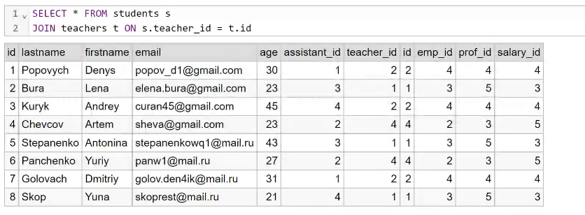

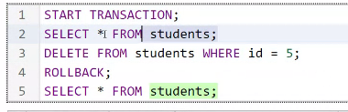

SELECT od.OrderID, od.Quantity, p.Price, od.Quantity*p.Price AS Total

FROM OrderDetails AS od

LEFT JOIN Products AS p ON od.ProductID = p.ProductID

|  |  |  |
| --- | --- | --- |
| SELECT s.lastname, s.firstname, s.age  FROM students AS s  WHERE s.assistant_id =  (SELECT ta.id  From teacher_assistants AS ta  WHERE ta.emp_id = (SELECT e.id  FROM employee_name AS e  WHERE e.name = 'Alina')) | SELECT s.lastname, s.firstname, s.age  FROM students AS s  JOIN teacher_assistants AS ta ON s.assistant_id = ta.id  WHERE ta.emp_id = (SELECT e.id  FROM employee_name AS e  WHERE e.name = 'Alina') | SELECT s.lastname, s.firstname, s.age  FROM students AS s  JOIN teacher_assistants AS ta ON s.assistant_id = ta.id  JOIN employee_name AS e ON ta.emp_id=e.id  WHERE e.name = 'Alina' |
| SELECT e.name  FROM employee_name AS e  WHERE id IN  (SELECT ts.emp_id  FROM timesheet AS ts  WHERE ts.salary_id IN  (SELECT s.id  FROM salary AS s  WHERE s.salary_hours <= 350  ORDER BY s.id) |  | SELECT e.name  FROM employee_name AS e  JOIN timesheet AS ts ON e.id = ts.emp_id  JOIN salary AS s ON ts.salary_id = s.id  WHERE s.salary_hours <= 350 |

s.id, s.lastname

SELECT *

FROM students AS s

JOIN teachers AS t ON t.id = s.teacher_id

JOIN teacher_assistants AS ta ON s.assistant_id = ta.id

JOIN employee_name AS en ON en.id = t.id

SELECT [s.id](http://s.id/), s.lastname  
FROM students s   
JOIN teachers t ON [t.id](http://t.id/) = s.teacher_id   
JOIN teacher_assistants ta ON [ta.id](http://ta.id/) = s.assistant_id  
JOIN employee_name en ON [en.id](http://en.id/) = ta.emp_id  
WHERE [en.name](http://en.name/) IN ('Nikolai','Katerina')

Select *

FROM salary;

UPDATE salary SET salary_hours = 300

WHERE prof_id = (SELECT id FROM prof WHERE prof_lvl = 'Middle');

Select *

FROM salary;