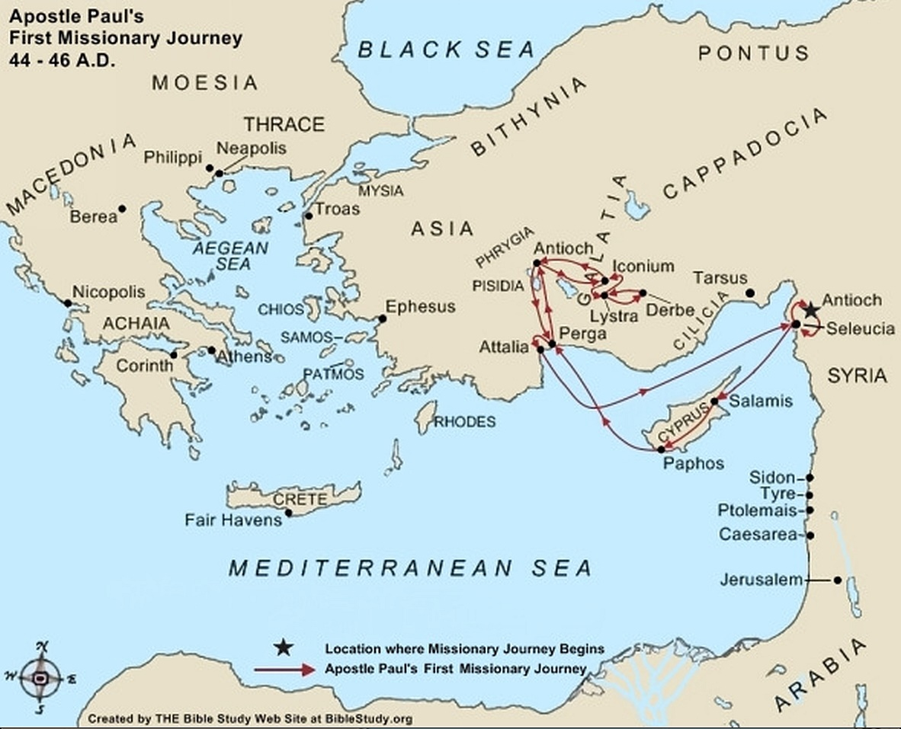

**Late Spring 44 A.D. to Fall 46 A.D.**

In the late Spring of 44 A.D. the brethren (Acts 13:1 - 3) ordain [Paul](https://www.biblestudy.org/trivia/apostle-paul.html) and [Barnabas](https://www.biblestudy.org/apostlepaul/barnabas-to-gallio.html) as apostles. From Antioch, the two apostles and [John (surnamed Mark)](https://www.biblestudy.org/beginner/john-to-mary.html) begin Paul's first missionary journey (Acts 13:4 - 52, 14:1 - 25).

Apostle Paul and company travel to Seleucia then sail to Salamis, the principle city and seaport of the island of Cyprus. [Cyprus](https://www.biblestudy.org/maps/new-testament-churches/cyprus.html) is where Barnabas was born and raised (Acts 4:36). In Salamis, they preach the gospel in several synagogues. They then cross the island by foot and arrive at Paphos.

While in Paphos, [the island's Roman governor](https://www.biblestudy.org/apostlepaul/life-epistles-of-apostle-paul/first-missionary-journey-begins.html) requests the two evangelists meet with him so that he can personally hear the word of God. Accompanying the governor to the meeting is a sorcerer and false prophet known as Elymas the magician. [Elymas](https://www.biblestudy.org/apostlepaul/barnabas-to-gallio.html) resists the gospel and tries to prevent the governor from accepting the truth of God (Acts 13:6 - 8).

The Apostle Paul perceives Elymas' intentions and responds immediately. Elymas immediately goes blind and is unable to see for a period. The governor, astonished at what he sees, believes the gospel (Acts 13:11 - 12).

**Mark abruptly leaves the team**

Apostle Paul, Barnabas, and Mark soon board a ship and sail to Perga. Mark then abruptly leaves the group and returns to [Jerusalem](https://www.biblestudy.org/maps/map-of-jerusalem-and-its-seven-hills.html) (Acts 13:13). The issue of Mark suddenly abandoning the first missionary journey will be the catalyst for the separation of the evangelists before Paul's next journey (Acts 15:36 - 41). They leave Perga and travel to [Antioch in Pisidia](https://www.biblestudy.org/biblepic/antioch-apostle-paul-missionary-journeys.html) (also called Pisidian Antioch, to distinguish it from the Antioch located in Syria).

**Thrown out of Antioch**

In Antioch, the evangelists visit a local synagogue where the apostle preaches a powerful message (Acts 13:16 - 41). After the Jews leave the synagogue, the Gentiles (proselytes) in the audience ask him to speak the next Sabbath day. Then, after the dismissal of the synagogue, many Jews and proselytes follow him and Barnabas in order to hear more about the gospel. [On the next Sabbath](https://www.biblestudy.org/godsrest/what-does-it-mean-to-keep-the-sabbath.html), almost the entire city comes to hear the word of God (Acts 13:42 - 44).

[Some Jews](https://www.biblestudy.org/question/how-do-jews-get-to-heaven.html), however, envious of the large crowd drawn by apostle Paul, begin to speak against the gospel. Their rejection of Jesus as the Messiah means that he and Barnabas will now primarily preach only to Gentiles (Acts 13:45 - 47).

As the word of the Lord spreads through the entire region, some Jews begin a campaign to convince important men and women of the city to be against him and Barnabas. Persecution soon sets in and culminates with both men expelled from the area.

Arriving in Iconium Paul speaks at [a local synagogue](https://www.biblestudy.org/godsrest/synagogue-miracles-of-jesus.html). His preaching convinces many Jews and Greeks to become believers. Jews who do not believe in what he teaches, however, stir others up against the gospel. Although Paul performs [signs and wonders](https://www.biblestudy.org/bible-study-by-topic/new-testament-miracles.html) to confirm what he says, the city still wonders whether he and Barnabas are true servants of God.

In a short time, some Jewish leaders, along with other Jews and Gentiles, conspire to have the two apostles stoned to death. After discovering a threat against their lives, the evangelists flee the city to Lystra (Acts 14:1 - 6).

**Worshipped like Greek gods**

In Lystra Paul meets a man born crippled and never able to walk. He perceives, after the man hears his message, that he has enough faith for God to heal him. When Paul commands the crippled man to stand, he miraculously leaps up and is able to walk (Acts 14:6 - 10)!

The response to Paul's amazing miracle was immediate and unexpected. The two evangelists tear their clothes in amazement! They are barely able to keep the crowd from sacrificing to them [as if they were Greek gods](https://www.biblestudy.org/apostlepaul/life-epistles-of-apostle-paul/paul-worshipped-stoned.html) (Acts 14:14 - 18)!

**Surviving a stoning**

In a short time, Jews from Pisidian Antioch and Iconium arrive in Lystra and succeed in turning people against the two evangelists. After being stoned, some people drag Paul's dead body out of the city. Some believers find his body and as they stand around it, [he comes back to life!](https://www.biblestudy.org/question/who-has-been-resurrected-from-the-dead.html) Amazingly, He re-enters the city.

The next day Paul and [Barnabas](https://www.biblestudy.org/beginner/list-of-important-people-in-new-testament.html) travel to Derbe (Acts 14:19 - 20). They preach the gospel in Derbe then retrace their steps through Lystra, Iconium, and Antioch in order to strengthen the brethren. From Pisidian Antioch they travel to Perga and then to Attalia, where they catch a ship to sail back to where their missionary journey started (Acts 14:21 - 26).

**Fall 46 A.D. to Late Summer 49 A.D.**

Paul and Barnabas stay in Antioch for almost three years, from the Fall of 46 A.D. to the late summer of 49 A.D. (Acts 14:26 - 28).