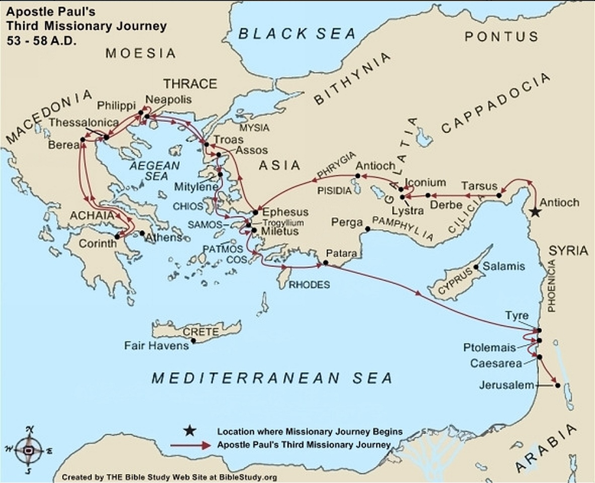

**Autumn 52 A.D. to Summer 53 A.D.**

[Paul](https://www.biblestudy.org/trivia/apostle-paul.html) stays in Antioch from the Autumn of 52 A.D. to the Summer of 53 A.D. (Acts 18:23). Peter visits Antioch during the Spring Holy Day season. While celebrating [the Feast of Unleavened Bread](https://www.biblestudy.org/bibleref/holy-days/passover-and-feast-of-unleavened-bread.html) Peter does not have a problem with eating or fellowshipping with uncircumcised Gentile converts. During the Feast some Jewish converts from Jerusalem arrive. These converts still believe all Christians (e.g. the Gentiles) [should also be circumcised](https://www.biblestudy.org/apostlepaul/life-epistles-of-apostle-paul/controversies-in-the-early-church.html) in order to receive salvation.

As Apostle Paul relates in the book of Galatians, Peter (and [Barnabas](https://www.biblestudy.org/apostlepaul/barnabas-to-gallio.html)) treat the Gentile converts quite differently when the Jewish converts arrive. Their behavior, according to him,[deserved a public rebuke](https://www.biblestudy.org/apostlepaul/life-epistles-of-apostle-paul/paul-confronts-peter.html).

**Summer 53 A.D.**

Paul's third evangelistic tour begins by revisiting [the churches in Galatia](https://www.biblestudy.org/roman-empire/roman-provinces-in-new-testament/asia-galatia-bithynia.html) in order to follow-up on the epistle he wrote to them in late spring (book of Galatians). He then visits brethren in the Phrygia province to strengthen them in their walk as Christians (Acts 18:23).

**Autumn 54 A.D. to Early Winter 57**

Paul, from the Phrygia region, journeys to [Ephesus](https://www.biblestudy.org/biblepic/ephesus-apostle-paul-missionary-journeys.html) and stays in the city for a little more than three years (Acts 19:1 - 20). In the late winter of 56 A.D., while at Ephesus, he writes the book of 1Corinthians. He writes his second epistle to [the Corinthians](https://www.biblestudy.org/biblepic/corinth-apostle-paul-missionary-journeys.html) in late summer of 57 A.D.

While in Ephesus he discovers twelve believers who were baptized as a sign of repentance by [John the Baptist](https://www.biblestudy.org/question/john-the-baptist-doubts-jesus.html) but who DID NOT as yet have God's spirit. He tells the disciples about Jesus and baptizes them in His name. Upon baptism they immediately receive God's Holy Spirit (Acts 19:1 - 7).

Paul preaches boldly about the Gospel for three months in a local synagogue. Some, however, who do not believe what he teaches begin to speak evil of God's way. Paul and those who believe the Gospel leave the synagogue (Acts 19:8 - 10).

One day seven sons of a Jewish priest named Sceva arrive in Ephesus. The sons are Jewish exorcists who travel from place to place and [pretend to cast demons](https://www.biblestudy.org/apostlepaul/life-epistles-of-apostle-paul/paul-at-ephesus.html) out of people. They witness Paul casting out demons and decide to try his method for themselves. They run into someone possessed of an evil spirit and attempt to cast it out of the person. The response they receive is totally unexpected!

What happens next to the seven sons serves as a warning to anyone who assume to have the authority of God to command powerful evil spirits. As the sons learn, merely using the name of Jesus does not guarantee the ability to access His power (Acts 19:13 - 17).

After what happened to the sons of Sceva many who practiced magic repented of their deeds and burned their books of spells and other evil-related practices (Acts 19:18 - 19).

**Early Winter 57**

In the early winter of 57 A.D. an Ephesian silversmith named Demetrius, who makes a significant profit creating small replicas of [the pagan goddess Diana and her temple](https://www.biblestudy.org/apostlepaul/life-epistles-of-apostle-paul/paul-versus-pagans.html), becomes concerned about a recent loss of business (Acts 19:24 - 27)

The preaching of Paul in the area has persuaded many people to stop purchasing and using idols, and to abandon altogether the worship of false gods like Diana. The goddess Diana is zealously worshipped in Ephesus and in other places around the empire.

The city of Ephesus is famous for possessing the Temple of Diana (Artemis), which in modern times is considered [one of the seven wonders](https://www.biblestudy.org/apostlepaul/life-epistles-of-apostle-paul/wonder-of-ancient-world.html) of the ancient world. Demetrius [the silversmith](https://www.biblestudy.org/bible-study-by-topic/silver-in-the-bible.html) organizes a meeting of fellow tradesmen to discuss the drop in idol sales.

During the meeting a riot breaks out. The crowd finds and seizes two of Paul's traveling companions. When Paul wants to talk to the mob some disciples stop him from doing so and jeopardizing his life (Acts 19:28 - 31). The riot is eventually quieted by a city clerk (Acts 19:32 - 40).

The worship of Diana is so well-known and universally accepted that, according to the clerk, there was no danger of it being destroyed by the evangelist and what he taught. The clerk chides the crowd for their unreasonable fears and warns them there are consequences if they continue being disorderly! The riot soon disperses.

[Paul leaves Ephesus](https://www.biblestudy.org/apostlepaul/life-epistles-of-apostle-paul/revisiting-new-churches.html) and journeys to Macedonia. During his three month stay in the region he visits [Corinth](https://www.biblestudy.org/apostlepaul/life-epistles-of-apostle-paul/second-visit-to-corinth.html) (Acts 20:1 - 3) and writes his letter to the Romans.

**58 A.D.**

The apostle Paul and company travel back through Macedonia to [Troas](https://www.biblestudy.org/biblepic/troas-apostle-paul-missionary-journeys.html), where they keep the Feast of Unleavened Bread (Acts 20:6). On his last day at Troas he preaches and teaches until late in the night. Listening to him is a young man sitting in a window. The man soon [goes into a deep sleep and dies](https://www.biblestudy.org/apostlepaul/life-epistles-of-apostle-paul/paul-resurrects-dead.html) when he falls from the window to the street below. The evangelist immediately goes to the young man, embraces him, and [he comes back to life](https://www.biblestudy.org/question/who-has-been-resurrected-from-the-dead.html) (Acts 20:7 - 11)!

After the Feast Luke and a few others sail from Philippi and meet Paul in Troas. Although [Luke](https://www.biblestudy.org/apostlepaul/luke-to-persis.html) and several others decide to sail from Troas to [Assos](https://www.biblestudy.org/biblepic/assos-apostle-paul-missionary-journeys.html), Paul chooses to walk to the city (Acts 20:13 - 14).

In Assos the entire group takes a ship to Mitylene (Acts 20:14). From Mitylene they sail past the islands of Chios and Samos, dock for a night at Trogyllium, then eventually arrive at Miletus (Acts 20:15).

From Miletus the apostle requests that the elders in the Ephesian church visit him. When they arrive [he warns them](https://www.biblestudy.org/apostlepaul/life-epistles-of-apostle-paul/warning-to-the-church.html) about the coming apostasy in the church (Acts 20:26-31).

[Paul soon boards a ship](https://www.biblestudy.org/apostlepaul/life-epistles-of-apostle-paul/paul-sails-to-jerusalem.html) in Miletus. His vessel sails to the islands of Cos and Rhodes but only to dock briefly off their coasts. He eventually arrives at Patara, where he boards another boat bound for the city of Tyre in Phoenicia (Acts 21:1 - 4). Landing at [Tyre](https://www.biblestudy.org/apostlepaul/life-epistles-of-apostle-paul/paul-arrives-in-tyre.html) he stays will fellow believers in the area for one week (Acts 21:5 - 6).

From Tyre Paul sails to Ptolemais where his visits some brethren for a day. He again boards a boat and arrives at Caesarea. [Philip the evangelist](https://www.biblestudy.org/apostlepaul/peter-to-sergius-paulus.html), who lives in Caesarea, has him stay in his home for many days (Acts 21:8,10). While at Philip's house a prophet from Judea named Agabus comes to see him. He takes his belt, binds his own hands and feet, and gives a prophecy of Paul's capture (Acts 21:11).

Although those with him plead with him not to go to Jerusalem he decides to go anyway (Acts 21:12 - 15).

**Late Spring 58 A.D.**

Paul arrives in Jerusalem around the late spring of 58 A.D., possibly near the time of [the Feast of Pentecost](https://www.biblestudy.org/bibleref/holy-days/message-of-pentecost.html) (Acts 21:17).