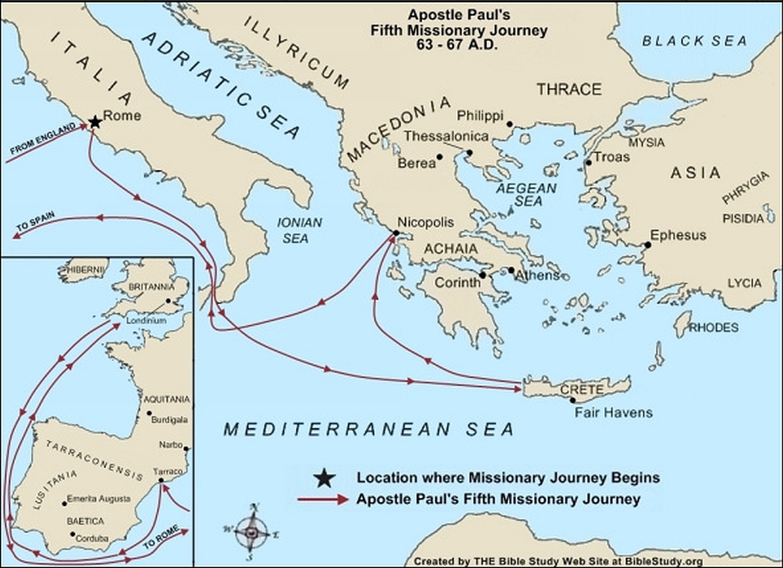

**63 A.D.**

In the Spring of the year, in Rome, [the apostle Paul](https://www.biblestudy.org/apostlepaul/when-were-books-by-apostle-paul-written.html) is acquitted of the charges against him and is set free. He sails from Rome to the island of Crete in order to meet with Titus (Titus 1:5). He then leaves [Titus](https://www.biblestudy.org/apostlepaul/silas-to-zenas.html) in Crete and sails to Nicopolis (Titus 1:5, 3:12). From Nicopolis he writes the New Testament books of 1Timothy and Titus.

**63 A.D. to 67 A.D.**

Paul continues his mission of spreading the gospel by traveling to Spain. In the winter of 57 A.D. He writes to the church at Rome regarding his planned travel to this western part of the empire.

For this reason also, I have been hindered many times from coming to you (the believers in Rome Paul had never visited). But now, there being no place in these regions that has not heard the gospel, and having a great desire to come to you for many years whenever I may go to Spain, I will come to you because I hope to see you while passing through Rome . . .

Therefore, when I have finished this task (delivering aid to [poor saints in Jerusalem](https://www.biblestudy.org/basicart/what-does-bible-say-about-poor.html)), and have safely delivered into their hands the fruit that was collected, I will set off toward Spain and will come to you (Romans 15:22 - 24, 28, HBFV).

There is also evidence, though not conclusive, that Paul also preached the gospel in Britain (Britannia).

**67 A.D.**

Paul is back in a prison in Rome. While prisoner he writes his last book which is addressed to his best friend [Timothy](https://www.biblestudy.org/bible-study-by-topic/people-in-the-bible/timothy.html).

**68 A.D.**

Paul is beheaded, under Roman Emperor Nero, around May or June. [His death](https://www.biblestudy.org/question/sauldie.html) occurs just before Nero's suicide on June 9, 68 A.D. in Greece. He is about 66 years old.

Nero is the first emperor of [the Roman Empire](https://www.biblestudy.org/maps/roman-empire.html) to actively persecute and kill Christians. Rome will carry out at least TEN major efforts to exterminate Christians and expunge Christianity from the empire. The persecutions first start under Nero in 67 A.D. and [continue until 313](https://www.biblestudy.org/maps/map-of-roman-empire-under-diocletian-constantine.html).

Paul's impact on Christianity will be enormous. During his ministry he wrote fourteen books of the Bible and carried out no less than five missionary journeys. He paid a price, however, for his strong devotion to God and the truth by spending a total of five of his ministry years in prison. He remained faithful to the very end of his life.