DataStrc Reviewer
MODULE 4 - Queues and Trees

QUEUES - A queue is an abstract data type (ADT) and a linear data structure where elements are inserted and removed from different ends.

REAR (Tail) – the end where a new element is inserted or added.
FRONT (Head) – the end where an existing element is deleted or removed.

A queue follows the FIFO (First In, First Out) principle. This means that the first element inserted into the queue will be the first element removed.
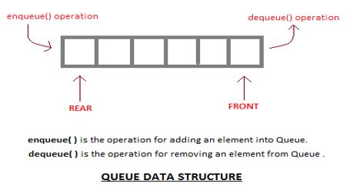

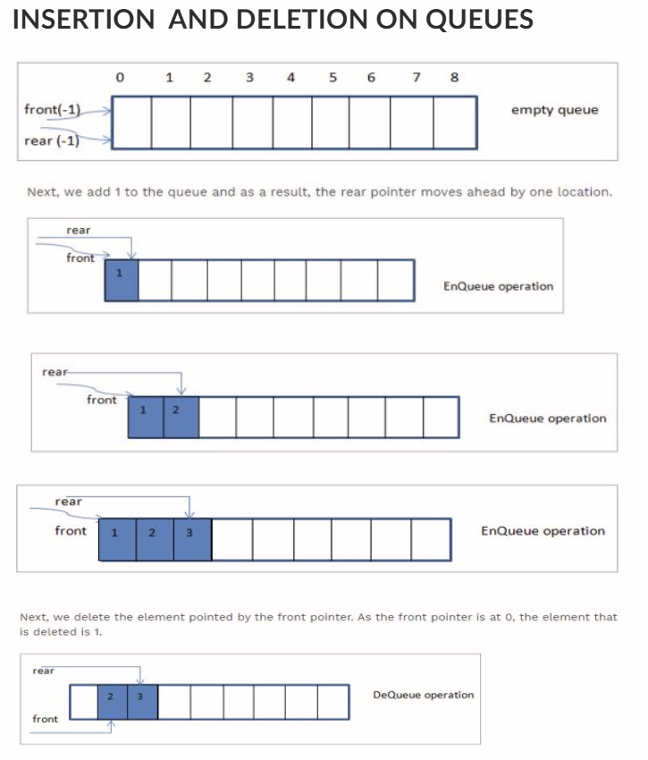
Enqueue - Process to add an element into a queue.
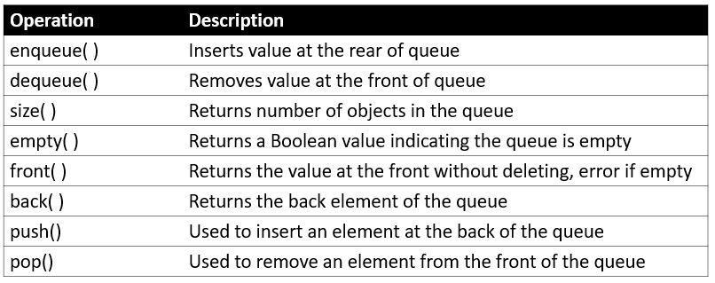
Dequeue - Process of removal of an element from queue.

APPLICATIONS OF QUEUES
Queues are used to manage tasks fairly because they follow FIFO.

Common applications include:
- Waiting lists for shared resources like printers, disks, and CPUs.
- Data transfer between processes, such as pipes, file I/O, and sockets.
- Buffers in applications like MP3 and CD players.
- Playlists for managing songs in order.
- Operating systems for handling interrupts.
Queues are also found in real-life situations, such as waiting in line to order food or buy cinema tickets.

REPRESENTATION OF QUEUES
Array Representation - Queues can be represented using an array or linked list.
- Use an array when the number of elements is known and there are fewer insertions and deletions.
- Use a linked list when the number of elements can change frequently.

QUEUE AS A ONE-DIMENSIONAL ARRAY
A queue can be represented using a one-dimensional array with two variables:
- FRONT → points to the first element and where deletion occurs.
- REAR → points to the last element and where insertion occurs.
Initially, FRONT = -1 and REAR = -1, meaning the queue is empty.
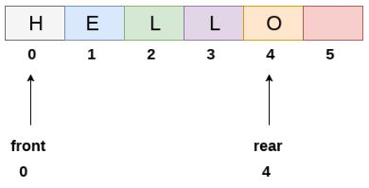

QUEUE INSERTION AND DELETION
Enqueue → insertion of an element into a queue.
Dequeue → deletion of an element from a queue.

When the queue is empty, FRONT = -1 and REAR = -1.
During enqueue, the REAR is increased and the new element is added there. During dequeue, the element at FRONT is removed, then FRONT is increased.

ENQUEUE
- Check if the queue is full.
- If full → Overflow error.
- If not full → increase REAR and add the new element.
- Return success.
DEQUEUE
- Check if the queue is empty.
- If empty → Underflow error.
- If not empty → remove the element at FRONT.
- Increase FRONT to the next element.
- Return success.

DRAWBACKS OF ARRAY IMPLEMENTATION
Memory Wastage:
Deleted spaces before FRONT cannot be reused in a simple array queue, causing unused memory.
Fixed Array Size:
The array size must be decided in advance. If the queue grows beyond its size, expanding the array can require reallocation, which takes time and may cause more memory wastage.
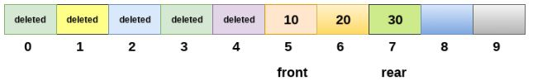

Linked List Representation of QUEUES - A linked list can be used instead of an array to avoid problems like memory wastage and fixed array size. A linked queue can grow or shrink as needed, making it suitable for larger applications.

QUEUE AS A SINGLY LINKED LIST
A linked queue uses two pointers:
- FRONT → points to the first element.
- REAR → points to the last element.
Insertion → REAR
Deletion → FRONT
If FRONT = NULL and REAR = NULL, the queue is empty.

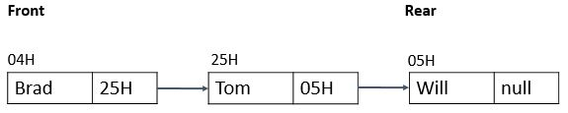

INSERTION (ENQUEUE)
A new element is always added at the REAR.
- If the queue is empty, the new node becomes both FRONT and REAR.
- If the queue already has elements, the new node is connected after REAR, then REAR is updated to the new node.
- The new REAR → NEXT is always NULL.

DELETION (DEQUEUE)
Deletion removes the element at the FRONT, following FIFO.
- First, check if the queue is empty.
- If FRONT = NULL, an Underflow occurs.
- Otherwise, remove the node pointed to by FRONT.
- Move FRONT to the next node.
- Free the old front node.

CIRCULAR QUEUES - A circular queue is a queue that follows FIFO (First In, First Out) where the last position connects back to the first position, forming a circle.
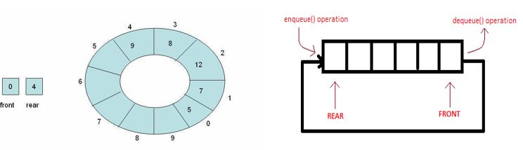

It solves the memory wastage problem of a linear queue by allowing previously deleted spaces to be reused.
Key idea: The first index comes after the last index.

INSERTION (ENQUEUE)
- If the next position of REAR is FRONT, the queue is full → Overflow.
- If REAR is not at the last position, move REAR forward and insert the element.
- If REAR reaches the last position but there is still available space, move REAR back to 0 and insert there.

DELETION (DEQUEUE)
- If FRONT = -1, the queue is empty → Underflow.
- If there is only one element, set both FRONT and REAR to -1.
- If FRONT reaches the last position, move it back to 0.
- Otherwise, simply move FRONT forward.

PRIORITY QUEUE - A priority queue is a specialized type of queue where each item is assigned a priority. Unlike a normal queue, elements are served based on their priority rather than simply their arrival order.
- Lower key value = Higher priority
- High-priority elements are dequeued first.
- If two elements have the same priority, they follow FIFO order.
- Items are inserted according to their priority/order.
Important: A priority queue is not purely FIFO because priority determines which element is removed first.

ENQUEUE
When an element is inserted, it is placed in the correct position based on its priority.
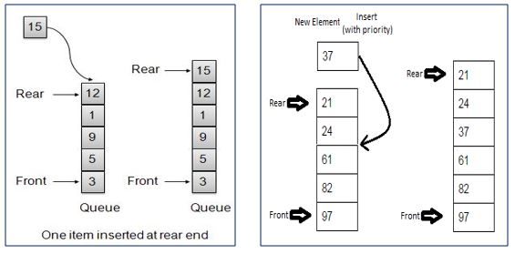

DEQUEUE
The element with the highest priority is removed first.
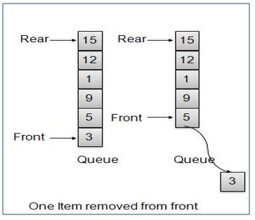

PRIORITY QUEUE IN CPU SCHEDULING
Priority queues can be used by an operating system for CPU scheduling. Each process is given a priority, and the process with the highest priority is executed first.

If processes have the same priority, they are handled using First Come, First Served (FCFS).
Priority can be based on factors such as:
- Memory requirements
- Time requirements
- Resource requirements
The Arrival Queue contains processes waiting to be executed. Each process has an arrival time, execution time, and priority.
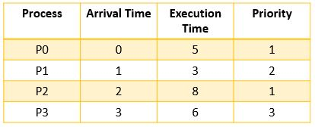

A Gantt chart is used to show the order in which processes are executed by the CPU.
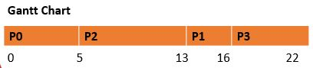

Waiting Time measures how long each process waits before execution. The Average Waiting Time (AWT) is calculated by adding all waiting times and dividing by the number of processes.
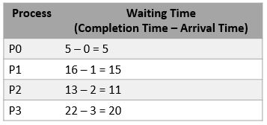

AWT = (5 + 15 + 11 + 20) / 4
= 51 / 4
= 12.75

THE TREE DATA STRUCTURE

TREES - A tree is a data structure that organizes data in a hierarchical structure and shows relationships between different elements or nodes. Trees are commonly used in databases, searching, sorting, and organizing information.

WHAT IS A TREE?
A tree consists of nodes, with one node called the root. The other nodes are connected through parent-child relationships.
- Root → the top node of the tree, at Level 0.
- Parent → a node that has one or more children.
- Child → a node connected below a parent.
- Siblings → nodes that have the same parent.
- Subtree → a smaller tree formed from a node and its children.
- A node can have multiple children, but only one parent.
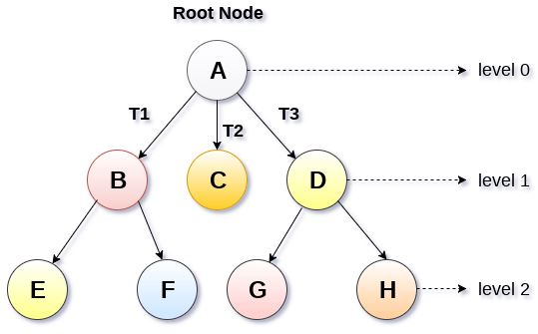

TYPES OF TREES
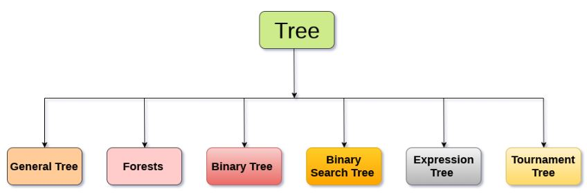

General Tree → A tree where a node can have any number of children.
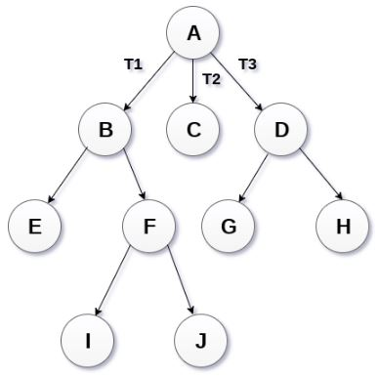

Forest → A collection of disjoint trees, formed by removing the root and its connecting edges.
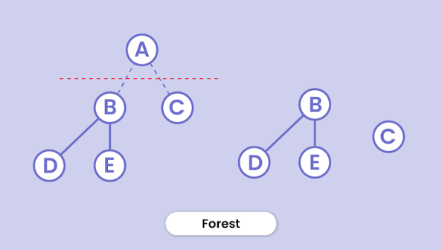

Binary Tree → Each node can have at most 2 children. A node with no children is called a leaf node.
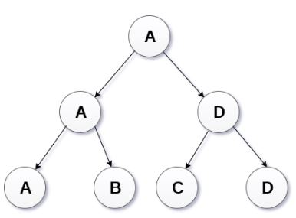

Binary Search Tree (BST) → An ordered binary tree where:
- Left subtree → values less than the root
- Right subtree → values greater than or equal to the root
Used for searching and sorting.
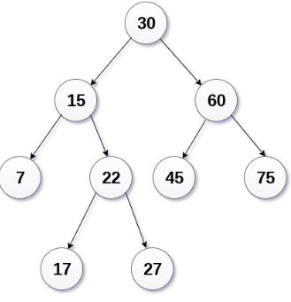

Expression Tree → A binary tree used to represent and evaluate arithmetic expressions. Operators are internal nodes, while operands are leaf nodes.
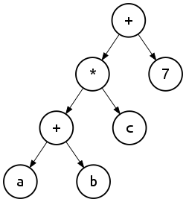

Tournament Tree → Used to determine winners in a competition. The players are at the external nodes, match winners are stored in internal nodes, and the overall winner is the root.
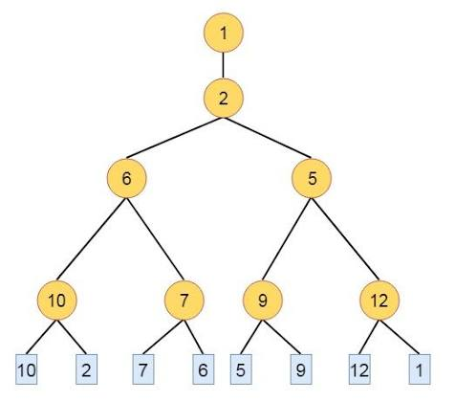

BASIC TREE TERMINOLOGIES
Nodes – The elements that make up a tree. They contain data and are connected by edges. Each node can have at most one parent.

Root Node – The topmost node of the tree. It has no parent and is where the tree begins.
Edges / Lines / Paths – The connections between nodes that show their relationships. Trees are generally accessed from the root downward.

Leaf Nodes – Nodes with no children. They are also called terminal nodes and have a degree of 0.

Internal / Child Nodes – Nodes located inside the tree that have children. Nodes with the same parent are called siblings.

Subtree – A smaller tree made from a node and its descendants. The subtree starting from the root is the entire tree, while one starting from another node is a proper subtree.

Visiting a Node – When a program reaches a node to perform an operation, such as checking or displaying its data.

Traversing – The process of visiting all nodes in a specific order, also called walking the tree.

Levels – The different generations or positions of nodes starting from the root. The root is at Level 0.

Degree – The number of children a node has.

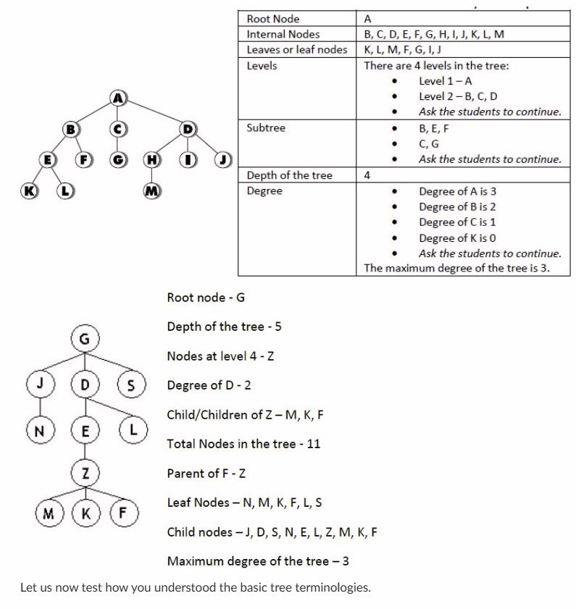
Depth of the Tree – The highest level reached in the tree.

TREE REPRESENTATION USING LINKED LIST
Trees can be represented using linked lists, specifically singly linked lists or doubly linked lists.
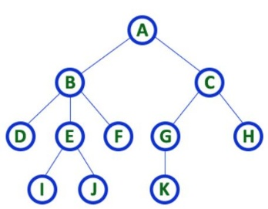

A tree with N nodes can have a maximum of N − 1 edges. Each individual element in a tree is called a node.

SINGLY LINKED LIST REPRESENTATION
Uses two types of nodes:
- Data Node → stores the actual data.
- Reference Node → stores references that connect the nodes.
The representation starts from the root data node and uses reference nodes to connect it to other nodes. This process continues until all tree nodes are represented.
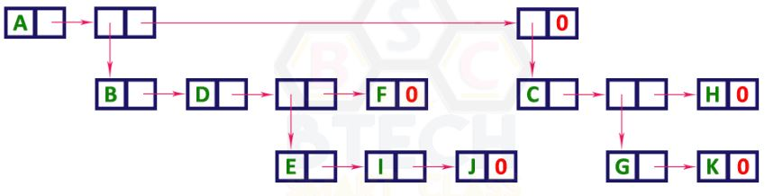

DOUBLY LINKED LIST REPRESENTATION
Uses one type of node with three fields:
- Data → stores the node's actual value.
- Left Child Reference → points to the node's left child.
- Right Sibling Reference → points to the node's right sibling.
If a node has no left child or right sibling, the corresponding reference contains NULL.
