Binary search tree can be defined as a class of binary trees, in which the nodes are arranged in a specific order. This is also called ordered binary tree.
- In a binary search tree, the value of all the nodes in the left sub-tree is less than the value of the root.
- Similarly, value of all the nodes in the right sub-tree is greater than or equal to the value of the root.
- This rule will be recursively applied to all the left and right sub-trees of the root.
As seen in the given tree, the root node is 30. All the values in its left subtree should be less that the root node. 15, 7, 22, 17 and 27 are all less than 30. On the other hand, values on the right subtree should be greater than the root node. As we can see, 60, 45 and 75 are all higher than 30.

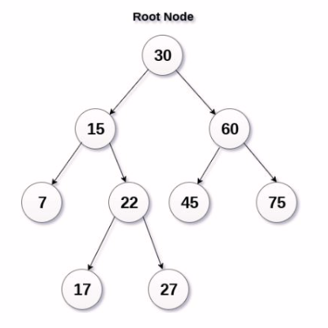

ADVANTAGES OF USING BST
- Searching become very efficient in a binary search tree since, we get a hint at each step, about which sub-tree contains the desired element.
- The binary search tree is considered as efficient data structure in compare to arrays and linked lists. In searching process, it removes half sub-tree at every step. Searching for an element in a binary search tree takes o(log₂n) time. In worst case, the time it takes to search an element is 0(n).
- It also speed up the insertion and deletion operations as compare to that in array and linked list.

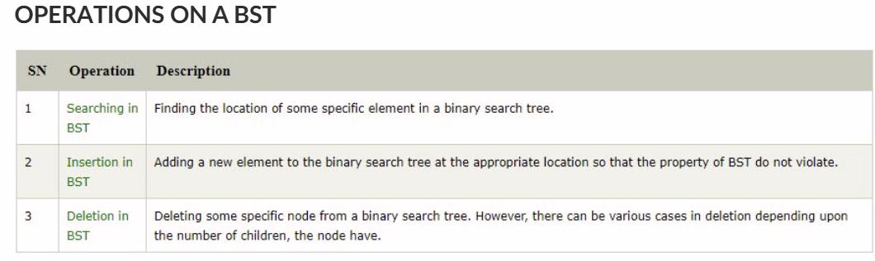

As mentioned in the previous discussion, creating a binary search tree involves the insertion operation. Here is the algorithm for creating a BST:
- Insert the first element into the tree as the root of the tree.
- Read the next element, if it is lesser than the root node element, insert it as the root of the left sub-tree.
- Otherwise, insert it as the root of the right of the right sub-tree.

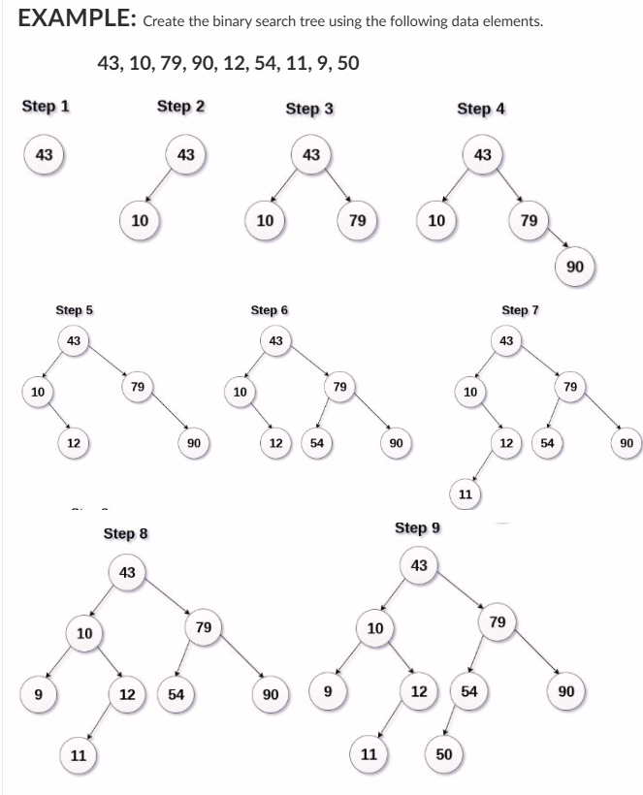

To insert a new node in a BST, we always have to follow the rules wherein all elements in the left subtree should be less than the value of the root node and all values in the right subtree should be greater than the root. A new key is always inserted at the leaf node. Start searching a key from root till we hit a leaf node. Once a leaf node is found, the new node is added as a child of the leaf node.

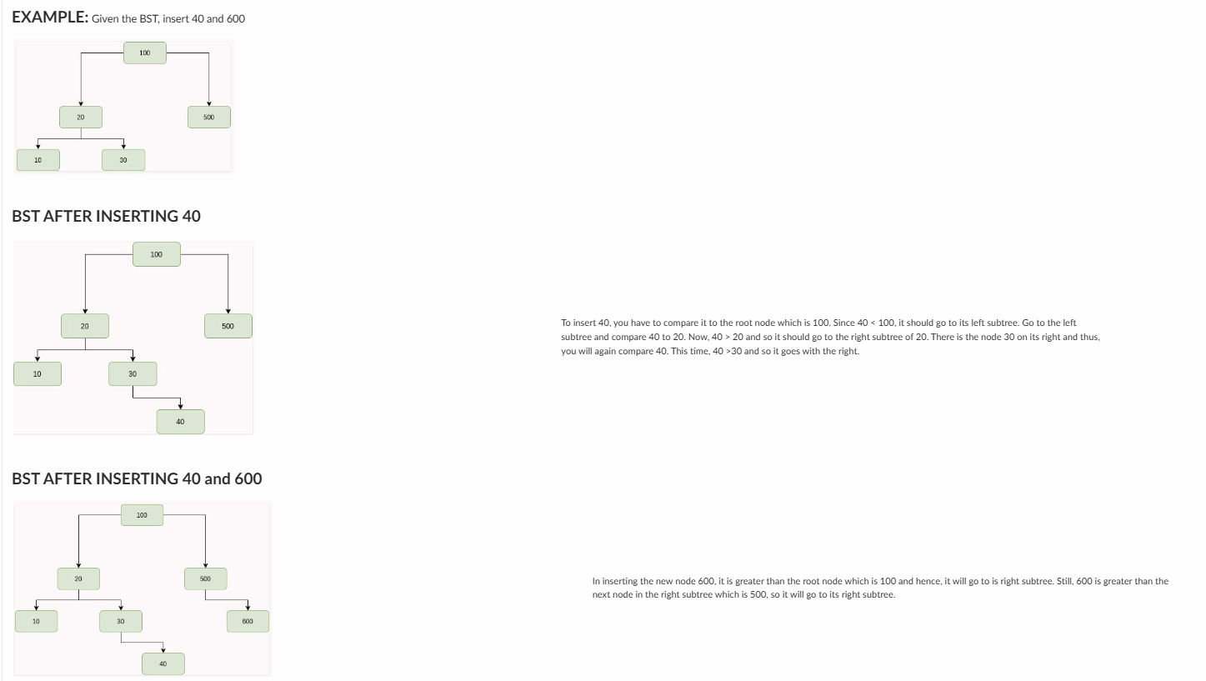

Deleting a value from a BST depends on the position of the node you want to delete. Also, we have to remember the properties of BST and make sure that we do not violate them. Let us see the different scenarios of deleting a node from a binary search tree.
The node to be deleted is a leaf node
It is the simplest case, in this case, replace the leaf node with the NULL and simple free the allocated space.
In the following image, we are deleting the node 85, since the node is a leaf node, therefore the node will be replaced with NULL and allocated space will be freed. We will simple delete 85.
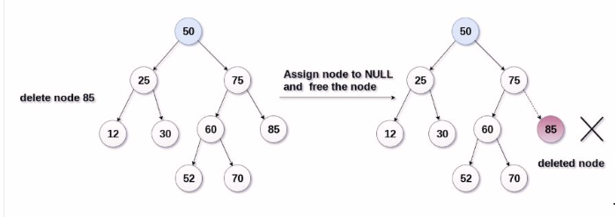

The node to be deleted has only one child
In this case, replace the node with its child and delete the child node, which now contains the value which is to be deleted. Simply replace it with the NULL and free the allocated space.
In the following image, the node 12 is to be deleted. It has only one child. The node will be replaced with its child node and the replaced node 12 (which is now leaf node) will simply be deleted.

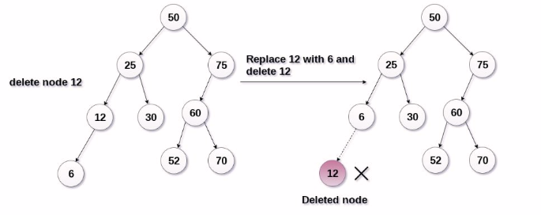
The node to be deleted has two children

It is a bit complex case compare to other two cases. However, the node which is to be deleted, is replaced with its in-order successor or predecessor recursively until the node value (to be deleted) is placed on the leaf of the tree. After the procedure, replace the node with NULL and free the allocated space.
In the following image, the node 50 is to be deleted which is the root node of the tree. The in-order traversal of the tree given below.
6, 25, 30, 50, 52, 60, 70, 75.

Replace 50 with its in-order successor 52. Now, 50 will be moved to the leaf of the tree, which will simply be deleted.

