Current Technologies – Journal

Project Meetings:

Course Start: 13.10.2011

Meeting 1: 28.11.2011 Monday, 8:30 (First Meeting)
Presenting:
- Project Description
- Use Case Diagrams
- Analysis of Terracotta, Memcached and Infinispan

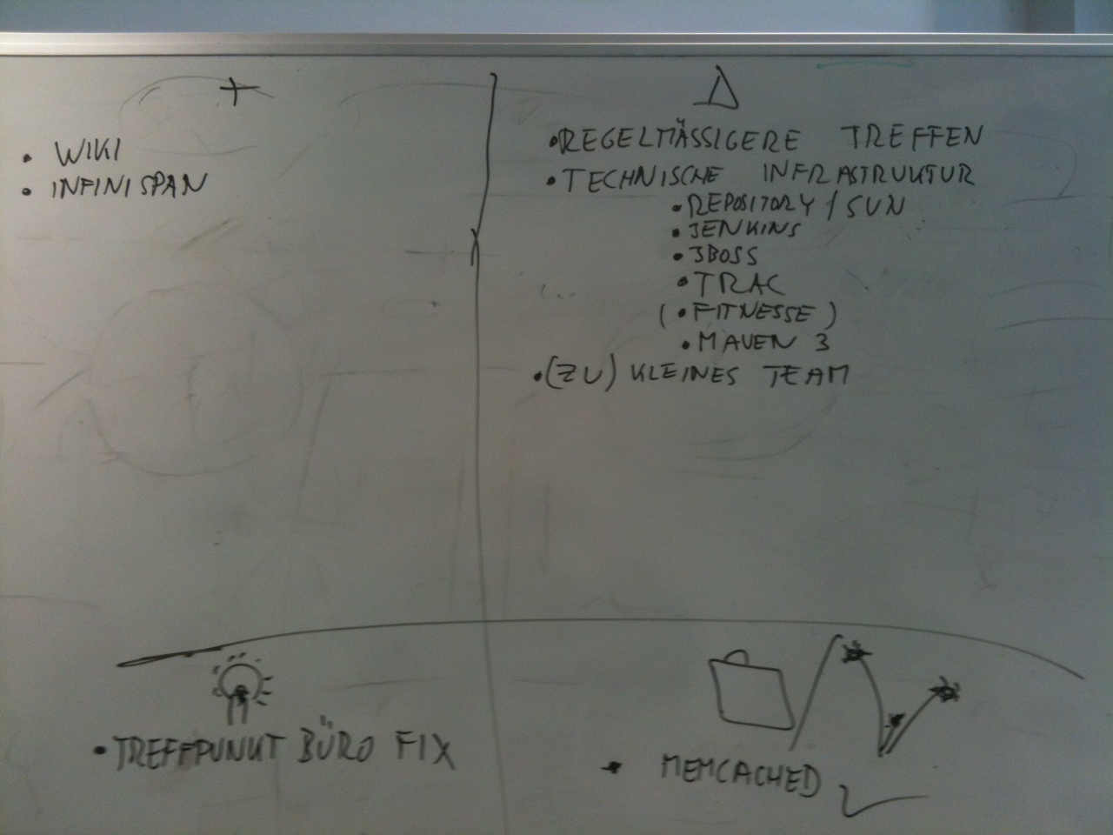
Picture 1: Retrospective of current meeting

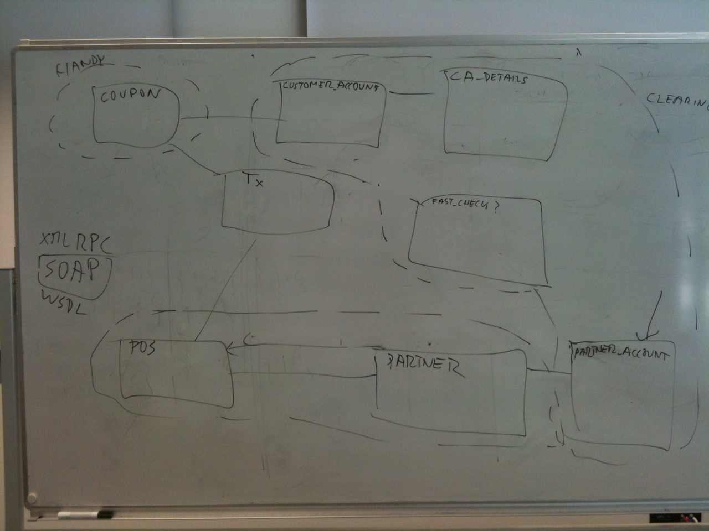
Picture 2: Project structure

Meeting 2: 12.12.2011 Monday, 8:30
- Expand Use Case diagrams
- First Compiled Project

Meeting 3: 09.01.2012 Monday, 8:30
- Enhance Project structure
- Implemented first version of Fastcheck and DelayedTransactionProcessor
- Simple Point of Sale client can send Transaction to Fastcheck
- JMS (HornetQ Configuration)
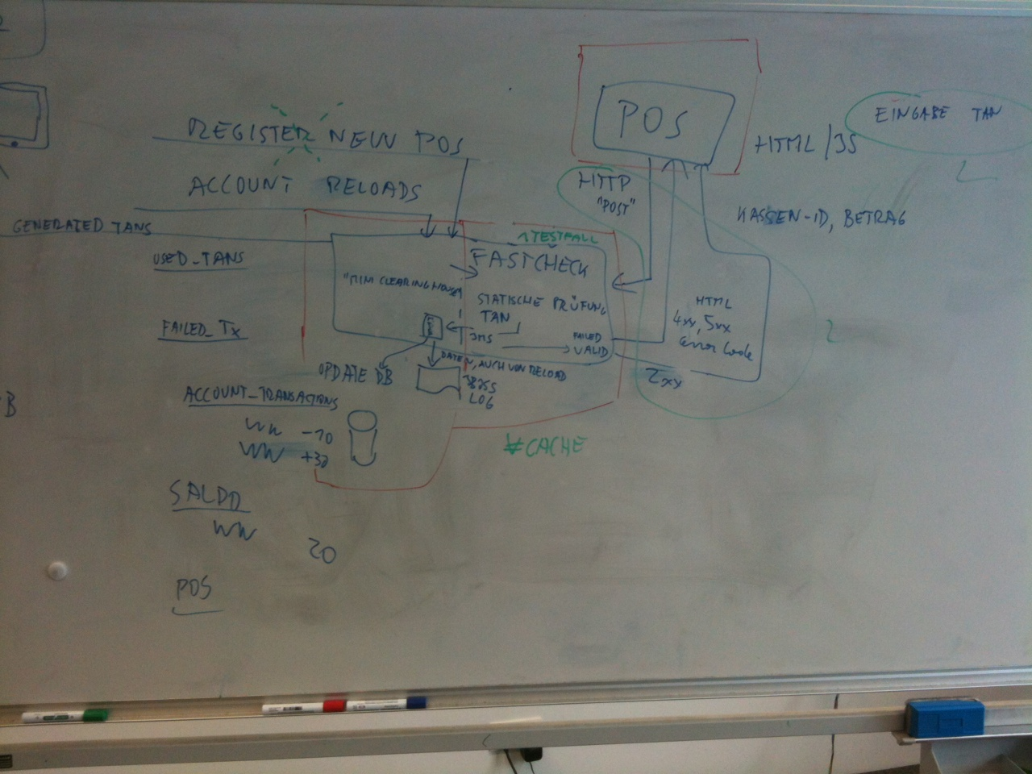
Picture 3: Project structure state

Meeting 4: 23.01.2012 Monday, 8:30
- Implement Java Persistence (JPA)
- Transactions are stored permanently

Meeting 5: 23.01.2012 Monday, 8:30 (Final Meeting)
- Mapping between object and persistence
- Web application for customers, so that they can see an overview of their transactions
- New Users can register

