Turtle Games is a leading player in the gaming industry operating as a manufacturer and retailer; they aim to increase sales performance by considering customer trends. As part of the data analysis team, this project aims to enhance decision-making with data-driven insights through effective analysis of sales data and customer reviews, unlocking insights for data-driven business growth.

. Turtle Games seeks answers to pivotal questions, including loyalty point accumulation, customer segmentation for targeted marketing, leveraging social data for campaigns, product-specific sales impacts, data reliability assessments, and uncovering relationships between North American, European, and global sales.

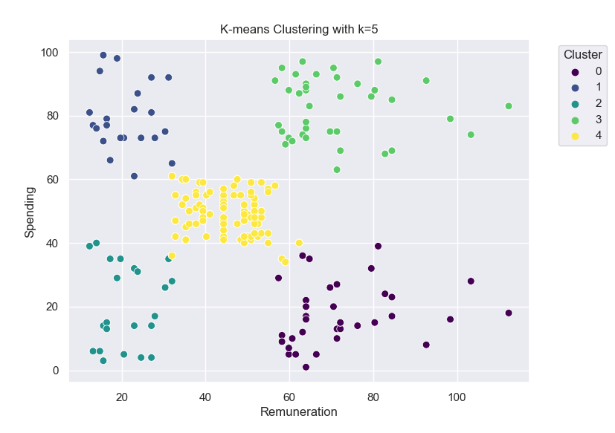

The analytical journey seamlessly unfolds through data import, cleansing, and analysis, impeccably tailored to address Turtle Games' objectives. Operating within the Python ecosystem, the employment of Pandas and Stats Models was touted as an efficient means to import and manipulate data.

The subsequent narrative of data cleaning and manipulation echoed an air of meticulousness. A sense-check of the data frame was allegedly conducted to safeguard data integrity. Regrettably, the precise parameters and benchmarks of this "rigorous" validation remained veiled, leaving room for scepticism regarding its thoroughness. The identification and handling of missing values, though mentioned in passing, lacked granularity, evoking questions about the methodologies employed and their impact on downstream analyses.

Superfluous columns, those deemed less worthy of attention, were unceremoniously dispatched from the dataset. Yet, the rationale underpinning this culling and the potential insights that might have been sacrificed in the process remained unexplored. Similarly, the cosmetic makeover of column labels—bestowing them with the guise of "remuneration" and "spending score"—may have overshadowed the intricate considerations of semantic alignment and the potential consequences of such renaming in the larger analytical context.

Transitioning to the much-touted realm of Exploratory Data Analysis (EDA), where the latent promise of insights was poised to be unveiled, one is left yearning for a deeper critical lens. While scatterplots and regression lines supposedly unfurled potential associations, the intricacies of variable selection, the assumptions underlying linearity, and the inherent limitations of these methods in capturing complex relationships were notably absent from the discourse.

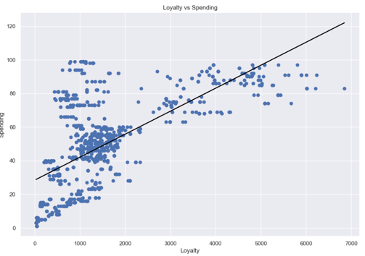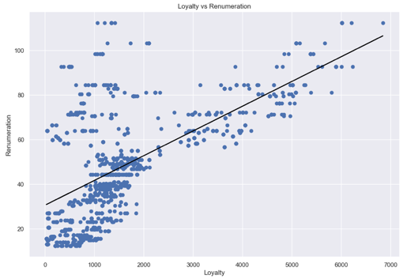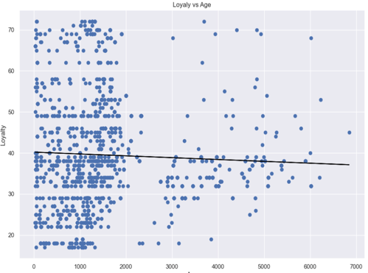

The subsequent foray into clustering, a hallmark of customer segmentation, reeked of a formulaic approach. While the creation of a new data frame and employment of Silhouette and Elbow methods were purported as strategic manoeuvres, the critical rationale behind their deployment, including the impact of varying parameter settings and inherent biases, remained elusive.

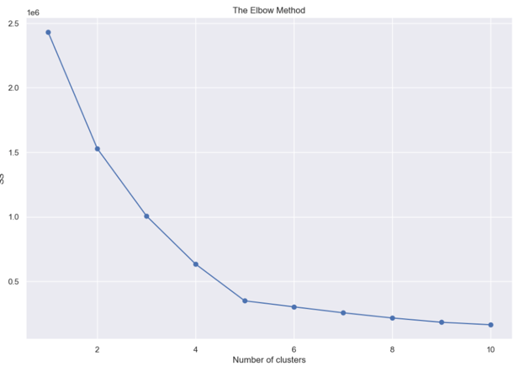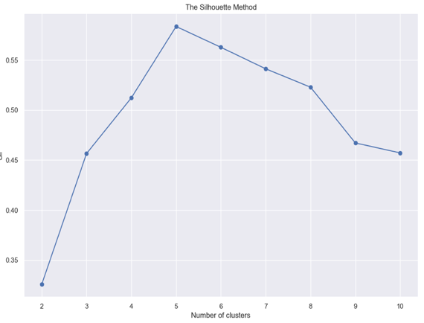

The discourse around sentiment analysis and Natural Language Processing (NLP) invoked a semblance of sophistication. However, the nuanced decisions—like the specific tokenization methods chosen, the handling of stopwords, and the assessment of sentiment polarity—were conspicuously overshadowed. This left a discerning reader pondering the accuracy, validity, and potential biases inherent in the sentiment analysis results.

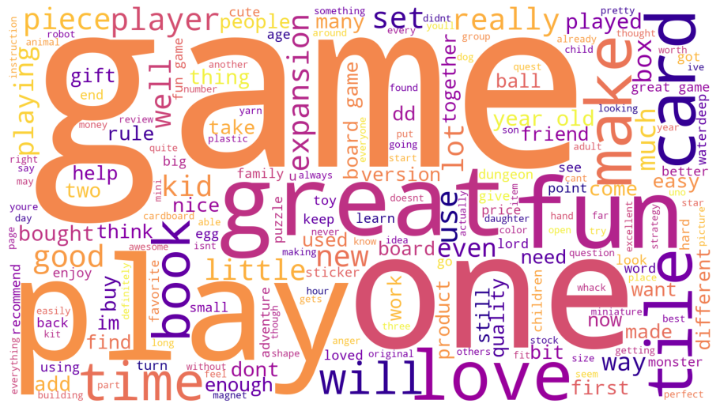

The strategic selection of visualizations served as a compass, navigating through the labyrinth of objectives in both Python and R environments. In R, where the analytical voyage unfolded, a symphony of visual revelations emerged to unlock profound insights.

Applying an astute lens of relevance, scatterplots, histograms, and boxplots were handpicked to unfurl the enigmatic tapestry of sales data. Each visualization was not a mere stroke of aesthetics but a calculated choice to illuminate underlying patterns and correlations, unfurling the story within the data. These visualizations were akin to diagnostic tools, decoding the pulse of sales performance.

The philosophy of best practices permeated through the visual realm, with scatterplots adorned with trend lines emerging as paragons of this ethos.

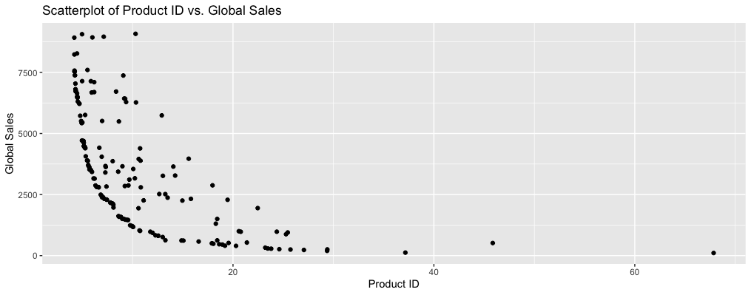

These were not just aesthetic embellishments but rather strategic choices to expose the linear relationships that lay hidden within the data's intricate weave. An illustration of this prowess lay in the revelation of linear relationships between loyalty points and other variables. This insight became a bridge between data and decision-making, potentially holding the key to enhancing customer loyalty and, by extension, overall sales performance.

Word clouds emerged as a unique vantage point into the realm of customer sentiment and feedback. Through these ephemeral constellations of words, common terms in reviews were spotlighted, capturing the very essence of customer discourse. These weren't just visual artefacts but windows into the customer's voice, revealing sentiments and preferences that could potentially guide marketing strategies.

It is paramount to note that visualizations, while aesthetically captivating, are incomplete without a coherent narrative that bridges the chasm between data and insights. This narrative was intricately woven into each visualization, rendering them as dynamic conduits of understanding. Interpretations were not relegated to footnotes but were embedded within each visual artefact, infusing them with tangible meaning.

The journey of interpretation ventured beyond the surface. Histograms and boxplots were not just arrangements of bars and boxes but portals into distributional insights, potentially underpinning targeted marketing endeavours. The very practice of selecting specific visualizations to convey results was underscored by meticulous attention to audience interpretation. Each visualization wasn't an endpoint but a starting point, beckoning the audience to delve deeper into the insights it harboured.

A meticulous exploration of Turtle Games' sales dataset unfolded, shedding light on intricate patterns and unveiling strategic predictions was executed in R with the setup of a coupled with a judicious selection of essential libraries, setting the stage for an insightful analysis.

The voyage of exploration delved deeper into the data's essence. Prudent elimination of extraneous columns ('Ranking,' 'Year,' 'Genre,' 'Publisher') sculpted a focused data frame, poised to extract meaningful insights. This critical step laid the foundation for pattern recognition and predictive modelling.

Visualizations emerged as the storytellers of the dataset, illuminating patterns through scatterplots, histograms, and boxplots. These visual narratives were instrumental in revealing sales trends, potential outliers, and distribution characteristics, thus arming business decisions with vital insights.

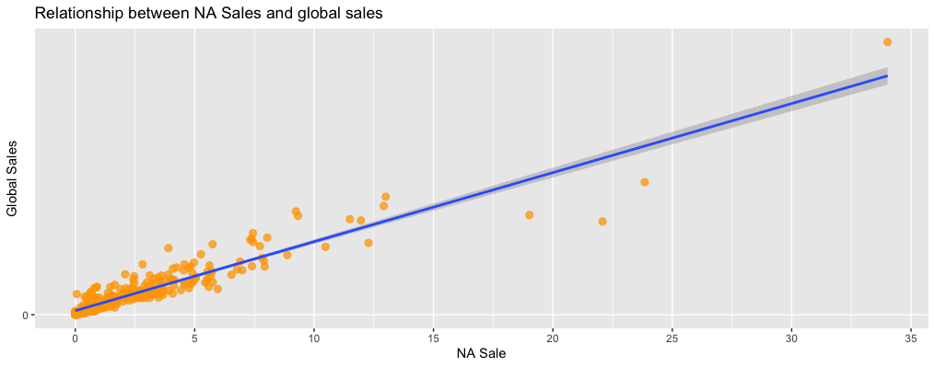

The expedition further embarked on statistical exploration, unearthing essential patterns. Basic statistics unravelled the range and central tendencies of sales data. The impact of product IDs on sales was meticulously deciphered through groupings, casting light on strategic product implications.

Diving into the relationship between North America, Europe, and global sales, regression models showcased intricate patterns. Simple and multiple linear regressions unveiled correlations between sales columns, leading to informed predictions. The predictive power of these models fostered actionable foresight, aiding the formulation of precise strategies.

In conclusion, this analytical journey transcended mere data analysis, unveiling profound patterns and empowering predictions. By leveraging visualization, statistics, and predictive modeling, it provided Turtle Games with a compass to navigate the intricate market landscape. These insights serve as a strategic asset, guiding the company's decisions and propelling it toward success in an ever-evolving industry.