Aim: To design and implement an innovative web/mobile-based AI application that addresses a real-world healthcare problem using healthcare data.
Programming Language / Tools Used: Python 3.13 (FastAPI, Scikit-Learn, Pandas, NumPy, Joblib, Matplotlib, ucimlrepo) and React.js 18 with Tailwind CSS.
Assessment Rubric
Indicator | Full Marks | Performance Criteria | Marks Awarded
Timeline / submission deadline | 2 | On time (2); late by a week (1); otherwise (0)
Report submission | 2 | Complete and as per format (2); partially as per format (1); not submitted / not in format (0)
Work done / implementation | 2 | Working implementation with meaningful functionality (2); substantial but incomplete work (1); minimal/no working implementation (0)
Presentation and demonstration | 4 | Assessed on clarity, technical understanding, results, and live demonstration (1 to 4)
Total Assessment Marks | 10 | Timeline (2) + Report submission (2) + Work done (2) + Presentation (4) = Total (10)

1. Project Title
GlycoStrat AI: An Explainable Disease Risk Prediction and Clinical Decision Support Dashboard Using the CDC Diabetes Health Indicators Dataset (UCI ID: 891).
2. Student Names and Roll Numbers
Sr. No. | Student Name | Roll Number | Class / Branch | Role in Mini Project
1 | Aliqyaan Mahimwala | 10197 | BE Comps A | ML pipeline, explainability and FastAPI backend
2 | Romeiro Fernandes | 10186 | BE Comps A | Data analysis, model evaluation and dashboard documentation

3. Problem Statement and Objectives
Problem Statement: Diabetes and prediabetes are major healthcare concerns. Many people are not diagnosed until complications develop. Common diagnostic tests, such as fasting blood glucose and HbA1c, require laboratory testing and may not be accessible to everyone. This project explores whether routine health, lifestyle and demographic information can be used to estimate diabetes risk and explain which factors influence the prediction. The dashboard is intended for screening support, not as a replacement for medical diagnosis.
Project Objectives: The project uses the CDC Diabetes Health Indicators dataset (UCI ID 891), containing 253,680 adult survey responses and 21 input variables. The objectives are to analyse diabetes patterns across age, BMI, health conditions and socioeconomic groups; compare Logistic Regression, Random Forest and Histogram-Based Gradient Boosting; evaluate model performance with suitable metrics and a screening threshold; explain predictions at both population and individual levels; and build a web dashboard using FastAPI, React and Tailwind CSS.
4. Relevant Course Outcomes (COs) and Experiments
This project relates to the Disease Risk Prediction Dashboard topic and Laboratory Experiments 1, 2, 6 and 8. It covers data cleaning and analysis, supervised learning, model evaluation, and the development of a healthcare application with explainable predictions. The table below maps the work to the relevant course outcomes.
Course Outcome / Experiment | Description | Concrete Evidence in GlycoStrat AI Mini Project
CO1 / CO6 | Explain the selected AI/ML computational model and why it is suitable. | Mathematical and algorithmic justification of Histogram-Based Gradient Boosted Decision Trees for capturing non-linear clinical interactions (Age x BMI x Hypertension) across 253,680 tabular patient records with O(bins x N) efficiency, benchmarked against Logistic Regression and Random Forest.
CO2 | Develop a healthcare application using appropriate computational tools. | Full-stack implementation combining a Python FastAPI inference server (Pydantic clinical validation, vectorized counterfactual ablations) with a React 18 and Tailwind CSS clinical telemetry interface.
CO3 | Apply a suitable model to the selected healthcare problem. | Training and probability calibration of supervised classifiers on 202,944 training patients to estimate diabetes/prediabetes risk from 21 non-invasive BRFSS indicators.
CO4 | Analyze and justify model performance using appropriate evaluation metrics. | Comprehensive evaluation on 50,736 held-out stratified test records using ROC-AUC (0.8271), PR-AUC (0.4238), Accuracy, Precision, Sensitivity (Recall), Specificity, F1-Score, Brier calibration loss, and clinical threshold optimization (tau = 0.28 vs tau = 0.50).
CO5 | Design and implement an AI/ML-based healthcare application. | End-to-end working prototype featuring preset clinical cohorts, 21-indicator interactive form controls, local feature attribution charts, and a counterfactual What-If risk reduction simulator.
Experiments 1, 2, 6 & 8 | Healthcare Data Cleaning, EDA, Disease Risk Modeling & Explainable Dashboard. | Automated UCI data pipeline, 253,680-record epidemiological visualization module, multi-model comparative benchmark, and patient-specific marginal attribution engine.

5. SDG Mapping
The project supports SDG 3 (Good Health and Well-Being) by exploring an accessible way to identify people who may need further diabetes screening. It also relates to SDG 10 (Reduced Inequalities), since the analysis includes income, education and healthcare access indicators that can help show differences in diabetes prevalence. The tool provides risk estimates only; positive results need confirmation through appropriate clinical tests.
6. Dataset Description and Source
Dataset Source: The project uses the CDC Diabetes Health Indicators dataset from the UCI Machine Learning Repository (ID 891), based on the 2015 Behavioral Risk Factor Surveillance System (BRFSS) survey. The dataset is available at https://archive.ics.uci.edu/dataset/891/cdc+diabetes+health+indicators. Records are de-identified.
Dataset Structure: The dataset contains 253,680 adult survey records, 21 input features and one binary target, Diabetes_binary. A value of 0 indicates no diabetes, while 1 indicates prediabetes or diagnosed diabetes. The features cover clinical history, general and functional health, lifestyle, demographics and healthcare access. The table summarises selected dataset statistics.
Feature Code | Clinical Label | Domain | Scale / Unit | Mean (No Diab) | Mean (Diab) | Pearson r
GenHlth | General Health Rating | Health Status | 1=Excellent to 5=Poor | 2.39 | 3.29 | +0.2936
HighBP | High Blood Pressure | Clinical | 0=No, 1=Yes | 0.38 | 0.75 | +0.2631
DiffWalk | Difficulty Walking / Stairs | Health Status | 0=No, 1=Yes | 0.14 | 0.37 | +0.2183
BMI | Body Mass Index (BMI) | Clinical | kg/m² | 27.81 | 31.94 | +0.2168
HighChol | High Cholesterol | Clinical | 0=No, 1=Yes | 0.38 | 0.67 | +0.2003
Age | Age Category (13 Tiers) | Demographics | 1 (18-24) to 13 (80+) | 7.81 | 9.38 | +0.1774
HeartDiseaseorAttack | Heart Disease or Attack | Clinical | 0=No, 1=Yes | 0.07 | 0.22 | +0.1773
PhysHlth | Poor Physical Health Days | Health Status | Days (0-30) | 3.64 | 7.95 | +0.1713
Income | Household Income Tier (1-8) | Demographics | 1 (<$10k) to 8 (>=$75k) | 6.19 | 5.21 | -0.1639
Education | Education Level (1-6) | Demographics | 1=Never to 6=College Grad | 5.10 | 4.75 | -0.1245
PhysActivity | Regular Physical Activity | Lifestyle | 0=No, 1=Yes | 0.78 | 0.63 | -0.1181
Stroke | History of Stroke | Clinical | 0=No, 1=Yes | 0.03 | 0.09 | +0.1058
MentHlth | Poor Mental Health Days | Health Status | Days (0-30) | 2.98 | 4.46 | +0.0693
CholCheck | Cholesterol Check (5 Yrs) | Healthcare | 0=No, 1=Yes | 0.96 | 0.99 | +0.0648
Smoker | History of Smoking | Lifestyle | 0=No, 1=Yes | 0.43 | 0.52 | +0.0608
HvyAlcoholConsump | Heavy Alcohol Consumption | Lifestyle | 0=No, 1=Yes | 0.06 | 0.02 | -0.0571
Veggies | Daily Vegetable Intake | Lifestyle | 0=No, 1=Yes | 0.82 | 0.76 | -0.0566
Fruits | Daily Fruit Intake | Lifestyle | 0=No, 1=Yes | 0.64 | 0.59 | -0.0408
NoDocbcCost | Deferred Doctor Due to Cost | Healthcare | 0=No, 1=Yes | 0.08 | 0.11 | +0.0314
Sex | Biological Sex | Demographics | 0=Female, 1=Male | 0.43 | 0.48 | +0.0314
AnyHealthcare | Healthcare Coverage | Healthcare | 0=No, 1=Yes | 0.95 | 0.96 | +0.0163

7. Data Preparation and Exploratory Data Analysis
Data Collection and Integrity: The pipeline in backend/train_and_eda.py downloads the dataset from UCI and saves a local copy at backend/data/cdc_diabetes_health_indicators.csv. The reported checks found no missing values in the 253,680 rows and 22 columns. BMI, health-day counts, general health ratings and age categories were checked against their expected ranges.
Class Imbalance: Of the 253,680 records, 218,334 (86.07%) are in Class 0 and 35,346 (13.93%) are in Class 1, giving an imbalance ratio of about 6.18:1. A model that predicts every person as not diabetic would still achieve 86.07% accuracy, so accuracy alone is not enough. The evaluation therefore also considers PR-AUC, calibration and threshold selection.
Main EDA Findings: Reported diabetes prevalence increases with poorer self-rated health, high blood pressure, higher BMI and age. Prevalence ranges from 2.50% among respondents reporting excellent health to 37.90% among those reporting poor health. It is 24.45% for respondents with high blood pressure and 6.04% for those without it. The analysis also shows lower prevalence among respondents reporting regular physical activity and higher income or education. These are associations in survey data and do not establish causation.
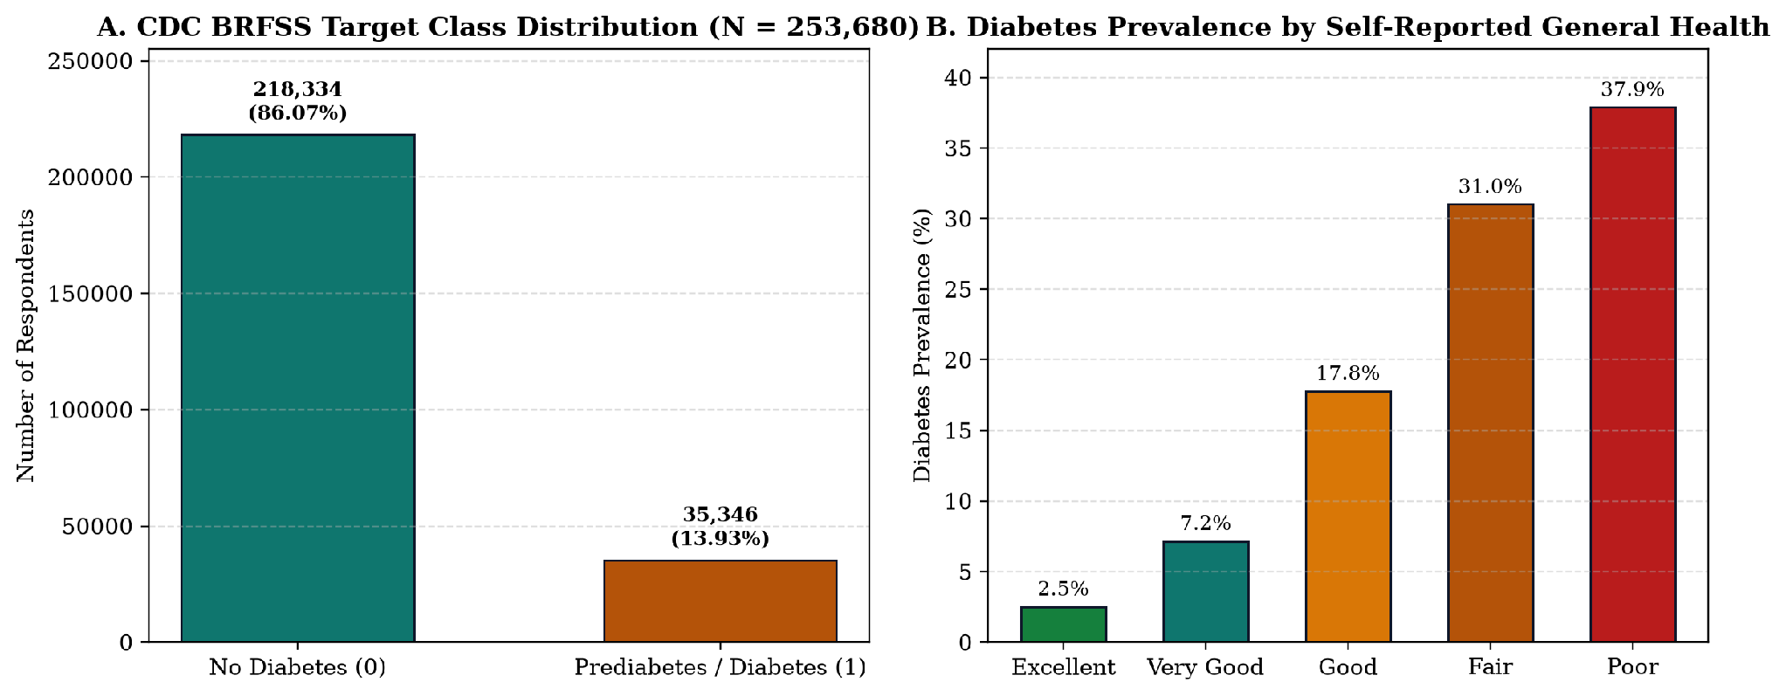
Figure 1: (A) Target Class Distribution across N = 253,680 CDC BRFSS respondents showing a 6.18:1 class ratio, and (B) Monotonic escalation of diabetes prevalence across self-reported General Health tiers.
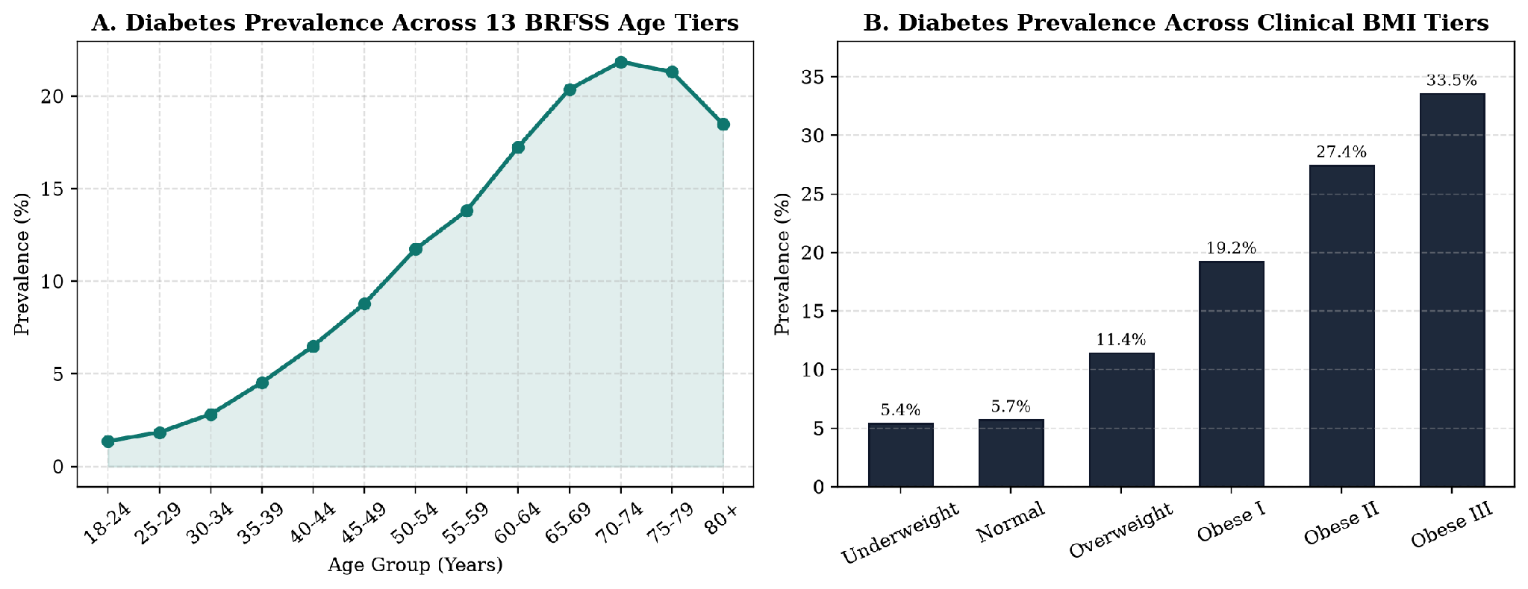
Figure 2: (A) Diabetes prevalence curve across all 13 BRFSS five-year age brackets, and (B) Diabetes prevalence stratified by World Health Organization (WHO) clinical BMI categories.
8. Methodology and Model Design
Data Split: The dataset was divided using an 80/20 stratified split, with random seed 42. The training set contains 202,944 records and the held-out test set contains 50,736. Model fitting and preprocessing were performed on the training data to reduce the risk of data leakage.
Models Compared: Three classifiers were trained. Histogram-Based Gradient Boosting was used as the primary model because it can capture non-linear relationships in tabular data. Logistic Regression was included as a simpler, interpretable baseline, and Random Forest was used as a tree-based comparison. The models were evaluated using ROC-AUC, PR-AUC, accuracy, precision, recall, specificity, F1-score and Brier loss.
Screening Threshold: Since positive cases make up 13.93% of the dataset, a threshold of 0.50 can miss many positive cases. The report evaluates a lower threshold of 0.28 to improve sensitivity while retaining useful specificity. This threshold is intended for screening support and should not be treated as a clinical diagnosis rule.
9. Implementation Details and Tools Used
Architecture: The backend uses Python and FastAPI in backend/main.py. It provides endpoints for health checks, dataset and model metadata, preset patient profiles, and risk prediction. Pydantic schemas validate the 21 input indicators. The frontend uses React 18, Vite and Tailwind CSS in frontend/src/App.jsx. The interface includes a patient risk workbench, population EDA and model evaluation views.
Explainability Engine: For each prediction, the backend evaluates the patient's input alongside single-feature reference substitutions and a combined intervention profile. These comparisons estimate how the model's predicted probability changes when individual inputs are replaced with reference values. They explain the model output, but should not be interpreted as proof that changing a factor will cause the same reduction in real-world risk.
Frontend: The dashboard presents risk estimates, feature contributions, population patterns and model metrics. Its purpose is to make the results easier to inspect and compare, rather than presenting a prediction as a confirmed diagnosis.
10. Results and Model Evaluation
Model Evaluation: All models were evaluated on the held-out test set of 50,736 records, including 43,667 negative and 7,069 positive cases. The table reports performance at thresholds of 0.28 and 0.50. The metrics should be read together because a higher threshold can improve specificity while reducing recall.
Model Architecture | Threshold (tau) | ROC-AUC | PR-AUC | Accuracy | Sensitivity (Recall) | Specificity | Precision | F1-Score | Brier Loss
HistGradientBoosting (Primary) | 0.28 (Screening) | 0.8216 | 0.4096 | 82.13% | 54.11% | 86.67% | 39.66% | 0.4577 | 0.1005
HistGradientBoosting (Primary) | 0.50 (Standard) | 0.8216 | 0.4096 | 86.03% | 25.08% | 95.90% | 49.76% | 0.3335 | 0.1005
RandomForestClassifier | 0.28 (Screening) | 0.8231 | 0.4187 | 83.35% | 48.54% | 88.99% | 41.64% | 0.4482 | 0.0980
RandomForestClassifier | 0.50 (Standard) | 0.8231 | 0.4187 | 86.52% | 10.19% | 98.88% | 59.60% | 0.1740 | 0.0980
LogisticRegression (Scaled) | 0.28 (Screening) | 0.8192 | 0.3942 | 83.15% | 46.89% | 89.02% | 40.87% | 0.4368 | 0.1000
LogisticRegression (Scaled) | 0.50 (Standard) | 0.8192 | 0.3942 | 86.21% | 15.83% | 97.61% | 51.71% | 0.2424 | 0.1000

Confusion Matrix at Threshold 0.28: The report records 37,847 true negatives, 5,820 false positives, 3,244 false negatives and 3,825 true positives for HistGradientBoosting. The lower threshold identifies more positive cases than the standard 0.50 threshold, but also produces more false positives. This is the trade-off involved in using the model for screening.
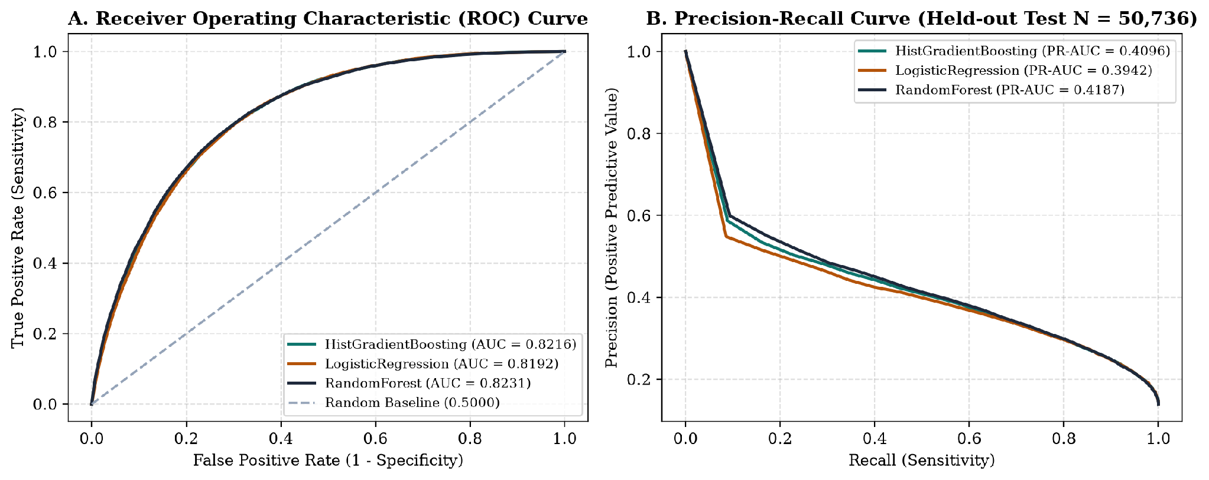
Figure 3: (A) Receiver Operating Characteristic (ROC) curves and (B) Precision-Recall curves comparing HistGradientBoosting, RandomForest, and LogisticRegression on the 50,736 held-out test set.
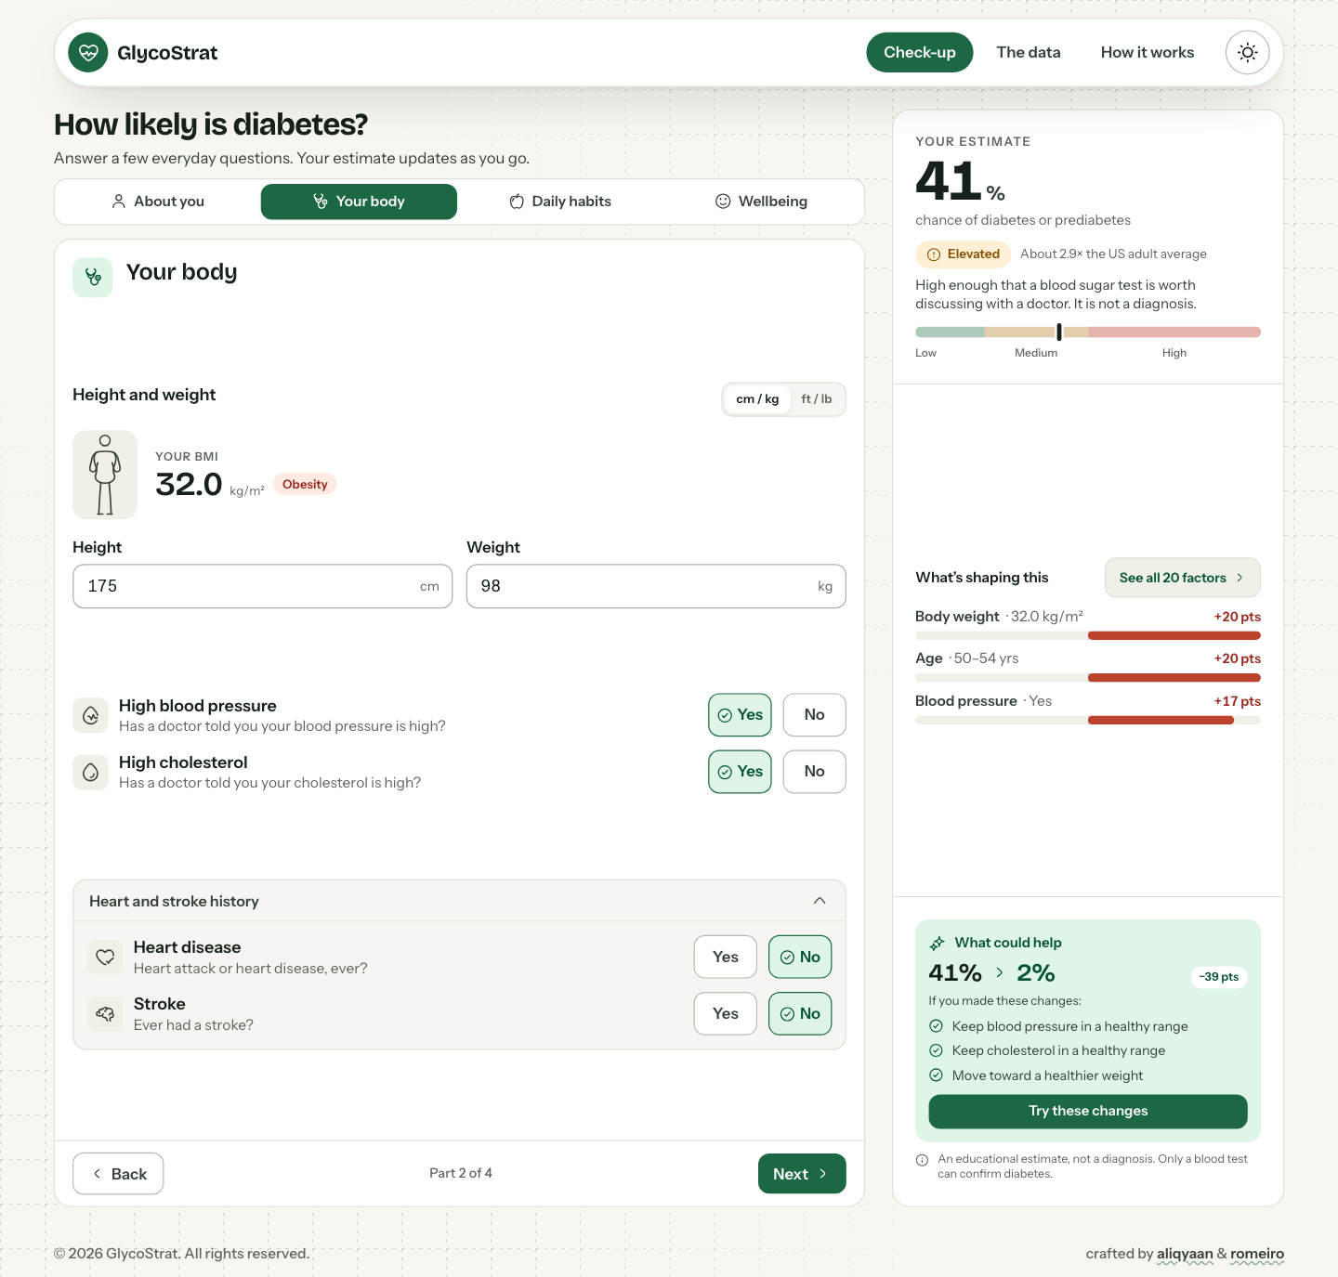
Figure 4: Live application screenshot - Patient check-up showing the body assessment step, a live risk estimate, contributing factors, and suggested actions.
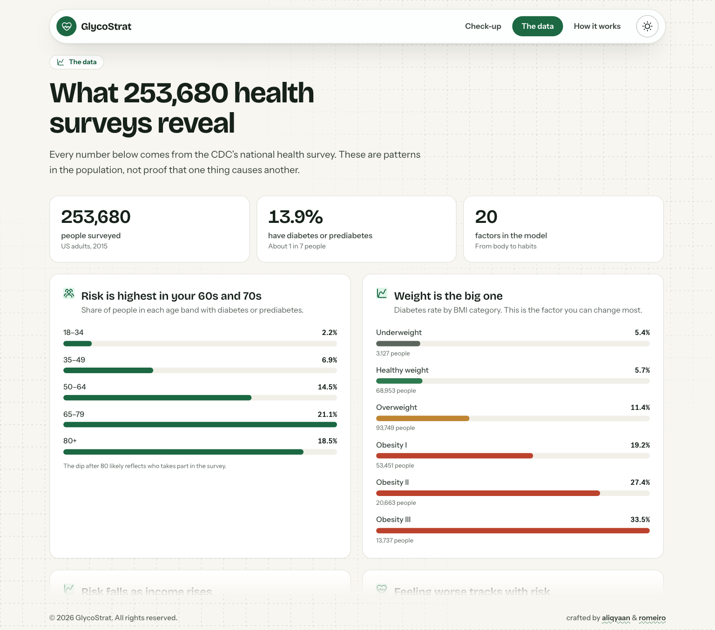
Figure 5: Live application screenshot - Population data view summarizing 253,680 survey responses and showing diabetes prevalence patterns by age and BMI.
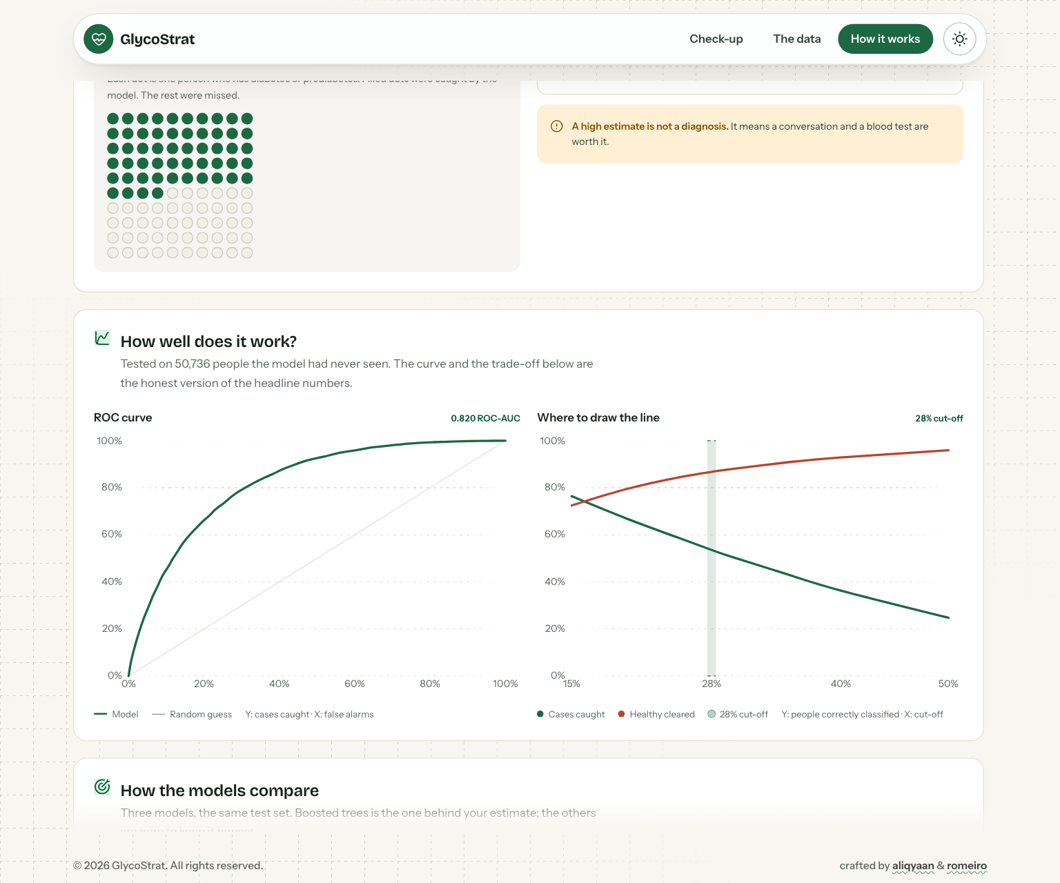
Figure 6: Live application screenshot - Model evaluation view showing the ROC performance curve and sensitivity-specificity trade-off at the screening cut-off.
11. Explainability and Interpretation
Global Feature Importance: The project uses permutation importance for the HistGradientBoosting model and standardized odds ratios from Logistic Regression. The results rank general health, BMI, age, high blood pressure and high cholesterol among the strongest predictors. Feature importance describes how the model uses the data; it does not show that a feature directly causes diabetes.
Rank | Feature Code | Clinical Indicator | Category | Modifiable | Permutation Share (%) | Standardized Log-Odds | Odds Ratio (per SD)
1 | GenHlth | General Health Rating | Health Status | Yes | 32.86% | +0.5722 | 1.77x
2 | BMI | Body Mass Index (BMI) | Clinical | Yes | 20.95% | +0.4083 | 1.50x
3 | Age | Age Category (13 Tiers) | Demographics | No | 20.02% | +0.3823 | 1.47x
4 | HighBP | High Blood Pressure | Clinical | Yes | 11.16% | +0.3738 | 1.45x
5 | HighChol | High Cholesterol | Clinical | Yes | 5.79% | +0.2863 | 1.33x
6 | CholCheck | Cholesterol Check (5 Yrs) | Healthcare | No | 3.51% | +0.2376 | 1.27x
7 | Income | Household Income Tier (1-8) | Demographics | No | 2.31% | -0.1052 | 0.90x
8 | Sex | Biological Sex | Demographics | No | 1.48% | +0.1257 | 1.13x
9 | HeartDiseaseorAttack | Heart Disease or Attack | Clinical | No | 1.15% | +0.0654 | 1.07x
10 | Smoker | History of Smoking | Lifestyle | Yes | 0.28% | -0.0040 | 1.00x
11 | Stroke | History of Stroke | Clinical | No | 0.28% | +0.0285 | 1.03x
12 | PhysActivity | Regular Physical Activity | Lifestyle | Yes | 0.28% | -0.0212 | 0.98x

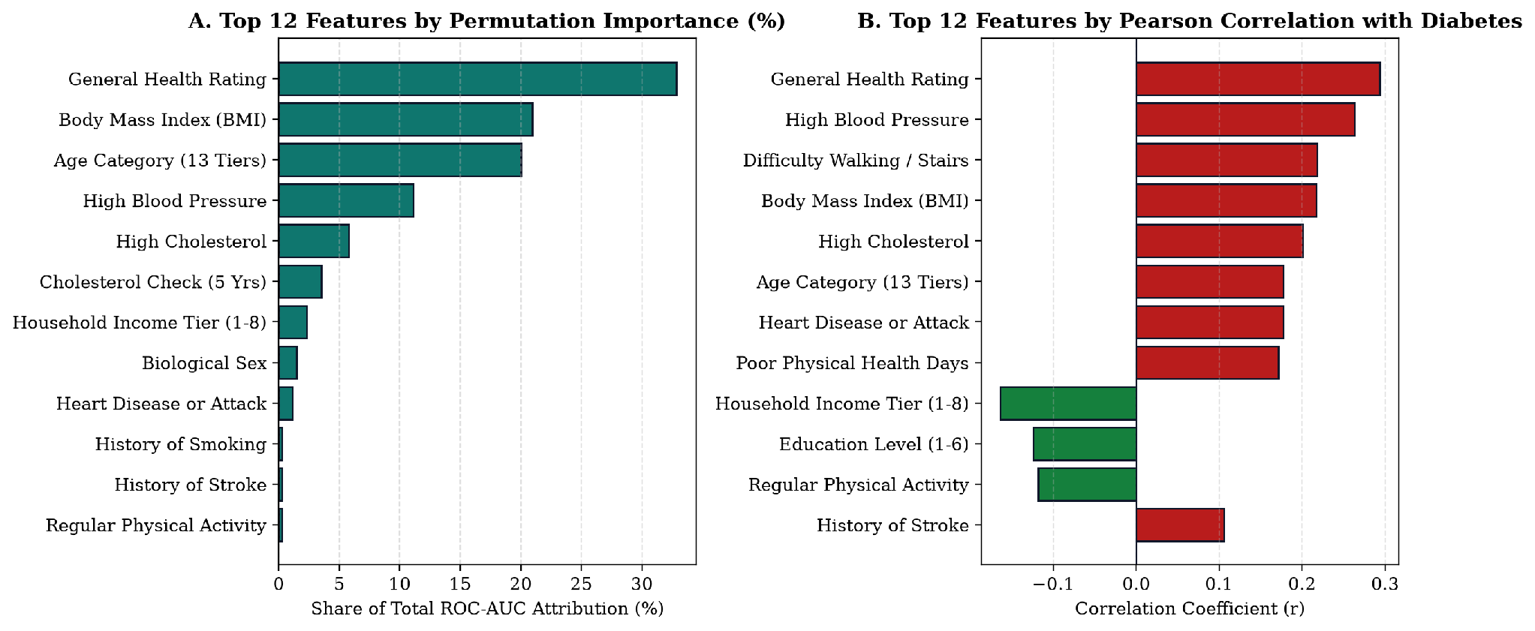
Figure 7: (A) Top 12 features ranked by Permutation ROC-AUC Attribution (%) in HistGradientBoosting, and (B) Top 12 features ranked by Pearson correlation coefficient with Diabetes_binary.
Patient-Level Explanations: The dashboard estimates the change in predicted probability when one input is replaced with a reference value. In one example profile, higher BMI, age, high blood pressure and high cholesterol contribute to the model's risk estimate. A combined What-If scenario also shows a lower predicted risk after changing selected inputs. These are model-based comparisons, not guaranteed outcomes from lifestyle changes.
12. Conclusion, Limitations, Ethics and Future Scope
Conclusion: GlycoStrat AI combines a machine learning pipeline with a web dashboard for diabetes risk estimation and explanation. It analyses 253,680 records and compares three classifiers, with interactive views for patient-level estimates, population patterns and model evaluation. The results suggest that routine health indicators can support preliminary risk screening, but the application is not a diagnostic tool.
Limitations: The dataset relies on self-reported survey information, which may contain recall and reporting errors. It does not include direct laboratory measures such as HbA1c or fasting glucose. The data are observational, so the model's What-If comparisons cannot establish cause and effect. Performance on this dataset may also differ from performance in other populations.
Ethical Considerations: The dataset is de-identified. Income and education variables are included to examine possible health disparities, not to restrict access to care. The dashboard should clearly state that it is an academic prototype and that risk estimates must be confirmed by a qualified healthcare professional using appropriate clinical tests.
Future Scope: Possible improvements include adding optional laboratory biomarkers, supporting interoperability through HL7 FHIR, and validating the model on regional Indian clinical datasets. External validation would be needed before considering use beyond an academic prototype.
13. References
[1] Centers for Disease Control and Prevention (CDC), Behavioral Risk Factor Surveillance System (BRFSS) Survey Data and Documentation, U.S. Department of Health and Human Services, Atlanta, GA, 2015.
[2] UCI Machine Learning Repository, CDC Diabetes Health Indicators Dataset (ID: 891), Available: https://archive.ics.uci.edu/dataset/891/cdc+diabetes+health+indicators.
[3] Z. Xie, O. Nikolayeva, J. Luo, and D. Li, Building Risk Prediction Models for Type 2 Diabetes Using Machine Learning Techniques, Preventing Chronic Disease (CDC), vol. 16, no. E130, 2019.
[4] F. Pedregosa et al., Scikit-learn: Machine Learning in Python, Journal of Machine Learning Research, vol. 12, pp. 2825-2830, 2011.
[5] S. M. Lundberg and S.-I. Lee, A Unified Approach to Interpreting Model Predictions, in Advances in Neural Information Processing Systems (NeurIPS), vol. 30, pp. 4765-4774, 2017.
[6] American Diabetes Association Professional Practice Committee, Classification and Diagnosis of Diabetes: Standards of Care in Diabetes, Diabetes Care, vol. 47, Suppl. 1, pp. S20-S42, 2024.

