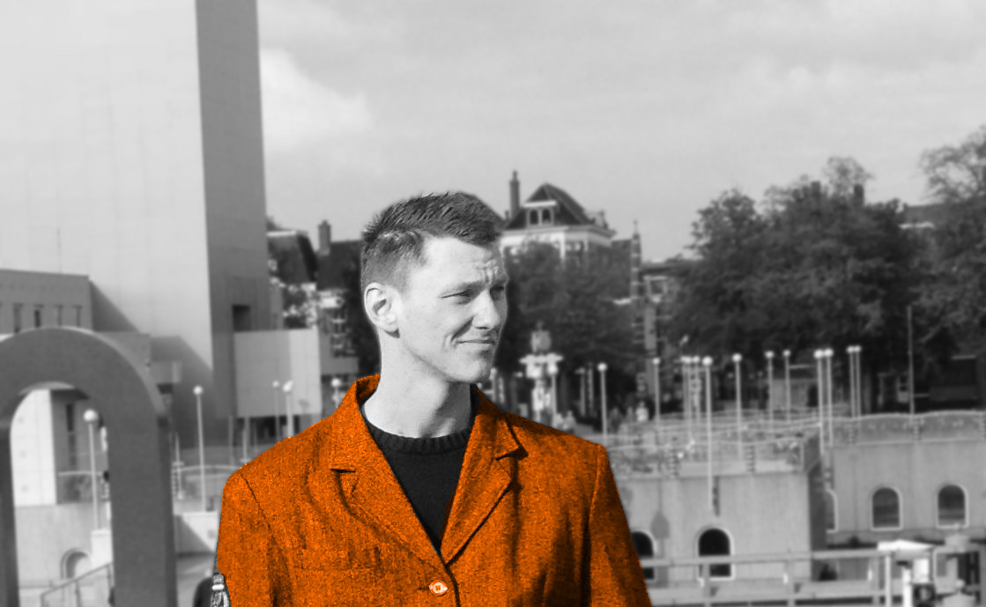

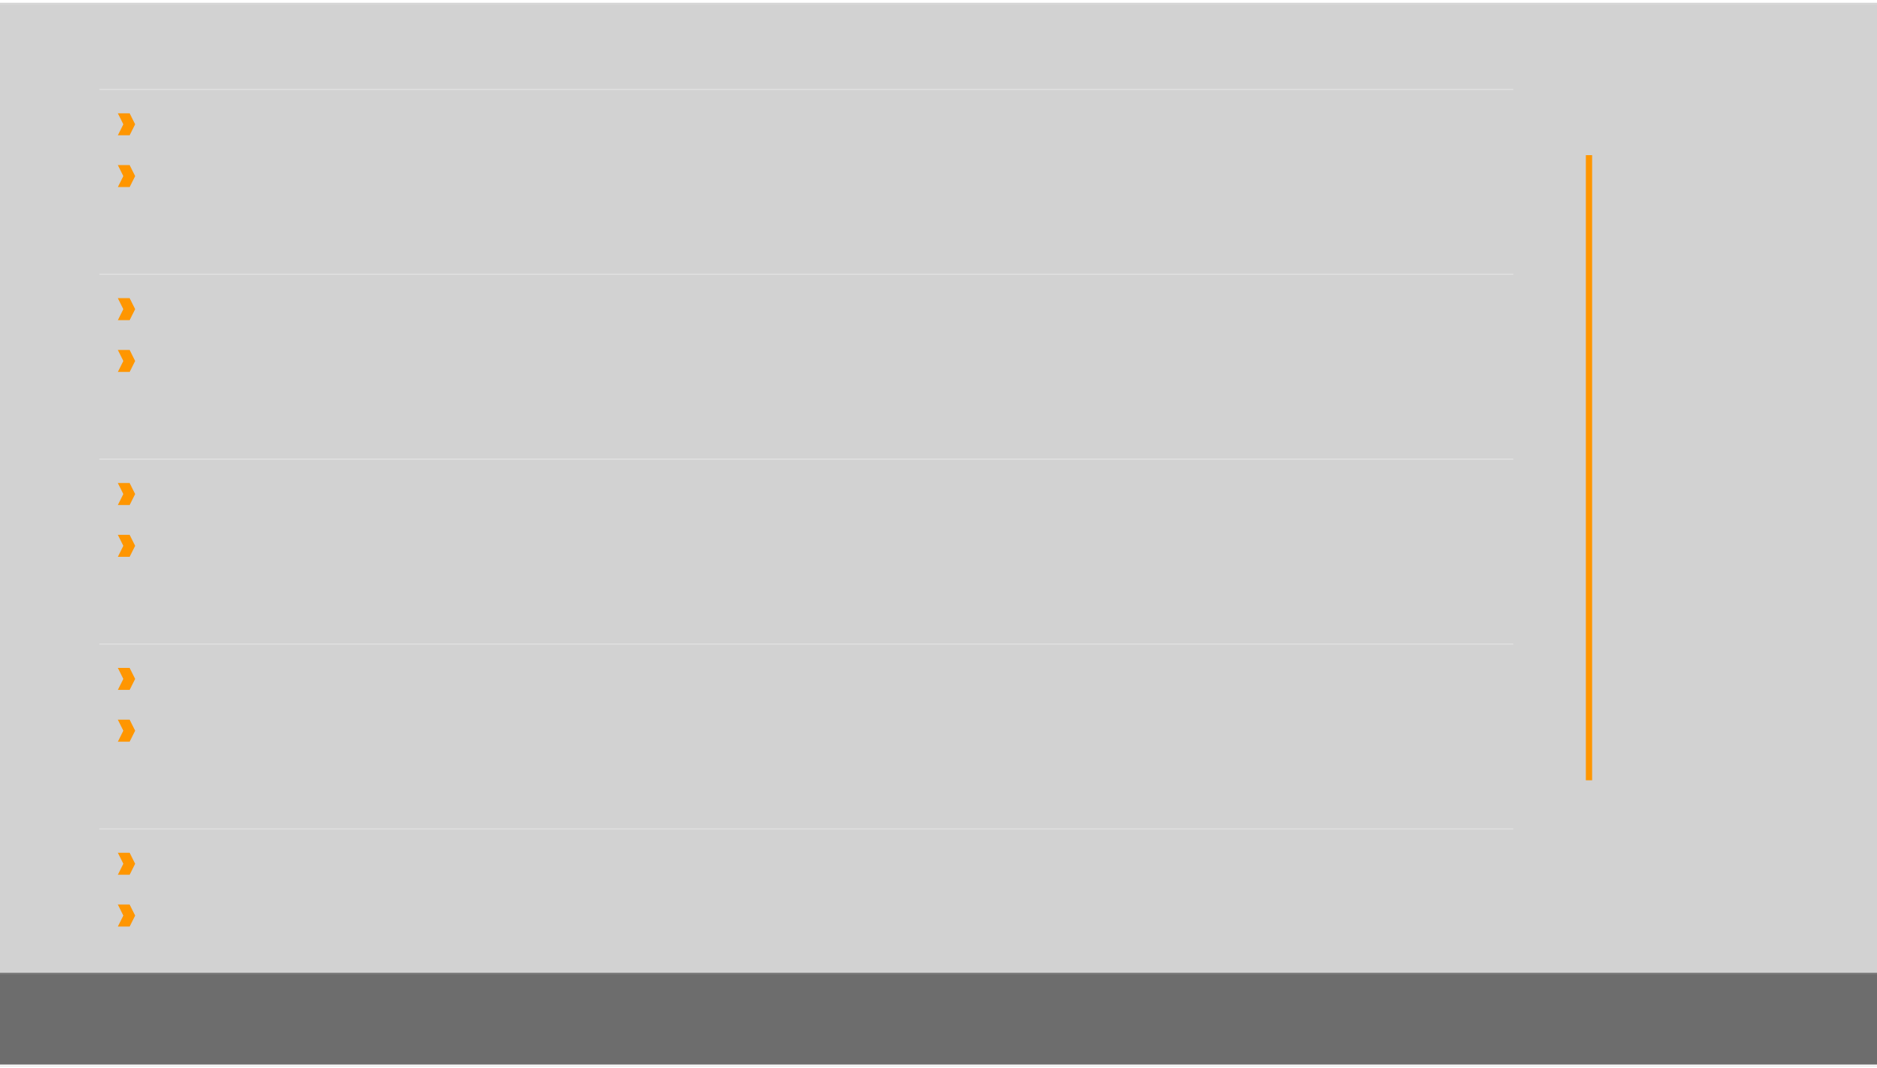
Consultant and Software Engineer · Bremen, Germany · info@jankuester.com · +49 176 313 XXX XX

JAN KüSTER

RESUME

I create awesome resume templates in LaTeX for everyone.
Status: PhD student, M.Sc. Digital Media, Fullstack JS Engineer
Fields: Software Development, Consulting, Education
Stack: Meteor, Mongo, React, Bootstrap, Fontawesome ,Mocha
Tools: Git, Sourcetree, Travis, Webstorm, Terminal
Activities: Global Game Jam, Sound Engineering, Blender, Martial Arts
Fullstack Javascript Engineer (University of Bremen) 2016 - now
Invent a realtime classroom management using Meteor and React
Design software architecture and leading development
IT Consultant for IBM XPages and Notes Domino (We4IT GmbH Bremen) 2014 - 2016
Realize projects in XPages and We4IT Aveedo, monitor project status, conduct reports
Integrated Camunda BPMN engine and BPMN.IO modeler in We4IT Aveedo
Scientific Employee / Software Development (University of Bremen) 2012 - 2014
Invented a flexible assessment framework, targeting industrial trainees
Supervised software development lifecycle, Recruited team members
Project Management Simulation Training (Getoq Consulting) Nov. 2011
Performed a two-day project simulation from management perspective
Topics included customer contracts, change management, controlling, operational tasks
Student Assistant / Programmer (otulea.uni-bremen.de) 2010 - 2011
Realized an online diagnosis platform for workforce literacy development (Flex)
Modeled software design, implemented various prototypes, conducted usability tests
Check out my open source projects at -github.com/jankapunkt
Graduated as M.Sc. Digital Media (University of Bremen) 2015 / 07
Master Thesis: Semi Automated Scoring in Technology Based Assessment
Developed and evaluated an algorithm for semi automated scoring of spreadsheet data
Master Project - PrIMA (University of Bremen) 2012 - 2013
Co-Invented a touch table application for medical support, co-developed software (Java)
Formed a scrum team, mainted project dev server (Debian), surveyed target audience
Master Studies Digital Media (University of Bremen) 2012 - 2015
Inter-cultural classes in English, covering special topics in computer science and design
Professionalized in research methods, software development and e-assessment
Semester Abroad (University of Melbourne) 2009 - 2010
Mastered six months of study and trans-cultural experience in Melbourne, Australia
Finished machine programming, information visualization, professional essay writing
www.jankuester.com · twitter.com/kuester_jan

